ABOUT

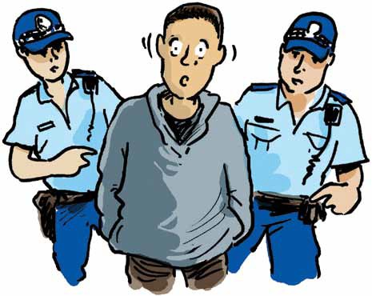 THE
POLICE,
COURT

AND LAWYERS

WHAT TO DO AND
WHAT NOT TO DO

Disclaimer and Acknowledgement
This book is intended to inform and guide a person with intellectual disability and his or her support network through the criminal justice process in Queensland. It provides basic information only and is not intended to replace the indepth material available from Legal Aid Queensland or the services of a legal practitioner.
This book is intended to protect and steer a vulnerable person and his or her decision maker (in the book they are named Dan and Hannah) from the first contact with Police to the first day at Court, by which stage “Dan” should be able to access a criminal lawyer through the Duty Law Service, or Legal Aid Queensland. So long as the lawyer is aware of the extent of “Dan’s” disability, he or she can then be Dan and Hannah’s guide for the remainder of the criminal justice process.
Ideally this book should be read to every person with intellectual impairment in Queensland, not because we anticipate that they will all need to know it, but just in case they and their support network need to know it. It should then be available for the person to access and explore at their leisure. Hopefully the illustrations will augment the words and help the person to remember the story.
This book is not intended to help people with intellectual disability get away with committing an offence, it is simply intended to help them benefit from the policies and procedures that are meant to protect them.
This book is funded by the Legal Aid Queensland Community Legal Education Collaboration Fund and produced by the Justice Support Program at Queensland Advocacy Inc., in collaboration with the Endeavour Foundation.
We gratefully acknowledge and appreciate the support of Legal Aid Queensland and the Endeavour Foundation and the contribution of all the individuals who’s shared memories and experiences have helped to shape the contents of this book.
Queensland Advocacy Inc.
43 Peel Street
South Brisbane Q 4101
1300 130 582 ISBN: 978-0-646-96457-7
qai@qai.org.au First Published: November 2016
www.qai.org.au Graphics by Simon Kneebone

Contents

About this book and how to use it | 1-3
Before going to the Police Station | 4-12
At the Police Station | 13-20
At the Watch House | 21-22
At the Police Station after being charged | 23-24
Getting legal advice | 26-28
At the Courthouse | 29-40
Contacts and Links | back cover

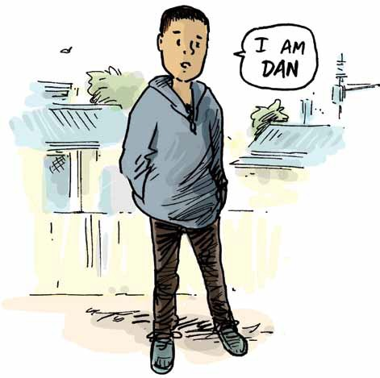and Lawyers.
About
the
Police,
the
Court
Do and What Not To Do.
What
To

This book is about Dan and Hannah.
Dan has an intellectual disability and Hannah is the person who helps him make decisions about everyday things, such as what clothes to buy and wear, what tablets to take and when to take them, what socks to wear in the morning.
This book is designed to help Dan and Hannah know and understand what they should and should not do if Dan is ever in a situation where the Police think he has broken the law.
It describes what steps Hannah can take to help Dan, as well as what Dan should do whether he’s by himself, or he’s with Hannah.

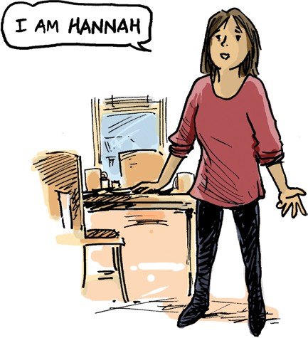

If you are like Dan and have an intellectual disability then this book should help you and your carer or decision maker understand and remember what to do if you ever have a problem with the Police.
The pictures might help you remember the story.
Some parts of this book are directed to Hannah, some parts to Dan and some to both of you, so you both need to read it together for it to make sense.

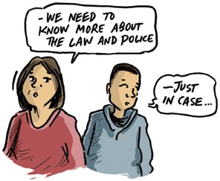Be prepared
It’s better to be prepared, to know what to do and what not to do before something happens and the Police become involved, rather than later, when Dan might find himself in a worse situation than he needs to be.

Police will be:
The first contact from
the
probably
A phone call to Hannah, a knock on the door, talking to Dan on the street, or at the scene.
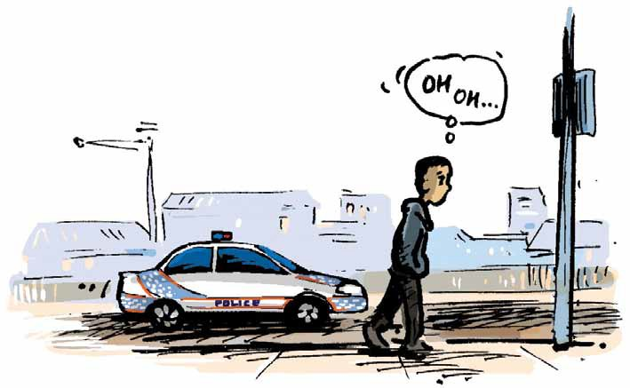

Police say:
The
might
“Dan go to the Station.”
“Dan come back to the Station with us.”
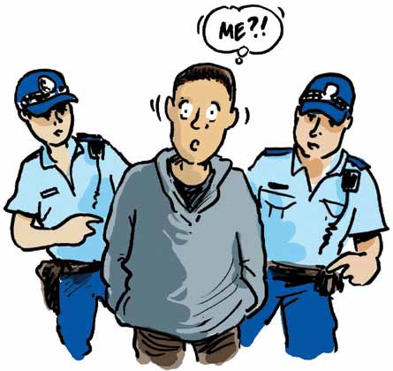
“Hannah, we have Dan here at the Station.”
“Hannah, bring Dan to the Station.”
“Hannah, we want to have a chat with Dan.”
“Hannah, we want Dan to help us with our investigations.”
“Hannah, we want to charge Dan” or something like that . . .

Dan go, it could mean -
Hannah, if
the
Police
say
HAS
to
• He has to go NOW otherwise they will just come and get him now; or
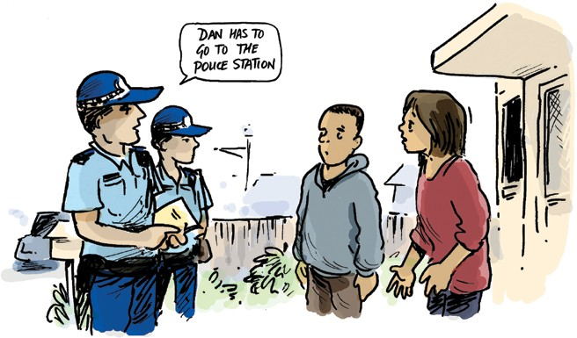
• He can come at a time that is convenient to Police, Dan, and to you, but he MUST come. Tell the Police you will be coming with Dan because of his disability.

an -
Hannah, if
you
make
appointment for another day
Don’t leave Dan at home by himself.
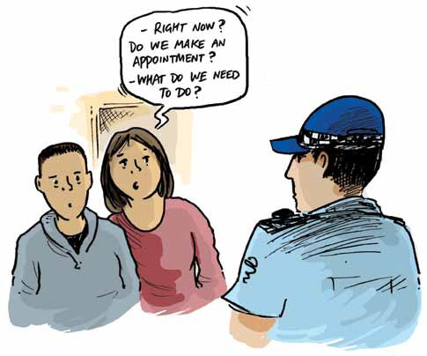
You could ask a friend to come and sit with Dan or preferably send him to respite care, to visit a friend, or stay with a relative.
Tell whoever is in charge of Dan about the Police appointment and that you don’t give permission for Dan
to go to the Station at any other time.

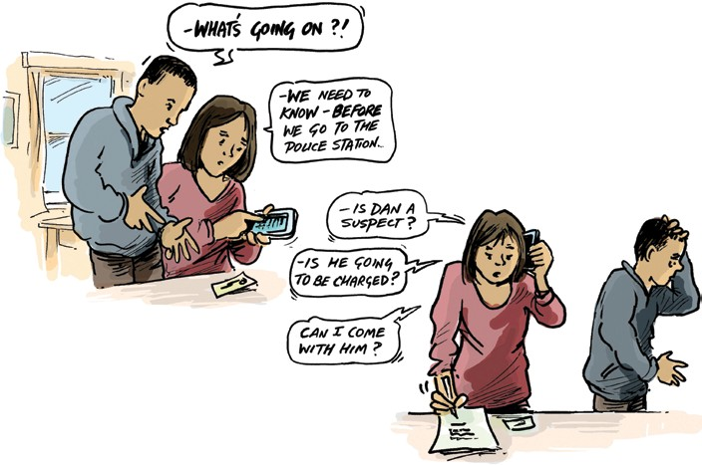Dan - find out:
Hannah,
before
you
take
to
the
Station
try
to

• Do Police intend to charge Dan?
• How serious is it, or what are they saying Dan has done?
• Will Dan be allowed to come home afterwards?

a
Hannah,
try
to
get
lawyer for Dan
The Legal Aid lawyers probably won’t be able to help Dan at this stage. Even if Dan can only afford to pay a private lawyer for a short time or for a small amount of work, this is the time to do so.
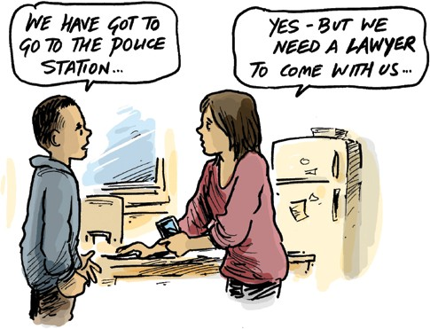
Find a lawyer who already knows Dan, otherwise one who specialises in criminal law and also does Legal Aid work.
Ask the law firm if they are a “Legal Aid Preferred Supplier” and if so, ask for a quote:
• For a lawyer to go with you and Dan to the Police Station; or
• For advice about the incident and any steps the lawyer can take before Dan goes, or instead of Dan having to go to the Station.

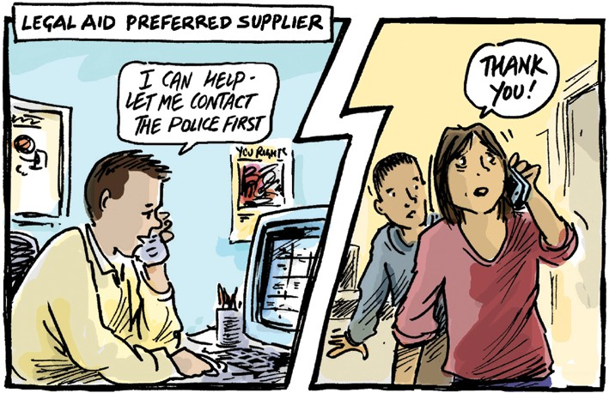

Dan
Hannah,
what
you
should
bring
with
to
the
Station
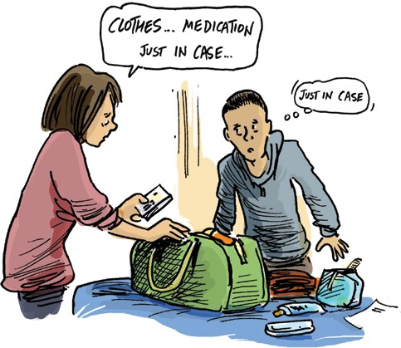
If Dan can’t afford a lawyer, try to find an advocate or a friend to go with him, someone who is prepared to stick up for him and has some understanding of Police procedures.
There’s some suggestions at the back of this book.
Bring the things that Dan would need to take on an overnight stay,
such as:
• Medication - A sample in the chemist’s container with a clear description of meds and dosage;
• A list of Dan’s special dietary requirements and any allergies;
• Comfortable clothes, personal hygiene products;
• Comfort object – favourite book, soft toy, blanket, rug, beanie, or clothing.

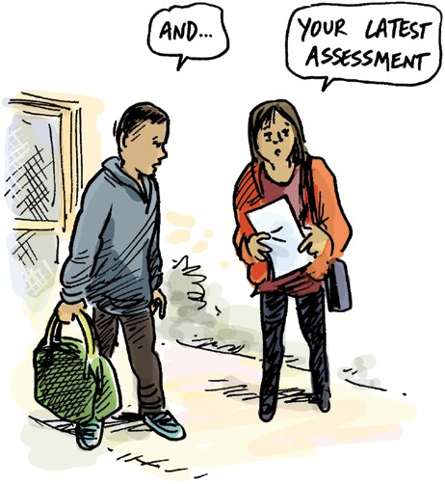

AND LAST BUT NOT LEAST ....
• Printed background information about Dan’s diagnosis, condition, or syndrome. Even something like a
Wikipedia printout is better than nothing;
• A copy of Dan’s latest assessment of capacity or level of impairment
(even if it dates back to school years).

Hannah and Dan,
before you are inside:
once
keep
to
you

Station,
rules

Dan, the Police may not be sure if you have broken the law.
go
into
the
work out some
to
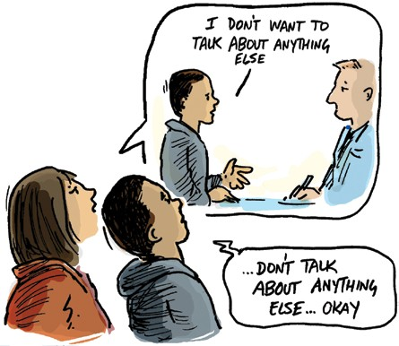
They may say that “Any statements you make might be used as evidence against you.”
This is their way of warning you that if you talk to them you might say something that makes them pretty sure you have broken the law and then they can charge you.
If you need help to make decisions about everyday things such as what socks to wear then of course you can’t decide if you should talk to the Police or what you should say.

Dan be:
your
rule
would
• That you won’t answer questions or talk to Police about the things they say you have done.

Hannah, some be:
rules for you
would
• You will tell Police about Dan’s intellectual disability;
• You will tell Police that you are his decision maker for today;
• You will tell Police that Dan will not be answering any questions and he has given you permission to interrupt and remind him even if he just starts talking casually to them;
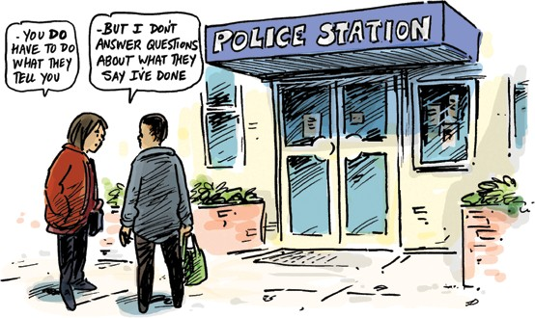
• You will give Dan a signal (finger across your lips, hand stop sign, nudge his arm) if he does start talking to Police.

Dan, if
you
Just tell Police:
at
the
Station
by
yourself:
are

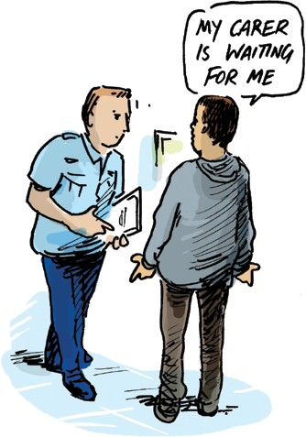• That you don’t want to talk to them or answer any questions;
• That your carer Hannah usually helps you make decisions, or makes decisions for you;
• That Hannah will be waiting for you to come home; and
• You want Hannah to come and look after you now.

are
Hannah, if
you
with
Dan:
Don’t talk about whether or not Dan did the things the Police say he has done.
Show the Police the printed information about Dan’s diagnosis and the copy of his assessment.
Explain that Dan’s not so good at reading or writing, that he needs help to understand
a lot of things and probably doesn’t understand much about what’s happening at the Station.
If Dan’s been having problems lately then explain about that and the steps you’ve taken or will take to get help for him.
Ask the Police to give Dan a second chance.

- are Police Station:
Dan,
this
is
important
while
you
inside
the
You have to do what the Police tell you to do.
• If the Police say “Sit here” then sit there;
• If they say “Turn around” then turn around;
• If they say “Go and stand over there” then do so;
• If you don’t understand then say so;
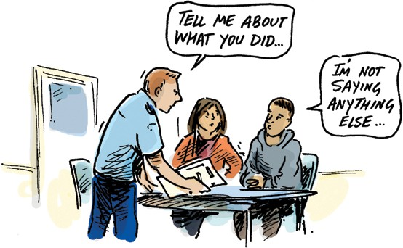
• If you need to use the toilet then say so;
• If you feel sick then say so.
You do have to give Police your name and address.
You don’t have to talk about anything else.
If they ask you about the thing they think you have done, then just say
“No comment.”

Dan – if are an
you
charged
with
offence
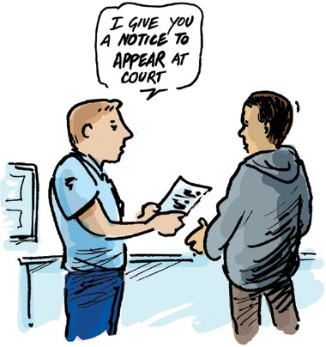
If the Police think they have enough proof that you have broken the law, they may decide to charge you, which means that they want you to go to Court.
There are a few different things that might happen if you are charged, the Police may:
• Give you a “Notice to Appear” and an “Identifying Particulars Notice” then let you leave;
• Give you Police or Watch House Bail then let you leave;
or
• Put you in the Watch House.

Notice to Appear
The Notice to Appear has got details of the law Police say you have broken, which Court you have to go to, and the time and date to go there, so it’s important you don’t lose it.

Identifying Particulars Notice
The says you have to go to another Police Station so they can
Identifying Particulars Notice
take your photo, fingerprints and maybe a sample for DNA testing.
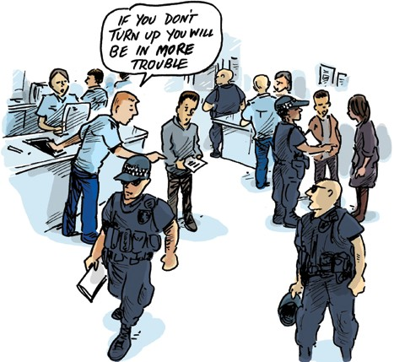
You will have to go to the Station within a certain time (usually a week) and if you don’t go, Police might add on
another charge and say you are unreliable.

Police or House Bail
Watch
If Police want to issue Bail it’s usually because they want you to do or not do certain things in future, as well as to go to Court.
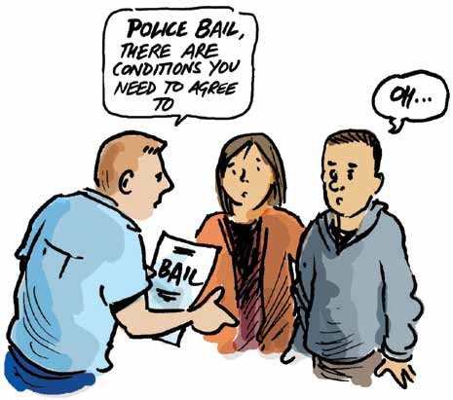
The things might be something like:
• for you to go to a local Police Station once a week;
• not to go near a certain person, street or shopping centre;
• not to use your phone anymore;
• not to go outside the yard unless a responsible adult is with you;
• not to go outside the yard after a certain time.

Bail
conditions
There are lots of different types of conditions the Police can make and it’s important that you understand them and will be able to keep them.
There’s no use for you to agree to go to a Police Station if you have no way of getting there.
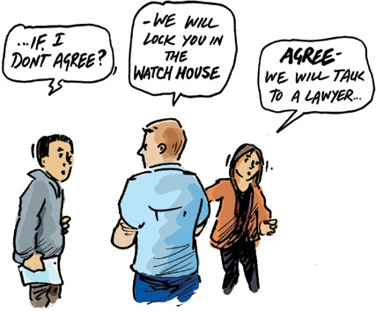
If the Policeman says to you “Well, you either agree to these bail conditions or we keep you in the Watch House,” then agree to them, but later tell your lawyer how difficult it is to keep to the conditions.

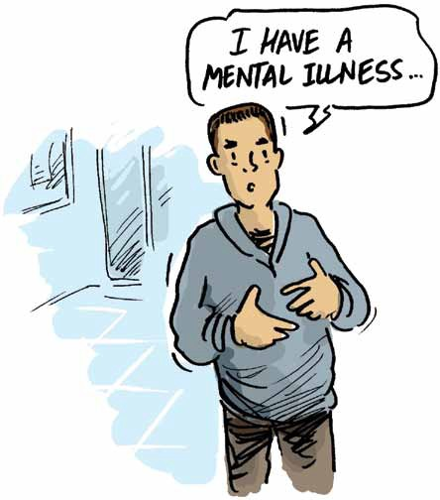
The Watch House
Dan, sometimes if they say you have broken a serious law the Police won’t want you to leave the Police Station at all.
This is when they keep you in the Watch House and if this happens Hannah won’t be able to be there with you.
There are some really important things that all the Watch House staff need to know, so if Hannah hasn’t already done so, you should calmly tell each new Policeman that you meet:
• If you normally take medication, what it’s for and when you usually take it;
• If you are allergic to anything, such as some foods or fabric;
• If you have a medical condition such as diabetes, epilepsy or kidney disease;
• If you have a mental illness.

It’s
OK
to
say you’re frightened
Tell the Officer in Charge:
• If you’re feeling really sad or frightened or fed up with everything;
• If you need to use the toilet or normally need help to use the toilet;
• Anything else that Hannah usually explains when you go to stay at a friend’s place or at a respite centre.
the

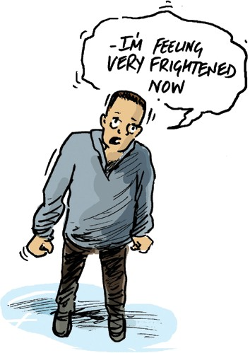
Dan
Hannah, before Watch House
goes

Tell the Officer in Charge about the things that help Dan sleep or feel safe when he’s away from home.
It might be the favourite book you read to him, the toy, blanket or rug that you brought with you, his favourite beanie, if you normally leave the night light on or the TV going to help him get to sleep.

into

Identifying Particulars
Taking
your
Dan, the Policeman might say, “Come into this room so we can take your fingerprints and photo,” or he might have given you an Identifying Particulars Notice.
Either way it’s a dull, boring thing that has to be done. It doesn’t hurt and is not scary, you just have to follow the Policeman’s instructions and tell him if you don’t understand.
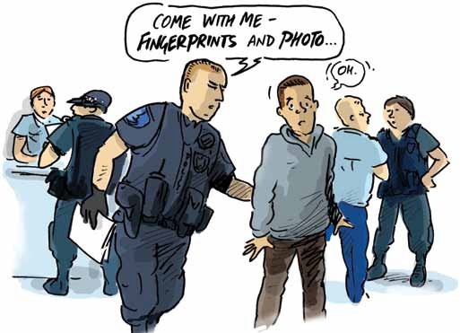

Fingerprints
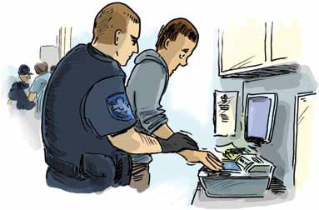
This is a picture of the lines and whirls on the end of your fingers. The Police use a stamp pad or a machine like a small photocopier without a lid.
Sometimes the machine is playing up or the Policeman isn’t very good at taking fingerprints and you’ll have to be patient while he keeps trying to get a clear scan.
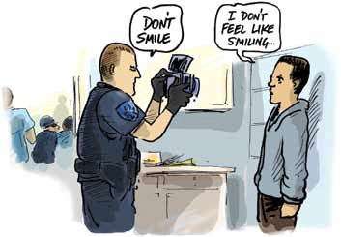
The best thing for you to do is try to relax and let the Policeman move your hand or finger around as if it’s not attached to your arm.

Photographs
The Policeman will tell you where to put your feet and which way to face, just stand up straight, keep still and find something straight ahead to stare at, such as the top of the Policeman’s head.

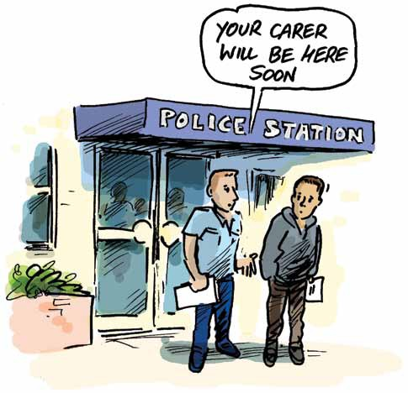
Police
You’re
out
of
there!!
(or
you’re
allowed
to
leave
the
Station
☺)
Dan, if Hannah’s not with you then tell the Police if you don’t know how to get home, or
if you need help to get home.
The Police might take you home or call Hannah.
Don’t leave the Station unless you have a plan for getting home safely.

a
Now
you
need
to
talk
to
lawyer
Dan, if Hannah doesn’t know about the charge then you have to tell her and show her the Police papers as soon as you can.
Hannah might be cross with you. That’s OK, it’s a pretty normal thing, but she’ll be really cross with you if you don’t tell her.
If Hannah doesn’t say how she will get help for you then you should tell her to contact Legal Aid straight away. If you have a Guardian, then Hannah must also tell your Guardian.
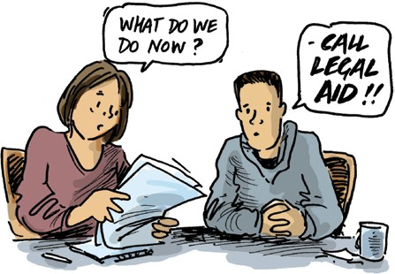
If Hannah doesn’t call Legal Aid or your Guardian, then keep on telling your next carer about the Police papers and how she needs to get help for you.
Hannah, you must tell Legal Aid about Dan’s disability and that he needs someone to look after him and help him make decisions about the everyday things in his life.

Legal
Advice
and
representation
Dan, if there’s enough time the people at Legal Aid will help you and Hannah talk to a lawyer before you go to Court. The lawyer will explain a little bit about the charge and the next steps Hannah and you need to take. If you’re frightened you will go to jail, now’s the time to ask the lawyer if that might happen.
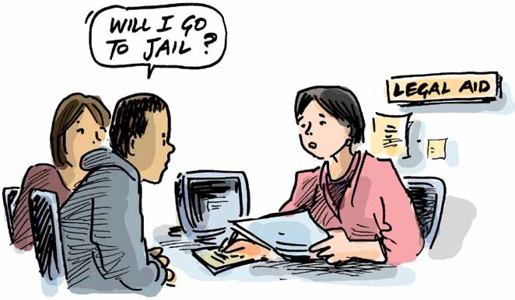

Talking
to
the
lawyer
Dan, the Legal Aid lawyers are used to explaining things to people who don’t understand, but
they’re not always so good at noticing people don’t understand them, so help the lawyer
when
by telling her if she uses words you don’t understand or if she speaks too fast.
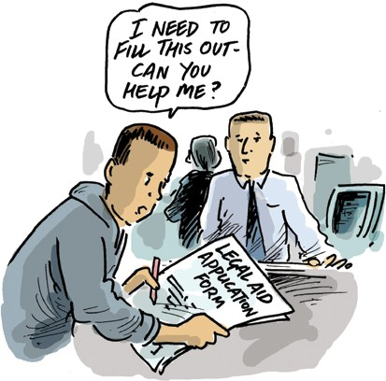
It’s OK if you and Hannah take a bit more of the lawyer’s time than usual because it’s important you both know how to take the next steps, such as filling out a Legal Aid application form or how to find the Duty Lawyer at the Courthouse.
If there’s not enough time to go to Legal Aid that’s OK because you will have a chance to have a quick talk to the Duty Lawyer at the Courthouse.
The Duty Lawyer Service is a free service that arranges for a lawyer to attend Court and help the people who have to go to Court that day.

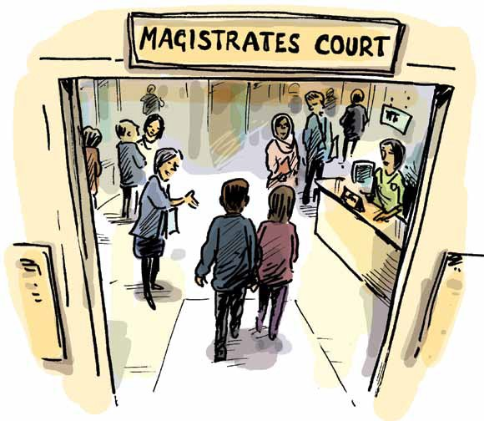

At the Courthouse
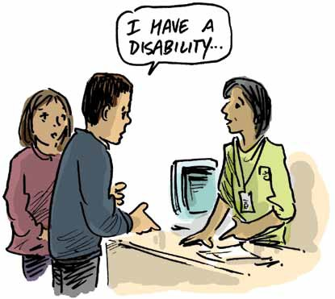
Dan, this is a busy place but everyone who works there is really polite and the biggest part of their job is to help people like you and Hannah. All the people who work there have rules they must follow. They will also expect you to behave yourself so you don’t stop them from doing their job or helping other people like you. There will probably be lots of all sorts of different people there, some will be loud and unruly, some will be really sad. You should aim to be the best behaved of them all.
The
Court Volunteers
They come to Court all the time and know just about everything about how stuff works at the Courthouse.
They know the staff, they know the security guard, they know the Duty Lawyer and they know the Police Prosecutor.
Dan, they may not know that you have a disability so you do need to tell them, but they probably won’t have time to listen to your life story.
They will help you or Hannah fill out the form that tells the Duty Lawyer that you will need his help.

Duty Lawyer
The
The Duty Lawyer has to find time to help all the people at the Courthouse so he’s usually pretty busy and won’t have a lot of time to talk to you. Each lawyer is different and will have his own way of doing things.
The most important thing for you or Hannah to tell the Duty Lawyer is that you normally need help to understand and make decisions about ordinary, everyday things.
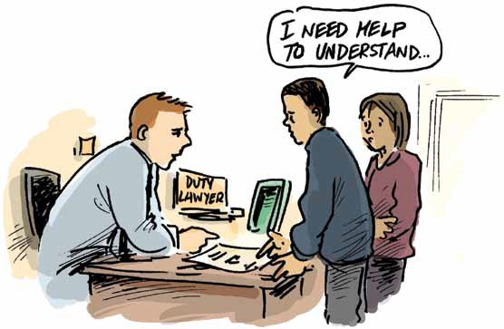
Hannah, go into the Duty Lawyer’s room with Dan and explain about his disability.
Give the Duty Lawyer a copy of the printouts or reports about Dan’s diagnosis.

Duty Lawyer about yourself
Talk
to
the
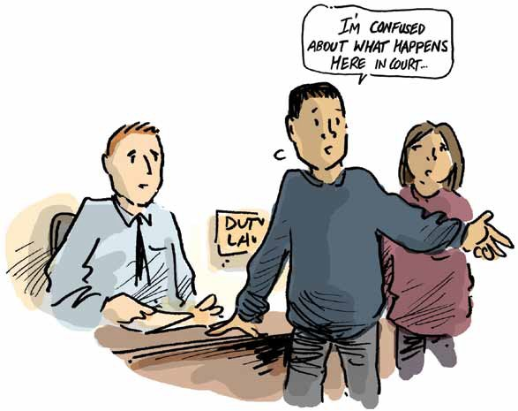
Dan, if you know that you did or didn’t do the things that the Police say you have done, you can tell that to the Duty Lawyer.
Let him know if you don’t understand what he’s saying or what’s been happening ever since the Police first spoke to you.

The
Courtroom
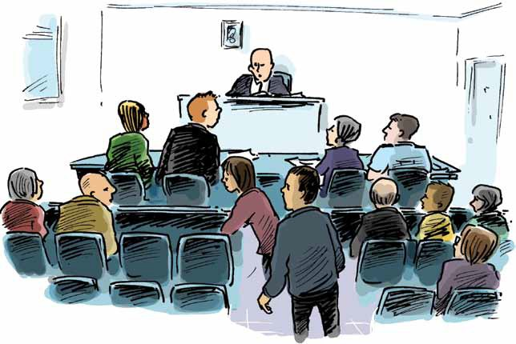
This is where the Judge is. The Judge sits behind a big high bench at the front and looks towards everyone else.

Inside
the
Courtroom
When you go into the Courtroom it’s as if you are a visitor and the Judge is the boss of that room. He needs to listen carefully to everything that’s said and has to think hard so he doesn’t make any mistakes.
It’s important you don’t distract him by talking or laughing or jiggling about. You will be expected to behave yourself, just as you would if you were at Church, at the movies or in a classroom.
Between the door and the Judge is a long bench with lots of chairs. The Prosecutors sit on the right end of the bench, one of them might be wearing a Police uniform.
The Duty Lawyer sits or stands on the left side of the long bench. He won’t be wearing a Police uniform.
Dan, you and Hannah sit until the Duty Lawyer or Prosecutor calls your name. Try to get a seat close to the centre aisle so you can get out easily.

Waiting
to
appear before the
Judge
While you’re waiting you mustn’t talk or laugh or comment on what the other people say, even if they’re being silly. Just watch how the other people go to stand at the very left end of the bench when their name is called.
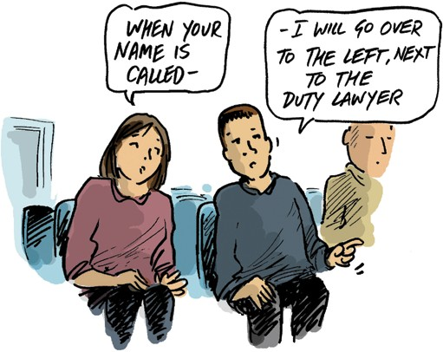
Notice that they don’t use bad language or butt in when the Judge, Lawyer or Prosecutor is talking.
This is where you and Hannah will go when your name is called and you will “appear” before the Judge.

“Appearing”
before
the
Judge
Dan, this is a fancy word for you going to stand at the long bench next to the Duty Lawyer, so that the Judge can see you. The Duty Lawyer will do most of the talking and he will tell you when to sit, stand or speak.
You stand to the left of the Duty Lawyer, Hannah can stand behind you or on your left. The Judge will probably want to know Hannah’s name and why she is there.
The Duty Lawyer can explain how you need someone to help you when you are at Court.
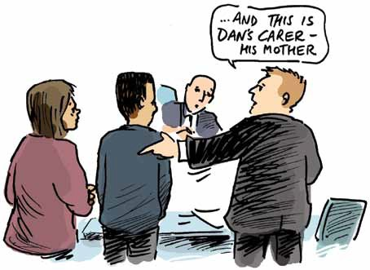

Asking
for an Adjournment
The Duty Lawyer will explain a few things and will probably ask the Judge for an adjournment.
This is a fancy way of asking “Can Dan go away and work out what to do next if he promises to behave himself and come back later?”
If you have something you desperately want to say to the Judge, you should tell the Duty Lawyer. Just wait for a time when the Duty Lawyer is not speaking to the Judge or the Prosecutor and quietly ask him if you can say it.
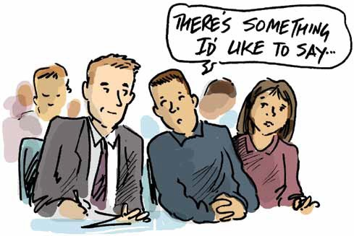

Bail
Court
Dan this is like the Police or Watch House Bail, it’s an undertaking (or promise) to behave yourself and come back to Court whenever the Judge says so. The Court staff prepare it, you and Hannah wait near the counter for your name to be called.
- You must not leave the courthouse until you have read and signed the bail.
Important
The lady at the counter will read the Bail Undertaking to you and you should tell her if you don’t understand.
There will be two copies for you to sign. The lady behind the counter will stamp them with the official Court stamp and give one copy to you. Give it to Hannah to look after it for you.
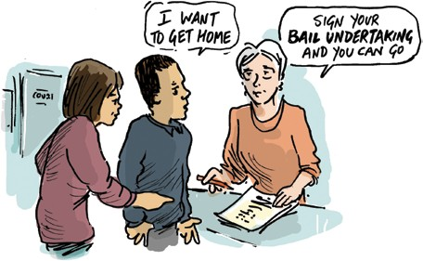

Now
you
can
go
home
☺
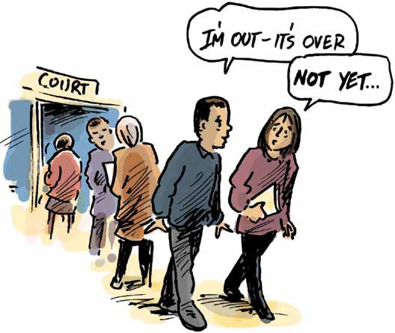
Dan, Hannah will probably help you fill out a Legal Aid application form if it hasn’t already been done. Explain about your disability and how you
don’t understand courts and usually need someone to help you make everyday decisions.
Hannah should
include the reports that describe how much help you need and why you need help.
Remember that Legal Aid helps people like you get a fair deal from the Police and the Judge.
If they say you should be OK without a lawyer then it probably means they don’t realise how confused you get, so be sure to tell them.

It’s
not
over
yet
Dan, it might take months or even years to sort it all out and there’ll be lots of stops and starts, but at least you will have a lawyer to explain things to you and Hannah, to look after you and get the best outcome for you.
If your lawyer doesn’t try to explain things to you then it might be because he doesn’t realise how much help you need, or he’s forgotten.
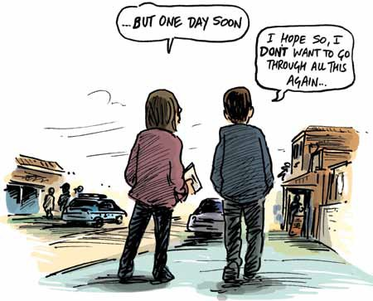
Just say “I don’t understand, can you say it a different way please?”
If you still don’t understand then it’s not your fault, it’s because your lawyer is not very good at talking to you and you might have to help him as much as he is helping you.
If your lawyer doesn’t change his words it’s time to tell someone else about the lawyer’s problem. You can ask Hannah to phone Legal Aid or call them yourself.
Dan, above all remember that until it’s all sorted out in the Court, you are on Bail and you must behave yourself.

Contacts and Links
Queensland Advocacy Inc. 1300 13 05 82 www.qai.org.au
search for “Justice Support Program” or
search for “The Police, the Court and Lawyers What to do and what not to do”
Legal Aid Queensland 1300 65 11 88 www.legalaid.qld.gov.au
search for “Have you been charged with an offence?” or
search for “Duty Lawyer Service - Magistrates & Children’s Court Contact & Service Status”
Caxton Legal Centre 07 3214 6333 www.caxton.org.au
search for “Police Powers: Your Rights A guide to your rights when dealing with the police”
Queensland Law Society 1300 367 757 www.qls.com.au
search for “Find an accredited specialist” and select the “Criminal Law” specialty
Queensland Government website www.qld.gov.au
search for “Being arrested and police custody” or “Being questioned”

