Queensland Advocacy Incorporated

ANNUAL REPORT 2016 -17

Promoting, protecting and defending through advocacy, the fundamental needs and rights and lives of the most vulnerable people with disability in Queensland
30 years

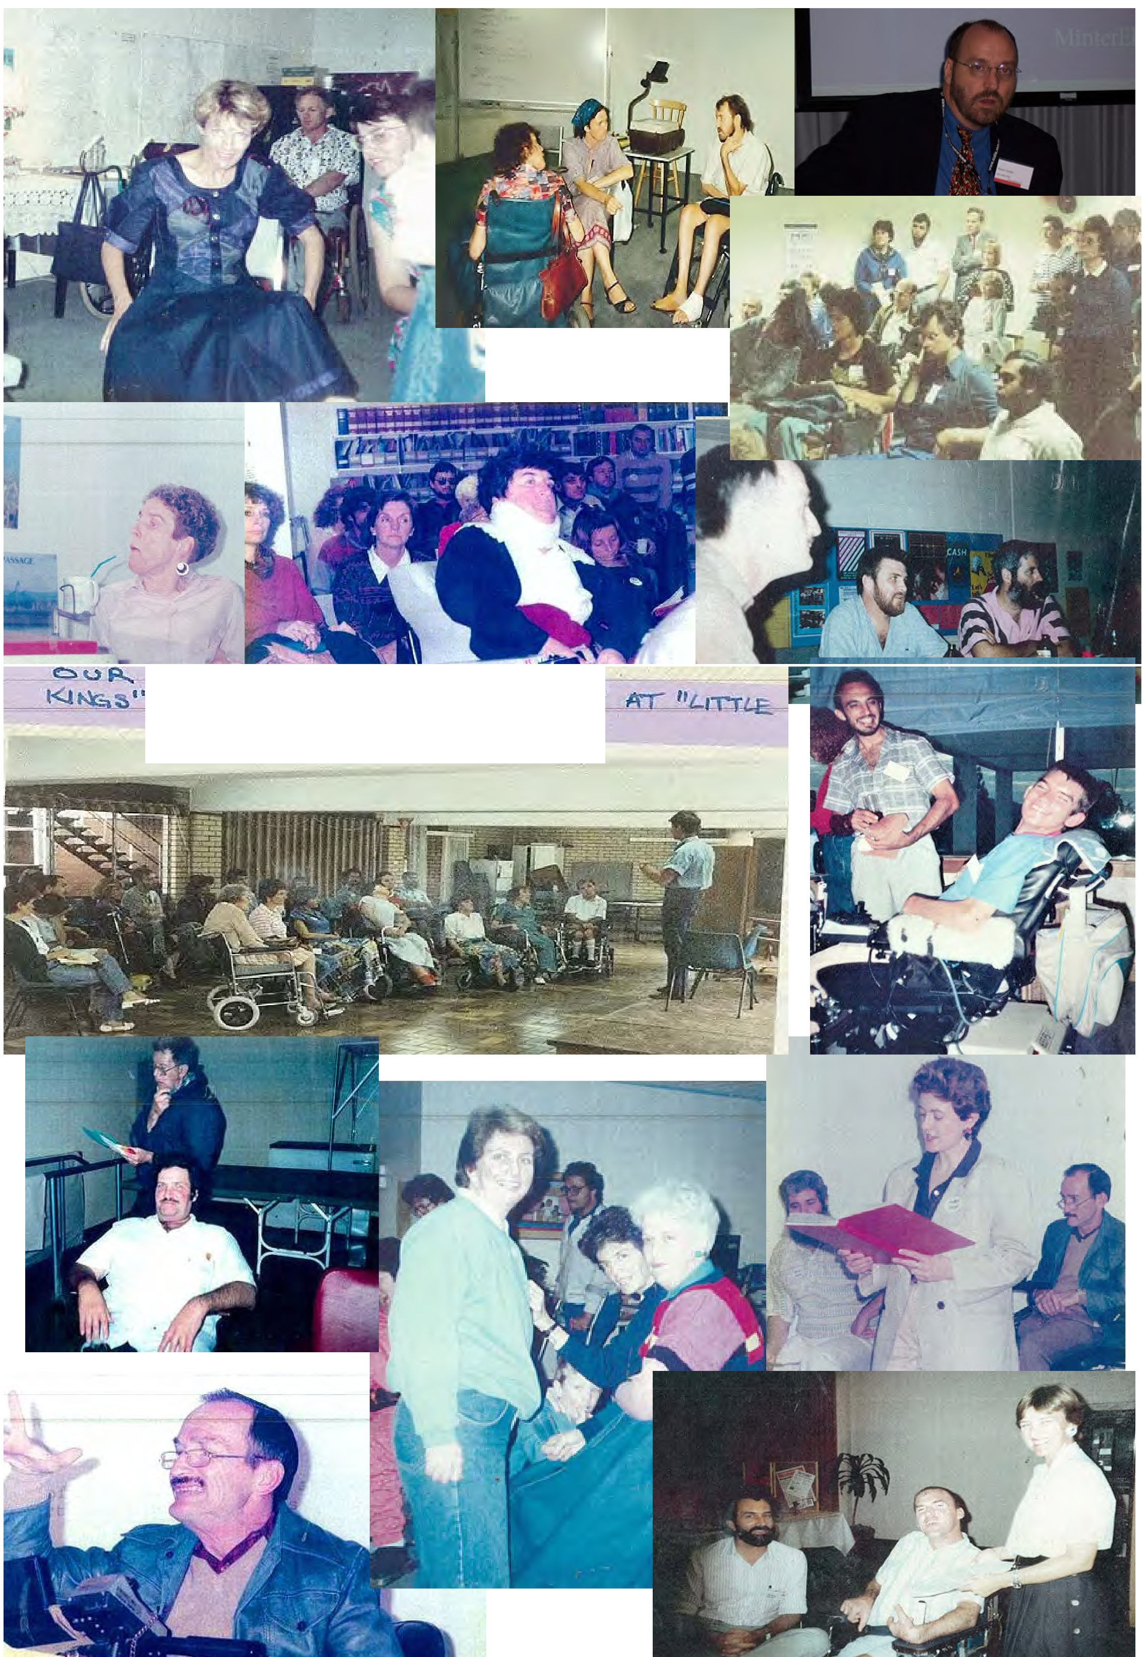

t- T PQC\'t-,lNrl',J - oR p

·, "'"" ' 1JH css czt-r ....

QAI Annual Report 2016 – 2017

Contents
Introduction 1
President’s Report 3
Treasurer’s Report 4
Director’s Report 5
Systems Advocacy – Emma Phillips, Nick Collyer & Michelle O’Flynn 11
Principal Solicitor’s Report 17
NDIS Appeals Support 20
Human Rights Legal Service 21
Mental Health Legal Service 24
Justice Support Program 29
30 Years of QAI Office Bearers 31
30 Years of QAI Staff 35
Audited Financial Report 36

Management Committee
President Byron Albury
Vice President Fiona Kennedy
QAI hours of Operation:
Monday to Friday
9am -5pm
Treasurer Meriel Stanger
Secretary Donna Best
Committee Member Trevor Boone
Committee Member Michael Duggan
Committee Member Niki Edwards
Committee Member Roba Rayan

Staff
Director Michelle O’Flynn
Systems Advocates Emma Phillips & Nick Collyer
NDIS Appeals Support Roy Henderson Justice Support Program Elizabeth Francis
Principal Solicitor David Manwaring & Rebekah Leong
Mental Health Legal Service Rebekah Leong, Tony McCarthy, Neha Vaidyanathan,
Jo Sampford, Elizabeth Beaumont & Carly Dennis Human Rights Legal Service David Manwaring & Tony McCarthy Office/Finance Manager Deborah Bryzak
Administration Assistants Shelly Samios, Rebecca Howes & Candice Kessell

Introduction

Queensland Advocacy Incorporated (QAI) is an independent community based systems and individual advocacy organisation for people with disability in Queensland. QAI advocates for the fundamental needs, rights and lives and protection of the most vulnerable people with disability in Queensland. QAI does this by engaging in systems advocacy work - through campaigns directed to attitudinal, law and policy change.
QAI also provides specialist individual legal and non-legal advocacy for vulnerable people with disability through four discrete services. The services are:

Justice Support Program (JSP)
JSP provides non-legal advocacy for people with a disability who are suspects, or have been charged with a criminal offence, and the person’s disability is a contributing factor to their situation. The first priority is to ensure the person accesses legal advice or representation, however the focus is to advocate for their access to appropriate and responsive supports which will help to prevent the problem re-occurring.

The Mental Health Legal Service (MHLS)
MHLS is a specialist legal service dedicated to providing legal advice and representation to individuals receiving involuntary treatment for mental illness in Queensland.

The Human Rights Legal Service (HRLS)
HRLS provides specialist legal advice and conducts strategic casework aimed at protecting and promoting the fundamental human rights of vulnerable people with disability in Queensland. Once a week, the HRLS operates a specialist, telephone-based Legal Advice Service (LAS). The aim of the LAS is to increase the access of people with disability to the law.

NDIS Appeals Support (NAS)
The QAI NDIS Appeals Support (NAS) services are based in Brisbane and Rockhampton and provide advocacy, support and referrals for people who are dissatisfied with a National Disability Insurance Agency (NDIA) decision. The NAS Advocate can help by:
- explaining the review processes, including what is involved in pursuing an appeal to the AAT;
- assisting with the preparation of the required documents;
- providing advice and building up the person’s skills so they can better represent themself when lodging an appeal; or
- attending AAT conferences and hearings to help the person put their case to the AAT.
The Department of Social Services funds QAI systemic advocacy and NAS. HRLS, MHLS and JSP are funded by both State and Commonwealth Governments. QAI has also received donations over the past year and continues to seek funding from philanthropic organisations and trusts for projects.
This Annual Report covers the period from 01 July 2016 to 30 June 2017. It describes in detail the efforts of QAI to be a strong and effective systems and individual advocacy organisation, committed to its mission of promoting, protecting and defending through advocacy, the fundamental needs and rights and lives of the most vulnerable people with disability in Queensland.

Our Mission
QAI’s mission is: “To promote, protect and defend, through advocacy, the fundamental needs and rights and lives of the most vulnerable people with disability in Queensland.”

Our Objectives
QAI’s objectives are:
- To affirm and put first people with disability in Queensland;
- To undertake systems advocacy that strives to promote, protect and defend the fundamental needs and rights and lives of the most vulnerable people with disability in Queensland;
- To undertake legal advocacy that strives to promote, protect and defend the fundamental needs and rights and lives of the most vulnerable people with disability in Queensland;
- To take an active leadership role in advocating for the fundamental needs and rights and lives of the most vulnerable people with disability in Queensland;
- To support, promote and protect the development of advocacy initiatives for the most vulnerable people with disability in Queensland;
- To be accountable to the most vulnerable people with disability in Queensland;
- To conduct an efficient and accountable organisation; and
- To adhere to and constantly reaffirm the following beliefs and principles:
  - All human life has intrinsic dignity and worth;
  - People with disability must positively and actively be accorded worth, dignity, meaning and purpose through being included in and with their community;
  - Social Advocacy is functioning (speaking, acting, writing) with minimum conflict of interest on behalf of the sincerely perceived interests of a person or group, in order to promote, protect and defend the welfare of, and justice for, either individuals or groups, in a fashion which strives to be emphatic and vigorous and is likely to be ‘costly’ to the actor in terms of:
    - Time or other resources;
    - Emotional stress;
    - Bodily demands;
    - Social opprobrium, rejection, ridicule;
    - Self-esteem, self-certainty;
    - Socio-economic security, livelihood; and
    - Physical safety, life
The essential elements of Social Advocacy are:
  - Strict partiality;
  - Minimal conflict of interest;
  - Emphasis on fundamental needs and issues;
  - Vigorous action;
  - Cost to the advocate;
  - Fidelity; and
  - Being mindful of the most vulnerable person.
Systems advocacy is a particular form of advocacy that focuses on influencing and changing ‘the system’, that is, the whole of society and the various systems operating within, in ways that will benefit people with disability as a group within society. Systems advocacy includes, but is not limited to, policy and law reform activities.

President’s Report

Good evening and welcome to the Annual General Meeting of Queensland Advocacy Incorporated.
I would like to acknowledge the traditional elders and descendants of the Turrbal and Jaggera tribes – the traditional owners of the land on which we meet. We thank them for their custodianship of the land and for the opportunity to meet in this place.
QAI also acknowledges people with disability who have come before us and died in institutional settings, as well as those who are still trapped in institutions or silenced by institutional practices. We take on the responsibilities of being clear about the rights of ALL people with disability and, where necessary, speak in an informed and considered manner, for those who cannot speak for themselves.
This is the 30th year of QAI as a collective force of advocacy. As the invitation noted this is the 30th election of QAI’s Committee. We had a captive audience earlier in March this year and held a pre-emptive 30th anniversary dinner, but the actual 30th Annual General Meeting will be next year. QAI has always had great parties and this is worth stretching the party over a couple of years! So we hope to see you all back here again next year too.
It has been a delight to serve as President of QAI for another year with my esteemed colleagues on the Management Committee. QAI has been immersed in a wide array of activities which both strategically and individually have promoted, protected and defended the needs, rights and lives of vulnerable people with disability.
I’d like to acknowledge the support and contribution of my colleagues, and the hard work of the staff. For the next twelve months we have committed to serve again as the Management Committee as an effective team and we have agreed to extend the size of the Committee to nine members.
In this past year the instigation of the new Mental Health Act injected new and additional funding from The Department of Justice and the Attorney General for legal representation for people with Mental Illness appearing before the Mental Health Review Tribunal where the Attorney General is represented. This has resulted in much improved outcomes for clients of QAI services. The influx of referrals has been fast and furious and we have new staff to deliver this much needed legal assistance. Our Principal Solicitor Rebekah Leong will discuss this further with her report.
The Department of Social Services has granted QAI and other National Disability Advocacy Program organisations to deliver non-legal advocacy assistance to people who experience dissatisfaction with their NDIS Plans or who are seeking reviews of decisions of ineligibility. QAI currently has two advocates working as NDIS Appeals Support Advocates, working in the Toowoomba, Ipswich and Scenic Rim areas and Rockhampton. QAI is funded to deliver this advocacy across Queensland. More about this later, from the Director’s report.
I’d like to commend and thank our hardworking staff members who are dedicated to enabling people with disability to live a good but ordinary life, and pay particular respects to Deborah Bryzak our Office Manager and her team in Administration for organising tonight’s event and the production and printing of this Annual Report.

Byron Albury.

Treasurer’s Report

It is with great pleasure that I present QAI’s Financial Report for the year ending 30th June 2017.
I would like to thank Hayward’s Chartered Accountants for the preparation of the Audited Financial Report and for their support throughout the year.
QAI’s work continues with Annual Funding with the Department of Social Services (DSS), Department of Justice and Attorney-General, Department of Social Services NDIS Appeals and fees from Legal Aid Queensland for legal representation to clients appearing before the MHRT.
QAI continues to review and update their policies and procedures and I am satisfied that we are well placed for the challenges ahead. It has been an interesting time adjusting to the changes within the disability sector and finding our place in the NDIS.
QAI’s day to day financial matters are administered by Deborah Bryzak. Deborah provides me with an enormous amount of assistance and I would like to thank her for guiding me through the maze of figures and reports.
I have thoroughly enjoyed working with the Management Committee and the dedicated staff at QAI and I would like to thank them for their support and continued vision. My time as Treasurer has been positive, harmonious and rewarding and I look forward to being passionate about my future as Treasurer of QAI

Department of Social Services | $498,087.00
Department of Social Services-NDIS Appeals | $137,000.00
Department of Justice and Attorney-General | $462,248.00
Other Income

University of Queensland-Disability Law Clinic | $4,000.00
Legal Aid Queensland-MHRT | $113,902.00
Memberships | $791.00
Donations | $1,088.00
ADAA Training Project | $8,989.00
COSP New York | $4,980.00
National Disability Conference | $10,000.00
*Audited financial reports can be found at the end of the Annual Report. Meriel Stanger

Director’s Report

QAI has made significant contributions to affect change in the disability landscape and the partnerships and collaborations with other organisations and individuals are gaining ever increasing momentum and effect.
The highlights of the past year have been momentous with the forum “Walk the Talk: Realising the
National Disability Strategy and our human rights promises held in March this year.
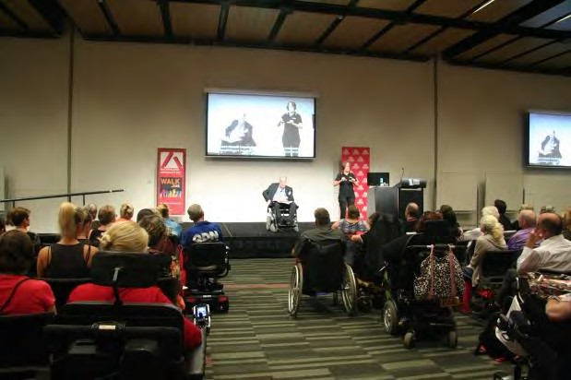
The event held in partnership with Griffith University at the Brisbane Convention and Entertainment Centre brought people with disability and families, advocates and supporters from all parts of the country, will luminaries such as Alastair McEwan, Ed Santow, Benedict Coyne and the authentic voices of people with disability as key presenters.
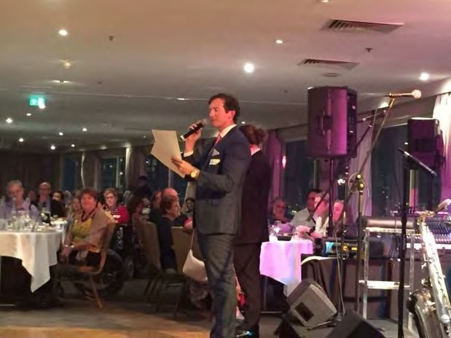
The report from this event is available online, as is the video on our YouTube channel.

Following this leadership event QAI celebrated 30 years of systems and individual advocacy with a celebration dinner with our special Master of Ceremonies Benedict Coyne.

The continued campaign for a Human Rights Act has been persistently pursued by QAI with Emma Phillips as our delegate.
Nick Collyer has been driving the campaign for accessible rolling stock trains from the rear carriage with people with disability in the engine compartment.

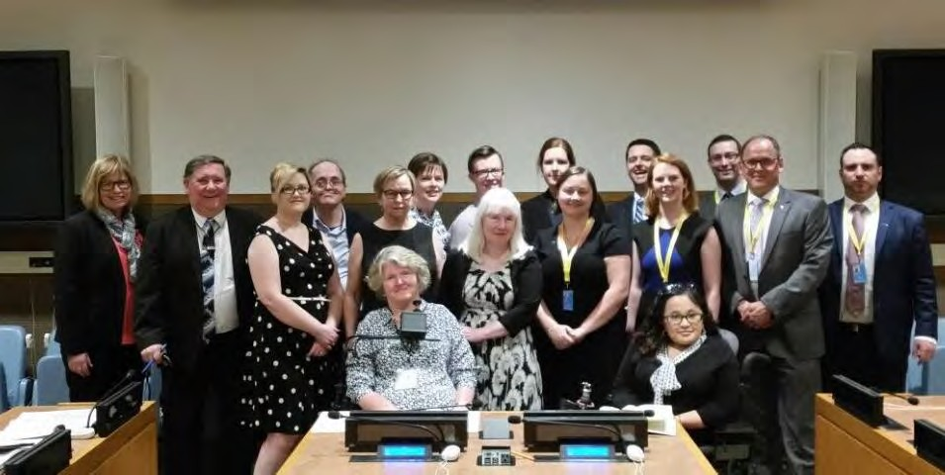
Funding and Quality Assurance
Tony McCarthy represented QAI in New York Conference of State Parties (COSP) to the Convention on the Rights of Persons with Disabilities (CRPD) this year to engage with other members of the Australian Delegation.

QAI key staff members met with Paul Davey from Legal Aid Qld to discuss the funding and allocation of work to represent people with mental illness before the MHRT under the new Mental Health Act. This has resulted in a new service with new staff members who have been a welcome addition to the QAI legal team.
QAI engaged the services of Catherine Weaver from Dreamweaver Consulting to add finesse to the final submission for the new funding process through QTenders for the Department of Justice and Legal Aid LPITAF funding.
QAI is grateful to the Department of Social Services for funding for the NDIS Appeals Support work initially undertaken in the Toowoomba rollout region, and then flowing into Ipswich prior to official rollout. Promotion has being undertaken across Queensland already and subsequently referrals have come from the Rockhampton region as well.
QAI is also appreciative to the Department of Social Services for funding to send delegate Tony McCarthy to New York in attending the Conference of State Parties (COSP) to the Convention on the Rights of Persons with Disabilities (CRPD).
In March this year, QAI began the representation for clients under the new referral pathway from Legal Aid for representation to the Mental Health Review Tribunal under the Mental Health Act with our new lawyers.

Partnerships and Collaborations
QAI continues to host regular CAGQ (Combined Advocacy Groups of Qld) teleconferences.
Disability Services Partnership Forum meets every 6 weeks and either Nick Collyer or I attend them on a regular basis when possible.
This organisation is a key leader in the campaign for a Human Rights Act for Queensland and as such continues to forge relationships in other states for a National Charter of Human Rights.
QAI has forged a very healthy and respectful working relationship with Natalie Siegel-Brown from Office of the Public Guardian and Mary Burgess from Office of the Public Advocate. Regular meetings have been established at 6 weekly intervals alternating between venues, with informative and productive working agendas to reform approaches to guardianship, support for decision making in the realm of the NDIS and guardianship matters and referral pathways to QAI.

As Director and Board member I continued to participate in DANA Management Committee
teleconference and face to face meetings.
QAI maintained our working relationship with a national network of allies in advancing Supported Decision-making.
QAI is a member of the Australians for Disability Justice Campaign.
With collaborators Benedict Coyne and Natalie Wade, QAI is a partner on disability issues for the

Australian Lawyers for Human Rights.
This organisation is a member of a national collective of proponents for ratification of the Optional Protocol Convention Against Torture, informing the group of the work of QAI around the Human Rights Act for Queensland and our submission to the Senate Inquiry regarding the indefinite detention of people with disability.
QAI and Australian Aged and Disability Advocacy (AADA) continue to partner in delivering training and information for people with disability, carers and health professionals about Guardianship and related directives.
QAI is a regular participant and presenter to QDN’s self-advocacy group Hot Topics with two events this year.

Publications/Promotions
Not only do our individual advocates engage with the Community Legal Centre of Queensland but our systems team are regular contributors and collaborators on mutual interests with at least two events this year.
Elizabeth Francis and the Justice Support Program developed the booklet for people with disability (intellectual/cognitive impairment) and their supporters when and if they come into contact with the criminal justice system

Client/Stakeholder Satisfaction
QAI received numerous complimentary feedback on the
segment of the ABC tv show “Australian Story”. This feedback from Australian Lawyers for Human Rights Natalie Wade - ‘Michelle O'Flynn was very reasonable and a fantastic human rights voice for the young people.’ Similar feedback was received from Miriam Taylor from QCIDD. The parents of one of the young persons featured in the story had this to say “Thank you for being part of the program…your calmness and patience was much appreciated and I'm so glad we have met you and know we have you there for future info and advice, thanks.’ Catherine and Gavin. QAI also received thanks from an audience member of the Rights Denied Forum for support to attend the event.
Dr Anthony Swain wrote and thanked QAI (in particular Emma Phillips) for her work on the removal on the statute of limitations for child sex abuse victims. ‘Thanks to everyone in your team who contributed to the process that led to this result. Thank you for the work you do every day!’
The Adviser to Disability Discrimination Commissioner Alastair McEwan wrote to QAI and said ‘I also want to acknowledge QAI’s excellent contributions to the Senate Inquiry into the indefinite detention of people with cognitive and psychiatric impairment – I haven’t read the full report but

from what I have read I can see QAI has been quoted and referenced numerous times.’
The Qld. Public Guardian Natalie Siegel-Brown was appreciative of QAI’s systems team that also included David Manwaring ‘My heartfelt thanks for providing your presentation today to my staff. I have had great feedback’…and from her team…’ It was very informative and thought-provoking. The networking opportunity was invaluable, in addition to the expansion of referral options for our clients.’
Service provider Uniting Care was appreciative of our participation in consultation in their re- branding in readiness for the NDIS ‘At the end of the year I wanted to thank you for the time you took to talk with Martin Hull and me a number of weeks ago about the branding and positioning of a contemporary disability service provider and Uniting Care’s Disability Services in particular. You have given us some very valuable insights and advice, which led to some very good discussions internally within Uniting Care about our branding and positioning.’
In accordance with a need to actively seek feedback on our organisation and the services we provide, QAI undertook a survey monkey with the following results (in summary):-
84 respondents
75% agreed that ‘QAI is an effective voice on behalf of people with disability’. 80% correctly identified QAI’s mission (from four options).
13 clients stated that QAI’s service was good or very good. 3 clients said service is/was fair or poor.
The majority of respondents have engaged with QAI in relation to our systemic projects. The Human Rights Act campaign has the highest rate of recognition.
2/3 of respondents find our location convenient; about 1/3 do not.

Respondents’ verbatim comments:
I have known of the work of QAI for many years - I believe QAI has been and still is a vital voice for human rights for people with disability in Qld. Now more than ever it is important for QAI to exist and remain a force for justice.
QAI has undertaken incredibly important systemic casework over the years and has produced excellent reports and resources.
QAI was instrumental in helping me to become the advocate and practitioner I am today. Thank you!
I think QAI is a must have organization re: watching brief & advocacy over systemic issues. It is also an important organization for advice re legal on complex matters and with is relationships with legal entities as an ally of vulnerable people in Queensland.
The following positive feedback was received regarding the systemic and individual advocacy and community education endeavours of QAI advocates and staff:-
- UNNSW gave positive feedback to the QAI research paper “Walk the Talk: Realising the National Disability Strategy and our human rights promises”
- Qld. Health Key staff offered positive feedback and requested copies of the presentation made regarding new Independent Patient Rights Advisers

- Service Provider Member of Disability Services Partnership Forum sent an email giving thanks and appreciation for the JSP Booklet “About the Police, The Court, and Lawyers”
- The Public Guardian offered thanks and positive feedback on the JSP booklet
- The Public Guardian offered thanks and positive feedback from all her staff regarding training on support for decision making offered to general guardians and has filmed the presentation for ongoing training of her staff.
- MHLS client has offered positive feedback for individual representation as well as our systemic advocacy actions – media releases, papers and reports – feedback offered via social media.
- QAI received accolades and positive feedback regarding the Forum “Walk the Talk” – a report regarding this important work will be finalised by end May.
- QAI also received very positive feedback on the 30th Anniversary dinner.
- I received positive feedback regarding the advocacy presentation to QUT social work and human services students
- Positive feedback received from TASC about recent training provided by QAI advocates.
- Verbal and written feedback via email and evaluation sheets gave an overall glowing response to the Walk the Talk forum and also the 30th Anniversary dinner.

Internal Systems and Processes Performance

Governance
Every year members of the Management Committee and staff review the Operational Plan and related Strategies. In September 2016 all staff and available Committee Members undertook Aboriginal and Torres Strait Islander Cultural Safety and Awareness training and we thank Aunty Betty McGrady and Jade Carroll from the Nutcha ATSI Corporation.

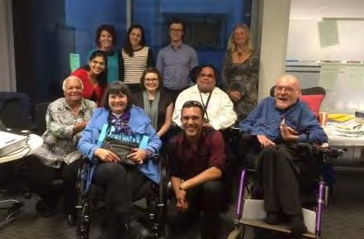

Administration and Financial Management
QAI maintains clear and accurate financial records for service and audit requirements.
QAI is financially viable. Records of the organisation’s financial position are kept up to date by the Office Manager who regularly consults with the financial auditor. QAI purchased a vehicle to support the work of advocates in both regional parts of Queensland for NDIS Appeals support (Toowoomba and Ipswich areas) as well as for lawyers working in places where public transport or rideshare/taxis are not viable or economical (ie The Park, FDS Wacol). The car is garaged in the carpark of our premises.

Human Resources
QAI has a collaborative approach to most of our work with lawyers often flexible enough to support each other when and as the workload increases. Our systems team is highly collaborative and key individual advocates are engaged in systemic work in a cohesive and effective working relationship. As is customary all systemic work is provided support and supervision, by either our Principal Solicitor or me.
All QAI staff take advantage of opportunities for continuous professional development with training identified at annual reviews.
After several scoping activities, we interviewed and employed Roy Henderson as the NDIS Appeals Support Advocate for Toowoomba and Ipswich regions. Jenny Smith has only recently been employed to deliver this support in the Rockhampton regions.
Neha Vaidyanathan’s contract came to an end in June and she has now moved on to work at RAILS.
Rebekah Leong returned in the New Year as our Principal Solicitor.
David Manwaring resigned to take up new opportunities in another CLC and Tony has moved from MHLS into the role at HRLS.
Elle Beaumont is the new lawyer working in MHRT referrals while Jo Sampford is now our Mental Health Legal Services coordinator, while still working (only with existing clients) for the MHRT referrals.
Shelly Samios finished her role as part time receptionist to take up her scholarship at Griffith Uni. Candice Kessell had taken up the position but has since moved on to a new venture.

Volunteers/Student Placement
QAI is well supported by a team of volunteers and students in our legal services (The Principal Solicitor report will acknowledge all those who have participated this last year). We have been very grateful to Elise Nolan who has contributed in her voluntary capacity with QAI for several years in providing expertise and collaboration on mutual interests. We wish her well in her future.
Our organisation has been enhanced by the addition of social worker student placements from QUT Kelvin Grove in recent years and Evee Perich has become a much valued member of our team. QUT has also been a contributor to updating our old and very tired website and we are extremely indebted to Cameron Pavey-Gilbert, Michael Jorgensen, Emmy Tran and William Nguyen for their creativity and their patience. It is still a work in progress to update and make all our imagery as accessible as possible.

Michelle O’Flynn

Systems Advocacy –
Emma Phillips, Nick Collyer & Michelle O’Flynn

Submissions
The systems team has researched and written the following submission:
- Draft comment on the Commonwealth Continuity of Support Programme – Specialist Disability Services for Older People, 7 September 2016
- Limitation of Actions (Institutional Child Abuse) Bill 2016, 16 September 2016
- Submission to Legal Affairs and Community Safety Committee on National Disability Insurance Scheme Savings Fund Special Account Bill 2016, 4 October 2016
- Department of Social Services – Disability Employment Services Reform from 2018 submission, December 2016
- Department of Social Services - National Disability Insurance Scheme Quality And Safeguarding Framework
- Child Protection Act Review Submissions, December 2016 and February 2017
- Submission to the Education, Tourism, Innovation and Small Business Committee on Child Protection and Education legislation (Reporting of Abuse) Amendment Bill 2017
- Submission to the Queensland Law Reform Commission review of whether a domestic violence disclosure scheme should be introduced in Queensland, February 2017
- Shaping our future: Discussions on disability rights: Australian Human Rights Commission Consultation, 1 March 2017
- Guardianship and Administration and Other Legislation Amendment Bill 2016 submission, 6 February 2017
- Deloitte Access Economics met with Michelle to discuss the Queensland Disability Policy Review - Students with disability. QAI provided them with issues that have been brought to our attention and any systemic activities we had undertaken in recent years on education of students with disabilities. Some of the issues included physical assaults by teachers and principals. This was the verbal QAI submission to the Review.
- Corrective Services (Parole Board) and Other Legislation Amendment Bill, 9 March 2017
- Submission on Productivity Commission Inquiry – NDIS, 31 March 2017
- Productivity Commission’s Human Services Inquiry
- Department of Communities, Child Safety and Disability Services “Towards an All Abilities Queensland”
- Department of Communities, Child Safety and Disability Services Forensic Disability and Other Legislation Amendment Bill 2017 – in confidence submission
- Inquiry into the design, scope, cost-benefit analysis, contracts awarded and implementation associated with the Better Management of the Social Welfare System initiative, 17 March 2017
- The Commonwealth Ombudsman met with QAI staff to provide information about their role and to hear from peak disability agencies, service providers and advocates about their experiences or concerns about the NDIS with the view to enhancing our complaint handling.
- National Disability Strategy Submission – Inclusive and Accessible Communities, 28 April 2017
- Joint Standing Committee on the National Disability Insurance Scheme Inquiry into the provision of services under the NDIS for people with psychosocial disabilities related to a mental health condition.
- NDIS Psychosocial Disability submission and supplementary submission, May 2017

- Modern Slavery Act submission (for Australian Lawyers for Human Rights), 28 April 2017
- Australia’s review under the International Covenant on Economic, Social and Cultural Rights, 28 April 2017
- National Disability Insurance Scheme (NDIS) – Code of Conduct Submission, June 2017
- Child Protection and Education legislation (Reporting of Abuse) Amendment Bill 2017, May 2017
- Special Rapporteur United Nations Questionnaire: The right to liberty and security of persons with disabilities
- Comment on the Committee on the Rights of Persons with Disabilities Draft General Comment No. 5 (2017) Article 19: Living independently and being included in the Community.
- Department of Social Services - Improving The Delivery Of Advocacy For Aboriginal And Torres Strait Islander People With Disability
- Input to DANA for a “Cost Benefit Analysis of Australian Independent disability advocacy organisations”.
- Civil Society NDIS Statement to the Council of Australian Governments (COAG) and the National Disability Insurance Agency (NDIA) Call for stronger engagement with people with disability in the NDIS.
- Penalties and Sentences (Drug and Alcohol Treatment Orders) and Other Legislation Amendment Bill 2017

Senate Inquiries
- Senate Hearing on the National Disability Insurance Scheme Savings Fund Special Account Bill 2016, 14 October 2016
- Senate Inquiry - NDIS psychosocial disability, 28 April 2017
- Senate Hearing – Better Welfare Reform, May 2017

Funding Applications

Application for bursary for Donna Best to attend Queensland Disability Conference in Maryborough in August 2016
- GOA application for HRA campaign funding
- Expression of Interest – Funding for a Human Rights Protection Framework for People Involuntarily Treated for a Mental Illness, December 2016
- Application to the Gambling Community Benefit Fund for funding to purchase a motor vehicle, 28 February 2017
- Successful funding application to attend the Conference of State Parties to the CRPD in June 2017

Research and Reports
- Research on the intersection of the international human rights treaties: This paper, with an accompanying annexure of case studies, was publicly released in November 2016. It helped to inform the think tank held on 14 November 2016 and will also inform QAI’s human rights forum scheduled for 20 March 2017.
- Rights-Based Approach to Disability: Paper for Australian Lawyers for Human Rights
- Report and Outcomes From The Forum “Walk the Talk: Realising the 2010-2020 National Disability Strategy and our human rights promises”
- Research on violence, abuse and neglect of vulnerable people with disability

Meetings (external) and events
Highlight:
Human Rights Conference & 30th Anniversary dinner, 20 March 2017
Walk the Talk: Realising the 2010-2020 National Disability Strategy and our human rights promises
On 20 March 2017, we held our national human rights conference. This event was very successful and included keynote speakers by four commissioners; six presentations showing the lived experience of people with disability; productive, interactive workshops on the six themes of the National Disability Strategy; and reporting back on the workshops.
This was followed by QAI’s 30th Anniversary Dinner at the Rydges Hotel, South Brisbane.

Metro South Health Disability Community Consultation on 25 July 2016 (an opportunity to provide oral feedback on the draft MSH Disability Plan) and follow-up meeting with Troy Hakala from MSH

Bespoke Lifestyle forum: “Real Work for Real Pay”, 16 August 2016
- Rights Denied Forum, 14 September 2016, as well as the ‘Rights Denied’ working group – regular Skype and telephone meetings
- Emma has spearheaded QAI representation at HRA meetings – regular steering committee and infrequent larger group meetings, as well as meetings with key MPs and potential funding bodies.
- The systems team attended and ran the Human Rights Think Tank, Griffith University, 14 November 2016, liaising with key speakers in the lead-up to this event
- Emma attended the OPCAT Roundtable, Australian Human Rights Commission, 8 December 2016
- Shaping our future: Discussions on disability rights: Australian Human Rights Commission, 18 November 2016
- Human Rights Defenders event, CLCQld, 12 October 2016
- ALHR National Conference, Melbourne, 18 February 2017
- Workshop - Relationships, Sexuality and People with Intellectual Disabilities, ASID (Qld), 9 March 2017
- CRU seminar on Supported Decision-Making – Sharing experience from Ireland and South Australia, 24 May 2017
- NDIS ILC Information session, 3 April 2017
- Labor Enabled Conference, 25 June 2017
- Chris Ison from the Moreton Social Support Network
- LAQ ahead of the implementation of the new MHA and the related representation work to be undertaken by QAI.
- briefing meetings on a regular basis with the Office of the Public Guardian, Able Australia (a new group of people who are deaf and blind), and DANA Board meetings and WWild gathering to support the initiative for a Council for People with Intellectual Impairment, as well as the 6 weekly Disability Services Partnership Forum and the regular CAGQ teleconferences.
- Michelle and Emma met with Human Rights Learning Centre Suzanne Arnold regarding the capacity of Australian organisations, business and governments in the field of human rights

- Following the submission “A Home of One’s Home” at their invitation, Michelle met with Logan Timms from Department of Housing and Public Works to discuss strategies for the Minister to table in Parliament.
- Tony McCarthy and Michelle O’Flynn joined SUFY with Disability Discrimination Commissioner Alastair McEwan as part of his national consultation
- With 25 years of the ADCQ the Director attended the event at the State Library “Reflecting on 25 years of the ADCQ 1991”
- CLCQ delegates including QAI with Ed Santow, recently appointed Australia’s Human Rights Commissioner
- Amparo and Griffith University CALD Symposium
- Jan Killeen (Churchill Travel Scholarship recipient from the United Kingdom) about supportive versus substitute decision-making frameworks.
- Nick Collyer has appeared as the QAI delegate to Mental Health Commissioner Strategic Conversations
- Michelle O’Flynn and Nick Collyer have represented QAI at the Disability Services Partnership Forum meetings
- Nick Collyer with Disability Commissioner Alistair McEwen recreating national standards for forensic disability

Campaigns and Media
Human Rights Act for Queensland: We have worked intensively on the campaign for the introduction of a Human Rights Act in Queensland. Our work on this campaign has included collaborating with other organisations in the campaign, engaging with individuals and organisations on the benefits of a Human Rights Act
Optional Protocol to the Convention Against Torture: We have also been heavily involved in the campaign for ratification of this UN convention, and in the working group developing a disability responsive approach to OPCAT.
Nick Collyer is the key liaison and action member of the Action group (part of the Queensland Rail Accessibility Reference Group) campaign to address Accessible NGR Trains
Other Campaigns: we have progressed campaigns on the elimination of Restrictive Practices and the cessation of indefinite detention (and closure of the Forensic Disability Service Unit).
As part of a campaign for a Disability Justice Plan QAI is hosting a face book group and key actions regarding Section 216 Criminal Code Queensland that potentially prohibits intimate relationships for people with disability.

Systemic Strategic Correspondence
State funded Advocacy – letters to State and federal Ministers and Senators including face to face meetings.
Correspondence sent to Director Community Care Services, the Minister for Health, the Minister for Communities, Child Safety and Disability Services and the Qld Premier in regard to the abdication of state funded services at the time a person is deemed to be a participant and sometimes an applicant for NDIS funded supports without regard to the state-funded supports and or services that are outside the scope of the NDIS. QAI has received replies from all departments offering assurances that state services will be reinstated to participants.

Media releases
Media releases by the systems team include:

“Queensland Advocacy Incorporated calls for a Human Rights Act that will offer real protection for vulnerable people in Queensland”, 27 July 2017

“UN Special Rapporteur Exposes Human Rights Hypocrisy” in response to the ‘End of Mission Statement’ issued by United Nations Special Rapporteur on the situation of human rights defenders, by Mr Michel Forst.
- “Queensland Advocacy Incorporated highlights the urgent need for human rights safeguards to stop the abuse of our most vulnerable”, 24 August 2016
- December 2016 Media Release - QAI Commends NDS’ Zero Tolerance to Abuse - But services can do more
- “Denial Of Support To Qld. Juror” In light of the High Court decision to deny deaf Queenslander Gaye Lyons her right to participate in the jury process
- “Extend the scope of the Northern Territory inquiry into youth detention”, 8 August 2016
- ‘Queensland Advocates Applaud the Federal Government Commitment to Ending Torture’ in regards to the Commonwealth announcement to ratify the Optional Protocol Convention Against Torture.
- “Attacks on Gillian Triggs by The Australian Newspaper”
- Media release issuing an urgent call for a Royal Commission into violence, abuse and neglect of people with disability, 28 March 2017
- In March Director Michelle O’Flynn was interviewed by radio station The Wire regarding mobility allowance and the NDIS
- When QAI appeared at the Senate Hearing into the Better Welfare reform initiative in May 2017, this appearance led to QAI being quoted favourably in the Guardian.
- Complaint to Australian Press Council regarding media coverage of the National Disability Insurance Scheme (NDIS) and the impact of this on Australians with disability and mental illness, 7 June 2017
- Director Michelle O’Flynn was interviewed by “The Wire” 4EB – in response to NDS report on the NDIS
- ‘Queensland Advocacy Incorporated supports the call for regulation of restrictions in aged care’
- against personal restrictions to increase operational efficiency
- Vocational Education for Students with Disability’ - Pointing out the challenges faced by persons with disabilities in getting work; lack of accessible workplaces and disability-friendly employers.

Presentations/ Publications/Promotions/Networking
Emma Phillips guest lecturing to Bond University students and mentoring of human rights law students on numerous occasions
David Manwaring, Nick Collyer and Michelle O’Flynn gave a presentation to Guardians from the Office of the Public Guardian, working in Restrictive Practices, about support for decision making to empower and enable people with disabilities in order to reduce and eliminate the use of these practices
Michelle acted as speaker at the Education Masterclass held by Community Resource Unit at the Autism Hub at /Dutton Park.

David Manwaring and Michelle O’Flynn gave a presentation on “Support or no support to exercise decision making capacity: same person, same decision, vastly different outcomes” at the annual AGAC conference in Sydney “Reflecting Will and Preference in Decision Making”.
Director Michelle O’Flynn presented short lecture about QAI advocacy to students of social work and human services at QUT.
Roy Henderson and Michelle distributed information regarding NDIS Appeals support and promoted rights regarding plan reviews, opportunities and options at the CRU event “Real stories of the NDIS”.
Michelle gave a presentation to Labor Enabled on the rights to relationships and the issues of Section 216 and 218 under the Criminal Code.

Capacity Building and Collaborations
QAI together with WWILD-SVP Association Inc., Community Living Association Inc., Queenslanders with Disability Network (QDN), ADA Australia and Australasian Society for Intellectual Disability (QLD Division) have joined forces from the event “A Voice for Queenslanders with Intellectual Disabilities” which was held in Parliament House and provided opportunity to workshop and collaborate to inform the organisers of strategies to advance this goal. QAI Board member Donna Best was a key highlight of the program. This network together with self- advocates from Loud and Clear, Wwild,CLA and Hot Topics, are working to establish a council for people with intellectual impairment across the state.
QAI provided advice and endorsement to QDN’s letter to the Minister in regard to the Taxi Subsidy Scheme.
In building capacity with and for people who experience mental health issues QAI met with two groups – GROW and Moreton Social Support Network to discuss and deliver training about advocacy
Nick Collyer and Michelle O’Flynn have provided support and collaborative efforts to Able Australia Qld. Branch – a group of people experience both deafness and blindness.
QAI has collaborated with Miriam Taylor from QCIDD and 121Care and Natasha Alexander from the Rights Denied Forum.
Further to this we now have an established relationship with people with disability who participate in political life as members of Labor Enabled.

Emma Phillips, Nick Collyer & Michelle O’Flynn

Principal Solicitor’s Report

Rebekah Leong returned to the Principal Solicitor role on 16/1/17. The work of David Manwaring as Principal Solicitor during her absence is gratefully acknowledged

Service provision
Since 2008, QAI has provided legal and non-legal assistance to people with disability in relation to human rights and substituted decision making, mental health law, and the criminal justice system. As at 30 June 2017, QAI has delivered 6310 services as follows:
- Opened 1392 legal cases, most requiring representation before a court or tribunal;
- Opened 205 non-legal cases, providing advocacy and support to people navigating the criminal justice system;
- Opened 7 non-legal cases, in relation to our newly established NDIS Appeals Support service;
- Provided 2251 legal advice and tasks, ranging from simple one off consultations, to advices requiring multiple client contact, information gathering, advocacy, and/or drafting;
- Provided 432 discrete non-legal assistance, also varying greatly in scope;;
- Fielded a further 2023 requests for assistance, and providing those callers with either information or referral to appropriate organisations.

Service highlights
2017-18 has been an exciting year for QAI’s individual services. In March 2017, the new Mental Health Act 2016 (Qld) commenced, heralding significant changes to the law, in particular, the role of lawyers in the Mental Health Review Tribunal. With legal representation mandatory for certain matters under the new Act, QAI’s Mental Health Legal Service has been able to increase its capacity for the first time in 7 years, as well as share our knowledge and expertise accumulated over this time.
In June 2017, QAI opened its first NDIS Appeals Support file, a new service to provide non-legal advocacy for people unhappy with their applications to NDIS.
We worked with The Advocacy and Support Centre (TASC) National to provide outreach services to people with mental illness and intellectual disability in the Toowoomba Region and in the process upskill TASC advocates to assist clients with issues relating to mental health law.
This year QAI’s individual advocates were involved in the development and delivery of three key resources: materials and related workshops on Advance Health Directives for Mental Health in partnership with ADA Australia; the Justice Support Project’s booklet “About the Police, the Court and Lawyers – What to do and what not to do”; and a 4-hour workshop on Advocacy in the Mental Health Review Tribunal.

Risk Management
In September 2016, QAI was cross checked for compliance with the National Association Community Legal Centre’s Risk Management Guide, as required for ongoing inclusion in the National Professional Indemnity Insurance Scheme.

Funding
QAI is funded by Queensland Department of Justice and Attorney-General and
Commonwealth Attorney-General to deliver our:
- Human Rights Legal Service
- Mental Health Legal Service; and
- Justice Support Program.
We have again been fortunate to secure this funding over 2017-20.
Since March 2017, our Mental Health Legal Service receives income from funded representation coordinated by Legal Aid Queensland and paid for by Queensland Health. Prior to the new Mental Health Act, some representation was funded by the Mental Health Review Tribunal.
QAI was also funded by Queensland Health this year to provide, in partnership with ADA Australia, resources and training on Advance Health Directives for mental health to consumers, carers and families.
The Justice Support Program received a grant from the Legal Aid Queensland Community Legal Education Collaboration Fund to produce a booklet to assist people with disability navigate the criminal justice system.
The Human Rights Legal Service receives pecuniary support from the University of Queensland
for its contribution to their clinical legal education program.

CLASS
In March 2017, a new client management database called CLASS (Community Legal Assistance Services System) was rolled out to all community legal centres in Australia.
The potential of CLASS is evident and it will eventually become an essential tool to streamline processes which will increase service efficiency, however it has not yet reached full functionality resulting in difficulties in obtaining complete statistics for services delivered in 2016-17.

Memberships
QAI is on the committee of the Queensland Legal Assistance Forum (QLAF) Mental Health Service Planning Working Group, established during the reporting period to promote cooperation and collaboration between legal service providers working with people with mental health issues, intellectual disability or cognitive impairment. With LawRight and ADA Australia, QAI prepared a number of project proposals to be considered for funding through QLAF. One of these proposals (aimed at improving collaboration between the legal assistance sector, Independent Patient Rights Advisers and the Court Liaison Service under the new Mental Health Act) was approved for funding in the QLAF work plan. More information about the Queensland Government’s process for allocating project funding is expected to be available later this year.
David Manwaring was an active member of the Queensland Law Society Health & Disability Committee. The committee provides a forum for legal, medical and health professionals and the government to identify debate and resolve issues in disability and health law. With David’s departure from QAI in April 2017 Tony McCarthy approached the committee for membership.
David was also a member of the Community Legal Centre Queensland Management Committee, our peak body for community legal centres in Queensland.

Pro bono support
We thank the following people for their support this past year:
- David Cormack, barrister at law
- Nanette Noble, barrister at law
- Karen Williams, barrister at law
- Nick Tucker, barrister at law
- Allens
- Clyde & Co
- Office of the Public Advocate, in particular long term volunteer lawyer Elise Nolan.

Clinics and student volunteers
The Disability Law Clinic (DLC) commenced operation on 30 July 2013 and is run during each university semester (13 weeks). DLC is in partnership with University of Queensland Pro Bono Centre as part of their Clinical Legal Education Program.
The Legal Clinic (Queensland University of Technology) was first held in semester 1 2016. This clinic in partnership with QUT Faculty of Law allows students to maintain academic support and undertake assessment whilst engaging in a legal placement with a community legal centre.
QAI also accepts applications for volunteering outside of these clinics. From time to time, we supervise students undertaking Practical Legal Training. All volunteers are asked to commit to a minimum of 10 working days, given the training and support QAI provides. While ultimate supervision of students and volunteers rests with the Principal Solicitor, students receive work from all services and all QAI staff are available to provide support, feedback and guidance.
We gratefully acknowledge the following clinic students and volunteers who generously gave their time in 2016-17:

Disability Law Clinic (University of Queensland)
Isabel Huf, Rachel Spain, Nicholas Thomas, Jessica Peters

Legal Clinic (Queensland University of Technology)
Chantelle Groth, Raphael Ebling, Gabrielle Davis, Philippa Robinson

Law student volunteers
Matthew Staley, Raphael Ebling, Britany Sandeman

Non-law student volunteers
Joanne Holt

Practical Legal Training placement
Maria Hall

Rebekah Leong

NDIS Appeals Support

QAI’s NDIS Appeals Support program commenced in the Toowoomba region and has stretched to Chinchilla, Warwick and Ipswich. The advocate has met with clients in all those areas, and liaised with QDN Support group members, advocates at TASC Toowoomba.
Since August, another advocate has commenced in the Rockhampton region. Her reports will be included in the next annual report.

Service provision
NAS opened 53 cases in the 2016-2017 financial year, with another 18 open cases since June, and a further 16 enquiries for assistance.

Types of issue include

Transport
Insufficient funds - respite
Rejection of Plan items – ie therapies, professional nursing care
Lack of appropriate supports – supports for sensory impairment, interpreting training
Aids and Equipment –assistive technology Home modification - ramps, grab rails Access to supports

Publications/Promotions/Networking
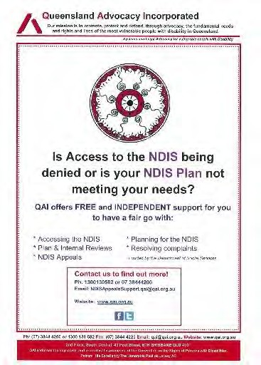
QAI produced several fliers and information sheets to promote and inform participants about their rights and the process of NDIS Appeals support. This includes a generic flier, one with a familiar image for Aboriginal and Torres Strait Islander people with disability, and a plain language booklet. These have been displayed on the website and the Face Book page and distributed at a number of events in Brisbane and Rockhampton. A media release was sent to all media contact in May, and advertisements placed in regional newspapers in all regional areas outside of Brisbane. Further to this the media release was sent to community radio stations in many regional areas outside of Brisbane.

Roy Henderson

Human Rights Legal Service

The Human Rights Legal Service was established in 2008, to provide specialist legal advice, referral and representation for people with disability in the promotion and protection of their:
- right to life, liberty and security;
- right to freedom from torture or cruel, inhuman treatment or punishment;
- right to equality before the law and equal protection of the law.
The work of the Human Rights Legal Service primarily supports people with impaired decision- making capacity, who require assistance with:
- Restrictive practices including the use of seclusion, containment and chemical, mechanical and/or physical restraint;
- Guardianship and administration, and other substitute decision making regimes;
- Forensic Orders (Mental Illness) (where the person has a dual diagnosis) and Forensic Orders (Disability);
- Health care and life sustaining measures;
- Funding and/or support issues which require legal intervention; and
- Abuse/neglect and serious injury of people with disabilities.
There are no other free services routinely providing legal representation in these areas of law.

Service provision

Casework
In 2016-17, the Human Rights Legal Service caseload was split between representing clients with intellectual disability or cognitive impairment on forensic orders (5 cases), and clients subject to guardianship and/or administration orders (6 cases). This time-consuming work involves developing rapport and trust with the client, discussions with multiple stakeholders, consideration of complex issues of fact and law, and representation at either a Mental Health Review Tribunal or Queensland Civil and Administrative Tribunal hearing. There was an additional case that investigated the validity of a gift of property made by a client while unwell some years ago.
Since March, many clients on forensic orders who would have been represented by QAI’s Human Rights Legal Service are now represented by QAI under separate funding arrangements with Legal Aid Queensland (see Mental Health Legal Service below). This has freed up much needed resources to focus on representing the most vulnerable, who are unable to self-advocate, who have limited or no family supports, and whose fundamental human rights are at risk; many clients are detained in facilities, subject to restrictive practices and/or have been denied their right to self- determination. Referrals for this work are increasing from the Office of the Public Guardian, Queensland Civil and Administration Tribunal and Independent Patient Rights Advisers.
Case study: QAI assisted a client diagnosed with an intellectual disability to get their Forensic Order (Disability) revoked. QAI had been assisting the client since early 2015 with a range of matters, including regular representation before the Mental Health Review Tribunal (MHRT), and engaging in stakeholder meetings with the client’s support network to resolve concerns about the quality of care provided by support workers, and to facilitate the client’s transition to greater independence (including securing more appropriate, independent accommodation). QAI assisted the client and their support network to show the MHRT that he no longer needed to be under the Forensic Order. The MHRT agreed, even though the Attorney-General’s representative was not supportive of the client’s Forensic Order being revoked at the hearing. The client said that he was very happy about finally being free from the order.

Case study: QAI assisted a client diagnosed with cognitive impairment and dysthymia (persistent depressive disorder) whose finances were being managed by the Public Trustee of Queensland. The client’s mental health treating team had applied for the administration order following deterioration in the client’s depressive mood. The client had a long history in business management and found the appointment of an administrator particularly embarrassing and demoralising, to the extent that the client felt that it was exacerbating their depressive symptoms. The client was also concerned about the fees incurred as a result of the Public Trustee’s management of their funds. The client sought to get the Public Trustee revoked so that they could manage their own finances. QAI assisted the client to collect information and put in place appropriate supports (including personal and professional supports) to show that they could manage their own finances, and represented the client at the Queensland Civil and Administrative Tribunal (QCAT) hearing. QCAT decided that the client has the capacity to manage their own finances and revoked the appointment of the Public Trustee. The decision (and QAI’s involvement) has provided the client with the means to regain their independence and confidence to manage their own finances.

Advices
HRLS provided 68 advices in 2016-17.
A large proportion of advices were delivered through QAI’s Telephone Legal Advice Service, an advice clinic held each Thursday and staffed by QAI and volunteer lawyers.
We thank the Office of the Public Advocate and Clyde & Co who have supported TLAS for a number of years, and welcome the addition of Hall & Wilcox in September 2017.

Advance Health Directives for mental health
An Advance Health Directive enables a person to express their views, wishes and preferences and plan for their future health care and treatment if they become unwell. The introduction of the Mental Health Act 2016 this year gave Advance Health Directives new significance for people with mental illness.
With funding from Queensland Health, QAI, in partnership with ADA Australia, developed printed and video resources to help individuals with lived experience and their families understand the purpose of and how to complete an Advance Health Directive for mental health. These resources can be found on ADA Australia’s website - https://adaaustralia.com.au/education/advance-health- directives-mh/.
The resources were then rolled out across Queensland in a series of 34 workshops, 16 of which were presented by QAI, between March and September 2017.
QAI contributed many unfunded hours to attend steering committee meetings, provide feedback on resource development, and liaise with mental health services to coordinate times and venues for workshops. The project was primarily coordinated by HRLS lawyers David Manwaring and Tony McCarthy, with Jo Sampford and Elizabeth Beaumont also assisting in the delivery of workshops.
QAI and ADA Australia have again been funded by Queensland Health to redevelop resources and deliver training on advance health directives to mental health clinicians in 2017-18.

Conference of State Parties (COSP) to the UN CRPD
In June, Tony McCarthy travelled to New York (funded through Department of Social Services) to attend the Civil Society Convention on the Rights of Persons with Disabilities (CRPD) Forum and the Conference of State Parties (COSP) to the CRPD. These forums provided a space for open discussion and sharing of experiences and perspectives about the implementation of the CRPD and the 2030 Agenda Sustainable Development Goals. Discussion at these forums was focused on how to ensure inclusion and full participation of persons with disabilities and their representative organisations in the implementation of the CRPD, addressing the impact of multiple discrimination, and promoting inclusive urban development and implementation of the New Urban Agenda (Habitat III).

Training, promotion, and law reform
During 2016-17,
- David presented a workshop session on Guardianship for TASC Toowoomba;
- David participated in a Continuing Legal Education panel discussion ‘Dealing with difficult clients’ organised by LawRight (formerly QPILCH) and hosted by CBP Lawyers;
- David and Michelle O’Flynn, attended Information, Linkages and Capacity Building (ILC) training in Sydney (NDIS Appeals);
- David and Michelle O’Flynn presented at the Australian Guardianship and Administration Council conference in Sydney;
- David with Michelle O’Flynn and Nick Collyer, gave a presentation to Guardians from the Office of the Public Guardian in regards to restrictive practices;
- David and Michelle O’Flynn met with Department of Communities to offer our concerns and feedback in regard to the review of the Forensic Disability Act 2011;
- David and Michelle O’Flynn, provided training to Restrictive Practice/Behavioural Support Guardians and general Guardians of the OPG in relation to support for decision-making.
- The service made submissions on amendments to the Guardianship and Administration Act 2000 (Qld) and the Disability Services Act 2006 (Qld);
- Staff attended regular meetings with the Public Guardian and the Public Advocate to discuss common issues of concern.
- David, Tony, Jo Sampford and Elizabeth Beaumont presented 16 Advance Health Directive workshops at various locations across Queensland.

Staffing
David Manwaring, who has headed the Human Rights Legal Service for 5 years, finished with QAI in April 2017. The Service is now coordinated by lawyer Tony McCarthy. Part time Human Rights Legal Service lawyer Neha Vaidyanathan also finished with QAI in June 2017. QAI systems advocate, Emma Phillips, has returned to the practice of law and coordinates the Telephone Legal Advice Service one day per week.

Tony McCarthy

Mental Health Legal Service

QAI’s Mental Health Legal Service was established in 2010 to provide legal advice and representation to people receiving involuntary treatment for mental illness under the Mental Health Act 2000 (Qld). The Service aims to empower individuals to meaningfully participate in treatment decisions made about them. This is achieved through representation at Mental Health Review Tribunal hearings, and outside the hearing room by providing clients with information and encouraging the development of skills to effectively self-advocate.
For many years, QAI was the only service routinely providing legal representation in the Mental Health Review Tribunal. Since the implementation of the new Mental Health Act 2016 (Qld) on 5 March 2017, the MHRT must appoint a lawyer to represent all patients in hearings where the Attorney General is represented, fitness for trial is at issue, there is an application for electroconvulsive therapy, or where the patient is under 18 years old. The Tribunal does this by making a referral to Legal Aid Queensland which has in-house lawyers as well as a panel of preferred suppliers, who provide representation to clients paid for by Queensland Health. QAI is one of these preferred suppliers. The role of the lawyer in the hearing is to represent the client’s views wishes and preferences, or if the client is unable to express these, the client’s best interests.
QAI has welcomed the significant increase in legal representation and mental health law practitioners. At the same time, we continue to use our Department of Justice and Attorney- General funding to support the many clients who do not qualify for an appointed legal representative or are seeking advice only, provide extended assistance in complex cases, and to develop and provide resources and training to our colleagues drawing on our long experience and expertise.

Service provision

Casework
In 2016-17, QAI opened 172 files to provide representation in mental health law:
- 83 matters were referred from Legal Aid Queensland for clients appointed a legal representative under the new Mental Health Act;
- 57 matters related to clients represented before the commencement of the new Act, or did not qualify for referral from Legal Aid Queensland under the new Act;
- 14 matters were referred to volunteer lawyers for pro bono representation;
- 18 matters were referred to barristers for representation on confidentiality orders under the old
Mental Health Act 2000 (Qld).
Introduction of the new Mental Health Act posed capacity issues during our first few months as caseworkers grappled with the new legislation, new procedures, and dealt with large numbers of adjournments due to non-compliance with filing time limits and evidential requirements under the new Act. Many existing clients became Legal Aid Queensland referral clients, reducing the number of clients coming from other referral sources. Six months on, we expect to see the number of both Legal Aid Queensland referral matters and other matters steadily increase.
The new referrals have brought us into contact with a wide range of new clients, many of whom have issues and advocacy needs which we are able to assist with beyond the MHRT hearing. In particular, the new referrals have enabled us to focus our attention on electroconvulsive therapy applications, which previously we had only seen a handful each year.

Cases by area of law
Area of law | Number of cases | %
Forensic orders (mental illness) | 97 | 56%
Treatment authorities (formerly Involuntary Treatment Orders) | 29 | 17%
Application for confidentiality orders | 18 | 10%
Electroconvulsive therapy | 16 | 9%
Forensic orders (disability) | 8 | 5%
Fitness for trial | 1 | <1%
Transfer | 1 | <1%
Appeal to Mental Health Court | 2  (1 representation, 1 extended assistance but not representation) | 1%

Cases by patient status
Patient status | Number of cases
Inpatient/involuntary | 87
Inpatient/voluntary | 14
Community patient/involuntary | 70
Community patient/voluntary | 1

Cases by most frequent Authorised Mental Health Service*
Authorised Mental Health Service | Number of cases
Royal Brisbane and Women’s Hospital | 27
Townsville | 25
The Prince Charles Hospital | 22
The Park | 20
Logan and Gold Coast area | 17
Toowoomba | 17
Sunshine Coast | 16
Princess Alexandra Hospital | 7

*not all cases could be included in the count

Case Study: We represented a person before the MHRT who sought to gain access to more leave to spend time with family. The client was also seeking a transfer to a health service located closer to family. The client had been detained in mental health services under a Forensic Order with no more than escorted leave (with staff members) since 2010. This was due in part to regular absconding (absence without permission). The client indicated that they regularly absconded so they could spend time with family and their indigenous community. QAI represented the client at their MHRT hearing, and made submissions for the client to have access to leave with family members. The Attorney-General was represented at the hearing and opposed any increase in leave. The MHRT decided to increase leave allowing the client to spend time with family. QAI also facilitated discussions with the treating team about a possible transfer to a health service closer to the client’s family and indigenous community. The treating team made a referral to a closer health service, and the client has now been transferred.
Case Study: We represented a young indigenous man who was the subject of successive applications for electroconvulsive therapy (ECT) for his diagnosed schizoaffective disorder. The matter raised multiple issues including the evidence base for the proposed therapy (which is less well established), standards for second opinion reports, and the impact of cultural and communication barriers in the diagnosis and treatment of indigenous patients.
On the instructions of the client and the Public Guardian we appealed the initial decision to approve ECT to the Mental Health Court, briefing Karen Williams to represent. While the appeal was unsuccessful, the questions raised during the process has resulted in changes to the treating team’s approach to this client, including referral to an expert in cultural psychiatry to inform a holistic approach to his ongoing treatment and care. The case also saw productive collaborations between QAI, the Office of the Public Guardian and Office of the Public Advocate which has resulted in increased consultation and cross-referrals in other matters.

Advices
Area of law | Number of cases
Treatment Authorities (formerly Involuntary Treatment Orders) | 110
Forensic Orders | 104
Electroconvulsive Therapy | 10
Treatment complaints | 9
Other | 10

* advice sometimes provided in more than one area of law

Pro bono partners
David Cormack, Nan Noble and Karen Williams continue, as they have done for many years, to give their services to our clients both for free and at reduced rates. We were deeply saddened by the sudden loss of Nick Tucker this year. His dedication and generosity to QAI and our clients will be truly missed.
We thank law firm Allens who provide volunteer lawyers to represent clients at review hearings, and also Aaron Brooks, the scheme coordinator who has now passed the position on to Jess Rusten.

Toowoomba Mental Health Legal Outreach Service
On 21 September 2016, QAI, in collaboration with The Advocacy and Support Centre (TASC) National, commenced a new outreach service to provide free legal advice to individuals with mental illness and intellectual disability in the Toowoomba region. Over 6 months, QAI staff travelled to Baillie Henderson Hospital and Toowoomba Base Hospital on 7 occasions, and assisted 22 clients. 10 clients were internally referred to QAI for representation.
Furthermore, as a result of the Outreach Service:
- QAI lawyers were able to upskill TASC advocates to assist clients with issues relating to mental health law;
- Baillie Henderson Hospital have made significant systemic changes (e.g. in-patients now have increased access to phones and private rooms for communication with lawyers/advocates);
- QAI established stronger referral pathways with TASC, Baillie Henderson Hospital and Toowoomba Base Hospital;
- QAI’s relationships with TASC and staff at Baillie Henderson Hospital and Toowoomba Base Hospital have significantly improved.
Due to pressures on QAI’s resources and TASC’s growing confidence in this work, QAI now only attends Toowoomba on an “as needed” basis. We are also exploring the use of video-conferencing as an alternative to face to face service provision.

Mental health law and advocacy training
QAI attended various meetings with Legal Aid Queensland to discuss arrangements for funded legal representation under the new Mental Health Act. With Legal Aid Queensland, QAI presented initial mandatory training on mental health law to preferred suppliers.
We also met with the Independent Patient Rights Advisers, and were part of their initial training, as well as delivering to them the Advance Health Directive for mental illness workshop in partnership with ADA Australia. Collaboration with Independent Patient Rights Advisers is ongoing, with opportunities for referral and knowledge sharing in the future.
In April 2017, QAI developed a 4-hour workshop on Advocacy in the Mental Health Review Tribunal in an effort to share our knowledge with legal and non-legal practitioners new to this area of law. So far, the training has received excellent feedback from participants in Cairns, Mackay, Toowoomba and the Gold Coast, and we have had requests to do further sessions in South West Brisbane and again in Mackay.

Training, promotion, and law reform
In 2016-17:
- Tony and Neha provided training to volunteer lawyers from Allens on forensic order matters;
- Tony co-presented in a webinar with Deborah Stafford (QPILCH), Catherine Aitken (ADAA) and Anthony Skelton (Barrister) regarding best practice in collaborative service delivery for clients with mental illness.
- Tony co-presented a CLE session with Imogen Coates-Marnane (QPILCH) to QPILCH’s Homeless Persons Legal Clinic pro bono lawyers. The CLE focused on best practice in assisting clients with mental illness.

- Neha and Tony provided training to the Queensland Health Victim Support Service about QAI’s services
- Neha provided training to BlueCare regarding QAI’s services and referral pathways.
- Tony, along with Michelle O’Flynn, attended a meeting at SUFY with Disability Discrimination Commissioner Alastair McEwan as part of his national consultation.
- Neha, along with Nick Collyer from Systems Advocacy, attended the Understanding Abuse and Staying Safe forum organised by Parent2Parent, in order to raise awareness of QAI’s services.
- Tony co-presented training with Karen Williams (ADA Australia) and Imogen Coates-Marnane (LawRight) to the new IPRAs regarding the value of collaboration with the legal assistance sector and referral pathways.
- Jo developed and delivered a 4 hour workshop on Advocacy in the Mental Health Review Tribunal in Cairns, Mackay, and the Gold Coast. Tony also delivered the workshop in Toowoomba.
- Tony presented to DFAT fellows from Timor Leste about QAI’s systems advocacy and individual services for individuals with mental illness.
- Tony co-presented training with Rachel Smith (Principal Lawyer, MHRT Team, LAQ) to LAQ preferred suppliers relating to legal representation before the MHRT.
- MHLS staff attended a training session provided by the Queensland Ombudsman in relation to complaints systems for individuals with disability within Queensland.
- MHLS staff participated in the Queensland Youth Mental Health Forum regarding the implementation of the Government’s response to the Barrett Adolescent Centre Commission of Inquiry report.
- Staff met with the MHRT to discuss systemic and procedural issues under the new MHA 2016.
- Jo published the service’s first Mental Health Law eBulletin, to promote collaboration, discussion and information sharing between mental health law practitioners.

Staffing
The Mental Health Legal Service has undergone some exciting staffing changes in the last 12 months. Initially staffed by Tony McCarthy and Neha Vaidyanathan (part time), QAI welcomed Jo Sampford in March 2017 to undertake referrals from Legal Aid Queensland. It soon became clear that further staff were necessary, and help arrived with new solicitors Elizabeth Beaumont and Carly Dennis, and paralegal Anna Brasnett, starting in July and August 2017. In June 2017, Jo Sampford took Tony McCarthy’s place as Mental Health Legal Service coordinator, and Neha Vaidyanathan sadly left QAI for new opportunities.

Jo Sampford

Justice Support Program

The Justice Support Program (JSP) provides non-legal advocacy for vulnerable people with impaired capacity who have been charged with a criminal offence. We identify their legal and social issues and link them with appropriate legal and support services. By doing this we help them achieve a fair outcome from the Court and by helping them resolve the personal or social problems which have contributed to their offending behaviour we prevent any further entrenchment into the criminal justice system.

Service provision
JSP has provided 33 discrete assistance and opened 17 ongoing casefiles during the reporting period.
The new Mental Health Act 2016, which came into force in March, gives Magistrates new powers to discontinue proceedings for simple offences, and has reworked the role of the Court Liaison Service in diverting people with disability away from the justice system. JSP has referred 3 clients to the Court Liaison Service to provide a report to the Magistrate on unsoundness of mind or fitness for trial. The Legal Aid Duty Lawyer team understand how crucial it is to set good procedures in place at each Magistrates Court so it’s a matter of alerting the CLS to be available and telling the Duty Lawyer about the client’s potential defence. So far the only drawback is that it has increased the number of adjournments but that will improve once Police Prosecutions and the Magistrates become more familiar with the new MHA.
JSP is still helping clients navigate the old Mental Health Act 2000 s238 report process. In one case the offences occurred in 2015, however the client has spent most of the intervening time in hospital or the Community Care Unit, and did not have to keep appearing in Court at each adjournment.
The NDIS has rolled out to the Ipswich area and JSP is assisting two clients with their applications. The first already has a good support package which should be transferred under the “No Disadvantage” promise by the Queensland Government, the other client, (who probably has more needs than the first but drew the short straw) has just applied and his family are waiting for the first planning meeting.
Other examples of JSP work include:
- Supporting a client at a recorded interview by Police, where she gave evidence to assist in investigating an offence;
- Visiting client’s at their home – to get to know their family and living arrangements so that I can advocate more effectively for them with Police, and arrange or recommend appropriate support,
e.g. I helped a parent arrange appropriate and effective therapy from a specialist psychologist and advocated with police on his behalf to ensure they were aware of his progress because of the therapy. 🤞 no charges so far;
- Ensuring effective legal representation by supporting clients when they are talking to or providing instructions to their lawyer.
- Supporting clients at appointments or appearances at Court e.g. I supported one client to attend Domestic Violence Court three times, and to her several appointments with: her DV lawyer; a counselling service, a tenancy advice service; her landlord; Rent Connect (Qld Housing), a real estate agent to inspect potential accommodation, and back to Rent Connect to successfully apply for a Bond Loan and Rental Grant. I advocated for her with the power company to further discount her rates and seamlessly transfer supply from one
property to another.

She’s now moved to accommodation which is closer to transport and essential services and above all, is flourishing in a far more safe and secure environment.
- Supporting clients at the Police station if they are to be charged.
JSP has published a book “About the Police, the Court and Lawyers – What to do and what not to do” It’s available in print from QAI, to download from QAI website and a series of videos available on QAI YouTube channel.
The book uses plain English and simple illustrations to guide Dan (who has an intellectual disability) and Hannah (who Dan needs to help him make decisions about everyday things) through the criminal justice process in Queensland. The book is
funded by the Legal Aid Queensland Community Legal Education Collaboration Fund and produced by JSP in collaboration with the Endeavour Foundation
Being arrested or questioned by the police or having to go to court is not something you would expect a person like Dan to cope with by himself so the book is designed to be read by a parent, carer or support worker to the person with intellectual impairment, this way they both learn their roles and “What to do and what not to do.”
If you know of someone like Dan who would be vulnerable in such a situation we encourage you to download or contact QAI to order a free printed copy for Dan to keep after it’s been read to him.

Elizabeth Francis

30 Years of QAI Office Bearers

1987 Steering Committee  Executive Disability Rights Centre Project |  | 1990-91 Management Committee
President | Jeremy Ward | President | Marg Schroder
Vice President | Michael Duggan | Vice President | Donna Best
Secretary | Denis Cowan | Secretary | Des Orr
Treasurer | Kevin Cocks | Treasurer | Douglas Eldridge
Committee Members Kevin Cocks
1987-88 Willie Prince Leah Nicjles
First meeting 20/8/87 & first Management
Committee elected 3/9/87 1991-92 Management Committee
1/3/1988 Incorporation approved -
“Queensland Advocacy Incorporated” President Marg Schroder
President | Jeremy Ward | Vice President | Willie Prince
Vice President | Michael Duggan | Secretary | Donna Best
Secretary/Treasurer | Denis Cowan | Treasurer | Douglas Eldridge
Treasurer (appointed Sept '87) | Kevin Cocks | Committee Members | Ray Bavinton
Committee Members | Donna Best | Michael Galligan | Barry Jones
Jan Dyke | Paul Grevell | Peter Mark | John McIlwain
Peter Hall | Margot Sheedy | Andrea Morton | Leah Nichles
1988-89 Management Committee |  | 1992-93 Management Committee
President | Jeremy Ward | President | Willie Prince
Vice President | Michael Duggan | Vice President | Donna Best
Secretary | Denis Cowan | Secretary | Michael Galliagan
Treasurer | Kevin Cocks | Treasurer | Douglas Eldridge
Committee Members | Donna Best | Committee Members
Jan Dyke | Paul Grevell | Ray Bavinton | Anna Close
Peter Hall | Margot Sheedy | Peter Mark | Jeff Murray
 | Leah Nichles Tony Zsoldos
1989-90 Management Committee
President | Michael Duggan | 1993-94 Management Committee
Vice President | Margot Sheedy | President | Willie Prince
Secretary | Marg Schroder | Vice President | Donna Best
Treasurer | Douglas Eldridge | Secretary | Michael Galliagan
Committee Members | Donna Best | Treasurer | Douglas Eldridge
Len Bytheway | Des Close | Committee Members | Anna Close
Bernadette McGarry | Andrew McLean | Jeff Murray | Leah Nichles
Ray Novley | Des Orr | Marg Schroder | Greg Wagner
Kim Schweida | Val Smith

1994-95 Management Committee
President | Douglas Eldridge
Vice President | Michael Galliagan
Secretary | Greg Wagner
Treasurer | Jeff Murray
Committee Members
Donna Best | Michael Duggan
Willie Prince | Nigel Webb
1995-96 Management Committee
President | Douglas Eldridge
Vice President | Nigel Webb
Secretary | Donna Best
Treasurer | Jeff Murray
Committee Members
Michael Duggan | Finnette Dwyer
Julie McStay | Cathy O’Malley
1996-97 Management Committee
President | Douglas Eldridge
Vice President | Nigel Webb
Secretary | Donna Best
Treasurer | Jeff Murray
Committee Members | Lisa Bridle
Michael Duggan | Cathy O’Malley
Narendra Sharma | David Swift
1997-98 Management Committee
President | Douglas Eldridge
Vice President | Nigel Webb
Secretary | David Swift
Treasurer | Donna Best
Committee Members | Jac Saxvik
Marg Schroder | Deborah Tobin
Michael Duggan | John Stannard

1998-99 Management Committee
President | Nigel Webb
Vice President | Michael Duggan
Secretary | David Swift
Treasurer | Donna Best
Committee Members
Douglas Eldridge | Marg Schroder
1999-00 Management Committee
President | Nigel Webb
Vice President | David Swift
Secretary | Michael Duggan
Treasurer | Donna Best
Committee Members | Douglas Eldridge
Bernadette Scalora | Marg Schroder
2000-01 Management Committee
President | Nigel Webb
Vice President | Bernadette Scalora
Secretary | Michael Duggan
Treasurer | Donna Best
Committee Members | Julie Conway
Michael Fisher | Amy Stockwell
2001-02 Management Committee
President | Nigel Webb
Vice President | Bernadette Scalora
Secretary | Michael Duggan
Treasurer | Robert Reed
Committee Members
Michael Fisher | Lisa Lehmann
2002-03 Management Committee
President | Nigel Webb
Vice President | Bernadette Scalora
Secretary | Michael Duggan
Treasurer | Robert Reed
Committee Members
Kate Kirkpatrick | Lisa Lehmann

2003-04 Management Committee
President | Mary Kenny
Vice President | Robert McRae
Secretary | Michael Duggan
Treasurer | Berkeley Cox
Committee Members | Byron Albury
Kay Hassis | Meriel Stanger
2004-05 Management Committee
President | Mary Kenny
Vice President | Robert McRae
Secretary | Michael Duggan
Treasurer | Berkeley Cox
Committee Members | Byron Albury
Kay Hassis | Meriel Stanger
2005-06 Management Committee
President | Robert McRae
Vice President | Byron Albury
Secretary | Michael Duggan
Treasurer | Andrew Fraser
Committee Members
Julie McStay | Meriel Stanger
2006-07 Management Committee
President | Robert McRae
Vice President | Byron Albury
Secretary | Michael Duggan
Treasurer | Andrew Fraser
Committee Members
Ken Wade | Meriel Stanger

2007-08 Management Committee
President | Robert McRae
Vice President | Byron Albury
Secretary | Michael Duggan
Treasurer | Andrew Fraser
Committee Members
Madonna Nichol | Meriel Stanger
Julie McStay | Ken Wade

2008-09 Management Committee
President | Robert McRae
Vice President | Byron Albury
Secretary | Michael Duggan
Treasurer | Meriel Stanger
Committee Members | Victoria McLennan
Karen Williams | Julia McStay
2009-10 Management Committee
President | Robert McRae
Vice President | Byron Albury
Secretary | Michael Duggan
Treasurer | Meriel Stanger
Committee Members | Karen Williams
Fiona Kennedy | Madonna Nichol
2010-11 Management Committee
President (resigned Aug ’10) | Robert McRae
Vice President | Byron Albury
Secretary | Michael Duggan
Treasurer | Meriel Stanger
Committee Members | William Beanland
Trevor Boone | Karen Williams

2012-13 Management Committee
President | Byron Albury
Vice President | Fiona Kennedy
Secretary | Trevor Boone
Treasurer | Meriel Stanger
Committee Members
Michael Duggan | Jade Chee

2013-14 Management Committee
President | Byron Albury
Vice President | Fiona Kennedy
Secretary | Trevor Boone
Treasurer | Meriel Stanger
Committee Members | Michael Duggan
Jade Chee | Julie Johnson

2015-16 Management Committee
President | Byron Albury
Vice President | Fiona Kennedy
Secretary (resigned Mar ’16) | Nicole Nolan
Secretary | Donna Best
Treasurer | Meriel Stanger
Committee Members | Trevor Boone
Michael Duggan | Niki Edwards
2016-17 Management Committee
President | Byron Albury
Vice President | Fiona Kennedy
Secretary | Donna Best
Treasurer | Meriel Stanger
Committee Members
Trevor Boone | Michael Duggan
Niki Edwards | Roba Rayan

2011-12 Management Committee
President | Byron Albury
Vice President | Fiona Kennedy
Secretary | Michael Duggan
Treasurer | Meriel Stanger
Committee Members
Trevor Boone | William Beanland
Aimee McVeigh | Jade Chee

2014-15 Management Committee
President | Byron Albury
Vice President | Fiona Kennedy
Secretary | Julie Johnson
Treasurer | Meriel Stanger
Committee Members
Trevor Boone | Michael Duggan
Jade Chee | Nicole Nolan

30 Years of QAI Staff
Director
1988 - 1998 | Jeremy Ward
1998 - 2011 | Kevin Cocks
2011 - 2014 | Kenneth Wade
2014 - | Michelle O'Flynn
Bioethics Advocate
1992 - 1997 | Jennifer Fitzgerald
1998 - 2004 | David Turnbull
2004 - 2006 | Lisa Bridle
Legal Advocate
1992 - 1995 | Matthew Keeley
1995 - 1997 | Alison Colvin
1995 - 2000 | Kathleen Dare
1998 - 2001 | John Stannard
2003 - 2007 | Julian Porter
2007 - 2008 | Stephen Lin
2008 - 2011 | Kenneth Wade
Systems Advocate
1988 - 1992 | Lorna Hallahan
1992 - 2002 | Christine Douglas
2002 - 2009 | Melinda Ewin
2007 - 2008 | Lyn Hamilton
2007 - 2012 | Rebekah Bradshaw
2010 -2011 | Julie Hearnden
2011 - 2011 | Rachael Andrews
2011 - 2011 | John-Matthew Haddad
2011 - | Nick Collyer
2011 - 2014 | Michelle O’Flynn
2014 - | Emma Phillips
Finance/Office Manager
2001 - 2004 | Rose Cenita
2004 - 2005 | Majorie Price
2004 - 2005 | Christina Cornilsen
2004 - 2005 | Lyn Giles
2005 - | Deborah Bryzak

Administration/Reception
1988 -1996 | Jennifer Wilson
1992 - 2003 | Julie Granger
1994 - 1995 | Catherine O’Malley
1996 - 1997 | Bobbie Noone
1996 - 1998 | Jennifer Barrkman (AAD)
1996 - 1998 | Mary Kenny
1996 - 2000 | Sharyn Pacey
1997 | Nic Geard
2000 - 2002 | Shelley Brook
2003 - 2008 | Lyn Giles
2004 - 2005 | Christina Cornilsen
2005 | Kay Marks-Richardson
2005 | Jennifer Barrkman
2005 - 2006 | Julienne Walter
2005 -2006 | Anne Hinde
2008 | Laura Wheeldon
2008 - 2009 | Renee Treml
2009 - 2010 | Erin O’Sullivan
2009 - 2010 | Constance Andrews
2009 - 2010 | Julie Hearnden
2010 - 2016 | Karlie Harris
2010 | Rebekah Taylor
2010 | Karl Tessman
2012 | Kyla Johnstone
2012 - 2013 | Connor Reidy
2014 | Kay Marks
2014 | Myles Lawrence
2014 - 2015 | Krischelle Mangalindan
2016 - | Rebecca Howes
2017 | Candice Kessell
2015 - 2017 | Shelly Samios
2017 - | Ashleigh Wakefield
2017 - | Jasmine Drummond

Principal Solicitor
2008 – 2011 | Jim Gibney
2011 - | Rebekah Leong
2012 - 2013 | Robert McRae
2015 - 2016 | David Manwaring
Mental Health Legal Service
2010 - | Rebekah Leong
2010 | Karen Thorpe
2010 - 2011 | Chantelle Baguley
2011 - 2015 | Julie Hearnden
2012 - 2013 | Robert McRae
2013 | Natalia Nash
2014 | Roba Ryan
2015 - 2017 | Tony McCarthy
2015 | Kylie McGrath
2015 - 2016 | Neha Vaidyanathan
2017 | Jo Sampford
Legal Aid - MHRT
2017 | Joanna Sampford
2017 - | Elizabeth Beaumont
2017 - | Anna Brasnett
2017 - | Carly Dennis

NDIS Appeals Advocate
2017 - | Roy Henderson
2017 - | Jennifer Smith
Justice Support Advocate
2008 - 2009 | Jenny Speed
2008 - 2010 | Roy Bunnett
2009 - 2010 | Lynette Barratt
2010 - | Elizabeth Francis
2012 - 2013 | Karlie Harris
2014 | Imogen Coates-Marnane
Human Rights Legal Service
2008 - 2011 | Jim Gibney
2010 - 2011 | Monica Taylor
2011 - 2017 | Althea Arends
2015 - 2016 | David Manwaring
2017 - | Paulette Dupuy
2017 - | Tony McCarthy
Support Workers
Damian Hicks | Bill Briner
Reg Doolan | Silas Horsely
Philip Jack | Ahmed Buasallay
Nicholas Randal

QUEENSLAND ADVOCACY INCORPORATED

FINANCIAL REPORT FOR THE YEAR ENDED 30 JUNE 2017

QUEENSLAND ADVOCACY INCORPORATED INCOME AND EXPENDITURE STATEMENT FOR THE YEAR ENDED 30 JUNE 2017

INCOME |  | 2017 | 2016
Grant - Department of Social Services | 498,087.65 |  | 451,314.16
Grant - Department of Social Services - NDIS | 137,000.00
Less Unexpended Grant - NDIS | (86,200.52)
 |  | 548,887.13
Grant - Dept of Justice & Attorney-General | 462,248.00 |  | 449,330.00
Unexpended Grant from Previous Year Less Unexpended Grant | (19,192.16) |  | 16,788.50
 |  | 443,055.84 | 466,118.50
Legal Aid Queensland - CLEC
Unexpended Grant from Previous Year | 20,000.00 |  | 20,000.00
Less Unexpended Grant |  |  | (20,000.00)
 |  | 20,000.00
University of Queensland - Disability Law Clinic |  | 4,000.00 | 4,000.00
Mental Health Review Tribunal |  | 113,902.91 | 21,548.25
Membership |  | 790.83 | 1,063.53
Donations |  | 1,087.85 | 29,086.00
Workshops, Functions and Events |  | 7,976.65 | 9,063.14
Paid Parental Leave |  |  | 11,826.00
QADA Training Project  ADAA Training Project |  | 8,988.20 | 4,615.47
Sundry Income |  | 150.00 | 2,461.24
Interest Received |  | 7,227 .55 | 8,178.32
Investment Income |  | 1,188.88 | 1,081.19
 |  | 1,157,255.84 | 1,010,355.80
LESS EXPENDITURE
Total Expenditure (Schedule Attached) |  | 1,102,944.60 | 982,826.19
NET OPERATING SURPLUS{(DEFICIT) FOR THE YEAR |  | $54,311.24 | $27,529.61
Market Value Adjustment to Investment |  | 2,151.16 | (3,352.21)
NET SURPLUS{(DEFICIT) FOR THE YEAR |  | $56,462.40 | $24,177.40

QUEENSLAND ADVOCACY INCORPORATED INCOME AND EXPENDITURE STATEMENT FOR THE YEAR ENDED 30 JUNE 2017
 |  | 2016
EXPENDITURE
Audit & Accountanc y 6,000.00 |  | 4,200.00
Bank Charges 429.72 |  | 690.79
Cleaning 2,420.00 |  | 2,400.00
Compute r Supplies & Support 10,840.34 |  | 9,796.80
Consultancy 73,894.64 |  | 38,729.48
Depreciation 8,623.00 |  | 10,303.00
Electricity 7,268.08  FBT Expense 8,369.20 |  | 6,170.14
Insurance 7,377.65 |  | 6,067.51
Interpreting Services 1,429.37 |  | 685.10
Management Committee Expenses 7,196.75 |  | 11,434.71
Minor Equipment 2,534.67 |  | 1,421.04
Occupancy Costs 92,166.60 |  | 90,212.30
Postage, Printing & Stationery 13,400.46 |  | 6,659.14
Repairs & Maintenance 236.36 |  | 100.01
Staff Amenit ies 1,586.01 |  | 2,084.84
Staff Training & Supervision 2,128.06 |  | 12,397.38
Subscriptions/Memberships 5,750.13 |  | 6,738.19
Sundry Expenses 2,343.05 |  | 1,764.29
Superannuation 65,910.64 |  | 61,056.83
Telephone 7,979.74 |  | 8,053.99
Travel Expenses 9,275.85 |  | 6,475.69
Wages & Salaries 726,590.54 |  | 679,615.56
Website Maintenance 708.00 |  | 648.00
Workers' Compensation 4,161.80 |  | 3,646.83
Workshops and Meetings 34,323.94 |  | 11,474.57
TOTAL EXPENDITURE $1,102,944.60 |  | $982,826.19

QUEENSLAND ADVOCACY INCORPORATED ASSETS AND LIABILITIES STATEMENT
AS AT 30 JUNE 2017

CURRENT ASSETS
Cash on Hand |  | 300.00 |  |  | 300.00
Cash at Bank (Note 2) |  | 470,114.61 |  |  | 369,976.44
Term Deposit  Debtors & Prepayments Deposits |  | 23,072.04  38,789.S4  SOO.OD |  |  | 22,477.46  16,7S1.37  SOO.DO
 |  | S32,776.19 |  |  | 410,00S.27
FIXED ASSETS (Note 3) |  | 40,936.09 |  |  | 29,4S3.00
INVESTMENT |  | S6,7S8.08 |  |  | S3,202.04
 |  | 630,470.36 |  |  | 492,660.31
CURRENT LIABILITIES
Creditors & Accruals |  | 27,92S.30 |  |  | 46,309.94
Provisions for Employee Entitlem ents |  | 109,123.08 |  |  | 94,783.47
Grants Received & Unexpended |  | lOS,392.68 |  |  | 20,000.00
 |  | 242,441.06 |  |  | 161,093.41
NET ASSETS |  | $388,029.30 |  |  | $331,S66.90
MEMBERS FUNDS
Balance 1 July 2016 |  | 331,S66.90 |  |  | 307,389.SO
Net Surplus/(deficit) for Year |  | S6,462.40 |  |  | 24,177.40
TOTAL MEMBERS FUNDS |  | $388,029.30 |  |  | $331,S66.90

QUEENSLAND ADVOCACY INCORPORATED SCHEDULE OF CASH FLOWS
FOR THE YEAR ENDED 30 JUNE 2017

CASH FLOWS FROM OPERATING ACTIVITIES
Receipts
Investment Income | 8,264.01 |  | 9,851.48
Other Income | 115,010.69 |  | 78,100.66
Cash flows from Government Grants | 1,097,335.65 |  | 900,644.16
Payments to Employees and Administation | (1,098,366.63) |  | (956,732.75)
Net cash provided by (used in) operating activities | $122,243.72 |  | $31,863.55
CASH FLOWS FROM INVESTING ACTIVITIES
Investment Units Purchased | (1,404.88) |  | (1,081.19)
Payment for purchase of plant & equip | (20,106.09) |  | (12,498.00)
Net cash provided by (used in) investing activities | $(21,510.97) |  | $(13,579.19)
CASH FLOWS FROM FINANCIAL ACTIVITIES
Net increase (decrease) in cash held | 100,732.75 |  | 18,284.36
Cash at beginning of the reporting period | 392,753.90 |  | 374,469.54
Cash at end of the reporting period | $493,486.65 |  | $392,753.90
Reconciliation of Net Surplus/Deficit to Net Cash Provided by (Used in) Operating Activities
Operating Result | 54,311.24 |  | 27,529.61
Plus Depreciation | 8,623.00 |  | 10,303.00
- (Increase)/Decrease in Receivables | (22,038.17) |  | (13,340.21)
- Increase/(Decrease) in Payables | (18,384.64) |  | 19,384.02
- Increase/(Decrease) in Provisions | 14,339.61 |  | 4,775.63
- Increase/(Decrease) in Grants Unexpended | 85,392.68 |  | (16,788.50)
Net cash provided by (used in) operating activities | $122,243.72 |  | $31,863.55

QUEENSLAND ADVOCACY INCORPORATED
NOTES TO AND FORMING PART OF THE FINANCIAL STATEMENTS FOR THE YEAR ENDED 30 JUNE 2017

- STATEMENT OF SIGNIFICANT ACCOUNTING POLICIES

This financial report is a special purpose financial report prepared in order to satisfy the financial reporting requirement of Australian Charities and Not-for-Profits Commission Act 2012. The committee has determined that the association is not a reporting entity.

The report is also prepared on an accruals basis and is based on historical costs and does not take into account changing money values or, except where specifically stated, current valuations of non-current assets.

The following significant accounting policies, which are consistent with the previous period unless otherwise stated, have been adopted in the preparation of this financial report.

  - Fixed Assets - Depreciation

Depreciation is charged on all Fixed Assets on the prime cost method and is brought to account over the estimated economiclives of all Assets.

  - Employee Entitlements

Liabilities for Wages & Salaries and Annual Leave are recognised and are measured as the amount unpaid at the reporting date at current pay rates in respectof employees' services up to that date. Other employee entitlements payable later than one year have been measured at the present value of the estimated future cash outflowsto be made for those entitlements.

Contribut ions are made by the association to an employee superannuation fund and are charges as expenses when incurred.

  - Comparative Figures

Comparative figures, where necessary, have been reclassified in order to comply with the presentation adopted in the figures reported for the current financial year.

( d) Economic Dependence

Queensland Advocacy Incorporated is dependant on government funding to operate. As at the date of the report the committee has no reason to believe the government will not continue to support the organisation.

QUEENSLAND ADVOCACY INCORPORATED
NOTES TO AND FORMING PART OF THE FINANCIAL STATEMENTS FOR THE YEAR ENDED 30 JUNE 2017

- CASH AT BANK

QAI Cheque Account |  |  |  | 390,469.79 |  |  | 291,914.39
QAI Gift Fund |  |  |  | 79,644.82 |  |  | 78,062.05
 |  |  |  | $470,114.61 |  |  | $369,976.44
3. FIXED ASSETS
Furniture & Equipment - Cost | 117,529.00 |  |  |  |  |  | 117,529.00
Less Accumulated Depreciation | 96,346.00 |  |  |  |  |  | 88,076.00
 |  |  |  | 21,183.00 |  |  | 29,453.00
Motor Vehicle - Cost | 20,106.09
Less Accumulated Depreciation | 353.00
 |  |  |  | 19,753.09
 |  |  |  | $40,936.09 |  |  | $29,453.00
4. AUDITOR'S REMUNERATION

Apart from the remuneration disclosed the auditors received no other benefits.

QUEENSLAND ADVOCACY INCORPORATED STATEMENT BY MEMBERS OF THE COMMITTEE

The committee has determined that the association is not a reporting entity and that this special purpose financial report should be prepared in accordance with the accounting policies outlined in Note 1 to the financial statements.

- In the opinion of the committee the financial report as set out on pages 1 to 6 are in accordance with the Australian Charities and Not-for-Profits Commission Act 2012 and:

  - Comply with the Australian Accounting Standards applicable to the entity; and

  - give a true and fair view of the associations financial position as at 30 June 2017 and its performance for the year ended on that date in accordance with the accounting policies described in Note 1 to the financial statements;

- At the date of this statement, there are reasonable grounds to believe that Prisoner's Legal Service Inc. will be able to pay its debts as and when they fall due.

This Declaration is signed in accordance with Subs 60.15(2) of the Australian Charities and Not-for­ Profits Commission Regulation 2013

President
/,S
t;, /;_ (B U -_

- - - - -

Treasurer t:v::'),..,,.,,.-•.a ./

Dated this 10th day of October 2017

LEVEL. 1 488 LUTWYCHE ROAD

CHARTERED ACCOUNTANTS
LUTWYCHE QL.D 4030
PO BOX 198
LUTWYCHE QL.D 4030

TELEPHONE: (07) 3357 8322

FACSIMILE: (07) 3357 9909

EMAIL:
8.
PARTNERS:
INDEPENDENT AUDITOR'S REPORT TO THE MEMBERS OF
admin@haywards.net.au

GREG DORGE PETER GESC!" PHIL ROBINSON

QUEENSLAND ADVOCACY INCORPORATED

Report on the Audit of the Financial Report

Opinion
We have audited the financial report of Queensland Advocacy Incorporated, which comprises the assets and liabilities statement as at 30 June 2017, the income and expenditure statement and statement of cash flows for the year then ended, and notes to the financial statements, including a summary of significant accounting policies, and the certification by members of the committee on the annual statements giving a true and fair view of the financial position and performance of the association.

In our opinion, the accompanyingfinancial report of Queensland Advocacy Incorporated has been prepared in accordance with Division 60 of the Australian Charities and Not-for-Profits Commission Act 2012 including:

  - giving a true and fair view of the associations financial position as at 30 June 2017 and of its performance for the year then ended; and

  - complying with Australian Accounting Standards to the extent described in Note 1 and Division 60 of the Australian Charities and Not-for-Profits Commission Regulation 2013.

Basis for Opinion
We conducted our audit in accordance with Australian Auditing Standards. Our responsibilities under those standards are further described in the Auditor's Responsibilities for the Audit of the Financial Report section of our report. We are independent of the association in accordance with the ethical requirements of the Accounting Professional and Ethical Standards Board's APESll0: code of Ethics for Professional Accountants (the Code) that are relevant to our audit of the financial report in Australia. We have also fulfilled our other ethical responsibilities in accordance with the Code.

We believe that the audit evidence we have obtained is sufficient and appropriate to provide a basis for our opinion.

Emphasis of Matter - Basis of Accounting
We draw attention to Note 1 to the financial report, which describes the basis of accounting. The financial report has been prepared to assist the association to meet the requirements of the Australian Charities and Not-for-Profits Commission Act 2012. As a result, the financial report may not be suitable for another purpose. Our opinion is not modified in respect of this matter.

Responsibilitiesof the Committee for the Financial Report
The committ ee is responsible for the preparation and fair presentation of the financial report in accordance with the financial reporting requirements of the Australian Charities and Not-for-Profits Commission Act 2012 and for such internal control as the committee determines is necessary to enable the preparation and fair presentation of a financial report that is free from material misstatement, whether due to fraud or error.

In preparing the financial report, the committee is responsible for assessingthe association's ability to continue as a going concern, disclosing, as applicable, matters relating to going concern and using the going concern basis ot account ing unless the committee either intends to liquidate the association or to cease operations, or has no realistic alternative but to do so.

LIABILITY LIMITED BY A SCHEME APPROVED UNDER PROFESSIONAL STANDARDS LEGISLATION

Auditor's Responsibilitiesfor the Audit of the Financial Report
Our objectives are to obtain reasonable assurance about whether the financial report as a whole is free from material misstatement, whether due to fraud or error, and to issue an auditor's report that includes our opinion. Reasonable assurance is a high level of assurance, but is not a guarantee that an audit conducted in accordance with the Australian Audit in g Standard s will always detect a material misstatement when it exists. Misstatements can arise from fraud or error and are considered material if, individually or in the aggregate, they could reasonably be expected to influence the economic decisions of users taken on the basis of this financial report.

As part of an audit in accordance with Australian Audi ti ng Standards, we exercise professional judgement and maintain professional scepticism throughout the audit. We also:

Ident ify and assess the risks of material misstatement of the financial report, whether due to fraud or error, design and perform audit procedures responsive to those risks, and obtain audit evidence that is sufficient and appropriate to provide a basis for our opinion. The risk of not detecting a material misstatement resulting from fraud is higher than for one resulting from error, as fraud may involve collusion, forgery, intentional omissions, misrepresentaiotns, or the override of internal control.

Obtain an understanding of internal control relevant to the audit in order to design audit procedures that are appropriate in the circumstances, but not for the purpose of expressing an opinion on the effectivenessof the association's internal control.

Evaluate the appropriateness of accounting policies used and the reasonableness of accounting estimates and related disclosures made by the committee.

Conclude on the appropriateness of the committee's use of the going concern basis of accounting and, based on the audit evidence obtained, whether a material uncertainty exists related to events or conditions that may cast significant doubt on the association's ability to continue as a going concern. If we conclude that a material uncertainty exists, we are required to draw attention in our auditor's report to the related disclosures in the financial report or, if such disclosures are inadequate, to modify our opinion. Our conclusionsare based on the audit evidence obtained up to the date of our auditor's report. However, future events or conditions may cause the association to cease to continue as a going concern.

Evaluate the overal l presentation, structure and content of the financial report, including the disclosures, and whether the financial report represents the underlying transactions and events in a manner that achievesfair presentation.

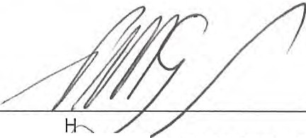
We communicate with the committee regarding, among other matters, the planned scope and timing of the audit and significant audit findings, including any significant deficiencies in internal control that we identify during our audit.

PETER GESC
HAYWARDS N-H ED ACCOUNTANTS
Level 1 / 488 Lutwyche Road LUTWYCHE QLD 4030

Dated this 10th day of October 2017

I

QUEENSLAND ADVOCACY INCORPORATED SUPPLEMENTARY INCOME AND EXPENDITURE STATEMENT FOR THE YEAR ENDED 30 JUNE 2017

DEPARTMENT OF SOCIAL SERVICES

INCOME  Grant - Department of Social Services | 483,107.65 |  | 451,314.16
 | 483,107.65 |  | 451,314.16
LESS EXPENDITURE  Total Expenditure (Schedule Attached) | 483,475.32 |  | 451,314.16
NET SURPLUS/(DEFICIT) FOR THE YEAR | $(367.67) |  | $ NIL

QUEENSLAND ADVOCACY INCORPORATED SUPPLEMENTARY INCOME AND EXPENDITURE STATEMENT FORTHEYEARENDED30JUNE2017

DEPARTMENT OF SOCIAL SERVICES

EXPENDITURE | 2017
Audi t & Accountancy | 2,910.00 |  | 2,100.00
Bank Charges | 252.24 |  | 372.83
Cleaning | 1,397.00 |  | 1,200.00
Comput er Supplies & Support | 5,217.40 |  | 4,898.40
Consult ancy | 3,925.29 |  | 3,728.65
Depreciation | 8,270.00 |  | 10,303.00
Electricity | 3,454.99 |  | 3,564.47
Equipment | 13,636.36
I nsurance | 3,447.05 |  | 3,033.75
Management Committ ee Expenses | 7,521.61 |  | 12,125.90
Minor Equipment | 1,041.64 |  | 710.54
Occupancy Costs | 45,060.96 |  | 45,106.26
Postage, Printing & Statio nery | 3,130.17 |  | 3,547.25
Repairs & Maintenance | 126.45 |  | 50.00
Staff Amenit ies | 954.65 |  | 965.49
Staff Training & Sup ervision | 1,375.19 |  | 6,554.74
Subscriptions/Memberships | 2,423.50 |  | 2,321.75
Sundry Expenses | 415.31 |  | 115.14
Superannuation | 29,573.36 |  | 28,337.71
Telephone | 3,052.59 |  | 3,674.72
Travel Expenses | 2,583.68 |  | 3,314.78
Wages & Salaries | 330,368.73 |  | 310,527.94
Website Maintenance | 370.14 |  | 324.00
Workers' Compensation | 2,226.56 |  | 1,891.59
Workshops and Meetings | 10,740.45 |  | 2,545.25
TOTAL EXPENDITURE | $483,475.32 |  | $451,314.16

QUEENSLAND ADVOCACY INCORPORATED SUPPLEMENTARY INCOME AND EXPENDITURE STATEMENT FOR THE YEAR ENDED 30 JUNE 2017

DEPARTMENT OF SOCIAL SERVICES - NDIS

INCOME | 2017 |  | 2016
Grant - Department of Social Services | 137,000.00
Less Unexpended | (86,200.52)
 | 50,799.48
LESS EXPENDITURE
Total Expenditure (Schedule Attached) | 50,799.48
NET SURPLUS!(DEFICIT} FOR THE YEAR | $ NIL |  | $ NIL

QUEENSLAND ADVOCACY INCORPORATED SUPPLEMENTARY INCOME AND EXPENDITURE STATEMENT FORTHEYEARENDED30JUNE2017

DEPARTMENT OF SOCIAL SERVICES

EXPENDITURE
Adve rtising | 130.00
Computer Supplies & Support | 151.92
Consu ltancy | 21,500.00
Depreciation | 353.00
Equipment | 6,469.73
Insurance | 133.50
Motor Vehicle Expenses | 1,592.34
Occupancy Costs | 1,727.74
Postage, Printing & Stationery | 173.30
Staff Training & Supervision | 417.02
Sundry Expenses | 185.95
Superannuation | 1,464.22
Travel Expenses | 283.12
Wages & Salaries | 16,217.64
TOTAL EXPENDITURE | $50,799.48 |  | $ NIL

QUEENSLAND ADVOCACY INCORPORATED SUPPLEMENTARY INCOME AND EXPENDITURE STATEMENT FOR THE YEAR ENDED 30 JUNE 2017

DEPARTMENT OF JUSTICE and ATTORNEY-GENERAL

INCOME | 2017 | 2016
Grant Received - Department of Justice and Attorney-General | 462,248.00 | 449,330.00
Unexpended Grant from Previous Year  Less Unexpended | (19,192.16) | 16,788.50
Mental Health Review Tribunal | 16,092.35 | 21,548.25
University of Queensland - Disability Law Clinic | 4,000.00 | 4,000.00
ADAA Training Project | 8,988.20
 | 472,136.39 | 491,666.75
EXPENDITURE
Audit & Accountancy | 3,090.00 | 2,100.00
Bank Charges | 184.45 | 317.96
Computer Supplies & Support | 5,104.66 | 4,898.40
Consultants | 12,850.62 | 17,213.40
Electricity | 3,429.62 | 2,605.67
I nsurance | 3,641.00 | 3,033.76
Interpreting Service | 1,233.93 | 685.10
Meeting Expenses | 223.08 | 374.15
Minor Equipment | 1,463.34 | 710.50
Occupancy Costs | 41,341.36 | 45,106.04
Office Cleaning | 913.20 | 1,200.00
Office Overheads | 2,208.65 | 3,276.89
Staff Amenities | 631.36 | 1,051.17
Staff Training & Supervision | 175.85 | 5,842.64
Subscriptions/Memberships | 3,468.45 | 4,416.44
Sundry Expenses | 885.55 | 50.01
Superannuation | 31,871.20 | 32,719.12
Telephone | 4,278.82 | 4,379.27
Travel Expenses | 4,334.84 | 1,863.89
Wages & Salaries | 346,430.44 | 357,261.62
Website Maintenance | 325.44 | 324.00
Work Cover | 1,935.24 | 1,823.42
Workshops and Meetings | 2,115.29 | 413.30
TOTAL EXPENDITURE | 472,136.39 | 491,666.75
NET SURPLUSL(DEFICIT) FOR THE YEAR | $ NIL | $ NIL

QUEENSLAND ADVOCACY INCORPORATED SUPPLEMENTARY INCOME AND EXPENDITURE STATEMENT FOR THE YEAR ENDED 30 JUNE 2017

LEGAL AID FUNDING

2017

INCOME

Legal Aid Queensland - CLEC Unexpended Grant from Previous Year Less Unexpended

20,000.00

20,000.00

20,000.00

(20,000.00)

EXPENDITURE

Consultant s Meeting Expenses
Postage, Printing & Stationery Reference Material Superannuation
Wages & Salaries
6,137.50
147.27
7,200.00
40.00
597.93
5,877.30

20,000.00

NET SURPLUSl(DEFICIT} FOR THE YEAR $ NIL $ NIL

LE VE L 1 4 8 8 L U T W YC HE R O A D L U T W YC H E OLD 4030

CHARTERED ACCOUNTANTS

PO Box 198
LUTWYC H E OLD 4030

TELEPHONE: (07) 3357 8322

20 October 2017

FACSIMILE : (07) 3357 9909
EMAIL: admin@h aywards,net.au

Department of Social Services Disability and Carer Policy Branch GPO Box 9820
CANBERRA ACT 2601

P A RT N E RS
GREG DORGE PETER GESCH PHIL ROB IN SO N

QUEENSLAND ADVOCACY INCORPORATED
DISABIUTY AND CARER SERVICE IMPROVEMENT AND SECTOR SUPPORT FOR THE YEAR ENDED 30 JUNE 2017

INCOME
Grant Received |  | 4,980.00
LESS EXPENSES
Administration Expenses | 520.85
Travel Expenses | 28.25
Workshops | 4,430.90
 |  | 4,980.00
UNEXPENDED GRANT FOR THE YEAR |  | $NIL

CERTIFICATE OF COMPLIANCE

This is to certify that the grant funds received by this organisation for the above project have been used for the purpose for Which they were provided and that conditions included in the letter of advice have been met.

20 October 2017 CHAIRPERSON

AUDITOR'S REPORT

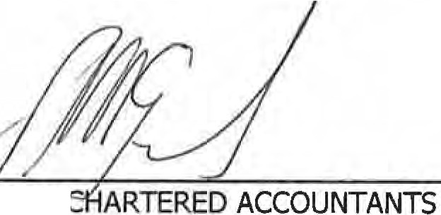In our opinion the above statement presents fairly the receipts and payments to which the statement relates for the period ended 30 June 2017.

20 October 2017 HAYWARDS,
PETER GESCH - PARTNER

LIABILITY LIMITED BY A SCHEME APPROVED UNDER PROFESSIONAL STANDARDS LEGISLATION

L E VE L 1 4 8 8 L U T W YC H E R O A D L U T W YC H E QLD 4 0 3 0

CHARTERED A CCOUNTANTS
P O Box 1 9 8
L U T W YC HE QL D 4030

TELEPHONE! (07) 3357 8322

10 October 2017

FACSIMILE: (07) 3357 9 909
EMAi L: admin@ h aywards.net au

Department of Social Services PO Box 9820
PERTH WA 6848
P A RT NE RS :
GREG D ORGE PETER G ESCH PHIL ROBI NS O N

QUEENSLAND ADVOCACY INCORPORATED DISABILITY, MENTAL HEALTH AND CARERS FOR THE YEAR ENDED 30 JUNE 2017

INCOME
Grant Received |  | 10,000.00
LESS EXPENSES
Postage, Printing & Stationery | 560.05
Travel Expenses | 317.03
Workshops | 9,122.92 | 10,000.00
UNEXPENDED GRANT FOR THE YEAR |  | $NIL

CERTIFICATE OF COMPLIANCE

This is to certify that the grant funds received by this organisation for the above project have been used for the purpose for which they were provided and that conditions included in the letter of advice have been met.

10 October 2017 CHAIRPERSON

AUDITOR'S REPORT

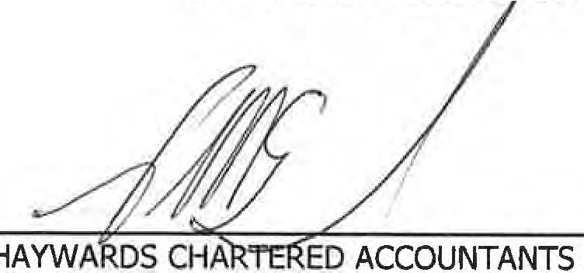
In our opinion the above statement presents fairly the receipts and payments to which the statement relates for the period ended 30 June 2017.

10 October 2017
PETER GESCH - PARTNER

LI A B ILI T Y LIMITED BY A SC H E M E AP P R O V E D UNDER PROFESSIONAL S T AN D A R D S L EG IS L AT IO N

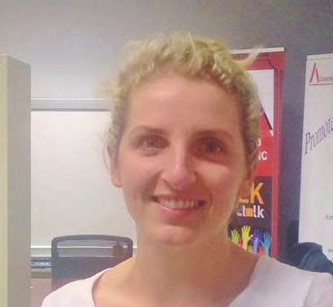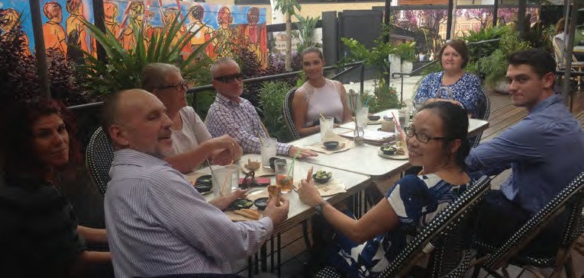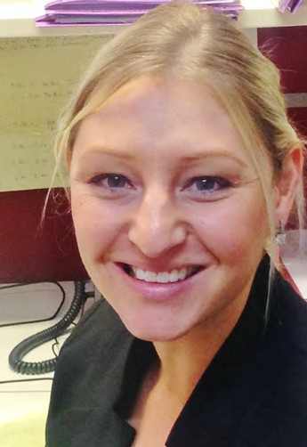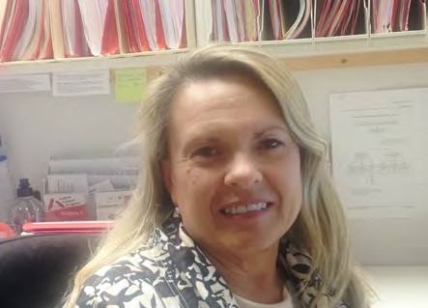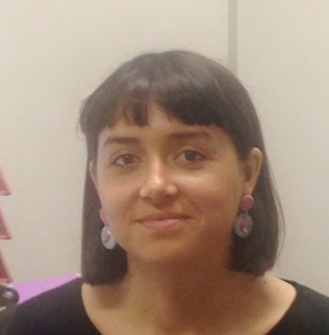

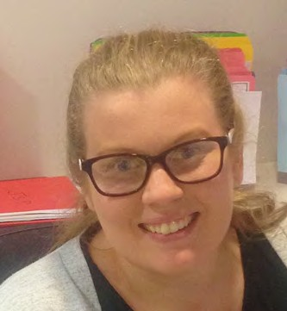

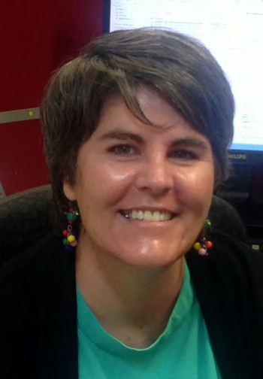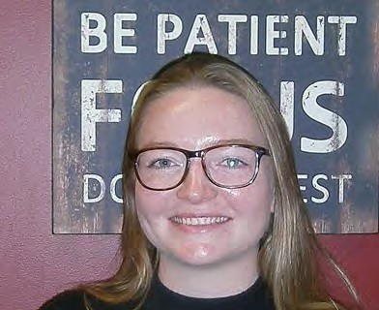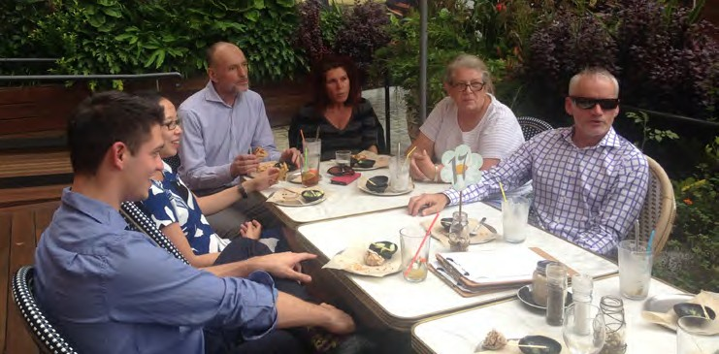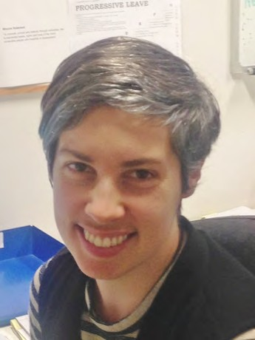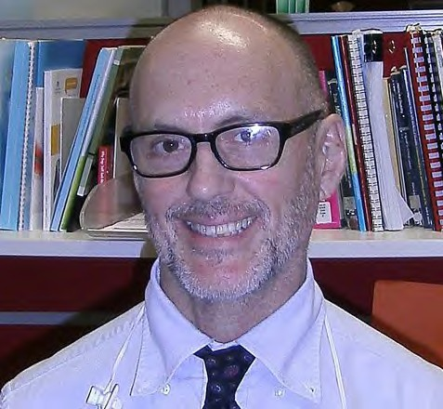

Queensland Advocacy Incorporated
2nd Floor South Central, 43 Peel Street (Cnr Merivale Street), Brisbane Q 4101
TELEPHONE 07 3844 4200 / 1300 130 582 FAX 07 3844 4220 EMAIL qai@qai.org.au VISIT www.qai.org.au

