What is it?
A Human Rights Act is about the relationship between the government and the people. By introducing a Human Rights Act the Queensland Government is binding itself to a commitment to protect, respect and fulfil human rights.

How does it work?
In a Human Rights Act each arm of government has a role:

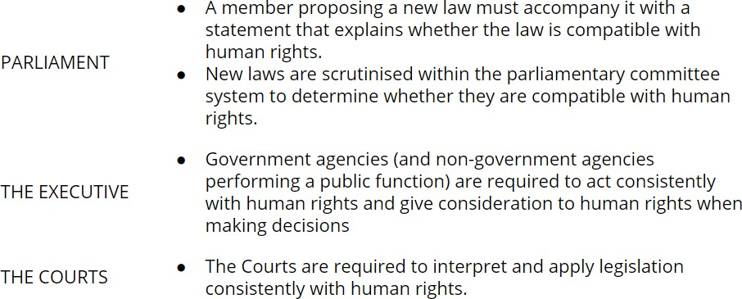

A Human Rights Act preserves parliamentary sovereignty. Nothing in the Act changes the parliament’s ability to pass laws. When laws limit people’s rights parliament has an obligation under the Act to justify the limitation. In their interpretation of laws courts cannot deviate from parliament’s intentions.

The role of people
Because a Human Rights Act is an instrument of the people, Queenslanders should be able to use it when government agencies unjustifiably limit their rights. Without this, a Human Rights Act becomes a governance instrument with little relevance to ordinary people. In Victorian and the ACT, where human rights legislation already exists, it has been used by people to improve their lives. For example, a woman with disability referred to her
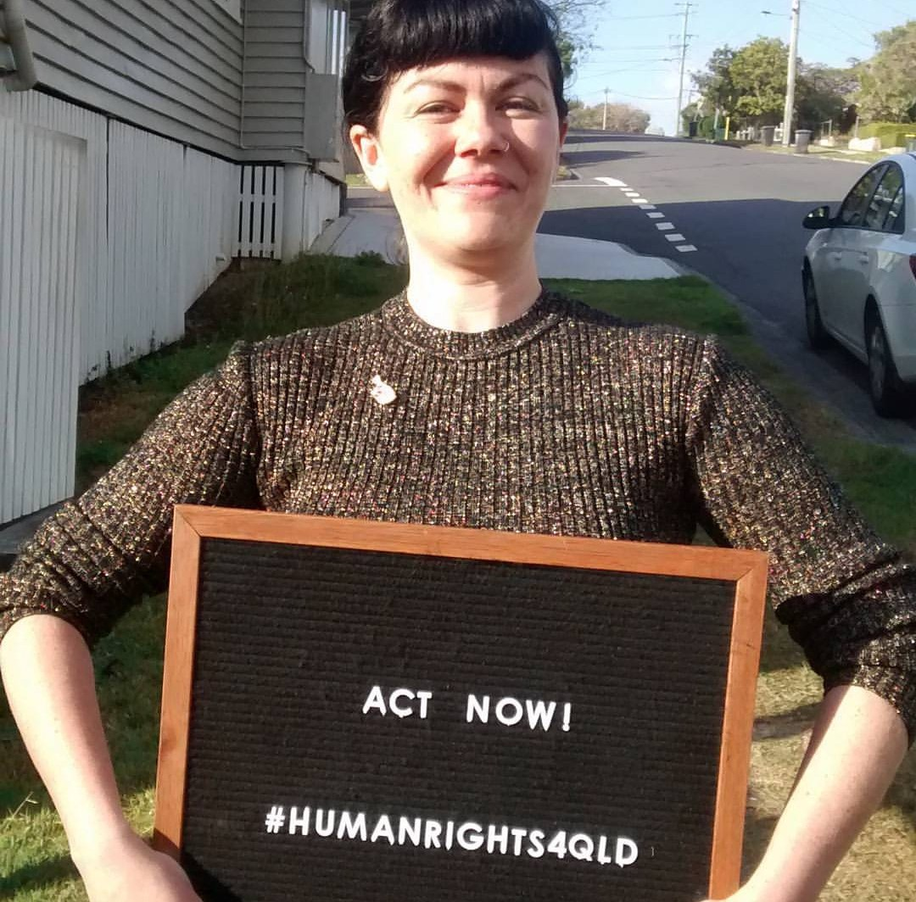
rights when asking for a shower curtain when showering. LGBTI people used human rights legislation to ensure that they had equitable access to superannuation death benefits. Young people, disabled people and Aboriginal people have relied on human rights legislation to challenge unfair evictions. A person with disability used human rights legislation to finally have his right to open his own mail recognised.

Examples of how human rights legislation has assisted people in other jurisdictions
Rights to be protected
The right to recognition and equality before the law
The right to life
The right to protection from torture and cruel, inhuman or degrading treatment
The right to freedom from forced
work
The right to freedom of movement The right to privacy and reputation The right to freedom of thought, conscience, religion and belief
The right to freedom of expression The right to peaceful assembly and freedom of association
The right to protection of families and children
The right to taking part in public life Cultural rights – including the cultural rights of Aboriginal and Torres Strait Islander peoples
The right of Aboriginal and Torres
Strait Islander peoples to self- determination
Property rights
Right to liberty and security of person
The right to humane treatment when deprived of liberty
The rights of children in the criminal process
The right to a fair hearing
Rights in criminal proceedings
The right not to be tried or punished
more than once
The right to protection from
retrospective criminal laws
The right to education

The right to privacy and housing
A Victorian woman was living in housing owned by a community housing provider. The housing provider had obtained a possession order from the Victorian Civil and Administrative Tribunal because of their concerns about the cluttering of personal items at the property. The woman had previously told the housing provider that the cluttering was a symptom of her mental illness – an illness that she was receiving medical treatment for.

The woman’s advocate argued that as a provider of low-cost housing to vulnerable tenants on behalf of the Victorian government, the community housing provider was required to act consistently with the Charter of Human Rights and Responsibilities Act and, in particular, they were required to give proper consideration to the woman’s right to privacy.

As a result of the negotiations, the woman was allowed to stay at the property.

Equality before the law
Amendments to the law in Victoria allowed same sex couples to access superannuation death benefits from one another. Because the amendments operated prospectively, they discriminated against older people in same sex relationships. An older woman and her advocate wrote to the Human Rights Unit at the Department of Justice advocating for an amendment to the law based on the claim that the amendments should be consistent with the Charter of Human Rights and Responsibilities. As a result an amendment to the law was made so that same sex couples could access superannuation death benefits both retrospectively and prospectively.

Property rights
A Victorian man suffering from physical disabilities and limited mobility continued to live in his family home after his mother had been admitted in an elderly care unit and placed under a financial administration order. In order to prevent the home being sold, the man’s advocate raised the right to property under the Victorian Charter of Human Rights and Responsibilities Act. In consideration of this right an agreement was reached so that the man could continue living in the house as a tenant paying rent.

A right to education
A Victorian student with a learning disability was threatened with expulsion by his school due to his behavioural issues. His advocate outlined to both the school and to the Department of Education and Early Childhood Development the student’s relevant human rights protected in the Victorian Charter of Human Rights and Responsibilities. As a result of the communication, the boy was provided with support, which reduced his behavioural issues and consequently, he was allowed to stay on at the school.

humanrights4qld.com.au

