Queensland Advocacy Incorporated

Our mission is to promote, protect and defend, through advocacy, the fundamental needs, rights and lives of the most vulnerable people with disability in Queensland.
Systems and Individual Advocacy for vulnerable People with Disability

POSITION PAPER ON

SUPPORT INDEPENDENT LIVING (SIL)

"Every human has four endowments – self-awareness, conscience, independent will and creative imagination. These give us the ultimate human freedom...The power to choose, to respond, to change.”
Stephen Covey

“The ache for homes lives in all of us, the safe place where we can go as we are and not be questioned.”
Maya Angelou

Ph: (07) 3844 4200 or 1300 130 582 Fax: (07) 3844 4220 Email: qai@qai.org.au Website: www.qai.org.au
2nd Floor, South Central, 43 Peel Street, STH BRISBANE QLD 4101
QAI endorses the objectives, and promotes the principles, of the Convention on the Rights of Persons with Disabilities.
Patron: His Excellency The Honorable Paul de Jersey AC

About QAI

Queensland Advocacy Incorporated (QAI) is an independent, community-based systems and individual advocacy organisation for people with disability. QAI’s mission is to promote, protect and defend, through advocacy, the fundamental needs and rights and lives of the most vulnerable people with disability in Queensland.

QAI has an exemplary track record of effective systems advocacy, with thirty years’ experience advocating for systems change, through campaigns directed to attitudinal, law and policy reform and by supporting the development of a range of advocacy initiatives in this state. In recent years, issues pertaining to the design and implementation of the National Disability Insurance Scheme (NDIS) have been a core focus of our systemic advocacy. QAI also provides highly in-demand individual advocacy through our individual advocacy services – the Human Rights Legal Service, the Mental Health Legal Service, Justice Support Program, National Disability Insurance Scheme Appeals Support Program and NDIS Decision Support Pilot, the Disability Royal Commission Advocacy Program and the Education Advocacy Service.

Our individual advocacy work has historically focused on the rights and lives of highly vulnerable adults with disability and the impact of serious issues that inhibit and restrict people from living a good, ordinary life.

QAI believes that all human beings are equally important, unique and of intrinsic value. Everyone should be seen and valued as a whole person, first and foremost. The human condition is such that societies tend to devalue those who do not fit within their models of perfection.

Our Human Rights and Mental Health services offer legal advice and representation on human rights, guardianship, administration, discrimination, and mental health matters. Our Justice Support, NDIS Appeals Advocacy and Decision Support Pilot programs provide non-legal advice and support to people with disability in the criminal justice system and engagement with and access to the NDIS. The Disability Royal Commission Advocacy Service assists individuals to engage with the Disability Royal Commission, to tell their story, appear as witnesses and/or engage by private sessions. The Education Advocacy Service is a new trial program funded by the Queensland Department of Education to provide information, advice, referral, and non-legal individual advocacy support to students with disability and their families/caregivers. This individual advocacy informs our campaigns at a state and federal level for changes in attitudes, laws and policies and assists us to understand the challenges, needs and concerns of people with disability.

QAI’s constitution holds that every person is unique, valuable and that diversity is intrinsic to community. People with disability comprise the majority of our board and their lived experience of disability is our foundation and guide.

POSITION STATEMENT

The following position statement is based on the values, beliefs and aspirations that Australians with disability can have a good but ordinary life when they have personal power, control and are supported to exercise their autonomy and rights as other citizens.

- Supported Independent Living (SIL) has become the mechanism for the proliferation of the archaic block funded group home. Rather than enabling a person to live ‘independently in their home’, it is in reality shared care in a congregated setting, often not of the person’s choosing but instead organised, negotiated, and created by the NDIS system and the service providers.
- A dearth of truthful information about the inflexibility of SIL, has reinforced the misconception that a person with high and or complex support needs must therefore enter a SIL arrangement. Most people do not have any independent unbiased information about SIL and have the mistaken belief that because they live in shared accommodation they must continue in the existing arrangements.
- People formerly living alone and supported for 24 hours of support, 7 days per week under the state system, are pressured by NDIA Planners as unwilling participants into SIL arrangements and costing Plans accordingly.
- In most instances, the avoidance of information about alternatives and benefits of accessing the NDIS with a non-SIL funded Plan, and lack of transparency regarding the over-inflation of SILS quotes is forcing more people back to the archaic model of group or shared home living.

If a participant wants to share with another person and articulates a desire to share some supports with their chosen housemate, (ie: overnight support only, or a combination of one or two activities), each person is very possibly able to obtain a Plan that is not only going to meet their needs but also be less restrictive, more flexible should either housemate wish to relocate, and is possibly more efficient and effective.
- The solution to the abovementioned is to abolish Supported Independent Living (SIL) from Plans.
- Replace it with individualised NDIS Plans for everyone including people who wish to share accommodation and support. When and where people who choose to live together, wish to share supports they merely state that intention in their Plans.

Opening statement – key issues and no single service provider

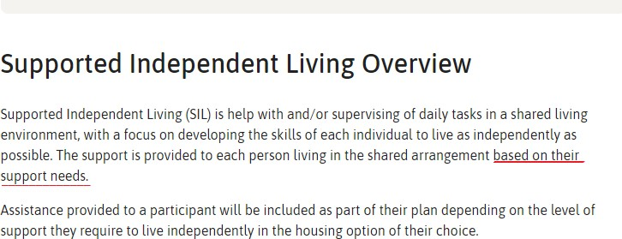
According to the NDIS website¹:

The National Disability Insurance Agency (NDIA) Submission to the Joint Standing Committee in 2019 stated “The NDIA has been and continues to be focused on supporting the smooth transition of participants into the NDIS, without creating support or funding gaps. The NDIA’s approach has been to put participants first by focusing on safe and effective transition into the NDIS from existing SIL arrangements.” By its very admission the NDIA poses that the NDIS is “based on insurance, not welfare principles, its purpose is to improve economic and social outcomes for all Australians with a significant and permanent disability, and to provide them with funding to access reasonable and necessary disability supports.”² Yet the NDIA continues to allow service providers free rein to provide all or any supports to the participant or group of participants including the provision of housing thereby enabling the glaring conflicts of interests that plague the Scheme.

The name Supported Independent Living (SIL) conjures imagery that should appear consistent with the purpose and intent of the National Disability Insurance Scheme (NDIS). The name of this arrangement appears to suggest that people are funded and supported to live independently.

The NDIS website overview implies that assistance according to level of support needed will be included in the Plan, and that support will be provided in the shared arrangement based on that need (and therefore on the funded Plan).

However, many people with disability who now have SIL in their NDIS packages live in ‘legacy’ dwellings, where prior to the NDIS, they received ‘wrap-around’, ‘block-funded’ accommodation and supports. The NDIA submits that it ‘has been working to manage these legacy arrangements during the transition period, however in-kind arrangements, transfers from state facilities and different working arrangements across different states and territories have resulted in considerable complexity – alongside significant increases in participant intake. As a result, the current SIL environment is complex, and continues to evolve.”³ QAI asserts that these complexities arise

1 https://www.ndis.gov.au/providers/housing-and-living-supports-and-services/housing/supported-independent-living.
²https://www.aph.gov.au/Parliamentary_Business/Committees/Joint/National_Disability_Insurance_Scheme/Independentli
ving/Submissions
³ ibid

because of a disregard for the NDIA’s own stated principle that the purpose of the NDIS is to improve economic and social outcomes for participants and suggests that while the Agency may now have taken this position, it also is attempting to step back from the economic rationalism that created SIL.

People who have been usurped into SIL because of their former block arrangements have found that their day-to-day living arrangements and, in particular, their support arrangements, have not altered or enabled ‘choice and control’, because:

- Affordable alternative accommodation is not readily available.

- When affordable accommodation is available, few participants are adequately funded to live independently.

- Service providers have a vested interest in keeping participants where they are. Participants who exercise choice and control represent a ‘risk’ and disruption. Service providers have no interest in encouraging people to seek alternative service provision.

- SIL arrangements enable service providers to wrest the ‘choice and control’ (catchphrase of the NDIS) from participants.

- Conflict of interests have not been addressed because of this power imbalance. Some providers have ‘ownership’ of participants - support coordinators are co-tenanting clients between themselves. This arrangement allows for enhanced SIL funding to the benefit of the provider where funding can be merged.
- Costing for SIL agreements are often greater than what participants may have for their individual NDIS plans without the restrictions of the SIL framework.

- SIL arrangements are potentially discriminatory, devalue people with intellectual disability, avoid authentic independent supported decision-making and assume capture of people who may be subject to guardianship orders.

What is even more concerning is that SIL is being applied to not only people transitioning from former block funded situations. Numerous participants who have lived in their own homes with ongoing round the clock support for many years have been forced or coerced into SIL funding in their NDIS Plans. Others have reported that even when living in the family home and not intending to leave, their NDIS Plan was funded under a SIL quote because it was deemed that they could share their supports and housing.

Once SIL funding is arranged in a participant’s Plan, its provision sustains and perpetuates congregate, institutional living for people with disability. On its own, SIL could be a way for people with disability to exercise choice and control in their living arrangements: two people could choose to live together, for example, and use SIL funding as a way to build their capacity for independent living and to share some supports of their choosing (for example – to share overnight support).

In practice, people with disability share SIL-funded supports at a common location that invariably is owned or run by the service providing the SIL supports. SIL is often coupled in Plans with congregate Specialist Disability Housing funding, which nominally should be paid to a separate provider but in practice rarely is.⁴ Or SIL funding sustains support for the occupants of non-SDA group homes and hostels that are owned or managed by the same organisation that is providing SIL supports.

The evidence discovered through our NDIS Appeals and other advocacy services suggests that SIL has become a key part of a de facto permit system for group homes, where the dwellings and their operators become the focus instead of people with disability. The business of vacancy management of group homes to maximise returns by advertising upcoming spaces and potential occupants is a primary function.

SIL props up the institutional ‘legacy’ practices that existed prior to the introduction of the NDIS. The parallels with the use of restrictive practices (RP) are striking. The Queensland legislation for the use of RP has become a rubber stamping mechanism, a ‘permit’ system that allows service providers to maintain business as usual and, in particular, allows them to maintain people with disability in pressure-cooker congregate arrangements that generate the ‘challenging behaviours’ that trigger applications for RPs.

Theoretically, the following living options should be available for NDIS Participants to choose from:

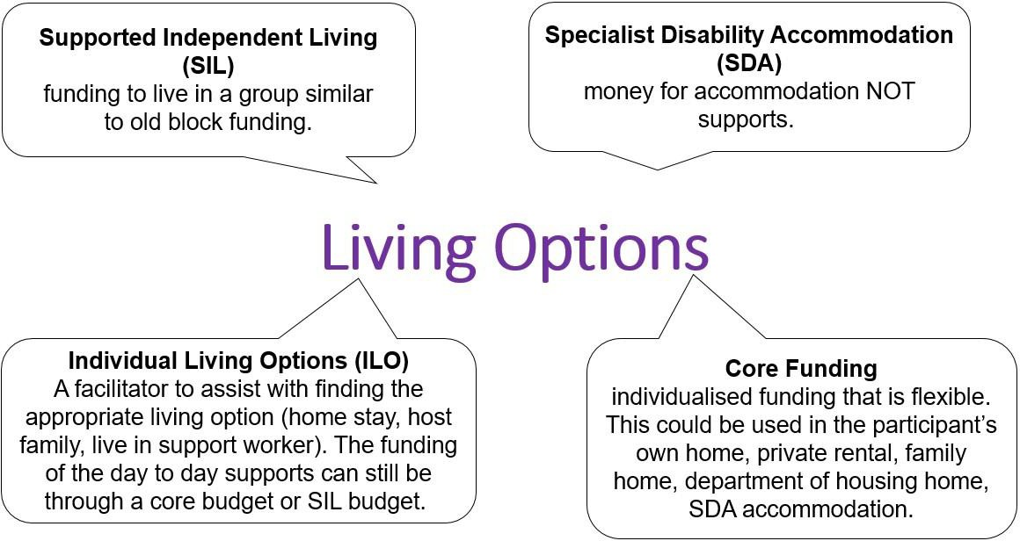

To facilitate choice, NDIS participants are assessed and funded separately by the NDIA for Specialist Disability Accommodation (SDA) and Supported Independent Living (SIL). The NDIA has predicted that over time this separation would improve choice and control for participants by allowing a change of support or accommodation provider without necessarily changing the other.⁵

4 In complete discordance with s 28 of the Disability Services Act 2006.
5 National Disability Insurance Scheme (Registered Providers of Supports) Rules 2013. Terms of Business for Registered Providers (effective 1 July 2016).

Even though Individual Living Options (ILO) is currently only an option for people who presumably need less support, is new and still untested, it can cover a wide range of living arrangements and provides greater flexibility and choice. The Core Funding option allows people to have real choice and control about the support received and who provides it.
In the interim, the Provider Toolkit’s ‘Terms of Business for Registered Providers’ states that while the same provider can deliver SDA housing and SIL support with separate contracts for each service, they must do so only with active management of conflicts of interest. A Registered Provider must not (by act or omission) constrain, influence or direct decision-making by a person with a disability and/or their family so as to limit that person’s access to information, opportunities and choice and control. The NDIA is inert in providing choice, control, or any safeguards to Participants. By merely expecting that providers will “do the right thing” or that Participants have a right to lodge complaints against providers who do not behave accordingly is one of the core issues that lay at why the NDIS is not delivering on its core purpose.
In practice, many disability service organisations not only fail to manage conflict of interest, they actively resist the separation of their housing and support functions. They treat housing and support as the key to their long-term survival. The NDIS is viewed as an opportunity to ‘double-dip’ by charging NDIS participants additional fees, including SIL, through the NDIS portal.
The NDIS represents uncertainty and risk to some service providers who cling to well-established models that involve the delivery of support to tenants in housing that the service provider owns or manages on behalf of another agency, usually a state or territory government. The scarcity of appropriate, accessible and affordable housing enables this approach. The result is that people with disability are bearing an unfair share of the costs associated with SIL arrangements.

The NDIA seems to absolve itself for the current issues with SIL by deferring responsibility to the ‘legacy state government arrangements’ The Agency poses potentials for “Future State” of SIL as if it might one day be possible but only if there is ‘improved market data to assist with development of future support models’.⁶ This is simply unacceptable as people with disability continue to be exposed to abuse, neglect and violence in shared supported accommodation. The NDIS is the ‘future support model for which people with disability waited 40 years.

In order to comply with fidelity to our obligations to the Convention on the Rights of Persons with Disability Articles 19⁷ and Article 16,⁸ we must implement the themes of the National Disability Strategy with authenticity and discard the tattered and filthy remnants of the past.

Let us not go backwards

Although SIL typically relates to participants in Supported Accommodation Services, the NDIA cannot instruct NDIS participants to move into group homes as this is contrary to the core principles

6
https://www.aph.gov.au/Parliamentary_Business/Committees/Joint/National_Disability_Insurance_Scheme/Independentlivi ng/Submissions
7 Living Independently and Being Included in Community.
8 Freedom from Exploitation, Violence and Abuse.

underpinning the NDIS Act 2013 (Cth),⁹ which incorporates principles from the International Covenant on Civil and Political Rights.

It is vital that the NDIS does not resile from its promise of an ordinary life for people with disability. SIL could be an opportunity for NDIS participants, and not for service providers as we have seen. Participants do not need SIL, but they do need better support coordination and time to build their own capacity to utilise their plans, to exercise their ‘choice and control’, and there are a few ‘Living Options’ that can provide that for people with disability.

However, service providers have no interest in encouraging and supporting people to seek alternative service provision or accommodation; they have a vested interest in the status quo, as do some guardians, statutory or not, and family members.

Congregate arrangements exist for institutional reasons: congregate arrangements are purported to save money for service providers, funding bodies and ultimately, the state and voting public, but some providers padding SIL quotes and relying on SIL for profits, QAI questions that SIL actually saves money. Worse, however, is that any perceived savings can come at a cost to people with disability, who have less choice, less control, less freedom, more restraint, a lower quality of life, and heightened risk of experience abuse, violence, neglect and/or death.

If a participant wants to share with another person and articulates a desire to share some supports with their chosen housemate (ie: overnight support only, or a combination of one or two activities), each person can potentially obtain a Plan that will not only meet their needs but also be less restrictive, more flexible should either housemate wish to relocate and potentially more efficient and effective.

Further reading on the foundation for this position statement is available here: https://www.qai.org.au/wp-content/uploads/2019/10/19.09.06-SIL-Submission-Final.pdf https://www.qai.org.au/wp-content/uploads/2020/06/QAI-Submission-DRC-Group-Homes.pdf

⁹ See sections 3 and 4.

