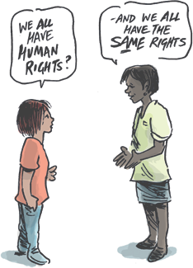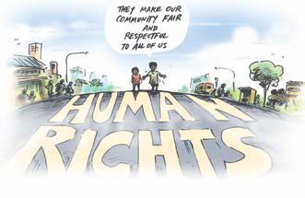Know Your Human Rights
A Guide to the Human Rights Act 2019 (Qld)

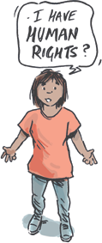
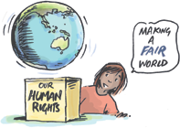

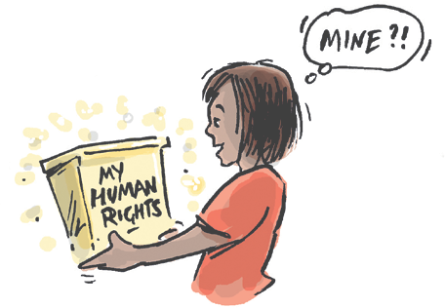
Human rights are very important rights. They belong to everyone.
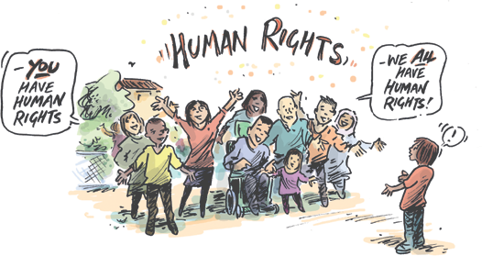
It doesn’t matter how old you are, where you’re from, your disability, or anything else. You have human rights and they are important.

about human rights?
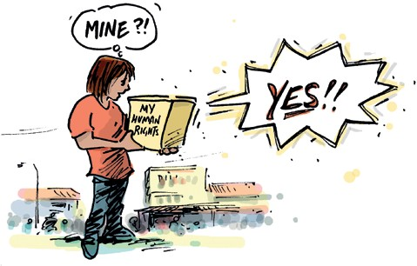
Knowing about your human rights is important.
It is the first step in making sure your human rights are respected.
There are now laws in Queensland that protect your human rights.

human rights?
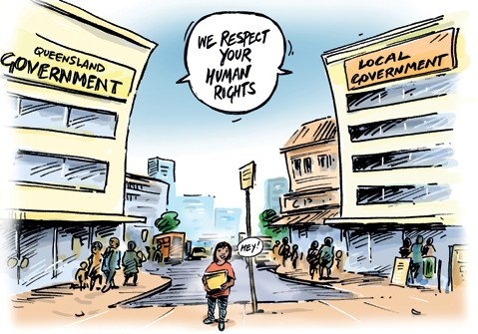
The Queensland Government and organisations doing things for the Government must respect your human rights.
This means that when they do something that affects you, they must consider your human rights.

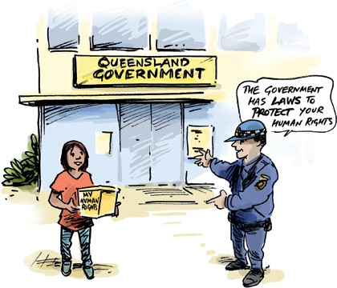
rights are protected?
In the next pages of this book, we will tell you which human rights are protected.
We will explain what each of these rights mean.

before the law
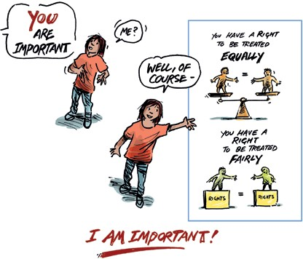
You are important and you have the right to be treated equally.
It doesn’t matter how you identify yourself (sexuality, disability, or any other thing).
Everyone has the right to be treated fairly and equally.
If you need extra help to do things other people can do, you have a right to this help.

You have the right to life.
You have the right to the things you need to stay alive.
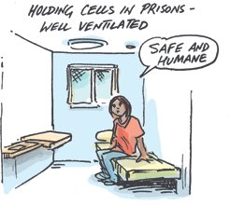
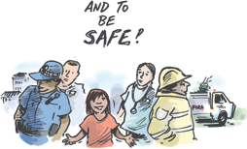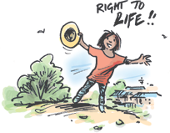You have the right to be safe in emergencies, like fires and floods.

inhuman or degrading treatment
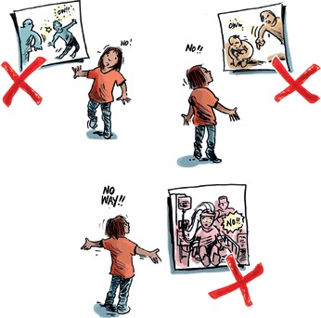
No one is allowed to do things that hurt you, physically or mentally.
No one can treat or punish you in a way that abuses you or makes you feel bad or embarrassed.
No one can make you have medical treatment or use you for scientific experimentation unless you agree to it (unless the law says they can).

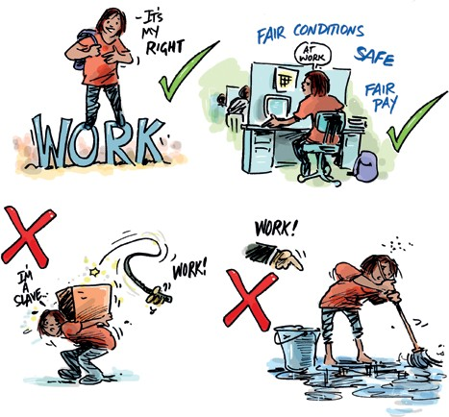
Work rights
You have the right to fair conditions of work, including to be safe at work and to be paid fairly.
You cannot be owned by another person (slavery).
You cannot be forced to work for another person.

Freedom of movement
You have the right to move freely within Queensland.
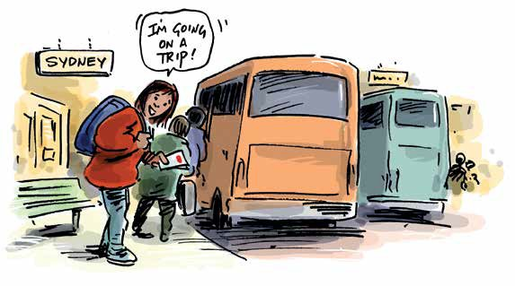
You have the right to leave Queensland and to come back.

your own religion or beliefs
You have the right to choose your own religion or beliefs.
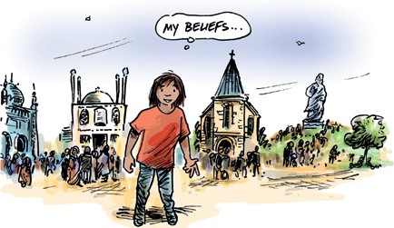
You have the right to demonstrate your beliefs however you choose. No one can force you to be religious if you don’t want to be.

You have the right to have your own opinion about things. No one can tell you what to think.
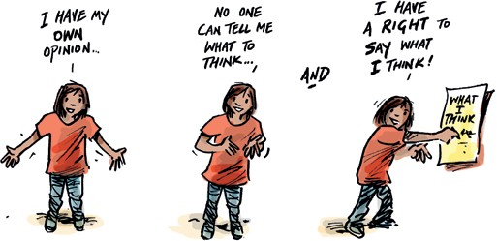
You have the right to say your opinion in any way you choose. You have the right to ask for and receive information.

freedom of association
You have the right to protest peacefully with others.
You have the right to choose who you want to be friends with and meet with.
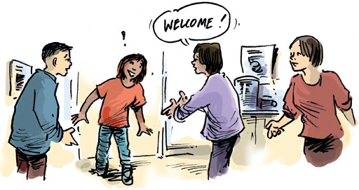
You have the right to join a group of like-minded people.

You have the right to be involved in politics. You have the right to vote and be elected.
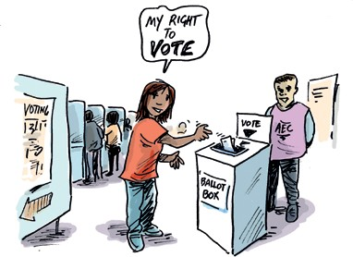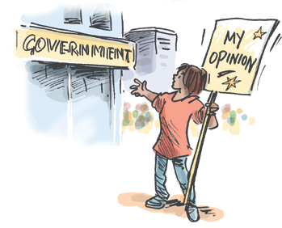You have the right to have an opinion about what the government does.

You have the right to own property and to choose where you live.
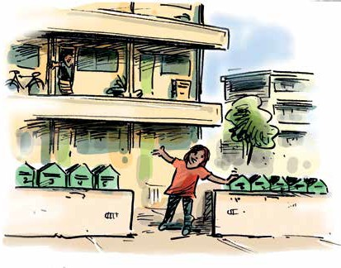
Your property should not be taken away from you without a good reason.
You have the right to a private life.
You have the right to keep your information private.
You have the right to basic things that help you to stay private, like a lock on your bedroom or bathroom door or a shower curtain if you’re living in a shared home.
No one is allowed to say things about you that are untrue or unfair.

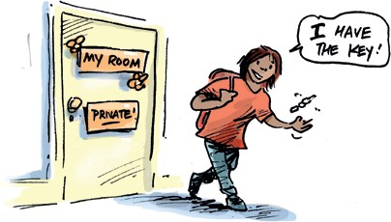

You have the right to live with your family and your children.
You have the right to have the support you need to have a good life with your family.
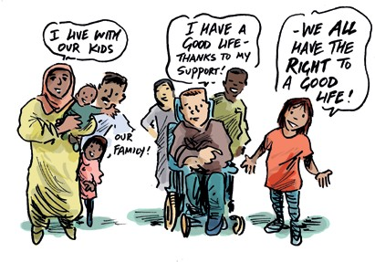
If you are a child, you have the right to the protection you need.
You have the right to enjoy and belong to your culture
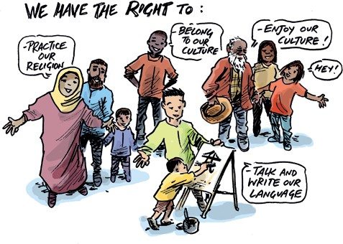
You have the right to openly practice your religion.
You have the right to talk and write in your language.

and Torres Strait Islander peoples
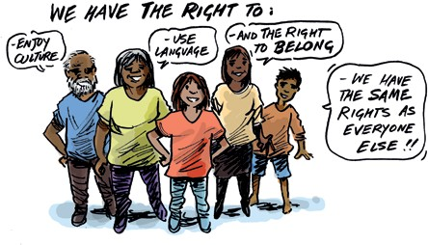
If you are an Aboriginal person or Torres Strait Islander person –
You have the same rights as everyone else.
You have the right to enjoy your culture and to use your language with your community.
You have the right to belong to your culture.

when deprived of liberty
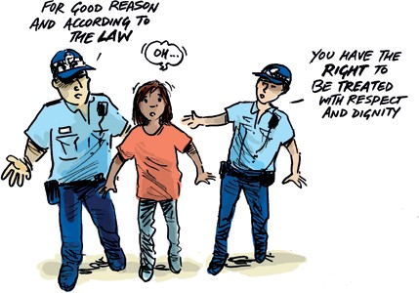
If you are arrested or detained, it must be for a good reason and it must be done the way the law says it must be done.
You have the right to be treated with respect and with dignity.
You should not be kept on your own for a long time and you should be given the supports and services you need while you are in prison or detention.

You have the right to be treated fairly by the law. This includes getting help from police and lawyers if you are in trouble, are arrested or need to go to court.
If you have to go to court, you have the right to a fair hearing.
You should not be tried or punished more than once for the same offence.
You should not be found guilty of something if what you did wasn’t considered a crime when you did it.

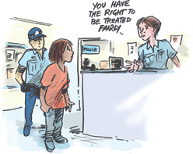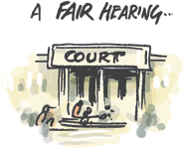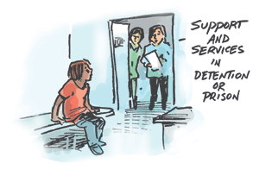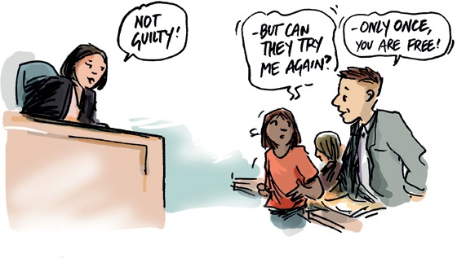

If you are a child and you are in trouble with the police, you have the right to special protection.
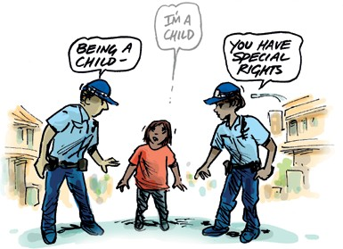
You must be separated from adults and have the right to be treated properly, in a way that’s appropriate for your age.
You have the right to an education equal to other students’ education. You have the right to go to a regular school.
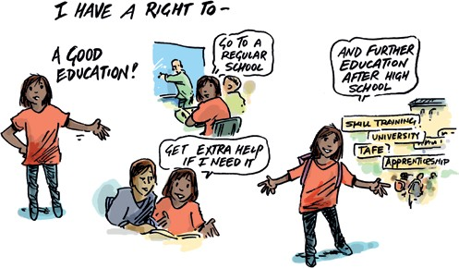
You have the right to get extra help to learn if you need it.
You have the right to further education, beyond high school,
based on your abilities.

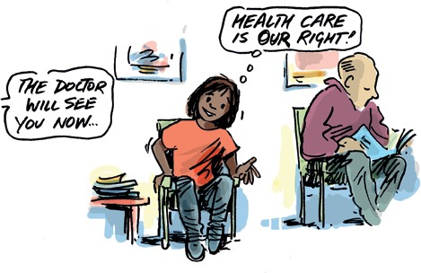
You have the right to get health care.
You should always be able to see a doctor, to have medicine or go to hospital when you are sick or hurt.
You have the right to use the same health services that everyone else can use.

breached your human rights?
The Government has to properly consider your human rights when they make a decision about you. They have to make decisions that respect your human rights.
The Government has to make decisions about how your rights fit with other people’s rights.
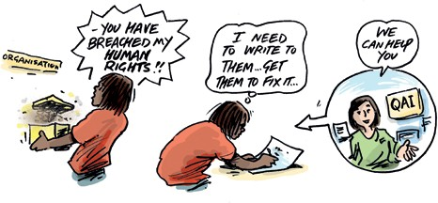
It could mean that your human rights may be limited by the Government if there is a really good reason.
Any limits must be appropriate in the circumstances.

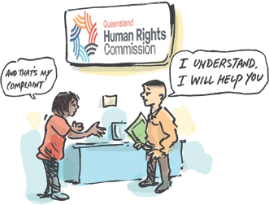
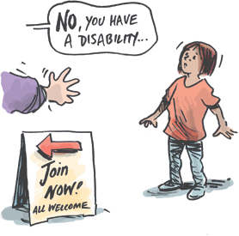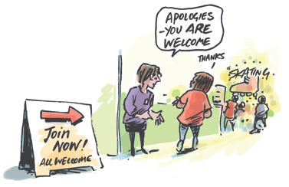breached your human rights?
You can write to the Government and tell them how they have breached your human rights. QAI or another advocacy organisation can help you do this.
If the Government doesn’t fix it, after 45 business days or 9 weeks, you can make a complaint to the Queensland Human Rights Commission.
You can add your human rights complaint to court action for other legal rights. QAI or another advocacy organisation can help you to do this.
Complaining is not just letting the Government know that you’re not happy. It can also make them change things.

or want more information
You can call QAI and we will help you to understand if you have a human rights problem:
Phone: 07 3844 4200 or 1300 130 582
Email: qai@qai.org.au
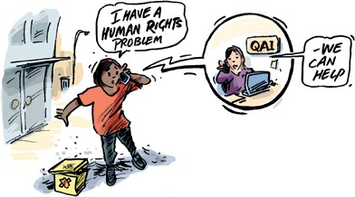
Website: www.qai.org.au

You can contact the Queensland Human Rights Commission
for more information:
Phone: 1300 130 670
Email: info@qhrc.qld.gov.au
Website: www.qhrc.qld.gov.au

QAI gratefully acknowledges the funding provided by the Department of Social Services, which was instrumental in supporting QAI’s work for the campaign which resulted in the introduction of the Human Rights Act 2019 (Qld). This funding has also supported the development of this publication. QAI also acknowledges our Patron, His Excellency The Honourable Paul de Jersey AC, Governor of Queensland.
QAI acknowledges and thanks Simon Kneebone, Cartoonist & Illustrator, for creating the illustrations that have brought this publication to life.
This publication is for general information only. The information provided in this publication is not legal advice and should not be treated as such. This booklet is not to be published or reproduced for commercial purposes without the express permission of the authors. Information is current as at June 2020. QAI does not accept any liability for the accuracy of the information in this publication.
© QAI ISBN: 978-0-9775937-5-0

