An enforceable Human Rights Act for Queensland
A Discussion Paper

www.humanrights4qld.com.au

Background Paper – A Human Rights Act for Queensland

Introduction
This paper explains the features of a Human Rights Act (Part 1) and the key benefits of having human rights protections (Part 2).

Key terms used in this paper are defined in the Glossary on page 11.

This paper was prepared with assistance from Allens and the Human Rights Law Centre.

Contents
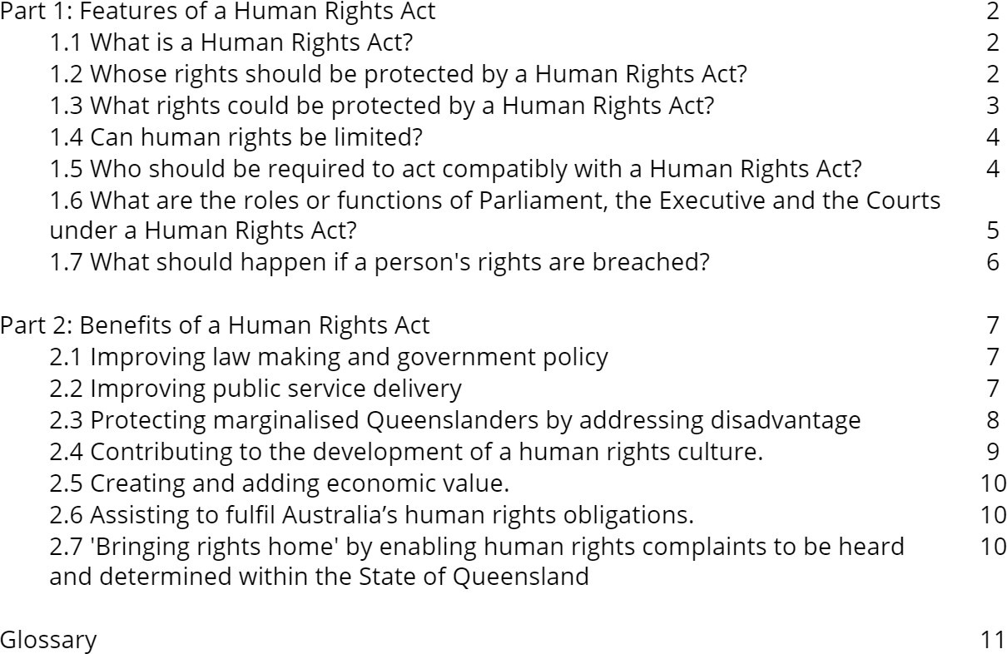

Part 1: Features of a Human Rights Act

What is a Human Rights Act?
A Human Rights Act is an ordinary piece of legislation

Human rights are the basic rights that belong to every person, regardless of age, race, sex, social status or any other characteristic. They are derived from the dignity and worth of each person. Human rights include the right to a fair trial, freedom of speech and the right to be free from torture or other inhuman or degrading treatment or punishment.

Different countries have taken different approaches to protecting human rights. One method, undertaken in The United States, Canada and South Africa is to have a constitutional bills of rights. This means the rights are embedded in the constitution and can only be changed through a complex and challenging amendment process. It also means that the government cannot introduce laws that will conflict with the rights protected in the constitution of their country.

Traditionally Australia has relied largely on the 'common law' (the law applied by the courts) to protect human rights. Additionally, a small number of rights are protected in the Constitution and in other legislation. In 2004 and 2006, the Australian Capital Territory and Victoria enacted their own human rights laws. These are ordinary pieces of legislation that require the government to respect, protect and fulfil the rights listed in the enactments. The United Kingdom and New Zealand have similar laws too.Here, it's worth mentioning if Queensland were to introduce a formal human rights protection, it would model the Australian enactments already existing in the ACT and Victoria.

Whose rights should be protected by a Human Rights Act?
A Human Rights Act should protect the rights of all people in Queensland

Human rights protect the dignity and worth of human beings, allowing everyone to have a fair go. Therefore, only the rights of human beings should be protected by a Human Rights Act. The rights of corporations and similar entities should not be protected. Indeed, many – if not most – human rights would not make sense if applied to such entities. For example, it does not make sense to say that a corporation has the right to life or education.

A Human Rights Act will protect the rights of all people in Queensland – citizens and non-citizens. In general, this protection must be equal, although differentiation between citizens and non-citizens is appropriate to a limited number of rights, such as the right to vote.

Most human rights protect the individual, but some protect the rights of groups - such as the various human rights protecting families and the rights of indigenous peoples.

What rights could be protected by a Human Rights Act?
A Human Rights Act could protect the human rights contained in the international human rights treaties that Australia has signed.

Human rights are recognised and protected under international law. Many are contained in treaties. The two key treaties are the International Covenant on Civil and Political Rights (the ICCPR) and International Covenant on Economic, Social and Cultural Rights (the ICESCR). Australia has signed and is formally in agreeance with both treaties. It has also committed to five of the six other human rights treaties. The key rights protected by the ICCPR and ICESCR are set out in the table below.

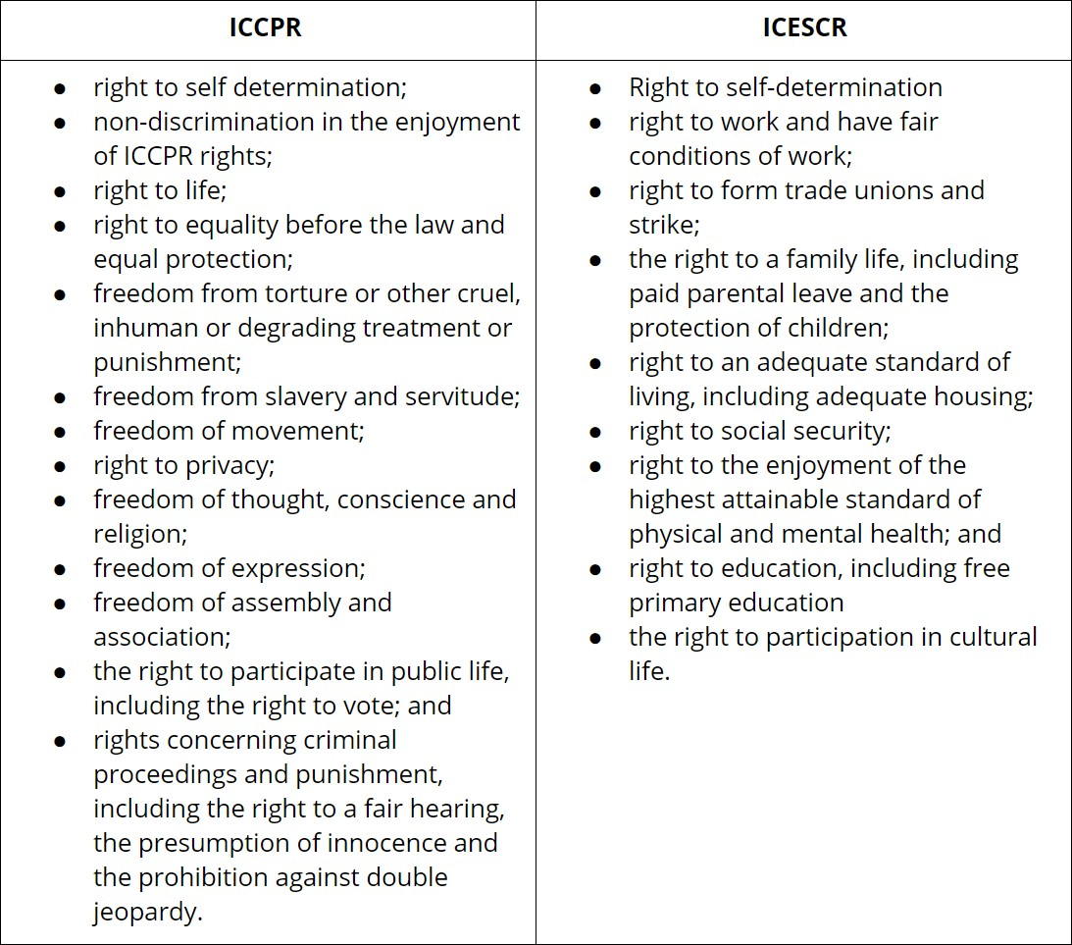
The ACT, Victorian, UK and New Zealand Human Right Acts contain a selection of the rights listed above - some being civil and political rights and some economic, social and cultural rights. For example, the right to education is protected in the ACT and UK; the cultural, religious and language rights of minorities are protected in the ACT, Victoria and New Zealand; the cultural rights of Aboriginal peoples are specifically protected in Victoria.

A Queensland Human Rights Act could protect some or all of rights in the above table.

Can human rights be limited?
Many human rights are subject to 'reasonable limits'. Other rights, such as the right to freedom from torture, cannot be limited.

It is generally accepted that not all human rights are unconditional. Their enjoyment can be limited in certain circumstances, for example to protect the enjoyment of other rights or to protect public health and order. The ACT and Victorian Acts allows for all rights to be limited but only to a justifiable and reasonable limit, which must take into account all relevator factors. Relevant factors might include the type of right affected, the type of limitation and its extent.

Some rights, such as the rights to be free from torture and slavery, are unlimited, meaning that the state cannot infringe the right in any circumstances. A Queensland Human Rights Act would state that these rights should not be limited.

Who will have to comply with a Human Rights Act?
The Queensland Government, organisations and businesses carrying out certain functions should comply with A Human Rights Act.

The central aim of a Human Rights Act is to ensure that the government respects, protects and fulfils human rights in accordance with Australia's international human rights obligations - that is, the treaties Australia has committed to (discussed above).

Some government functions are increasingly carried out by other authorites, for example private businesses and organisations. This can commonly occur when the government outsources its power, giving certain roles to private bodies. All persons and entities exercising government power should therefore be bound to protect and promote human rights while they are exercising such power. This is the popular approach typically taken by other human rights legislation.

Examples of public functions include public education, aged care, disability services, child protection services, transport, housing and health services, and supply of gas, electricity and water. A Human Rights Act is only concerned with government action, meaning private bodies would not be bound by the Act when they are exercising private functions.

The ACT Act has a provision allowing private entities to 'opt in' to the obligations of public authorities. A Queensland Human Rights Act could include this, as it encourages the development of a human rights culture in Queensland’s business sector. However, it is not a complete solution, as the experience in the ACT is that the mechanism was only adopted by the 'usual suspects'. If an opt-in function is create, perhaps Queenslanders could implement other initiatives to encourage this mechanism.

What are the roles or functions of Parliament, the Executive and the Courts under a Human Rights Act?
All arms of government should be required to have regard to, and respect for, human rights in making, applying and administering of laws and in their other activities, but failure to do so must not invalidate the law or the activity.

The human rights legislation in the ACT, Victoria and the UK aim to create awareness of human rights and encourage governmental compliance, whilst also giving some compensation to people whose rights have been violated. These pieces of legislation are described as a 'dialogue' model. This means that the three arms of government (Parliament, Executive and Courts) play important parts in a dialogue about human rights, with the aim of building a culture that is respectful of human rights.
However, laws that breach human rights are not automatically invalidated or rejected under the laws. The role of each of the arms of government in respect of human rights is considered in turn.

Under the ACT and Victorian Acts, Parliament is required to consider the human rights compliance of all laws that it passes. Each new bill is accompanied by a statement of compatibility, stating whether the bill is consistent with human rights and the nature and extent of any inconsistency. The bill is also scrutinised by the parliamentary committee to identify any human rights issues. In addition, the Victorian Act enables the Parliament to, in exceptional circumstances, expressly override its Human Rights Act, declaring the relevant law effective despite its incompatibility with human rights.

Courts are obliged to interpret legislation in a way that is compatible with human rights and may consider international and domestic comparisons while doing so. The Supreme Courts of each state or territory are empowered to issue a declaration of incompatibility when a law cannot be interpreted consistently with human rights. This does not invalidate the incompatible law, but Parliament is obliged to prepare and table a response to the declaration. In certain circumstances, Courts may
also facilitate proceedings where a breach of human rights is raised as a ground to invalidate the decision of a public authority.

Public authorities are obliged to act compatibly with human rights, and to give proper consideration to relevant human rights when making a decision. As explained above, a public authority is a government agency or an organisation or business performing public duties on behalf of
the government. A person affected by an authority's failure to do so can apply to the court for a remedy in certain circumstances.

A Human Rights Act in Queensland could empower a body to investigate, report on and rectify human rights complaints, intervene in relevant legal proceedings, conduct alternative non-legal resolution processes, and research and report on compliance and reform of the Act. In Queensland, the Anti Discrimination Commission could competently carry out this role.

What should happen if a person's rights are breached?
When people experience human rights abuses they should be able to bring legal proceedings against the offender for the full range of remedies, including damages. More flexible and accessible remedies, such as mediation and complaints mechanisms, should complement this right.

A Human Rights Act must ensure that people whose rights are violated have access to an effective remedy.

The Queensland Act could improve on existing Australian laws and allow a freestanding cause of action with a full range of remedies, including damages. Damages is the award, typically money, granted to a person when they have suffered loss or damage. The ACT Act has a freestanding cause of action, although damages are not recoverable. The Victorian remedies are more complex. In Victoria, claims of unlawfulness under the Human Rights Charter may only be raised in an action if there is another ground on which to challenge the decision or action. In this way, the application is not 'freestanding' since it must be raised in addition to another ground. Damages are not recoverable.

A recent independent review of the Victorian Act has recommended that the Act be simplified by providing a freestanding cause of action like the one that exists in the ACT. However, rather than being required to start court proceedings in the Supreme Court, it is recommended that proceedings be started in the more accessible Victorian Civil and Administrative Tribunal (Victoria’s equivalent of Queensland’s QCAT). It has also been recommended that the Victorian Equal Opportunity and Human Rights Commission be empowered to receive and conciliate complaints under the Victorian Act.

When a person’s human rights are breached they should have affordable access to a remedy. To ensure this is the case Queensland’s Human Rights Act should include:

    - a separate cause of action for breaches of the human rights protected in the Act;
    - the ability to make a complaint to the Anti-Discrimination Commission and for the complaint to be heard and reconciled by the Commission;
    - power for the Anti-Discrimination Commission to investigate and report on human rights
    - provision for the Queensland Civil and Administrative Tribunal to receive applications alleging breaches of the Act;
    - the full range of judicial remedies, including declarations, injunctions, orders to cease the
offending conduct and damages.

Part 2: Benefits of a Human Rights Act
As well as protecting human rights in law, a Human Rights Act would also provide important social, economic and cultural benefits. The key benefits are:

- improving law making and government policy;
- improving public service delivery;
- protecting marginalised Queenslanders by addressing disadvantage;
- contributing to the development of a human rights culture;
- creating and adding economic value;
- assisting to fulfil Australia’s human rights obligations; and
- 'bringing rights home' by enabling human rights complaints to be heard and determined within the State of Queensland.

Improving law making and government policy.
A Human Rights Act can improve the quality of laws by making the consideration of human rights part of all law-making and policy development processes. Compatibility statements, override statements and declarations of incompatibility will all play a part in encouraging Parliament to act in a manner consistent with human rights. It can be a 'bad look' for Parliament to breach a Human Rights Act (and be required to publicly acknowledge that), thereby encouraging lawmakers to pass laws which are consistent with the human rights set out in a Human Rights Act.

This benefit has been observable in the experience of the ACT since the introduction of its Act in 2004. In 2009, the Australian National University described the improvement to the quality of law making in the ACT as one of the 'clearest effects' of the Act. The ACT Government has also acknowledged the positive effects, observing that the Act has had a 'positive impact on political debate and consideration of policy issues by Government', provides 'an impetus for agencies to properly consider human rights obligations and consult within and across different areas of government on the implications of their bills' and has increased 'awareness through Government of human rights issues'.

In Victoria, it was clear in the first eight years of operation that the Victorian Act played an important role in ensuring that human rights were appropriately considered by government, including in the development of law and policy.[34]

Improving public service delivery.
A Human Rights Act can also encourage the incorporation of human rights standards into public service delivery.

An inquiry in the UK in 2009 found that the UK Act has had a positive effect in a number of public sector areas, including health, local authority services, policing, schools and regulatory authorities. The inquiry concluded:

…the human rights framework, backed by the legal underpinning of the Human Rights Act, has had a positive impact in the delivery of public services…Properly understood and applied, it can have a transformative function, transforming the organisation itself, the services delivered, and ultimately the lives of the people receiving these services.

In the UK the experience of public authorities that have begun to embed human rights into their service provision is that the services are more responsive to the users. This is because stigma and mistrust are eroded, and prejudicial attitudes are challenged. It improves relationships between public service providers and the users of their services.

A human rights approach can lead to organisational renewal – that is, employees of public authorities remember the values and motivation which led them to start working in the public service in the first place.

A human rights framework can be an effective mechanism to challenge existing poor practice in service delivery. Case studies from the UK demonstrate how human rights arguments have been used successfully in the UK to challenge routine practices that infringe the dignity of service users.

In both New Zealand and the UK, the introduction of a Human Rights Act led to the government publishing handbooks for public authorities, designed to increase awareness of human rights issues and to provide guidance on how to conduct functions consistently with the human rights standards of the respective Acts.

The ACT Attorney-General acknowledged “a marked shift” in how government undertakes its work, saying that “many agencies, particularly those with a service delivery focus, are exploring the opportunities to better serve the community through human rights compliant policies, legislation and operational practices.”

The Victorian Act has led to improvements in public service design, delivery and outcomes. The Victorian Equal Opportunity and Human Rights Commission (the VEOHRC) observed that the use of the Victorian Act:

…has matured beyond simple compliance with the law. The Charter is not only part of 'everyday business' for many public authorities, but drives important human rights initiatives to address systemic issues. In this way, it prompts organisations to take a proactive, rather than reactive, approach to their operations and the way they engage with the community.

The VEOHRC also noted that, while there is still much to be done, the Victorian Act has become 'firmly embedded' in the 'work, language and culture' of many public authorities.

  - Protecting marginalised Queenslanders by addressing disadvantage.
There is strong evidence a human rights approach can:

    - empower marginalised and vulnerable individuals, communities and groups;
    - provide a framework for the development of more effective, efficient and holistic public and social policy;
    - promote more flexible, responsive, individualised and 'consumer friendly' public and social services;
    - challenge 'poor treatment' and thereby improve the quality of life of marginalised and disadvantaged individuals and groups; and
    - assist in the development of more effective social inclusion and poverty reduction strategies.

The empowering effect of a Human Rights Act is one of the key benefits of the Victorian Act identified by the VEOHRC, as it gives Victorians the tools to question and challenge matters that have the potential to impact their human rights.[46] The VEOHRC has also identified this beneficial effect at a group level, with organisations:

…increasingly using the Charter in more sophisticated ways to review, develop and implement policies and practices that aim to protect people from breaches of their human rights or to actively promote the realisation of rights.

The experience in the UK appears to have been similar, with a compilation of case studies (the 'Changing Lives' report) leading the British Institute of Human Rights to conclude:

…groups and people themselves are using not only the letter of the law, but also the language and ideas of human rights to challenge poor treatment and negotiate improvements to services provided by public bodies….Human rights are an important practical tool for people facing discrimination, disadvantage or exclusion.

That report concluded that awareness-raising about human rights empowers people to take action.

There is also some evidence in the UK that a human rights approach can extend existing approaches to addressing inequality and discrimination. In particular, the human rights framework can give a voice to marginalised groups that fall outside the UK's anti-discrimination legislation such as LGBT+ partners, family carers, mothers in prison and domestic violence victims. In this way, human rights underpin equality.

  - Contributing to the development of a human rights culture.
Not only can a Human Rights Act improve the dialogue within government and public authorities about human rights, it can also play a role in influencing community perception and dialogue about human rights, and thereby contribute to a human rights culture in the wider community.

Creating a culture of respect for human rights is not simply a matter of enacting a law. Education, among other things, is vital. The British Institute for Human Rights noted the cultural importance of human rights laws:

When the Human Rights Act was passed in 1998, the Government explained that its purpose was to support a culture of respect for everyone’s human rights – making human rights a feature of everyday life…Thus the Human Rights Act would have its greatest impact not in our courts of law, out of the reach of the public at large, but in the wider community…Through this process, a culture of respect for human rights would take root in the UK.

Similar sentiment was expressed in the 2015 review of the Victorian Act:

The Charter is a strong statement of the importance of the values of freedom, dignity, equality and respect in our society; it is one mechanism by which we set out our expectations of how these values will be recognised and protected.

The 2015 review report stated that, for the Victorian Act to be effective, the Victorian Government needed to do more to build a human rights culture, particularly in respect of public sector interactions with Victorians. This would be achieved by senior leadership and organisational vision, improving operational capacity, external input and oversight and human rights education. A strong human rights culture facilitates better government decision-making and human rights protection.

It has been the ACT's experience that:

Establishing a human rights culture and developing its underpinning framework is a constructive process of continuous improvement through incremental developments in case law and policy…

However… [there is a] need to promote greater understanding of the [Human Rights Act] by the general community, legal professionals and public authorities by increasing the availability of training programs to address the lack of systemic education about human rights within the ACT public service.

  - Creating and adding economic value.
While further research in this area is needed, there is a growing body of academic research that suggests countries protecting human rights have, overall, stronger economies. Human rights are critical to development, and their absence contributes to poverty.

The Productivity Commission has previously concluded that reducing disability discrimination may yield substantial economic benefits by:

- increasing the productive capacity of the economy by enhancing the participation and employment of people with disabilities; and
- this in turn may provide incentives to students with disabilities to improve educational outcomes, making them more productive members of society.

  - Assisting to fulfil Australia’s human rights obligations.
A Human Rights Act in Queensland would contribute to, and improve upon, Australia's fulfilment of its international human rights obligations.

For example, some international obligations state that human rights protections extend to all parts of federal states without limitation or exception. Consequently, the State Party must ensure that all government authorities, including at the state level, respect, protect and fulfil the human rights obligations under these treaties.

  - 'Bringing rights home' by enabling human rights complaints to be heard and determined within the State of Queensland.
Assuming the Human Rights Act passed in Queensland contains a complaint mechanism, this would provide Queenslanders with the opportunity to lodge, and have resolved within the State, a human rights complaint against State authorities. Depending on the legislative model selected by the Parliament, it is possible that separate and direct recourse to the courts may be available for such human rights complaints. This would significantly improve access to justice for Queenslanders.

Glossary

