Inclusion

Position Statement

by

Queensland Advocacy Incorporated

October 2021

The United Nations Convention on the Rights of Persons with Disabilities requires the full and effective participation and inclusion in society for people with disabilities, explaining further:

“The concepts of full and effective participation and inclusion and accessibility mean that society, both in its public and in its private dimensions, is organized to enable all people to take part fully. Being fully included in society means that persons with disabilities are recognized and valued as equal participants. Their needs are understood as integral to the social and economic order and not identified as ‘special’. To achieve full inclusion, an accessible, barrier-free physical and social environment is necessary” (United Nations, 2010)

QAI is firmly committed to self-determination for people with disability. QAI believes that disability inclusion is both a process and an outcome. For inclusion to be achieved there must be the active participation of people with lived experience of disability in public and private decision making.

Disability inclusion is also an outcome, namely a changed society. Inclusion is the opposite of exclusion. A society that produces exclusion cannot be expected to include people with disabilities without fundamental restructure.

QAI believes disability inclusion must be more than providing individual supports to people with disability to ensure equitable access. It must address the way that structures of society perpetuate inequality. QAI believes in inclusion, as demonstrated by the third box in this picture:
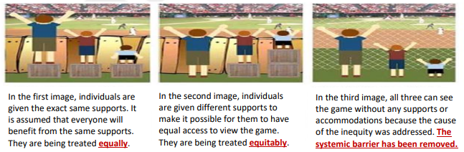

Image: three boxes each showing three people of various heights watching a sporting event. In the first image, individuals are given the exact same supports. It is assumed that everyone will benefit from the same supports. In the second image, individuals are given different supports to make it possible for them to have equal access to view the event. In the third image, all three can see the game without any supports or accommodations because the cause of the inequity was addressed. The systemic barrier has been removed.

Disability inclusion is a benefit to all people in society, as a person without disability gains from the interaction through having an opportunity to engage with another person's experience of disability and, as a result becomes more aware of their own humanity. Both lives can be enriched through this exchange.

The aim of inclusion is not to abolish difference but to celebrate it. This is known as a recognition agenda, which compares to a redistribution agenda. Differences between people should be celebrated rather than reduced to a comparison with an idealised able body. An example of this is with the deaf community. A redistribution agenda would call for cochlear implants for all deaf children, while a recognition agenda supports deaf parents’ choices to raise their children within the deaf community using Auslan while requiring changes to society that ensure the regular use of Auslan in society as required. We are firmly committed to self-determination for people with disability.

A diverse community adds richness to society. Everyone is entitled to inclusion in community life. People with disability belong as valued members of their community, and barriers to full participation should be removed.
We have more than a right to uniformity, we have a right to be different and this is inherent to QAI’s understanding of inclusion. This is positive discrimination; seeking to redress social injustices. We recognise that human beings generally operate within the limits of their experience. We are committed to challenging people's existing frame of reference; to extending their awareness of the rights and needs of people with disability.

QAI recognises that inclusion goes beyond disability and extends to inclusion of diverse peoples including Aboriginal and Torres Strait Islander, older or younger people, CALD and LGBTIQ+ communities. However, as an organisation of people with disabilities, QAI is focused on disability inclusion while recognising the intersection with these other inclusions.

