Queensland Advocacy Incorporated

Advocacy for people with disability

Inspector of Detention Services Bill 2021

Submission by Queensland Advocacy Incorporated

Legal Affairs and Safety Committee

November 2021

About Queensland Advocacy Incorporated
Queensland Advocacy Incorporated (QAI) is an independent, community-based advocacy organisation and community legal service that provides individual and systems advocacy for people with disability. Our mission is to advocate for the protection and advancement of the fundamental needs, rights and lives of people with disability in Queensland. QAI’s Management Committee is comprised of a majority of persons with disability, whose wisdom and lived experience is our foundation and guide.
QAI has been engaged in systems advocacy for over thirty years, advocating for change through campaigns directed at attitudinal, law and policy reform. QAI has also supported the development of a range of advocacy initiatives in this state. For over a decade, QAI has provided highly in-demand individual advocacy services. These services are currently provided through our three advocacy practices: the Human Rights Advocacy Practice (which provides legal advocacy in the areas of guardianship and administration, disability discrimination and human rights law, non-legal advocacy support with the Disability Royal Commission, the justice interface and education, and social work services); the Mental Health Advocacy Practice (which supports people receiving involuntary treatment for mental illness); and the NDIS Advocacy Practice (which provides support for people challenging decisions of the National Disability Insurance Agency and decision support to access the NDIS). Our individual advocacy experience informs our understanding and prioritisation of systemic advocacy issues.

QAI’s recommendations

Queensland’s National Preventative Mechanism (NPM) for the purposes of The Optional Protocol to the Convention Against Torture and other Cruel, Inhuman or Degrading Treatment or Punishment (OPCAT) must:

- Recognise that people with disability are over-represented in all sites of detention. Issues relating to disability must therefore be a core feature of all monitoring activity.

- Be aware of, understand, and meet the needs of all people with disability in all sites of detention. It must understand the legislative frameworks that support people with disability and which govern many aspects of their lives. And it must accommodate the specific needs of people with various disabilities. This will require sufficient resourcing and funding.

- Be designed with reference to Australia’s broader international obligations, including the Convention on the Rights of Persons with Disabilities (CRPD) which requires Australia to protect people with disability from all forms of exploitation, violence, and abuse.

- Take an expansive definition of ‘sites of detention’ for the purposes of OPCAT compliance. It should extend beyond traditional sites of detention to include psychiatric hospitals, compulsory care facilities, community-based residential and aged-care facilities, i.e. disability-specific and disability- dominated institutions, many of which currently lack any meaningful inspection framework. Further consultation should be undertaken to ascertain the best model for reviewing places of detention that are disability-specific, such as the Forensic Disability Service.

- Acknowledge the use of Restrictive Practices as a method of behavioural control is a form of cruel, inhuman and degrading treatment.

- Require a formalised relationship with civil society, as recommended by the Subcommittee on Prevention of Torture and other Cruel, Inhuman or Degrading Treatment.

- Acknowledge and address the range of systemic issues that people with disability endure in sites of detention to understand and address the endemic torture and ill-treatment experienced by people with disability in these environments.

- Increase the frequency of inspections to ensure that adequate oversight is a legislative rather than political commitment.

Background
QAI acknowledges that significant changes to this Bill have been adopted since an earlier draft was circulated, many of which are positive and reflect changes suggested by QAI and others. We value this ongoing dialogue and make the following submission in this context.

This submission will highlight the need for a disability-aware NPM in Queensland and provides recommendations for how this could be achieved in the context of the Bill. OPCAT takes a deliberately broad approach to the prevention of torture and ill-treatment that seeks to prevent all forms of torture and ill- treatment in all sites of detention. This submission asserts that disability should not be treated as a peripheral feature of the NPM, but rather should lie at the heart of all of the NPM’s activities. People with disability are over-represented in all sites of detention, are held in disability-specific sites of detention, and are at greater risk of torture and ill-treatment in these settings, including disability-specific types of torture and ill-treatment.

QAI supports an Inspector of Detention Services that is adequately empowered, informed and resourced and which is part of a broader system of protection against human rights abuses. We share concerns expressed by Sisters Inside and Prisoners Legal Service that this work can only be effective if there is a clear link between individual advocacy and systemic issues. The serious deficiencies in existing complaints mechanisms which have been highlighted in other inquiries and reviews must be addressed to ensure OPCAT implementation is full and robust. We hold concerns that the impact of the current legislation could be whittled away to an ‘OPCAT-lite’ implementation in circumstances of inadequate resourcing or the appointment of an Inspector who is not sufficiently experienced or inclined to robustly go boldly behind firmly closed doors. The Inspector needs to be someone who understands the words of Nelson Mandela when he said “I cherish my own freedom dearly, but I care even more for your freedom. Your freedom and mine cannot be separated.”

There are various solutions that could be posed to ameliorate this risk. For example, the Western Australian model of independent oversight stands out as a robust and standalone entity, ensuring specialisation and resourcing through its deliberately separate structure. Another solution which we have advocated for previously is to increase the frequency of inspections to ensure adequate oversight is a legislative, rather than political commitment.

Introduction
People with disability are over-represented in all sites of detention and are at greater risk of experiencing torture and ill-treatment in these settings. The Optional Protocol to the Convention Against Torture and other Cruel, Inhuman or Degrading Treatment or Punishment (OPCAT), which comes into effect in Australia in January 2022, outlines a mechanism for reducing these risks. OPCAT takes a preventive approach and requires States to create an inspectorate body called the National Preventive Mechanism (NPM). This submission explores how OPCAT can be implemented in Queensland in such a way that ensures the rights of people with disability in sites of detention are upheld.

OPCAT recognises that torture tends to occur ‘behind closed doors’ and flourishes in the absence of scrutiny. It has been an effective tool internationally for mitigating torture and ill-treatment. In particular, its successes in New Zealand and the United Kingdom suggest it could successfully be implemented in Australia.¹ It relies upon two key definitions. First, ‘Torture and other cruel, inhuman or degrading treatment or punishment’ refers to any act that inflicts pain or suffering, whether physical or mental, on a person for purposes such as to retrieve a confession, coercion, punishment, intimidation, or discrimination.² The distinction between torture and ill-treatment is necessarily fluid because what qualifies as torture or ill-treatment depends upon a range of factors including duration, physical and mental consequences, and the age, sex, and/or ethnicity of the victim.³ Second, OPCAT defines a ‘site of detention’ as anywhere that a ‘deprivation of liberty’ occurs.⁴ This refers to any place where someone cannot leave of their own free will, extending beyond settings where there is a locked door to include those where is someone chemically restrained in a hospital emergency ward or residential setting.⁵ This expansive definition extends beyond traditional sites of detention such as prisons and police detention, to include psychiatric hospitals, compulsory care facilities, community-based residential and aged-care facilities, and boarding schools, among others.⁶ It therefore presents an opportunity to investigate and address institutional practices of violence against people with disability in these settings.

OPCAT should also be considered in the context of Australia’s broader international obligations. In 2007, Australia signed the UN Convention on the Rights of Persons with Disabilities (CRPD) which enshrines full equality under the law for people with disability and legislates against discrimination on the basis of disability.⁷ In signing the CRPD, Australia has committed to protecting people with disability from all forms of exploitation, violence, and abuse.⁸ Reading OPCAT in light of the CRPD then suggests that deprivation of liberty on the basis of disability may be construed as torture and/or ill-treatment.

¹ Australian Human Rights Commission, “Consideration of Australia’s Ratification of the Optional Protocol to the Convention Against Torture,” Australian Human Rights Commission, 29 March 2012, https://humanrights.gov.au/our-work/legal/consideration-australias- ratification-optional-protocol-convention-against-torture; Richard Carver, and Lisa Handley, Does Torture Prevention Work? (Liverpool: Liverpool University Press, 2016), 84.
2 Convention against Torture and Other Cruel, Inhuman or Degrading Treatment or Punishment, opened for signature 10 December 1984, A/RES/39/46 (entered into force 26 June 1987), Article 1.
3 Penelope Weller, “OPCAT Monitoring and the Convention on the Rights of Persons with Disabilities,” Australian Journal of Human Rights 25 (2019): 134.
4 Optional Protocol to the Convention Against Torture and other Cruel, Inhuman or Degrading Treatment or Punishment, Article 4(2). 5 Australian Human Rights Commission, Implementing OPCAT in Australia (Sydney: Australian Human Rights Commission, 2020), 42. 6 Lea et al, “A Disability Aware Approach to Torture Prevention?” 75.
7 Convention on the Rights of Persons with Disabilities, opened for signature 30 March 2007, A/RES/61/106 (entered into force 16 August 2008), Preamble.
8 Nora Sveaass, and Victor Madrigal-Borloz, “The Preventive Approach: OPCAT and the Prevention of Violence and Abuse of Persons
with Mental Disabilities by Monitoring Places of Detention,” International Journal of Law and Psychiatry 53, no. 1 (2017): 16.

People with disability in sites of detention
People with disability are significantly over-represented in sites of detention and face greater risk of torture and ill-treatment in these settings. While 18% of the general population identify as persons with a disability, 29% of prisoners identify as having a disability,⁹ 10% of whom possess a mild intellectual disability and a further 25-30% a borderline intellectual disability.¹⁰ Violence against people with disability is deeply embedded in the system. People with disability are over-represented as victims of crime,¹¹ much of which occurs in institutional settings. For example, assault by support staff, personal violence from carers, and deprivations of liberty from public authorities and supported accommodation providers.¹²

Sites of detention are shown to be particularly dangerous for those with intellectual and psychosocial disabilities. As the Senate Affairs References Committee wrote in 2015, “the committee is convinced that violence, abuse and neglect against people with disability is widespread and is occurring across all Australian communities. At the heart of this mistreatment are questions as to how our society views people with disability.”¹³ People with disability can be socialised as passive, compliant with authority figures, and ;dependent on others for care, making them less likely to resist or report sexual predation, assault, and other crimes from figures of authority or trust.¹⁴ People with disability are particularly vulnerable to crimes being committed against them in residential settings by staff,¹⁵ where the greater the physical and social isolation of the victim and the greater their dependence on others for care, risks of torture and ill-treatment increase significantly.¹⁶ Furthermore, abuse in these environments is more likely to go undetected because of this isolation from public scrutiny. An estimated 40-70% of crime against people with disability in residential settings goes unreported.¹⁷ This is because people with disability are often dependent on these institutions for support. This dependency, paired with limited options for obtaining alternative service providers, means that people with disability tend to tolerate abuse and exploitation rather than risk losing their support system by reporting this abuse.¹⁸ Evidently, people with disability face significant risks of torture and ill-treatment in sites of detention.

9 Australian Institute of Health and Welfare, The Health of Australia’s Prisoners (Canberra: Australian Institute of Health and Welfare, 2018), 82.
10 Australia Institute of Health and Welfare, The Health of Australia’s Prisoners, 76.
11 Queensland Advocacy Incorporated, Disabled Justice: Reforms to Justice for Persons with Disability in Queensland (Brisbane: Queensland Advocacy Incorporated, 2015), 15; Law Reform Committee, Inquiry into Access and Interaction with the Justice System by People with an Intellectual Disability and Their Families and Carers (Melbourne: Parliament of Victoria Law Reform Committee, 2013), 5.
12 Phillip French, Disabled Justice: The Barriers to Justice for Persons with Disability in Queensland (Brisbane: Queensland Advocacy Incorporated, 2007), 20.
13 Senate Community Affairs References Committee, Violence, Abuse and Neglect Against People with Disability in Institutional and Residential Settings, 64.
14 French, Disabled Justice, 23.
15 Hilary Brown, June Stein, and Vicky Turk, “The Sexual Abuse of Adults with Learning Disabilities: Report of a Second Two-Year Study,” Mental Handicap Research 8, no. 1 (1995), 13.
16 Christina Burke, and Gerard Quinn, “The Integrity of the Person: The Convention Against Torture and Other Cruel, Inhuman or Degrading Treatment or Punishment and Disability,” in Human Rights and Disability: The Current use and Future Potential of United Nations Human Rights Instruments in the Context of Disability, ed. Anna Bruce, Gerard Quinn, Theresa Degener, Christine Burke, Shivaun Quinlivan, Joshua Castellino, Padraic Kenna, and Ursula Kilkelly (Geneva: United Nations Office of the High Commissioner for Human Rights, 2002), 134; Law Reform Committee, Inquiry into Access and Interaction with the Justice System, 27-28.
17 Law Reform Committee, Inquiry into Access and Interaction with the Justice System, 28-29.
18 French, Disabled Justice, 23-24; Law Reform Committee, Inquiry into Access and Interaction with the Justice System, 28-29.

Disability-specific treatment in closed environments
In addition to experiencing torture and ill-treatment in sites of detention, people with disability also experience a range of disability-specific types of torture and ill-treatment in these settings. The following case studies canvass some examples of disability-specific treatment that could and should be investigated within this framework.

Case Study 1

James is subject to a forensic order and is detained in a secure mental health facility. He requires 24-hour supervision to manage the risk he poses to self and others as a result of the symptoms he experiences due to his mental illness. As a result of the significant risk he poses, there are very limited opportunities for James to access leave with appropriate supports.

James suffers from a complex mental illness and has limited communication ability. Due to his significant mental health symptomology, he experiences chronic psychosis which causes him agitation and he engages in behaviours which are violent and aggressive. Importantly, his mental illness has proven relatively treatment-resistant, which means that there is limited opportunity for James to rehabilitate and experience a reduction in his symptoms despite the high dosage of prescribed medication he takes. As such, James receives regular treatments of electroconvulsive therapy (ECT) approved by the Mental Health Review Tribunal under the Mental Health Act 2016 (QLD), to help minimise the severity of his symptoms and distress. Despite ongoing maintenance ECT, James’ mental state reflects little improvement in terms of stability and reduction of symptomology.

Due to the invasive nature of ECT and the requirement to undergo general anaesthesia for each treatment, James is required to fast overnight prior to the treatment, and this requires James to be placed in seclusion overnight. This is significantly restrictive for James as he can receive ECT up to 3 times a week if his mental state requires, and therefore is required to be held in isolation and fasted for up to three occasions per week.

In addition, the mental health unit where James permanently resides due to his low level of functioning and forensic risk, has additional restrictions which impact on James’s quality of life. James has limited luxuries to look forward to and does enjoy certain food and drink options such as soda and treats. Due to the restrictions placed on specific items of food and drink being consumed on the ward, James is subject to additional limitations preventing him access to food and drink he enjoys while in the unit. As James is not able to access leave to the canteen or on or off the hospital grounds as often as other consumers, due to his mental illness, James does not get to enjoy these food items like the other consumers he resides with.

James’ family are concerned about the limitations placed on James such as the restrictions on food and drink and the ongoing use of invasive treatment such as ECT given the limited signs of positive outcomes from this treatment. They question whether ECT has clinically efficacy or is being used as a form of behaviour management due to his complex presentation.

Case Study 2

Adam resides in a high secure mental health facility under a forensic order. He is considered high risk of reoffending and suffers from a dual disability, a complex treatment resistant type mental illness and an intellectual impairment. Adam has resided in the high security unit which is a seclusion type arrangement for over 6 years. Adam has very limited access to leave and is currently only permitted by order of the Mental Health Review Tribunal to access escorted on ground leave on the campus of the high security mental health unit which he to date, has not been successful in accessing for some years.

Other than his confinement, Adam is supported to access leave to the common room on the ward where he has access to books. He is only able to access the common room in isolation due to the threat he poses to co-patients. He regularly declines opportunities to leave his room as he considers that his belongings in his room will be stolen or taken if he leaves, which is part of his condition. Any contact with family, or his lawyers is at a distance due to the risk of harm he poses to others and is usually facilitated via contact through a secure fence on the perimeter of his seclusion room or by a phone being placed on speaker through the hatch door in his room. This poses serious concerns for his rights to privacy, connection with family and access to his lawyer.

Adam’s family have observed a longitudinal regression in his condition and perception of self. The clinical treating team have also noted that Adam regularly declines opportunities to leave his room or participate in recreational activities and exercise opportunities on the grounds of the hospital, such as swimming which he reportedly enjoyed many years ago.

Adam identifies that he is a dangerous person and should be in jail and regularly makes verbal threats to harm others.

*All names have been changed to ensure confidentiality

These case studies depict a number of systemic issues and disability-specific types of treatment of people in closed environments, including indefinite detention and the use of Restrictive Practices. People with disability may find themselves in indefinite detention following a Forensic Order, or under a mental health, disability, or guardianship framework – a process depicted in Appendix C. People with disability deemed unfit to stand trial face indefinite detention in prisons or psychiatric facilities without a criminal conviction, often for longer than the maximum sentence for the offence committed.¹⁹ They are held in sites of detention because of a lack of other supported options in the community, but in these settings they often endure human rights breaches and languish in purgatory with no exit pathway.²⁰ This has been an ongoing issue in Australia with limited signs of improvement. The case examples highlight the negative consequences of indefinite detention for people with disability. This is a particular issue in Queensland which, unlike some other states, does not have limiting terms²¹ for people with disability on Forensic Orders.

19 United Nations Committee on the Rights of Persons with Disabilities, Concluding Observations on the Initial Report of Australia, Adopted by the Committee and Its 10th Session, 2-13 September 2013 (Geneva: Office of the High Commissioner for Human Rights, 2013), 5.
20 Senate Community Affairs References Committee, Indefinite Detention of people with Cognitive and Psychiatric Impairment in Australia (Canberra: Commonwealth of Australia, 2016), 100.
21 ‘Limiting terms’ refer to the period of time a person found unfit to stand trial can spend in forensic custody under supervision. The length of a limiting term represents the sentence of imprisonment a court would have imposed for the offending conduct if the person

The cases also highlight the use of Restrictive Practices as a practice that causes harm that could be considered under an OPCAT lens. This refers to any practice or intervention that restricts the rights or freedom of movement of a person with disability for the primary purpose of protecting the person, or others, from harm.²² Three conditions are necessary to justify restrictive intervention: to prevent the person from causing harm to themselves or others; that the intervention is the least restrictive option in the circumstance; and that the use of restraint or seclusion are part of a previously defined behaviour management plan.²³ However, the cases highlight that this is not always the case, and that Restrictive Practices are sometimes used illegitimately in ways that do not comply with this framework and which can be considered torture and ill-treatment. For example, forcing a person to endure ECT when it has no clinical benefit and cannot be justified on the grounds of protecting the person from causing harm. Or denying a person access to their environment, including access to food. Research supports this, suggesting that Restrictive Practices are frequently improperly used in institutional settings, often in violation of existing human rights protocols.²⁴ Furthermore, seclusion and confinement is particularly harmful to people with cognitive disabilities,²⁵ and many of the behaviours they seek to control are not inherently irrational behaviours, but are instead adaptive behaviours to the maladaptive environment that is institutional care.²⁶ Using Restrictive Practices as a form of behavioural control in some situations may be considered a form of cruel, inhuman and degrading treatment that must be within the purview of Queensland’s NPM if Queensland, and indeed Australia, are to meet its international obligations under both the CRPD and OPCAT.

People with disability are therefore evidently over-represented in all sites of detention, experience higher rates of violence in these settings, and are subject to disability-specific types of torture and ill-treatment. The need for disability to be held centrally to OPCAT’s implementation in Queensland and for it to be disability- aware, is critical.

Queensland’s progress
OPCAT comes into effect in Australia at the end of January 2022. So far, the Australian Government has indicated its plans to implement a federated NPM network. Each state and territory is required to create its own NPM led by the NPM coordinator, the Commonwealth Ombudsman, which will be responsible for

had been found guilty at trial. A person on a limiting term will stop being a patient at the end of their limiting term unless their forensic patient status is extended by the court. Queensland currently lacks any legislation regarding limiting terms, which increases the likelihood for people with disability to find themselves in indefinite detention. Other states such as New South Wales, Northern Territory, and Victoria have various mechanisms in place to limit terms, reducing the likelihood of indefinite detention.
22 Department of Social Services, National Framework for Reducing and Eliminating the Use of Restrictive Practices in the Disability Service Sector (Canberra: Department of Social Services, 2013), 1.
23 Paul Ramcharan et al., Experiences of Restrictive Practices: A View From People with Disabilities and Family Carers (Melbourne: Department of Human Services Victoria, 2009), 9.
24 Ramcharan et al., Experience of Restrictive Practices, 6.
25 Michael L. Perlin, “International Human Rights and Institutional Forensic Psychiatry: The Core Issues,” in The Use of Coercive Measures in Forensic Psychiatric Care Legal, Ethical and Practical Challenges, ed. Birgit Völlm, and Norbert Nedopil (Cham: Springer International Publishing, 2016), 16.
²⁶ Ramcharan et al., Experience of Restrictive Practices, 6.

Commonwealth sites of detention and facilitating collaboration throughout the NPM network.²⁷ By August 2021, only Western Australia was on track to meet the January deadline – not even the Commonwealth Ombudsman as NPM coordinator was poised to be ready for January.²⁸ The Australian Government has appeared reticent to ratify OPCAT, raising questions about its commitment to ‘best practice’ OPCAT implementation. It has explicitly indicated its intention to focus on ‘primary’ places of detention such as prisons, police cells, and immigration facilities,²⁹ which would exclude many sites of detention where people with disability are held, especially disability-specific sites. As per Appendix A, this disregards at least 33 of Queensland’s 108 primary places of detention. This approach ignores the high rates of violence against people with disability in detention settings and the failings of the existing systems to protect them from harm.³⁰ It disregards studies that have shown that Australia lacks a comprehensive system of preventive monitoring for all sites of detention.³¹ Queensland itself currently has eight existing oversight bodies, none of which meet the essential requirement of functional independence of an NPM.³² The table in Appendix B further depicts how disability-specific institutions have some of the weakest existing inspection frameworks in Queensland. QAI notes that many disability-specific sites such as psychiatric wards, compulsory care facilities, residential and group homes, and aged care facilities currently lack any inspection framework to monitor them.³³ Evidently, OPCAT presents a unique opportunity to strengthen oversight for all sites of detention in Queensland, but particularly disability-specific and disability-dominated institutions, many of which currently lack any meaningful inspection framework.

Creating a disability-aware NPM for Queensland
OPCAT provides States Parties significant discretion over how they design their NPM. The NPM’s mandate is to visit sites of detention, assess the risks of torture, and provide recommendations to mitigate against these risks. This must be construed within the context of the CRPD which empowers people with disability to have a voice in all aspects of decision-making around their services.³⁴ This extends to OPCAT implementation and NPM design and means that the voices of people with disability must be central to design and implementation of Queensland’s NPM.

The minimum powers and guarantees necessary for the NPM include:

27 Australian Human Rights Commission, Implementing OPCAT in Australia, 15; Michael Manthorpe, Implementation of the Optional Protocol to the Convention Against Torture and Other Cruel, Inhuman or Degrading Treatment or Punishment (Canberra: Commonwealth Ombudsman, 2019), 7.
28 Human Rights Law Centre, “Australia Off Track to Implement Anti-Torture Protocols by International Deadline.”
29 George Brandis, “Torture Convention – The Australian Government OPCAT Announcement,” Human Rights Law Centre, 22 February 2017, https://www.hrlc.org.au/bulletin-content/2017/2/22/torture-convention-the-australian-government-opcat- announcement; Manthorpe, Implementation of the Optional Protocol to the Convention Against Torture and other Cruel, Inhuman or Degrading Treatment or Punishment, 8-9.
30 Disabled People’s Organisations Australia, Position Paper: Disability Inclusive National Preventive Mechanism (NPM) (Sydney:
Disabled People’s Organisations Australia, 2018), 3.
31 Richard Harding, and Neil Morgan, “Ratifying and Implementing OPCAT: Has Australia Missed the Boat?” (paper presented at the
Implementing Human Rights in Closed Environments Conference, Monash University, Melbourne, 21 February 2012), 6.
32 Manthorpe, Implementation of the Optional Protocol to the Convention Against Torture and other Cruel, Inhuman or Degrading Treatment or Punishment, 25.
33 Queensland Advocacy Incorporated, OPCAT in Australia (Brisbane: Queensland Advocacy Incorporated, 2017), 10.
34 Convention on the Rights of Persons with Disabilities, Article 4(3); Ramcharan et al., Experience of Restrictive Practices, 4.

- Independence in structure, staffing, and financing;³⁵
- Necessary experience, capabilities, and expertise among staff, including that regarding minority groups;³⁶
- Sufficient financial and human resources including a multidisciplinary team;³⁷ and
- Access to all places of deprivation of liberty, including relevant documents and information, and to speak privately with detainees and staff.³⁸

Queensland therefore has an opportunity to design an NPM that is disability-aware from the start. An NPM that is disability-aware is one that is aware of, understands, and meets the needs of people with disability. It must understand the legislative frameworks that support people with disability and which govern many aspects of their lives. And it must be aware of the barriers, both environmental and attitudinal, that deny people with disability their human rights and fundamental freedoms, demonstrating an intimate understanding of the lived experience of Australians with disability.³⁹

Best practice NPM design recognises that people with disability are over-represented in all sites of detention. Issues relating to disability must therefore be a core feature of all monitoring activity.⁴⁰ In this sense, a disability-aware NPM would assist in identifying individual and systemic human rights violations and provide a framework for addressing them in a disability-responsive way.⁴¹ As Weller writes, “the first task of a disability inclusive NPM is to recognise discrimination on the basis of disability… NPMs must make themselves aware of the systemic manifestation of discrimination on the basis of disability, the disproportionate incidence of deprivation of liberty, and impacts of discriminatory assumptions about people with disabilities.”⁴² There is clearly both a significant need and opportunity for Queensland’s NPM to be designed in a disability-inclusive manner. But what specific elements make an NPM disability-inclusive?

Broad Conception of ‘Sites of Detention’
Perhaps one of the most meaningful ways Queensland’s NPM can be disability-aware is by ensuring all people with disability detained in sites of detention are within its remit. This requires a broad conception of what constitutes a ‘site of detention’, encapsulating all environments where people with disability are held against their will. The Australian Government has expressed intention to focus on ‘traditional’ sites of detention and explicitly commented that it does not intend to include aged care facilities and group homes in this.⁴³ However, since people with disability typically frequent these facilities (88% of aged care residents have a physical disability and 73% a psychosocial disability,⁴⁴ and can be deprived of their liberty in these settings, this directly

35 Optional Protocol to the Convention Against Torture and other Cruel, Inhuman or Degrading Treatment or Punishment, Article 18(1). 36 Optional Protocol to the Convention Against Torture and other Cruel, Inhuman or Degrading Treatment or Punishment, Article 18(2). 37 Optional Protocol to the Convention Against Torture and other Cruel, Inhuman or Degrading Treatment or Punishment, Article 18(3). 38 Optional Protocol to the Convention Against Torture and other Cruel, Inhuman or Degrading Treatment or Punishment, Article 20. 39 Australian Federation of Disability Organisations, “Being a Disability Confident Organisation,” Australian Federation of Disability Organisations, 15 September 2015, https://www.afdo.org.au/wp-content/uploads/documents/dfo- toolkit/being_a_disability_confident_organisation.pdf.
40 Lea et al, “A Disability Aware Approach to Torture Prevention?” 87-88.
41 Disabled People’s Organisations Australia, Position Paper, 3.
42 Weller, “OPCAT Monitoring and the Convention on the Rights of Persons with Disabilities,” 141.
43 People With Disability Australia, Safeguards Help Marginalised People with Disability (Surry Hills: People With Disability Australia, 2021), 20.
44 Australian Bureau of Statistics, A Profile of People Living in Residential Aged Care in Australia (Canberra: Australian Bureau of Statistics, 2018), 1.

neglects people with disability. In contrast, Denmark presents a best practice approach to conceptualising sites of detention. Denmark’s NPM understands a site of detention to refer to “any form of detention or imprisonment or the placement of a person in a public or private custodial setting which that person is not permitted to leave” and has even been understood to apply to a group of protesters contained within a police- cordoned area.⁴⁵ To be disability-aware, it is recommended that Queensland’s NPM adopts a broad conception of sites of detention. Failure to do so would neglects to recognise the many disability-specific sites of detention and numerous challenges people with disability face in these settings.

Sufficient Funding and Resources
To be disability-aware, the NPM also requires sufficient funding and resources to fulfil its remit. Adequate financial resources and operational autonomy are shown to be two of the strongest predictors of an effective NPM.⁴⁶ International experience teaches that when an NPM is under-resourced and/or underfunded, disability and minority interests are the first to become overlooked. This is because the NPM is forced to restrict the scope of its inspections, where underfunding is a major factor that leads States Parties to breach their OPCAT obligations.⁴⁷ For example in Switzerland, under-resourcing and underfunding were major factors underpinning its struggle to effectively implement OPCAT. These constraints forced its NPM to focus on traditional sites of detention, overlooking many sites where people with disability are detained, especially disability-specific sites.⁴⁸ Furthermore, resourcing and funding underpin an NPM’s ability to function independently and ideally, the NPM should be allowed to draft its own budget and choose how to use its funds without external pressures.⁴⁹ Evidently, an under-resourced and underfunded NPM will fail to demonstrate a commitment to people with disability in sites of detention. To be disability-aware, Queensland’s NPM will require receive sufficient resources and funding, such that it can include disability within its operational scope.

Civil Society
To ensure disability-awareness in an NPM, it must be co-designed with people with disability and their representative organisations. This will ensure the NPM’s processes and mechanisms are both disability-aware and disability-responsive. The CRPD enshrines that people with disability and their representative organisations should be consulted and actively involved in developing legislation and policy that affects their daily lives.⁵⁰ This extends to the design, development, and implementation of the NPM. Best practice for how NPMs can engage with civil society includes:
- Legislating the NPM in a way that is public, inclusive, and transparent;⁵¹

45 “Climate Activists Condemn Copenhagen Police Tactics,” BBC, 13 December 2009, http://news.bbc.co.uk/2/hi/europe/8410414.stm; Folketingets Ombudsmand, OPCAT Annual Report 2009 (Copenhagen: Folketingets Ombudsmand, 2009), 3.
46 Carver and Handley, Does Torture Prevention Work? 95; Steven Caruana, Enhancing Best Practice Inspection Methodologies for Oversight Bodies with an Optional Protocol to the Convention against Torture Focus: Report to the Winston Churchill Memorial Trust of Australia (Canberra: The Winston Churchill Memorial Trust, 2018), 41-55.
⁴⁷ Carver and Handley, Does Torture Prevention Work? 95; Lea et al, “A Disability Aware Approach to Torture Prevention?” 87.
48 Lea et al, “A Disability Aware Approach to Torture Prevention?” 87.
49 Ben Buckland, and Audrey Olivier-Muralt, “OPCAT in Federal States: Towards a Better Understanding of NPM Models and Challenges,” Australian Journal of Human Rights 25, no. 1 (2019): 27.
50 Convention on the Rights of Persons with Disabilities, Article 4(3); Lea et al, “A Disability Aware Approach to Torture Prevention?”
87.
51 Subcommittee on Prevention of Torture and Other Cruel, Inhuman or Degrading Treatment or Punishment, Report on the visit made by the Subcommittee on Prevention of Torture and Other Cruel, Inhuman or Degrading Treatment or Punishment to Sweden, UN Doc CAT/OP/SWE/1 (10 September 2008), para 41(b).

- Exploring creative ways of strengthening its human resources;⁵²
- Encouraging dialogue and strong relationships between the NPM and civil society;⁵³ and
- Taking steps to increase its interaction with civil society groups.⁵⁴

The Subcommittee on Prevention of Torture and other Cruel, Inhuman or Degrading Treatment further recommends that the relationship between NPM and civil society is strong and formalised.⁵⁵ By engaging people with disability and their representative organisations, the NPM can ensure that its monitoring approach conforms with best practice and holistically understands the experiences of people with disability in all sites of detention.⁵⁶ The Serbian approach could be replicated in Queensland. There, nine civil society organisations (including one disability-specific organisation) join the NPM when conducting inspections to ensure best practice inspection processes.⁵⁷ By including disability organisations in inspections, the NPM lays the foundation for a disability-aware approach by acknowledging the centrality of disability to the work of the NPM and building monitoring strategies based on the expertise of these organisations.⁵⁸ If Queensland’s NPM effectively engages with civil society groups, it would be disability-aware by more effectively including the experiences and issues facing people with disability in sites of detention. This Bill provides for this engagement, but does not require it.

Experts by Experience
Experts by Experience play a crucial role in ensuring a disability-aware approach to inspections. They are those who have personal experience in sites of detention and provide insight and understanding of where torture and ill-treatment can occur in these settings. As the Chief Inspector for the New Zealand Ombudsman commented, “as inspectors, we can see how things look; the Experts by Experience can tell us how things feel.”⁵⁹ Importantly, people in detention often find it more comfortable and easier to communicate and express their concerns to Experts by Experience. The UK’s NPM body acknowledges this, commenting “we have found many people find it easier to talk to an Expert by Experience rather than an inspector.”⁶⁰ Therefore,

52 Subcommittee on Prevention of Torture and Other Cruel, Inhuman or Degrading Treatment or Punishment, Report on the visit made by the Subcommittee on Prevention of Torture and Other Cruel, Inhuman or Degrading Treatment or Punishment for the purpose of providing advisory assistance to the national preventive mechanism of the Federal Republic of Germany, UN Doc CAT/OP/DEU/2 (29 October 2013), para 29.
53 Subcommittee on Prevention of Torture and Other Cruel, Inhuman or Degrading Treatment or Punishment, Report on the visit of the Subcommittee on Prevention of Torture and Other Cruel, Inhuman or Degrading Treatment or Punishment to New Zealand, UN Doc CAT/OP/NZL/1 (28 July 2014), para 17(f).
54 Subcommittee on Prevention of Torture and other Cruel, Inhuman or Degrading Treatment or Punishment, Visit to Spain Undertaken from 15 to 26 October 2017: Observations and Recommendations Addressed to the National Preventive Mechanism, UN Doc CAT/OP/ESP/2 (25 June 2018), para 21.
55 Australian Human Rights Commission, Implementing OPCAT in Australia, 58.
56 Lea et al, “A Disability Aware Approach to Torture Prevention?” 87.
⁵⁷ Council of Europe: Committee for the Prevention of Torture, Report to the Government of Serbia on the Visit to Serbia Carried out by the European Committee for the Prevention of Torture and Inhuman or Degrading Treatment or Punishment (CPT) from 26 May to 5 June 2015 (Strasbourg: Council of Europe: Committee for the Prevention of Torture, 2016), 14.
⁵⁸ Lea et al, “A Disability Aware Approach to Torture Prevention?” 91.
⁵⁹ Steven Caruana, The Implementation of OPCAT in Australia: Submission by the Australia OPCAT Network to the Subcommittee on Prevention of Torture and Other Cruel, Inhuman or Degrading Treatment or Punishment (SPT) and the United Nations Working Group on Arbitrary Detention (WGAD) (Canberra: The Australia OPCAT Network, 2020), 31.
⁶⁰ Care Quality Commission, Monitoring the Mental Health Act in 2016/17 (Newcastle upon Tyne: Care Quality Commission, 2019), 48.

this Bill has strongly enhanced the disability-awareness of the Queensland NPM by including Experts by Experience with disability in its inspections, allowing it to build trust with people in detention and gain candid insight into the experiences of people with disability in these settings.

Accommodate the Needs of People with Disability
For Queensland’s NPM to conduct inspections in a way that is disability-aware, it must recognise and accommodate the specific accessibility needs of people with disability. For example, NPMs often use surveys when conducting inspections, surveying people in detention, management, and staff to gain a holistic understanding of the specific site of detention.⁶¹ However, for a survey to be accessible, it must accommodate the varying communication needs of people with disability. This report has highlighted the prevalence of people with intellectual disability in sites of detention, but others such as those with limited/no vision or dyslexia, among others, might also require certain accommodations when completing surveys. For example, access to support workers may be required or material in plain or Easy English may be necessary.⁶² To conduct inspections in a disability-aware manner, Queensland’s NPM must recognise and accommodate the specific needs of people with various disabilities. Failure to do so will provide only a limited picture of a site of detention and potentially miss signs of torture and ill-treatment against people in detention, including people in detention with disability.

Systemic Issues
As previous research and the case studies in this report demonstrate, people with disability experience a range of systemic abuses in sites of detention. The NPM must seek to understand and address these systemic issues. For example, the indefinite detention of people with disability and the use of Restrictive Practices, as well as issues such as people with disability being forced to live in group homes, and the experiences of persons with multiple vulnerabilities in places of detention.⁶³ Moreover, QAI notes that many disability-specific sites of detention in Queensland have previously been closed and lacking in any meaningful form of scrutiny or accountability. OPCAT therefore presents an opportunity to access and inspect these institutions and address the myriad forms of cruel, inhuman and degrading treatment that occur within them.⁶⁴

For Queensland’s NPM to holistically understand the state’s detention systems, it is essential that it focuses on learning about the systems and processes used in these sites, many of which currently lack meaningful oversight or inspection bodies. While not an NPM in its own right, the ACT Inspector of Corrective Services (ICS) outlines a useful example for how Queensland’s NPM could approach systemic issues. The ICS conducts whole-of-centre reviews, thematic reviews, and critical incident reviews. Taking place every two years, whole- of-centre reviews look at all aspects of treatment and care of persons in detention including their daily life, healthcare, and psychosocial support. Thematic reviews also take place at least every two years and allow the ICS to explore particular systemic issues in greater depth; and critical incident reviews take place after a critical incident occurs, investigating its causes and how to prevent it reoccurring.⁶⁵ Queensland’s NPM should take a

⁶¹ Manthorpe, Implementation of the Optional Protocol to the Convention Against Torture and other Cruel, Inhuman or Degrading Treatment or Punishment, 11.
62 Manthorpe, Implementation of the Optional Protocol to the Convention Against Torture and other Cruel, Inhuman or Degrading Treatment or Punishment, 11.
63 Disabled People’s Organisations Australia, Position Paper, 3; Queensland Advocacy Incorporated, OPCAT in Australia, 3.
64 Queensland Advocacy Incorporated, OPCAT in Australia, 3.
65 Neil McAllister, Response to Safeguards and Quality Issues Paper (Canberra: ACT Inspector of Correctional Services, 2021), 3-4.

similar approach to addressing the range of systemic issues that people with disability endure in sites of detention to understand and address the systemic torture and ill-treatment experienced by people with disability across the detention system.

Conclusion
QAI supports an Inspector of Detention Services that is adequately empowered, informed and resourced and which is part of a broader system of protection against human rights abuses. We share concerns expressed by Sisters Inside and Prisoners Legal Service that this work can only be effective if there is a clear link between individual advocacy and systemic issues. The serious deficiencies in existing complaints mechanisms which have been highlighted in other inquiries and reviews must be addressed to ensure OPCAT implementation is full and robust. We hold concerns that the impact of the current legislation could be whittled away to an ‘OPCAT-lite’ implementation in circumstances of inadequate resourcing or the appointment of an Inspector who is not sufficiently experienced or inclined to robustly go boldly behind firmly closed doors. The Inspector needs to be someone who understands the words of Nelson Mandela when he said “I cherish my own freedom dearly, but I care even more for your freedom. Your freedom and mine cannot be separated.”

There are various solutions that could be posed to ameliorate this risk. For example, the Western Australian model of independent oversight stands out as a robust and standalone entity, ensuring specialisation and resourcing through its deliberately separate structure. Another solution which we have advocated for previously is to increase the frequency of inspections to ensure adequate oversight is a legislative, rather than political commitment.

This submission aims to highlight the overrepresentation of people with disability in all sites of detention, the disability-specific types of torture and ill-treatment they endure and the often disability- specific sites of detention in which they are detained. These factors demonstrate the need for Queensland’s NPM to be disability-aware and for the legislation underpinning this body to be robust.

Appendix A

Estimated Total Number of Facilities Falling Within the Definition of Primary Places of Detention Within States and Territories

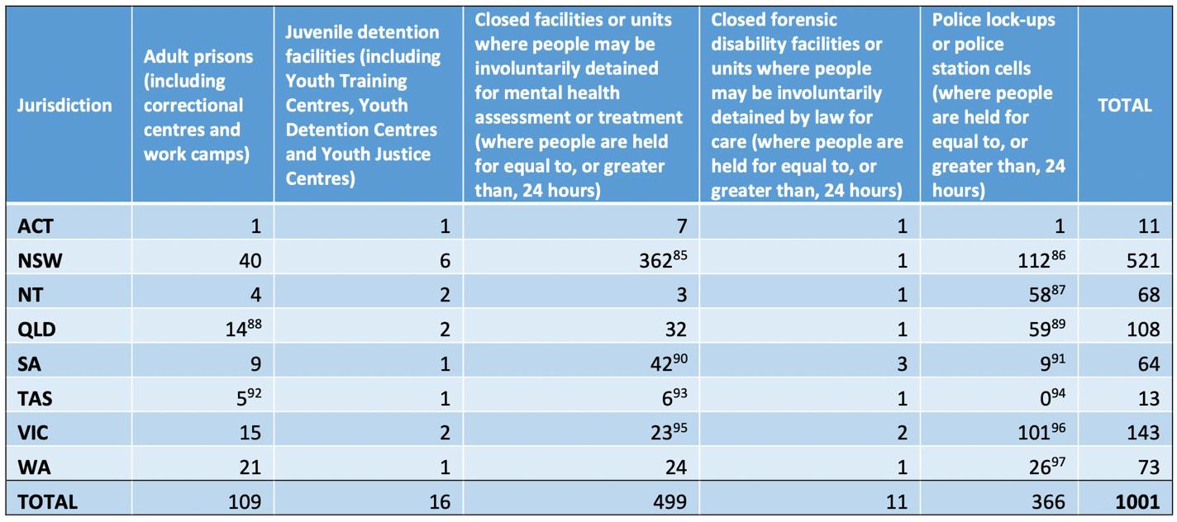

Michael Manthorpe, Implementation of the Optional Protocol to the Convention Against Torture and Other Cruel, Inhuman or Degrading Treatment or Punishment (Canberra: Commonwealth Ombudsman, 2019), 31.

Appendix B

Current Oversight for Sites of Detention in Queensland

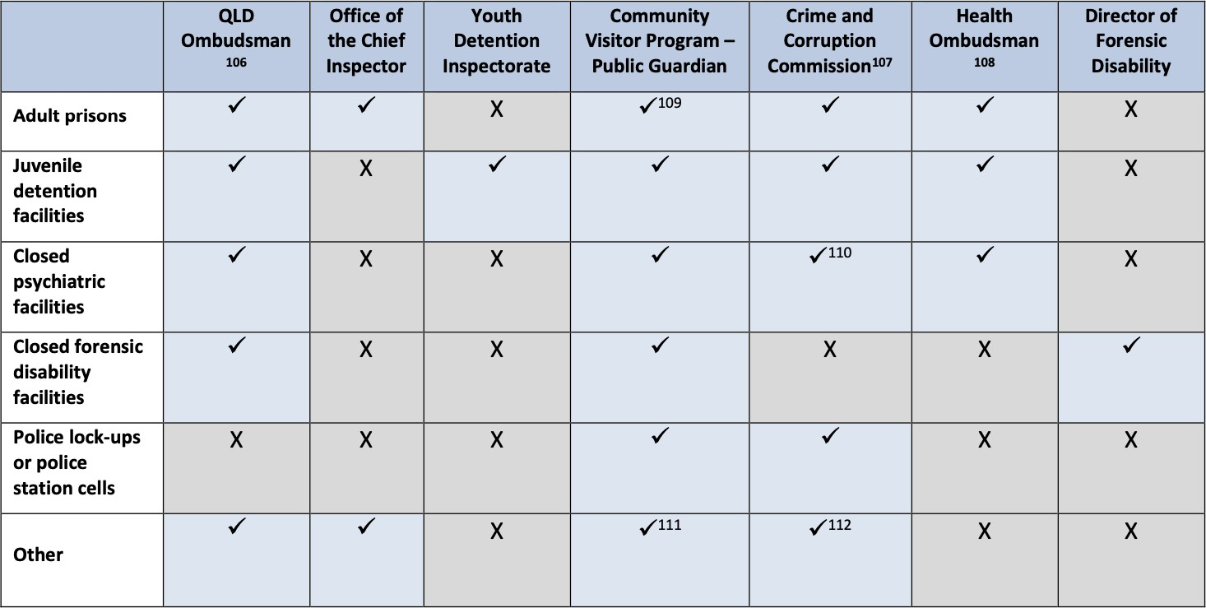

Michael Manthorpe, Implementation of the Optional Protocol to the Convention Against Torture and Other Cruel, Inhuman or Degrading Treatment or Punishment (Canberra: Commonwealth Ombudsman, 2019), 37.

Appendix C

Entry into the Queensland Forensic Mental Health System

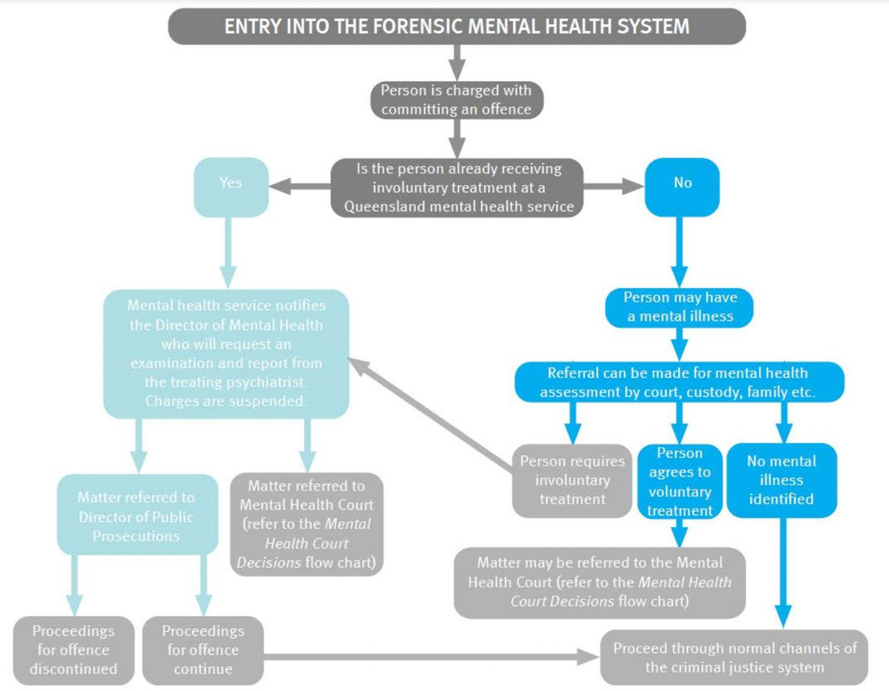

Senate Community Affairs References Committee, Indefinite Detention of people with Cognitive and Psychiatric Impairment in Australia (Canberra: Commonwealth of Australia, 2016), 19.

