Tuesday 25 January 2022

OPEN LETTER

Commonwealth and State governments called on for immediate actions required to prioritise COVID-19 safety measures for Queenslanders with disability

Queenslanders with disability, their families, carers, health, community and disability organisations and peak bodies are calling for immediate and urgent action to prioritise access for Queenslanders with disability to vital health and COVID-19 safety measures during this critical time. This current environment is having a significant impact on Queenslanders with disability and pose significant risks to people’s access to basic essential supports
We come together as a diverse group of organisations representing consumers, community organisations, unions, and professional organisations in the disability, health, community, and aged care sectors. Collectively we are working together to identify crucial issues and options to resolve, especially for our most vulnerable communities as we fast approach the peak of the Omicron surge.
Despite the previous work that has been undertaken in Queensland, the current Omicron situation is presenting unique challenges and there is a clear need for leadership, coordinated planning and targeted measures to ensure the protection, health, and well-being of Queenslanders with disability.

We are calling for people with disability and their families to be formally recognised as a priority cohort to access vitally needed supplies, services, and supports in the same way as the Commonwealth residential aged care sector.
We are calling for priority access to testing, vaccinations, boosters, and protective equipment for people with disability, including people with mental health, and chronic conditions, supported through the National Disability Insurance Scheme (NDIS), Queensland Community Support Scheme (QCSS) and community mental health and community care organisations, and their carers.
We seek urgent action around the following:
- In the absence of supply of Rapid Antigen Tests (RATs), immediately prioritise access to PCR testing and processing of results for people with disability, family, carers, and workers who receive NDIS or community care support, community mental health, or palliative care. This to include priority bookings and accessibility measures at testing sites that give people with disability direct access to tests without having to wait in long lines and meet accessibility needs.
- Advocate to the Commonwealth Government for priority access of PPE and distribution for NDIS participants and people with disability and mental health conditions supported through community managed organisations or palliative care programs and their workers as well as clear pathways to access supply.
- Priority access and distribution channels for stocks of giving kits, formula and continence aids to people supported in home in community.

- Provide transparent information about the overarching National plan for the requisition of PPE, RATs, giving sets, and formula for people with disability who receive disability supports in the community.
- As supply of RATs increases provide priority access and establish distribution pathways for NDIS participants, those receiving support through a community managed organisation, and palliative care clients as well as their workers.
- Deliver accessibility measures for Queenslanders with disability who need support to read RAT instructions and results for people who are vision impaired, blind and colour blind and people who are deaf and hard of hearing and for people with disability who may not be proficient in English.
- Continued and accelerated prioritisation of people with disability for vaccination shots and boosters, including disability accommodation sites.
We acknowledge that this needs to be underpinned by General Practice, pharmacists, nursing, allied health professionals, and support staff access to PPE to ensure primary health care services can continue to be delivered.
This is a vitally important time for Queenslanders with disability, families, and providers as well as the health services who deliver essential primary, allied and acute services.
We ask for immediate action to protect and prioritise Queenslanders with disability.

Paige Armstrong  Chief Executive Officer  Queenslanders with Disability Network Mobile 0408 720 099 | Melissa Fox  Chief Executive Officer  Health Consumers Queensland Mobile 0404 882 716

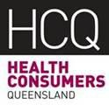
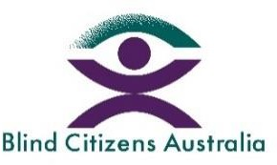
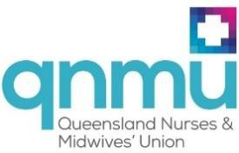
Queensland Advocacy Incorporated
Advocacy for people with disability

