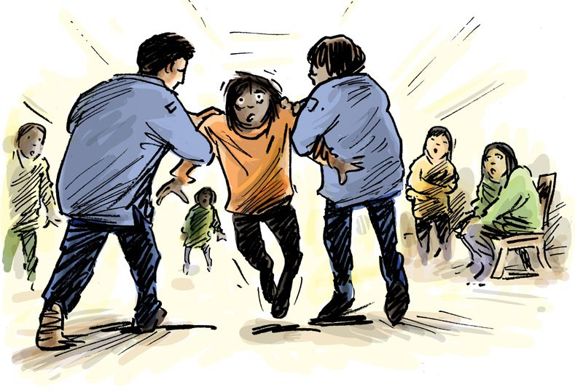

Your rights in the mental health service

www.qai.org.au

Contents

About this info guide 1
What the law says 2
Your right to dignity and respect 5
Your right not to be alone for a long time 9
Your right to good health care 13
Your right to ok living and learning areas 15
Your right to be safe 17
Your right to be heard and supported 19
To get more info 21

Council for Intellectual Disability made this document Easy Read. Images ©

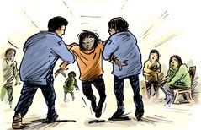

About this info guide

This info guide talks about your rights in the mental health service.

It will help you know what is ok and what is not ok when you get treatment in the mental health service.

You may get this treatment because

- A court said you have to

- You chose to.

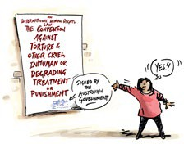

What the law says

There is a human rights law about the things that are not ok to do to someone.

This is an international law.

An international law is a law that countries can choose to say yes or no to.

This law says there are things that are not ok for the police or mental health staff to do.

This law says that torture is never ok.

Torture means that someone does very bad things to you.

Torture is when someone might

- Beat you

- Do sexual things you do not want

- Lock you up by yourself for a long time.

This law says you must not be treated in a way that makes you feel hurt or ashamed.

This could be things like

- Bullying or scaring you

- Not giving you health care or disability support

- Giving you health care or medication you do not want.

The Australian government said yes to this law.

But there are different laws made by each State or Territory government in Australia.

Some of these laws allow people to be treated in ways that the international law says is not ok.

This info guide talks about the international law and your rights.

Your right to dignity and respect

This part talks about dignity and respect.

Dignity means in a way that does not make you feel bad or ashamed.

This part will help you know if staff treat you with dignity and respect.

Staff in the service and other people like police must treat you with respect and dignity.

You can ask for someone to help you understand what is happening.

This could be an advocate or a lawyer.

An advocate is someone who helps you speak up.

Sometimes staff need to search you to see if you are hiding anything.

When they search you they will touch your body.

They want to see if you hide something in your clothes.

They must tell you

- Why they need to search you

- How they will do the search.

They should respect your wishes such as

- You do not want a woman in the room

- You do not want a man to search you.

They should not do anything that could make your mental health worse.

Mental health staff and police are allowed to do a strip search.

Strip search means they ask you to take some or all of your clothes off.

There are some rules staff must follow when they do a strip search.

Some rules are

- A strip search should be done as quickly as possible

- They must wear gloves to keep everyone safe

- You should not feel like they are making fun of you.

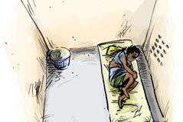

Your right not to be alone for a long time

When you are in a mental health service you have the right not to be alone for a long time.

You must not be kept alone because you have a disability.

Solitary confinement is when you are kept alone forover 22 hours.

+22
hours

This should only be done as a last option.

Solitary confinement should be for the shortest time only.

+15
days

It must not be for more than 15 days in a row.

If the staff put you in solitary confinement they should tell you

- Why they are doing it

- How long it will be for

- What you need to do to get out.

You should still be allowed to meet with a lawyer or advocate.

Even if you are in solitary confinement your room should be cleaned.

Staff must look after your basic needs. That means that you can always
- Drink water

- Use a toilet

- Have sanitary products if you have your period

- See a doctor if you are sick or your mental health gets worse.

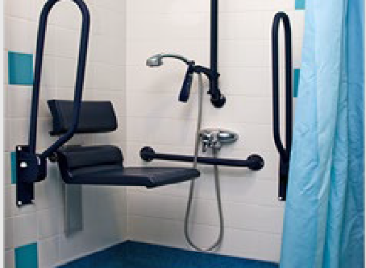
You should be allowed to use an accessible bathroom if you need.

There should be some things for you to do to pass the time.

You must be allowed fresh air. This could be going outside.

You should get support to move around outside if you need it.

If you have been in solitary confinement think about

- Who did you see?

- Did you see someone every day?

- Could you talk to them for a bit?

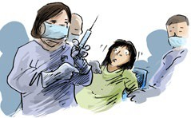

Your right to good health care

When you are in the mental health service you have the right to get good health care.

You can still choose what kind of health care you want to get.

The doctors can only share info about your health

- If you say it is ok

- If it is an emergency

- To keep you safe.

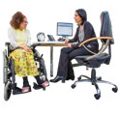You must get the health care and medications you need.

Sometimes a doctor might tell you to take medicine or do a treatment.

A treatment is something that is meant to make you feel better.

Treatment can be taking medication or talking to someone about how you feel.

The doctor must tell you

- Why you need it

- How long you need it.

They must get your consent.

Consent means you say yes to the medication or treatment.

You can have help to make a decision to give consent or not.

You have the right to ask the doctors if you still need the medication or treatment.

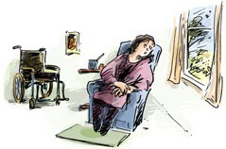

Your right to live in good living areas

When you are in the mental health service the things around you must be ok to live in.

This means you have

- Access to a room and bathroom

- A clean room

- A window

- Air that comes into the room.

You should get time alone in the bathroom or toilet.

You must also always get good food and drinks.

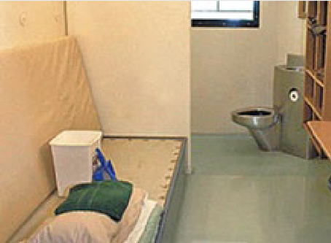If you share a room with other people it should not be crowded.

Your right to be safe

When you are in the mental health service you should not get hurt by anyone.

You must get health care straight away if someone hurts you.

Mental health staff must help you.

They need to make sure it will not happen again.

The mental health staff might use handcuffs or something else to tie your hands together when they

- Ask you questions

- Search you.

Police are allowed to use handcuffs or ties but only for a short time.

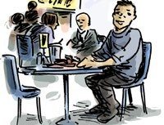

Your right to be heard and supported

When you are in the mental health service you have the right to get the support you need.

This means support to

- Do everyday tasks

- Understand things

- Be heard and make decisions

- Tell people what you want

- Move around.

The mental health staff should ask you what help you need.

The staff should make a disability support plan you can look at.

The staff must make sure things in the support plan get done.

To get more info

If you want help or to get more information about your rights you can speak to advocate or lawyer.

