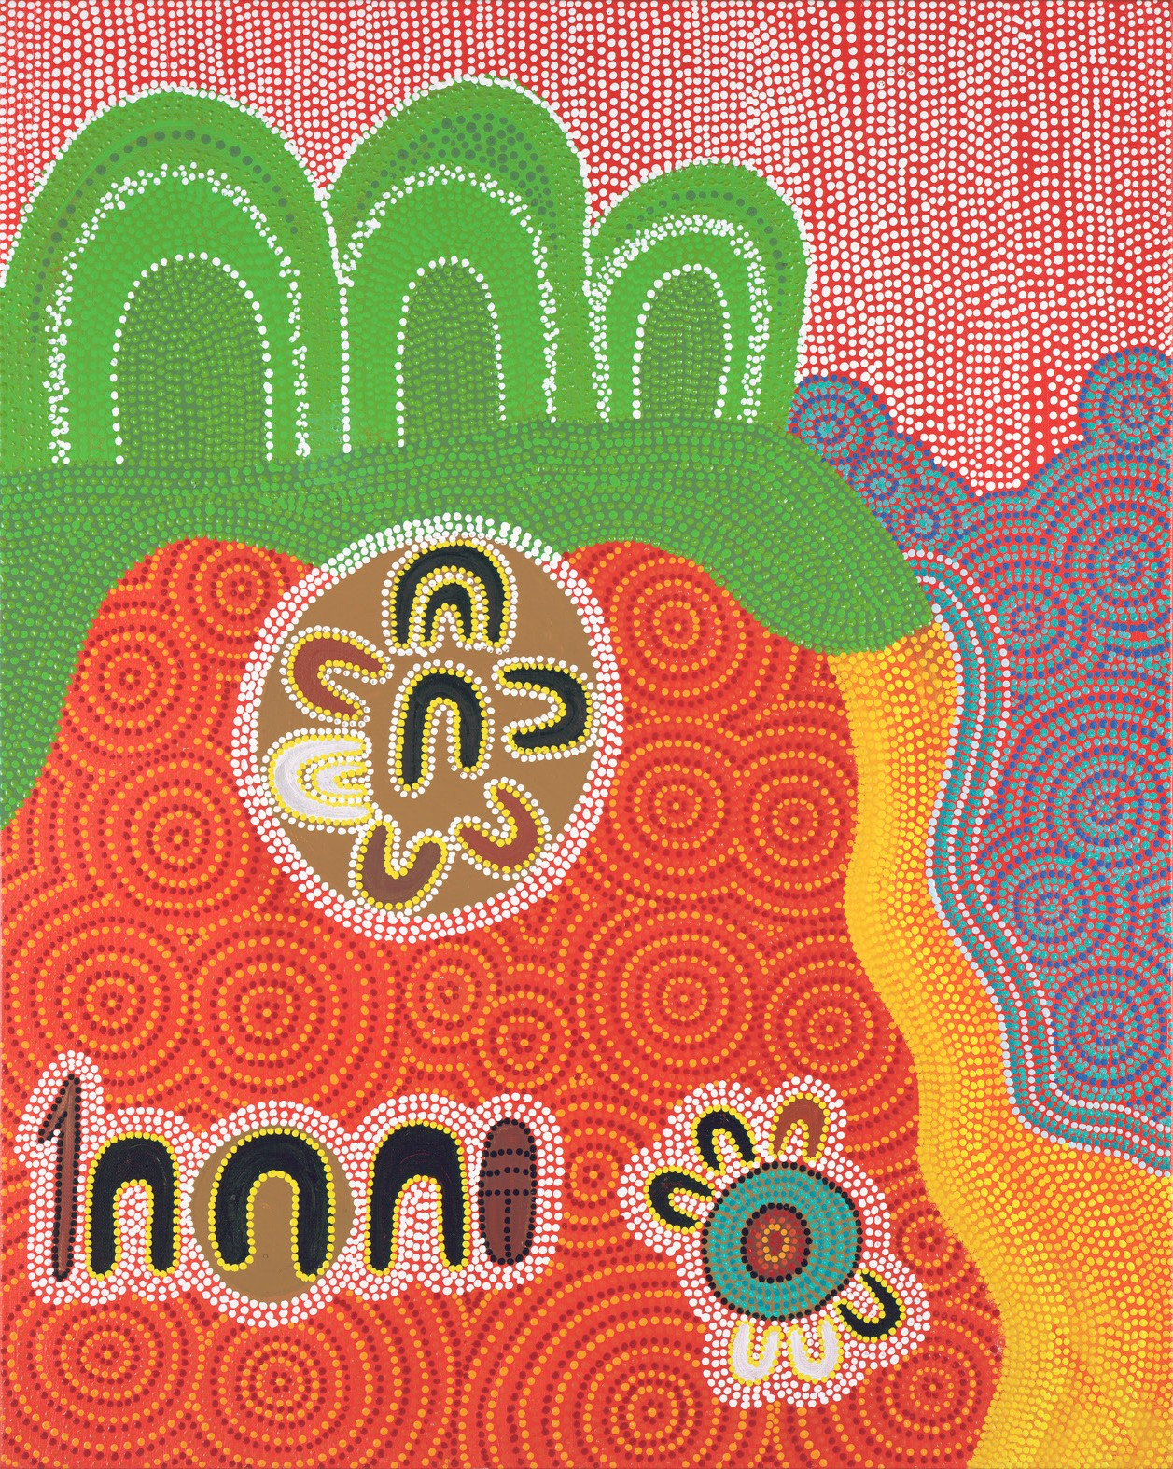

Queensland Advocacy for Inclusion
Reconciliation Action Plan (RAP) for 2022-2026

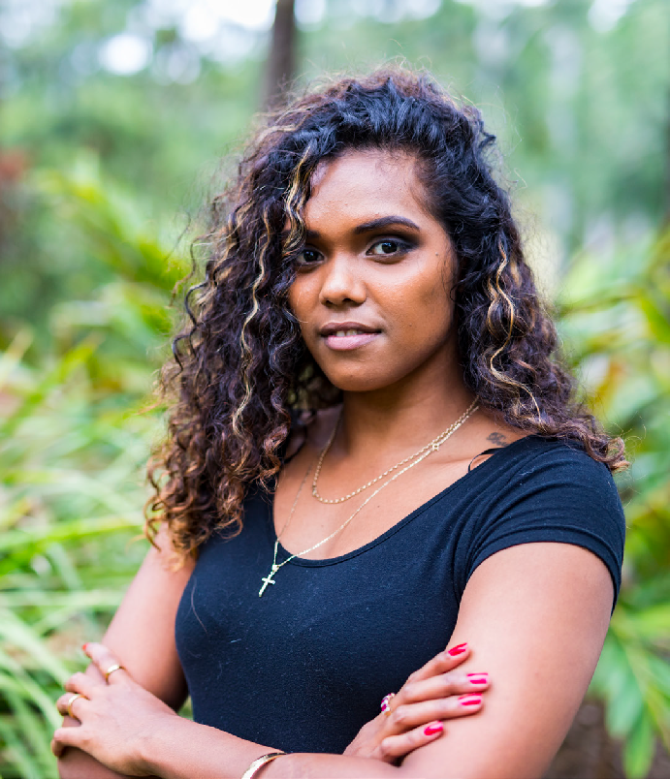
Acknowledgement of Country
Queensland Advocacy for Inclusion (QAI) acknowledges the Turrbul and Jagera peoples, the Traditional Custodians of the land of our head office in Meanjin, and pay respect to Elders past, present and emerging. We recognise the ongoing connection to the land, waters and community of the Traditional Custodians. QAI also acknowledges the Traditional Custodians of the many Nations throughout Queensland, where our work is undertaken.

We recognise, respect and celebrate the strength and wisdom of Australia’s First Peoples. With respect we strive for justice and inclusion for Aboriginal and Torres Strait Islander Peoples.

Queensland Advocacy for Inclusion’s vision for reconciliation
QAI believes that reconciliation is critical to achieving justice for all people with disability. QAI recognises that Aboriginal and Torres Strait Islander cultures are strong and the oldest living cultures on earth. The Aboriginal and Torres Strait Islander culture of inclusion is a powerful antidote to intersectional inequity.
QAI recognises that since colonisation, successive government policies have systematically disadvantaged and marginalised Aboriginal and Torres Strait Islander Peoples, who are disproportionately affected by poverty,
unemployment, chronic illness, disability, mental illness, lower life expectancy and high levels of incarceration. Disability interacts with intergenerational trauma and the ongoing force of colonisation continues to impact on Aboriginal and Torres Strait Islander Peoples with disability, who remain a minority within a minority. QAI is committed to working in a respectful way with Aboriginal and Torres Strait Islander organisations and communities to realise Aboriginal and Torres Strait Islander Peoples’ rights.
QAI affirms the special place and identity of Aboriginal and Torres Strait Islander Peoples as the First Australians by:

- recognising Aboriginal and Torres Strait Islander cultures and history, along with its diverse and dynamic nature.
- acknowledging the deep connections with and custodianship of the land since time immemorial.
- valuing the contributions that Aboriginal and Torres Strait Islander Peoples make to Australian culture and society.
- honouring Aboriginal and Torres Strait Islander Peoples’ resilience and strength.
- valuing the opportunity to learn from Aboriginal and Torres Strait Islander Peoples.
- recognising that in order to influence the policies and practices of government and other decision- makers, there must be multi-layered
action at local, regional, state, national and international levels.
- creating a continuous safe space which values the voice, perspectives and choices of Aboriginal and Torres Strait Islander Peoples and ensures contributions are meaningful.
- recognising the unique understanding of disability within Aboriginal and Torres Strait Islander cultures, including that there is no word to distinguish people with disability in Aboriginal and Torres Strait Islander languages.

2 3

QAI is a Queensland organisation providing independent, community-based systems and individual advocacy for people with disability.

QAI is majority-managed by people with disability and QAI‘s current president is an Aboriginal man. Our QAI Constitution requires Aboriginal and Torres Strait Islander representation on our Management Committee.

QAI’s purpose is to advocate for the protection and advancement of the needs, rights and lives of people with disability
in Queensland. QAI does this by engaging in systems advocacy work, including campaigns directed to attitudinal, law and policy change, submissions to government on legislation and policy, and
by supporting the development of a range of advocacy initiatives. QAI also provides individual advocacy in support of persons whose disability is at the centre of their issue.
QAI works with an Aboriginal and Torres Strait Islander reference group, the members of which provide advice and guidance based on their experience and knowledge of current and emerging realities, directions and needs in Aboriginal and Torres Strait Islander Australia.

Our Objectives are:
- To advocate for the protection and advancement of the needs, rights and lives of people with disability in Queensland;
- To protect and advance human rights including the Convention on the Rights of People with disability;
- To be accountable to the most disadvantaged people with disability in Queensland; and
- To advance the health, social and public wellbeing of disadvantaged people with disabilities.

Key themes of this RAP are:
- Relationships
- Respect
- Accountability

Relationships
Building strong relationships between Aboriginal and Torres Strait Islander Peoples and non-Indigenous Australians is important to QAI and its core business.

QAI’s Reconciliation Working Group (RWG) works collaboratively to:
- oversee the development, endorsement and promotion of the RAP;
- ensure Aboriginal and Torres Strait Islander Peoples are represented on the RWG;
- monitor and report on RAP implementation;
- establish its own policies.
QAI celebrates and participates in National Reconciliation Week by providing opportunities to build and maintain relationships between Aboriginal and Torres Strait Islander Peoples and non-
Indigenous Australians. Developing
and maintaining mutually beneficial relationships with Aboriginal and Torres Strait Islander Peoples, communities and organisations to support positive outcomes is important to QAI.
QAI is committed to raising internal and external awareness of our RAP with a view to promoting reconciliation across the sector.

Working collaboratively and inclusively with other people and with community and supporting Indigenous controlled organisations is important to QAI.

QAI supports the UN Declaration on the Rights of Indigenous Peoples.
QAI is committed to systemic advocacy on intersectional issues impacting Aboriginal and Torres Strait Islander People with disability.

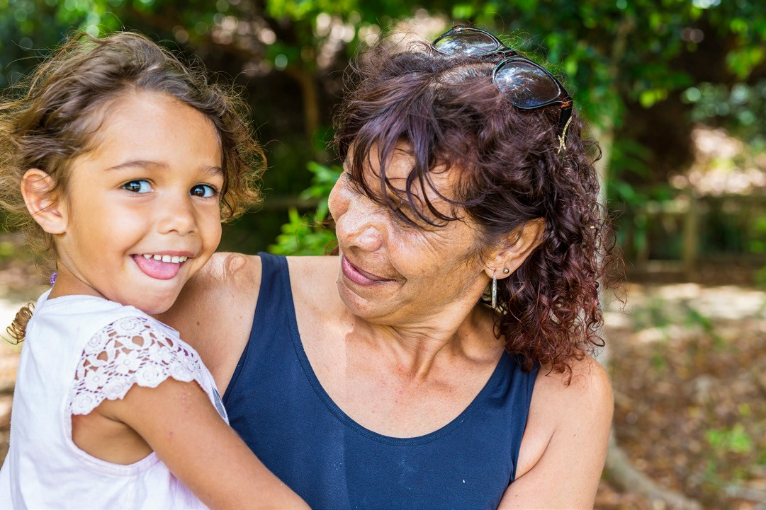

4 5

Respect
Respect for Aboriginal and Torres Strait Islander Peoples, cultures, lands, waters, histories and rights is fundamental to QAI and its core activities, including embedding pride in cultures and histories, understanding, appreciation, acknowledgment, learning, success
and celebration. QAI acknowledges the importance of respect in acknowledging the unique role and impact that Aboriginal and Torres Strait Islander Peoples have had in Australia’s history and in building
a future for Australia that is founded on respect.

QAI is committed to ensuring that we are a culturally safe and inclusive organisation for Aboriginal and Torres Strait Islander Peoples, including current and prospective staff, members and the people we work with and for.
To this end, QAI will:

- engage employees in cultural learning opportunities to increase understanding and appreciation of Aboriginal and Torres Strait Islander cultures, histories and achievements;
- engage employees in understanding the significance of Aboriginal and Torres Strait Islander cultural protocols, such as Welcome to Country and Acknowledgement of Country, to ensure there is a shared meaning;
- provide opportunities for Aboriginal
and Torres Strait Islander staff
to engage with their culture and communities by celebrating NAIDOC Week and other important events;
- investigate opportunities to improve and increase Aboriginal and Torres Strait Islander employment outcomes within our workplace;
- include other unique actions related to our core business and vision for reconciliation, including developing a cultural mentoring network and supporting Aboriginal and Torres Strait Islander leadership within our organisation.
- identify and support opportunities and actions related to our core business and vision for reconciliation, including recognising and celebrating Aboriginal and Torres Strait Islander dates of significance and supporting Aboriginal and Torres Strait Islander leadership within our sector.

Accountability
QAI is committed to accountability and transparency in working towards realising the rights of Aboriginal and Torres
Strait Islander Peoples and increasing the cultural safety of our organisation, including through the RAP.
To this end, QAI will:

- report RAP achievements, challenges and learnings internally and externally;
- review, refresh and update the RAP, drawing on learnings, challenges, achievements and formal feedback from Reconciliation Australia and other key stakeholders.

Artist Acknowledgement
We acknowledge with respect and gratitude, artist Uncle Paul Calcott for the artwork used here, which was commissioned by QAI in 2021.

We acknowledge Aboriginal and Torres Strait Islanders as the traditional owners and custodians, and primary guardians of their cultural heritage. Uncle Paul’s
interpretation of this artwork can be found in video format on QAI’s YouTube Channel. The original artwork is located in the QAI office in Meanjin (South Brisbane) on Turrbul and Jagera country.

Contact details
Name: Byron Albury Position: President Email: qai@qai.org.au
Name: Matilda Alexander
Position: CEO Phone: 07 3844 4200
Email: qai@qai.org.au

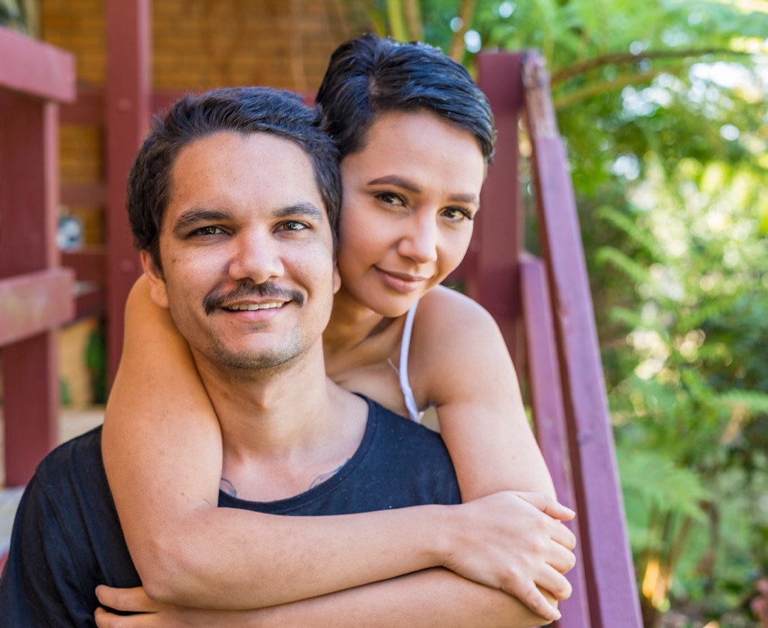

6 7

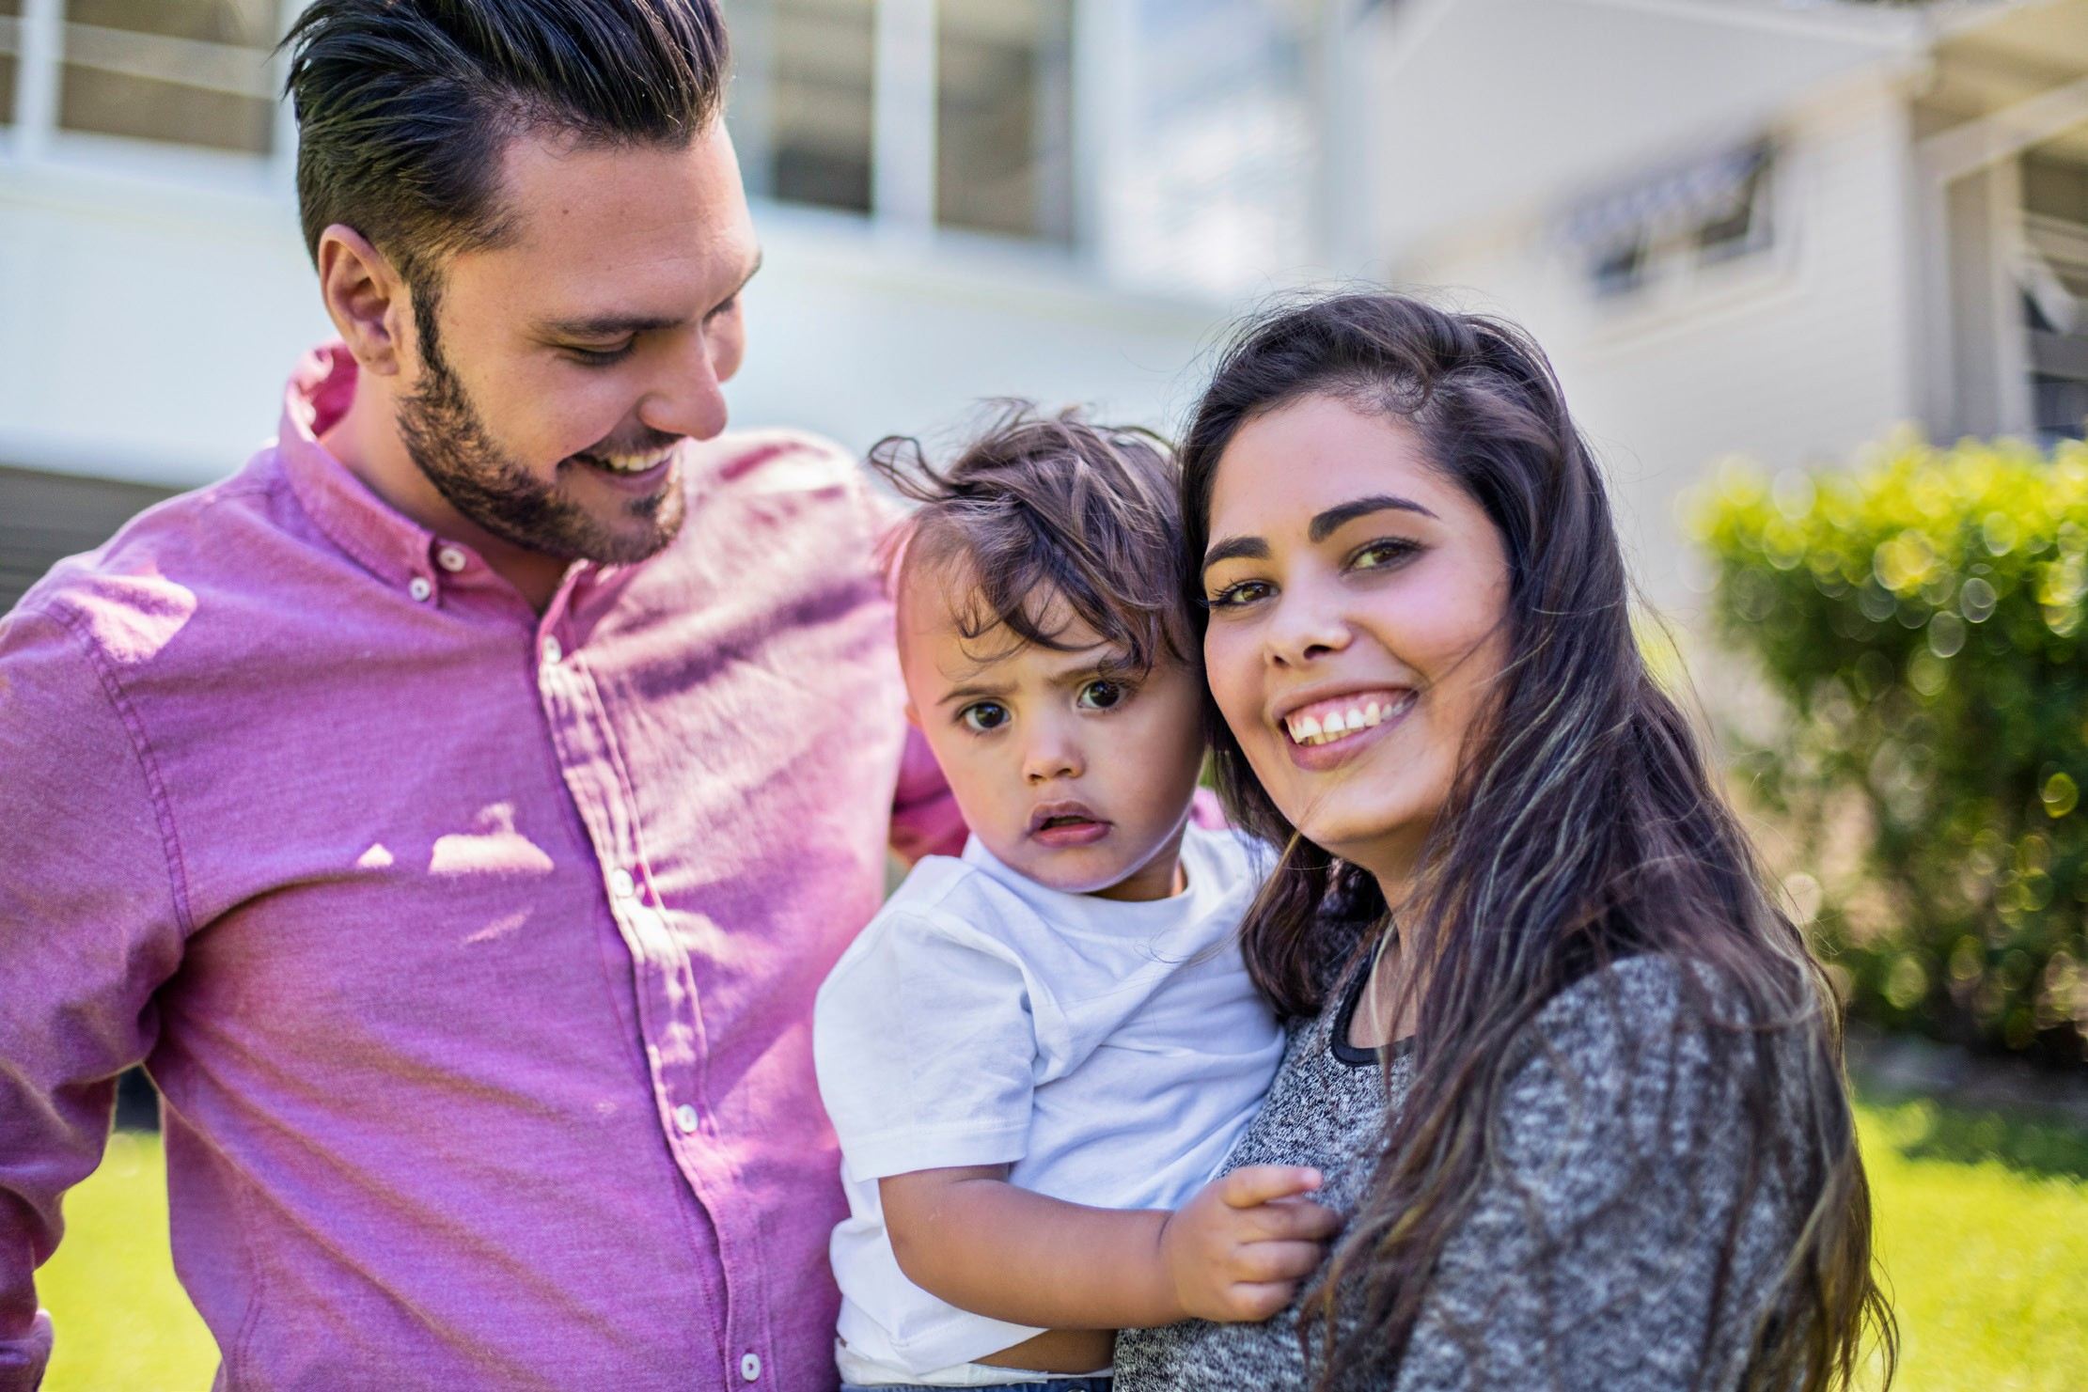

www.qai.org.au

