Don’t agree with your NDIS Internal Review decision?
What are the next steps?

Lodge appeal
1

If you would like to appeal the decision, you need to apply to the Administrative Appeals Tribunal. The application to the Tribunal must be done within 28 days of the internal review decision.

To appeal to the Tribunal, you must complete the online application and include a copy of the internal review decision letter with your application.

The application can be found at: https://online.aat.gov.au/Home/InstructionsGd

Once you have lodged with the Tribunal, you should immediately receive a confirmation email (if you don’t, check your junk, check the address, ring the Tribunal).

The Tribunal’s phone number is: 1800 228 333

2 Receive details
Sometime after, and not necessarily at the same time but in this order, you should receive:

an email confirming your case number
One
(always quote this number when dealing with the Tribunal)

a bundle of documents called ‘T-Documents’
Two
(Tribunal documents)

a date for a case conference
Three
(a case conference is a meeting with you, a Tribunal registrar and the NDIA, it is usually by phone and takes about an hour)

We are finding that it can take quite a few weeks for you to receive all the above. If you haven’t heard anything from the Tribunal after
3 or 4 weeks, give them a call to find out how long it will take to get the T-Documents and a date for the first case conference. Once you have the
T-Documents, call QAI to make an advice appointment.

Case conference
3

Usually just before the first case conference the NDIA will send you a Statement of Issues which sets out the NDIA position. The case conference is facilitated by a person from the Tribunal called the registrar. At the case conference there is a discussion about the issues, timetable and the evidence the NDIA is seeking. This is just the first stage and you will likely have more than one case conference.

You can find further information about our service and how we can help on our NDIS Appeals Support webpage.

Contact us

Queensland Advocacy for Inclusion (QAI)
Areas: All Queensland
Phone: 1300 130 582 or 07 3844 4200
Email: qai@qai.org.au
Website: www.qai.org.au

Other organisations
If we do not have the capacity to assist you in the timeframe you require, here is a list of other organisations who are also funded to provide assistance with external NDIS appeals at the Tribunal, and may be able to assist depending on their own capacity.

Legal Aid Queensland (LAQ)
Areas: All Queensland
Phone: 1300 65 11 88
Website: www.legalaid.qld.gov.au

Legal Aid have an NDIS reviews unit that provides advice to people who have received an internal review decision but have not yet lodged an external application with the AAT. Their advice clinic runs on Wednesdays and bookings can be made by calling them.

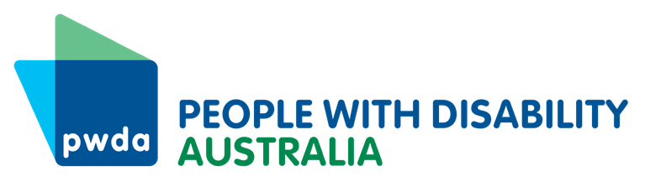
People With Disability Australia (PWDA)
Areas: All Queensland
Phone: 1800 422 015
Email: pwd@pwd.org.au
Website: www.pwd.org.au

Speaking Up For You (SUFY)
Areas: Brisbane, Redlands, Moreton Bay
Phone: 07 3255 1244
Email: sufy@sufy.org.au
Website: www.sufy.org.au

Rights in Action (RIA)
Areas: flyer with service areas
Phone: 07 4031 7377
Email: info@rightsinaction.org
Website: www.rightsinaction.org

Independent Advocacy North Queensland (IANQ)
Areas: list of service areas
Phone: 1800 887 688
Email: intake@ianq.org.au
Website: www.independentadvocacy.org.au

