Queensland Advocacy for Inclusion

Advocacy for people with disability

Analysis of NDIS Appeals Queensland Advocacy for Inclusion

Prepared for Department of Seniors, Disability Services and Aboriginal and Torres Strait Islander Partnerships

30 June 2022

Contents
About Queensland Advocacy for Inclusion 3
Background to this Report 3
Key Findings 5
Overview of the NDIS review process 5
Audit and analysis of published information 6
Internal review decisions 7
Internal review process 9
Number of applications made to AAT 10
Analysis of AAT Outcomes and Decisions 12
AAT Outcomes as reported by NDIA and AAT 12
Analysis of reported decisions 15
Representation of Applicants at the AAT 16
Timeframes at the AAT 17
Next steps 19

About Queensland Advocacy for Inclusion
Queensland Advocacy for Inclusion (QAI) (formerly Queensland Advocacy Incorporated) is an independent, community-based advocacy organisation and community legal service that provides individual and systems advocacy for people with disability. Our mission is to advocate for the protection and advancement of the fundamental needs, rights and lives of people with disability in Queensland. QAI’s Management Committee is comprised of a majority of persons with disability, whose wisdom and lived experience is our foundation and guide.
QAI has been engaged in systems advocacy for over thirty years, advocating for change through campaigns directed at attitudinal, law and policy reform. QAI has also supported the development of a range of advocacy initiatives in this state. For over a decade, QAI has provided highly in-demand individual advocacy services. These services are currently provided through our four advocacy practices: the Human Rights Advocacy Practice (which provides legal advocacy in the areas of guardianship and administration, disability discrimination and human rights law and non-legal advocacy support with the Disability Royal Commission and the justice interface); the Mental Health Advocacy Practice (which supports people receiving involuntary treatment for mental illness); the NDIS Advocacy Practice (which provides support for people challenging decisions of the National Disability Insurance Agency and decision support to access the NDIS); and the Disability Advocacy Practice (which operates the Pathways information and referral line, and provides non-legal advocacy support with Education and other systems that impact young people with disability).

From 1 January 2022, we have been funded by the Queensland Government to establish and co-ordinate the Queensland Independent Disability Advocacy Network (QIDAN), which includes operating the Disability Advocacy Pathways Hotline, a centralized phone support for all people with disability in Queensland providing information and referral. We have also been funded to provide advocacy for young people with disability as part of the QIDAN network, which we provide in addition to our non-legal education advocacy for Queensland students with disability. Our individual advocacy experience informs our understanding and prioritisation of systemic advocacy issues.

The objects of QAI’s constitution are:
- To advocate for the protection and advancement of the needs, rights and lives of people with disability in Queensland,
- To protect and advance human rights including the Convention on the Rights of Persons with Disabilities (CRPD),
- To be accountable to the most disadvantaged people with disability in Queensland, and
- To advance the health, social and public wellbeing of disadvantaged people with disability.

Background to this Report

The historic re-modelling of disability service provision created by the National Disability Insurance Scheme (NDIS) has changed the lives of many Australians with disability and has impacted mainstream service delivery in almost every sector. The task of implementing a nationwide scheme to replace services previously delivered by states and territories was always going to present considerable challenges. The introduction of an individualised model of disability service provision resulted from lengthy and arduous systemic advocacy regarding the inadequacies of the previous model, many of which were highlighted in the ‘Shut Out: The Experience of People with Disabilities and their Families in Australia’ report.

As of 31 March 2022, there were 518,668 active participants in the NDIS; an increase of 52,049 from the previous financial year.¹ The yearly percentage increase in active participants peaked in 2017-18 at 92%, with the actual number of active participants joining the scheme peaking in 2018-19 at 113,682 additional participants. Despite the peak of scheme growth having passed, the NDIA continues to report that “the rate of new entrants to the Scheme continues to be very high,”² while “the rate at which participants exit the Scheme…is also lower than expected”.³

Since 2017, QAI has provided services to people appealing a decision of the National Disability Insurance Agency (NDIA) both at the internal review and external review stage. Our team is lead jointly by two Principal Solicitors supporting three NDIS appeals advocates. Since the service commenced, our frontline experience is that of a significant increase in the number of people appealing a decision of the NDIA over time.

QAI is concerned about the increase in appeals to the Administrative Appeals Tribunal (AAT). The AAT process itself tends to be legalistic and formal and has the potential to reduce a person with disability’s choice and control, which is a key legislative object of the National Disability Insurance Scheme Act 2013 (Cth) (NDIS Act). QAI has been unable to meet the increased demand for individual advocacy services and the experience of our colleagues throughout the country is similar.

At its core, the NDIS is about improving the lives of Australians with disability, and this must remain at the forefront of policy reform in this area.
QAI has been commissioned by Department of Seniors, Disability Services and Aboriginal and Torres Strait Islander Partnerships (DSDATSIP) to undertake an analysis of NDIS plan reviews to identify trends and potential lessons for advocacy practitioners. This information will allow QAI to create and publish tools, links, and information resources to improve advocacy services and build the capacity of advocacy organisations to effectively assist Queenslanders with disability, their families and carers to access the supports the National Disability Insurance Scheme is designed to provide.

Despite the Joint Standing Committee on the National Disability Insurance Scheme recommending the NDIA develop and publish de-identified summaries of settlement outcomes in the AAT in their ‘NDIS Planning Final Report’ in December 2020, no such information has become available.

Instead, QAI has conducted a desktop audit of published AAT decisions (cases which have resolved via final hearing) for the period 1 January 2019 to 31 December 2021, and accessed other sources of information (eg. AAT annual reports and NDIS Quarterly reports) which provide further insight into the outcomes of NDIS plan reviews.

QAI has also accessed data from the AAT (via e-case database searches and direct request to the AAT) to gain some understanding of the overall status of AAT matters (including the large majority of cases which resolve without a final hearing).

This report represents the first deliverable of the project commissioned by DSDATSIP. It will be used to assist with the further deliverables which include the development of appropriate tools and other supporting material (e.g., fact sheets, decision trees, guidelines) to improve NDIS appeal advocacy services.

¹ ‘NDIS Quarterly Report to Disability Ministers’ (Q3 2021-22) 31 March 2022, p 13, https://www.ndis.gov.au/media/4466/download?attachment.
² ‘National Disability Insurance Scheme: Annual Financial Sustainability Report 2020-21’, p 6,
https://www.ndis.gov.au/media/3579/download?attachment.
³ Ibid, p 8.

Key Findings

From this work, QAI has identified the following key trends:

- The increase in applications to the AAT (for external review of a NDIA decision) is not matched by a commensurate increase in applications for internal review. This demonstrates that the key driving factor in the increasing number of people applying to the AAT appears to be a consequence of a change in approach by the NDIA at the internal review stage.
- There has been an increase in the percentage of internal review outcomes in which the reviewer has affirmed the original decision. The timeframe for this trend correlates with the introduction of the Participant Service Guarantee in which internal reviews must be completed with 60 days.
- Only 1% of matters result in a hearing with a published decision. This means a large majority of decision- making and outcomes at the AAT are opaque and shrouded in secrecy.
- The AAT reports that between 1 July 2021 and 31 May 2022, the ‘outcome’ of 35% of AAT applications was ‘other’ meaning they were either withdrawn by the applicant or dismissed by the AAT. This is significant and further analysis as to the reason for withdrawal is required.
- The AAT data indicates that in 2021, 63% of NDIS appeals matters were resolved by consent. QAI’s experience in acting for participants at the AAT in relation to a review of supports is that almost 100% of those cases result in a participant receiving additional supports.
- For the period 1 January 2019 – 31 December 2021 where a decision was made at the AAT in relation to the provision of supports, the AAT set aside or varied the original decision of the NDIA in 76% of decisions.
- For the period 1 January 2019 – 31 December 2021 where a matter went to hearing, 35% of applicants had no legal or advocacy representation at the hearing and either represented themselves or had a family member or friend assist.
- The AAT Reports that in the 2021 calendar year, only 13% of applicants had legal representation whilst a further 39% had an ‘advocate or agent’. The NDIA is always represented by a lawyer (who is either employed by the NDIA, the Australian Government Solicitors or an external law firm).

See analysis below for more detail about these key trends and next steps.

Overview of the NDIS review process
Under the NDIS Act, a participant in the NDIS has a right to request a review of certain decisions of the CEO.⁴ A reviewable decision must first be reviewed internally within the NDIA by a ‘reviewer’ who was not involved in the making of the decision under review.⁵ Once the reviewer completes the review, if a participant is not satisfied with the decision made at the internal review stage, an application for review can be made to the AAT.

The decisions most reviewed by participants at the internal review stage and then at the AAT are:

  - A decision to approve a statement of participant supports in a participants’ plan (commonly referred to as a plan review), and
  - A decision that a person does not meet the access criteria for the NDIS.

A request for an internal review must be made by a participant within 3 months of the date they receive the decision. The participant service guarantee for the NDIA to complete an internal review is set out in the NDIS Participant Service Charter and was, until September 2021, 90 days from the date the person makes a request

⁴ Section 99 of the National Disability Insurance Scheme Act 2013 (Cth) (NDIS Act) sets out the decisions of the CEO which can be reviewed.
⁵ Section 100(5) of the NDIS Act.

for review. In September 2021, this was reduced to 60 days. The NDIS Quarterly Report for the March 2022 quarter noted that while the NDIA met the 90-day time frame 94% of the time, it met the 60-day time frame in 87% of cases.

Following the receipt of the internal review decision, a person may then apply for review to the AAT. This must be done within 28 days of receipt of the internal review decision.

The above review mechanisms must be distinguished from ‘unscheduled’ or ‘change of circumstances’ reviews under section 48, within Chapter 3 of the NDIS Act. This section allows a participant to request a review of their plan at any time (beyond the three-month internal review period). It is the only mechanism after the 3-month review period to request a new plan during a current plan period.

The provision also permits the CEO of the NDIA to undertake such a review on their own initiative.⁶ On 1 July 2022, changes to this review mechanism will come into effect. It is hoped that these legislative changes will resolve some jurisdictional difficulties faced by applicants in the AAT, including for example, when a request for an internal review has been mischaracterised by the NDIA as a change of circumstances review, from which, limited external review rights flow.⁷

QAI has not accessed or analysed data concerning reviews undertaken by the NDIA under section 48 of the NDIS Act as they are beyond the scope of this project. However, QAI considers that further investigation through a freedom of information request might provide useful insight into the use of this tool by the NDIA over the past 18 months, particularly within 3 months of a new plan being issued.

Audit and analysis of published information
There is a substantial amount of information regarding the numbers of external reviews of NDIA decisions publicly available. However, differences in what information the AAT and NDIA report over time unfortunately limits our ability to reliably identify trends. Further, the AAT and the NDIA sometimes report different figures for the same period, including different figures from what their own previous reports stated. Accordingly, while we have referenced the source of data used in this report, there may be some inconsistency in figures.

In preparing this report QAI has:

  - Accessed the reported decisions by the AAT on the following publicly available websites: Austlii and Jade.
  - Reviewed NDIS Quarterly Reports to Disability Ministers from March 2019 – March 2022.
  - Reviewed AAT Annual Reports, AAT Caseload Reports, and AAT At a Glance Reports from June 2019 –
May 2022.
  - Accessed the AAT eCase Search database and made a specific request for further information directly to the AAT.
  - Carried out an analysis of the number and type of decisions made by the AAT, for matters that went to a hearing for the period 1 January 2019 – 31 December 2021.

⁶ Section 48(4) of the NDIS Act.
⁷ The client’s right to review by the AAT would be limited to reviewing the decision by the NDIA not to conduct a review
under s48(2) rather than the NDIA decision to approve the statement of supports.

Internal review decisions

To analyse NDIS appeals trends at the AAT it is useful to first consider the trends at the internal review stage, given that all decisions must undergo internal review before proceeding to the AAT. Internal review decisions under s 100 of the NDIS Act are difficult to track over time due to changes in the extent to which they are reported by the NDIA. No data has been reported for the period prior to 1 July 2019, following the NDIA’s implementation of a new off-system reporting database earlier that year.⁸

The number of internal review applications reported by the NDIA were only differentiated between decisions relating to access and decisions relating to supports from 1 April 2020.

From 1 April 2020 until the end of the last reported quarter (March 2022):

  - access decisions accounted for an average of 15% of internal reviews,
  - supports were the issue in an average of 85% of internal reviews.

At the last reported date, 12% of internal review applications concerned access decisions and 88% concerned supports decisions.⁹ Across the 1 April 2020 – 31 March 2021 period, the average number of days taken to complete an internal review of an access decision was 22 days, while the average time to complete an internal review of a planning decision was 49 days.¹⁰

Table 1 and illustration 1 below indicate the numbers and outcomes for internal reviews, across six consecutive quarters:

Internal review | Dec Q 20 | Mar Q 21 | June Q 21 | Sep Q 21 | Dec Q 21 | Mar Q 22
Requests for Internal Review11 | 10,045 | 10,730 | 11,948 | 13,177 | 12,138 | 10,955
Completed Internal Review12 | 8,349 | 10,383  ↑2,034* | 10,624  ↑241 | 14,436  ↑3,812 | 14,286  ↓150 | 12,351  ↓1,935
Outcome Internal Review Decision Not Changed13 | 1440 | 2189 | 3146 | 6211 | 8234 | 7610
Outcome Internal Review Decision Changed (varied/set aside/overturned)14 | 4440 | 5012 | 3936 | 4188 | 3320 | 1971
Outcome - Other15 | 11 | 8 | 8 | 16 | 17 | 12
Reviews completed but no outcome  reported | -2,458 | -3,174 | -3,534 | -4021 | -2,715 | -2758
Closed within 90 days16 | 98% | 92% | 95% | 96% | 96% | 94%
*Indicates change from previous quarter

⁸ ‘NDIS Quarterly Report to Disability Ministers’ (Q2 2019-20) 31 December 2019, p 126, https://www.ndis.gov.au/media/2128/download?attachment.
9 ‘NDIS Quarterly Report to Disability Ministers’ (Q3 2020-21) 31 March 2021, p 141, https://www.ndis.gov.au/media/3068/download?attachment.
10 Data extrapolated from in the NDIS Quarterly Report to Disability Ministers from 2019-20 Q4 (June 2019), 2020-21 Q1 (September 2020), 2020-21 Q2 (December 2020), 2020-21 Q3 (March 2021).
11 ‘NDIS Quarterly Report to Disability Ministers’ (Q3 2021-22) 31 March 2022, p 67, https://www.ndis.gov.au/media/4466/download?attachment.
12 Ibid, p 63.
13 Ibid, p 67.
14 Ibid, p 67.
15 Ibid, p 67.
16 Ibid, p 63.

Illustration 1
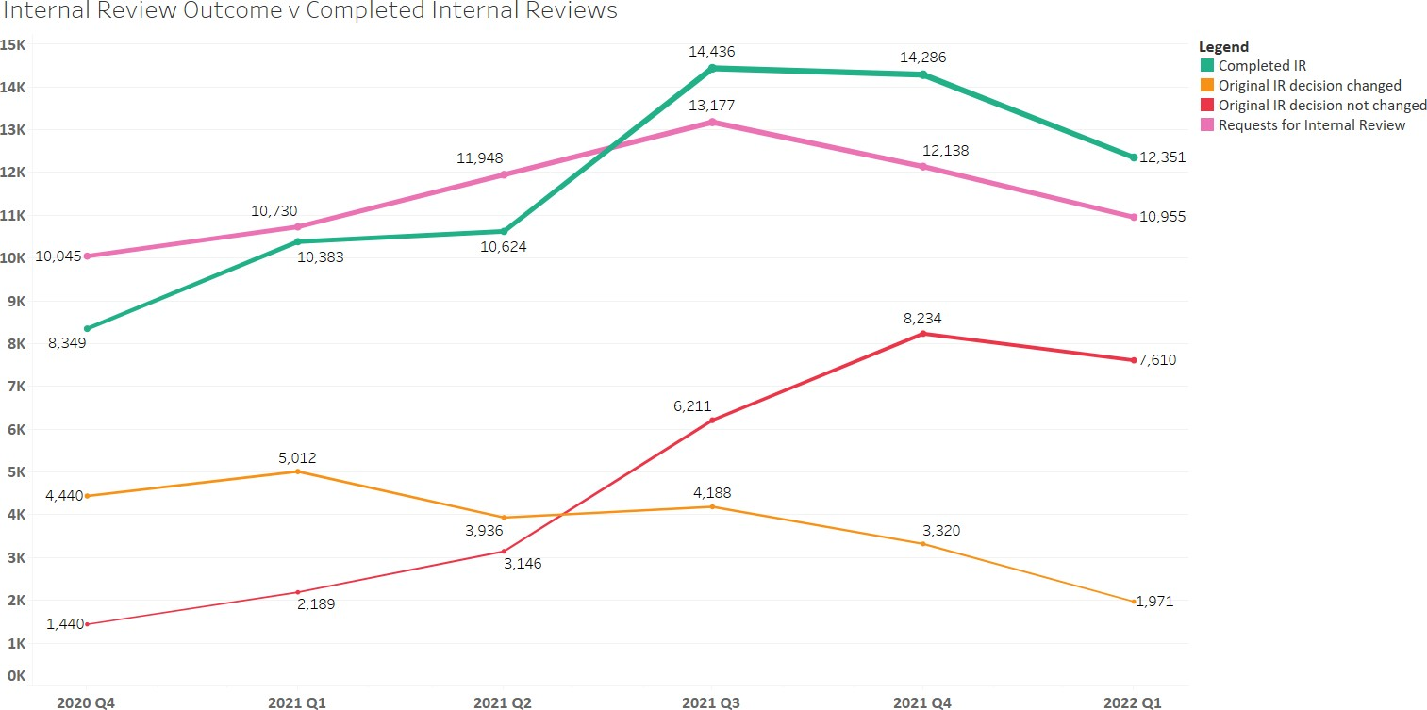

Notably, the number of requests for internal review remained relatively steady across all quarters. The biggest single increase in requests was in the September quarter with an approximately 9% increase on the previous quarter. This coincides with a significant increase in the number of reviews completed and in fact it is in this quarter that the number of reviews completed is higher than the number of requests made.
The change in number of internal review outcomes completed in the September quarter correlates with the timing of the change to the participant service guarantee to complete internal reviews (reduced from 90 days to 60 days), as depicted in the first bar graph below.
The graphs below are taken from the NDIS Quarterly Report to the Disability Minister. The focus in these reports is the time taken to make decisions rather than consideration of the outcomes at internal review.

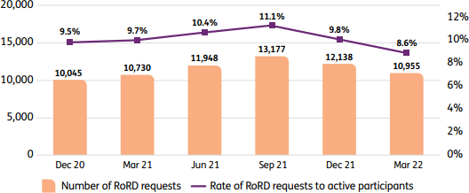
‘Request for a RoRD – quarterly trend’, from ‘NDIS Quarterly Report to Disability Ministers’ (Q3 2021-22) 31 March 2022, p 67.
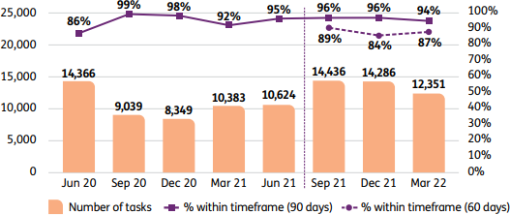
‘Complete RoRD after request is received’, from ‘NDIS Quarterly Report to Disability Ministers’ (Q3 2021-22) 31 March 2022, p 63.

Table 2 and illustration 2 below show the percentage change in outcomes for internal reviews, across six consecutive quarters using the numbers in Table 1.

Internal review | Dec Q 20 | Mar Q 21 | June Q 21 | Sep Q 21 | Dec Q 21 | Mar Q 22
Percentage affirmed against completed reviews in Quarter | 17.25% | 21.08% | 29.61% | 43.02% | 57.64% | 61.61%
Percentage varied / set aside / overturned against completed reviews in  the Quarter | 53.18% | 48.27% | 37.05% | 29.01% | 23.24% | 15.96%
Percentage with “other” outcome | 0.13% | 0.08% | 0.08% | 0.11% | 0.12% | 0.10%
Percentage of internal reviews reported  as “complete” but no outcome reported | 29.44% | 30.57% | 33.26% | 27.85% | 19.00% | 22.33%

Illustration 2
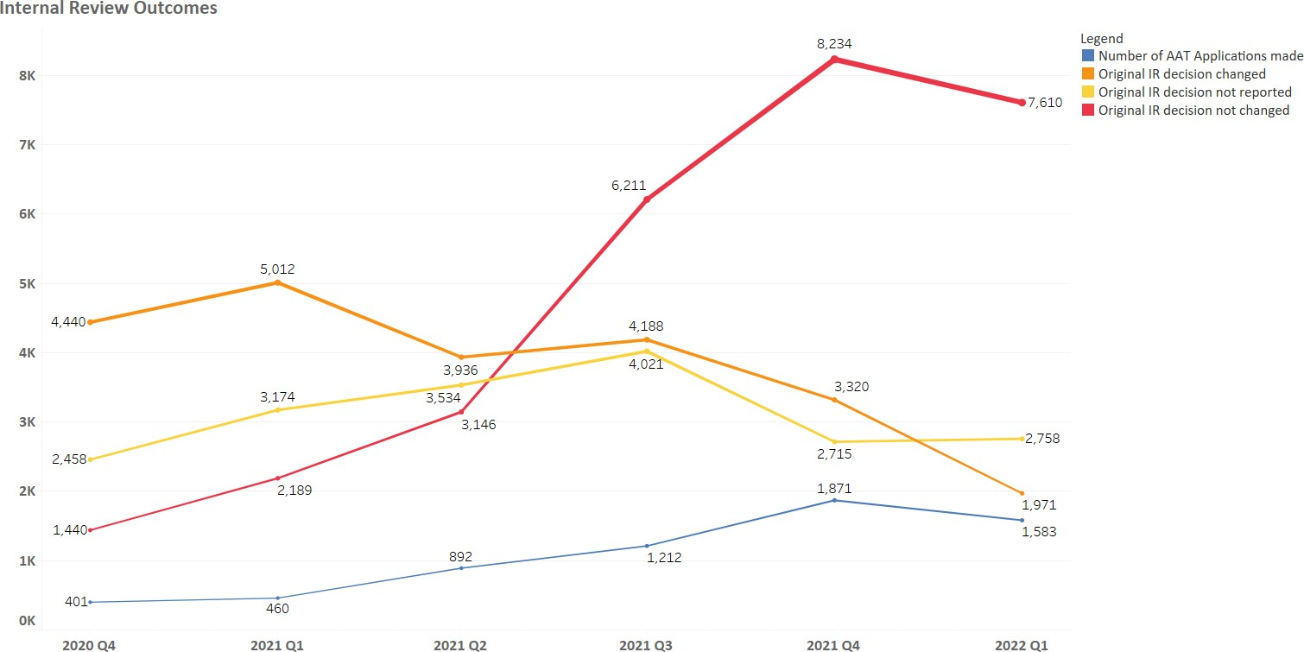
The outcomes show a marked change, with the percentage of decisions affirmed by the internal reviewer increasing and the percentage of decisions varied or set aside by the internal reviewer decreasing, from the June 2021 quarter onwards. The raw numbers (in table one) also indicate that the number reported as affirmed, set aside and other do not add up. These are noted in both tables 1 and 2 as ‘no outcome reported’.

Internal review process
The data above confirms our on the ground experience working with our clients. In addition to the marked change in the outcome of an internal review, the process and the quality of the reasons given in an internal review is a source of concern to us. In our view a better process and better reasons for decisions could result in better outcomes for participants, at an earlier stage in the review process.

In our advice service we speak with approximately 5 clients per week who have received an unfavourable internal review decision. The internal review decisions seen in our service (usually when a participant is at the AAT) commonly:

- fail to clearly articulate what supports the participant was seeking and what supports were already funded,
- mischaracterise or fail to consider requested supports,
- fail to provide adequate reasons for a decision (e.g. a decision will state a support cannot be funded because it is a duplication of supports but no detail is given as to what funded support the NDIA considers is a duplication of the support being requested). Reasons are rarely obvious, and advocates and participants are left guessing, and
- fail to consider all evidence provided by the participant.

Participants at the AAT often report to us that no one from the NDIA contacted them to speak about their internal review request, or if someone did contact them, they did not feel heard. Intrastate and interstate advocacy colleagues have shared similar concerns in a submission to the Joint Standing Committee for the NDIS.¹⁷

Number of applications made to AAT
The proportion of NDIS cases as a portion of the AAT’s cases has risen sharply in the past two years, despite the growth in participant numbers showing no such acceleration. This is demonstrated by the following illustration of new AAT cases over time’ from NDIS Quarterly Report to Disability Ministers (Q3 2021-22) 31 March 2022, p 68:

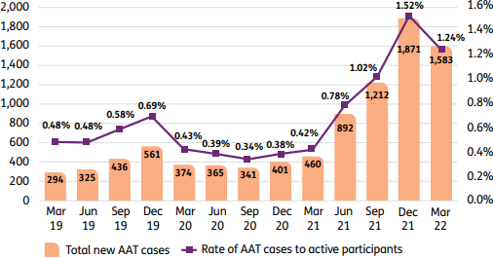

¹⁷ Submission to the Joint Standing Committee on the NDIS - General issues around the implementation and performance of the NDIS. Unreasonable and unnecessary harms: Joint submission regarding the NDIS internal review and external appeals processes, August 2021, Pg 39.

Within the AAT jurisdiction, NDIS matters accounted for just 1.99% (1,206 lodgements) of the AAT’s caseload in the 2018-19 financial year,¹⁸ growing to 5.76% (2,160 lodgements) in 2020-21¹⁹ before spiking to 13.66%
(5,546 lodgements) in the 1 July 2021 – 31 May 2022 period.²⁰

This rapid increase in applications to the AAT for review of NDIA decisions commenced in the 1 April 2021 – 30 June 2021 quarter, where total applications in the quarter grew from 470 in the previous quarter (0.33% of NDIS participants)²¹ to 907 (0.62% of NDIS participants).²² This growth continued through 2021, peaking at 1,910 applications (1.55% of NDIS participants) in the 1 October 2021 – 31 December 2021 quarter,²³ before
reducing slightly in the 1 January 2022 – 31 March 2022 quarter with 1,583 applications (1.24% of NDIS participants).²⁴ Table 3 and the illustration below correlates the number of internal review decisions which were affirmed v the number of AAT applications made in a Quarter:

 | Dec Q 20 | Mar Q 21 | June Q 21 | Sep Q 21 | Dec Q 21 | Mar Q 22
Number of AAT Applications made in the  Qtr.25 | 401 | 460 | 892 | 1,212 | 1,871 | 1,583
Internal Review Outcome – Affirmed (no change made to the original decision)26 | 1440 | 2189 | 3146 | 6211 | 8234 | 7610

Illustration 3
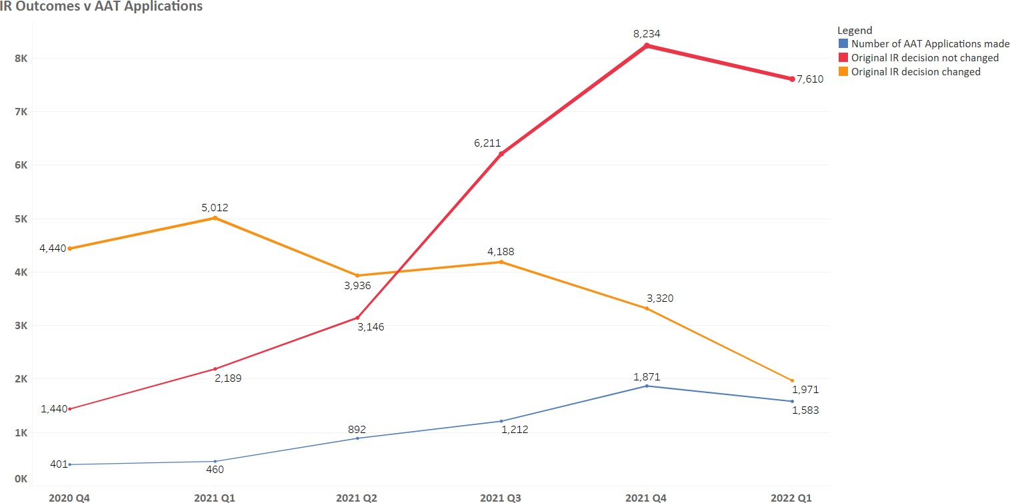

18 ‘AAT Caseload Report: For the period 1 July 2018 to 30 June 2019’, https://www.aat.gov.au/AAT/media/AAT/Files/Statistics/AAT- Whole-of-Tribunal-Statistics-2018-19.pdf.
19 ‘AAT Caseload Report: For the period 1 July 2020 to 30 June 2021’, https://www.aat.gov.au/AAT/media/AAT/Files/Statistics/AAT- Whole-of-Tribunal-Statistics-2020-21.pdf
20 ‘AAT Caseload Report: For the period 1 July 2021 to 31 May 2022’, https://www.aat.gov.au/AAT/media/AAT/Files/Statistics/AAT- Whole-of-Tribunal-Statistics-2021-22.pdf.
21 ‘NDIS Quarterly Report to Disability Ministers’ (Q3 2020-21) 31 March 2021, p 142, https://www.ndis.gov.au/media/3068/download?attachment.
22 ‘NDIS Quarterly Report to Disability Ministers’ (Q4 2020-21) 30 June 2021, p 158, https://www.ndis.gov.au/media/3474/download?attachment.
23 ‘NDIS Quarterly Report to Disability Ministers’ (Q2 2021-22) 31 December 2021, p 61, https://www.ndis.gov.au/media/4063/download?attachment.
24 ‘NDIS Quarterly Report to Disability Ministers’ (Q3 2021-22) 31 March 2022, p 67, https://www.ndis.gov.au/media/4466/download?attachment.
25 Ibid, p 68.
26 Ibid, p 67.

While the NDIA reported that AAT lodgements slowed in the March 2022 quarter, this information makes it clear that the NDIS Division of the AAT is still processing an unprecedented quantity of applications. Further, we note other factors associated with the COVID crisis during January and widespread floods could have impacted the number of applications in the March 2022 quarter. Matters at the AAT through that period rose steadily to 3,428 at the end of 2021 and then have continued to rise to 4,288 by 31 May 2022.²⁷

2021 NDISD AAT Applications Lodged and Finalised

4000

3500

3428

3000
3082
2600
2247
1974
1626
1733
1316
1454
1008
1069
1156
11067
15190
231043
277
117
302
164
326
154
301
194
437
196
511
238
579
225
737
254
602
256

2500

2000

1500

1000

500

0

Jan Feb Mar Apr May Jun Jul Aug Sep Oct

Nov

Dec

Lodgements Finalisation On hand
28

Analysis of AAT Outcomes and Decisions
The outcomes of AAT reviews are not transparent. Between 1 January 2019 – 31 December 2021, 7,532 appeals for NDIS decisions were lodged. In the same period, only 130 matters went to a hearing and resulted in a published decision being made by the AAT. Only 69 of these matters were substantive decisions relating to access or supports: 38 decisions regarding supports and 31 decisions regarding access. Decisions not about supports or access were primarily interlocutory matters associated with jurisdiction or other procedural matters.

This means that on publicly available data we are only able to determine the result in less than 1% of applications lodged at the AAT over the reporting period.

AAT Outcomes as reported by NDIA and AAT

In light of this, what actually happens in the majority of NDIS Appeals at the AAT is relatively opaque due to the extremely small number of cases which go to hearing and have a decision published. Both the AAT and the NDIA report outcomes in their respective reports under three overarching types:
- outcome by AAT decision (these are published – see table above),
- outcome by parties’ consent, and
- other outcome (including withdrawn by applicant, dismissed by AAT, and no jurisdiction).

27 ‘AAT Caseload Report: For the period 1 July 2021 – 31 May 2022’, https://www.aat.gov.au/AAT/media/AAT/Files/Statistics/AAT- Whole-of-Tribunal-Statistics-2021-22.pdf.
28 Illustration taken from information provided by Justice Fiona Meagher (AAT President, previously Division Head of NDIS Division of AAT) at LegalWise NDIS Law Conference on 23 February 2022.

In the 2018-2019 and 2019-2020 financial years the AAT broke down the outcomes in some detail. For the 2020-2021 financial year, we located no such data. The NDIA report for 1 July 2021 – 31 May 2022 provides the following:

Table 4
AAT Outcome - 1 July 2021 – 31 May 2022 | Percentage
AAT Decision | 2%
Consent of NDIA and Applicant | 63%²⁹
Other - withdrawn by Applicant or dismissed by NDIA | 35%³⁰ *

*According to AAT Reports, the majority of “other outcomes” in NDIS matters are due to applicant withdrawals:
84% in 2018-19³¹ and 83% in 2019-20.³²

Illustration 4
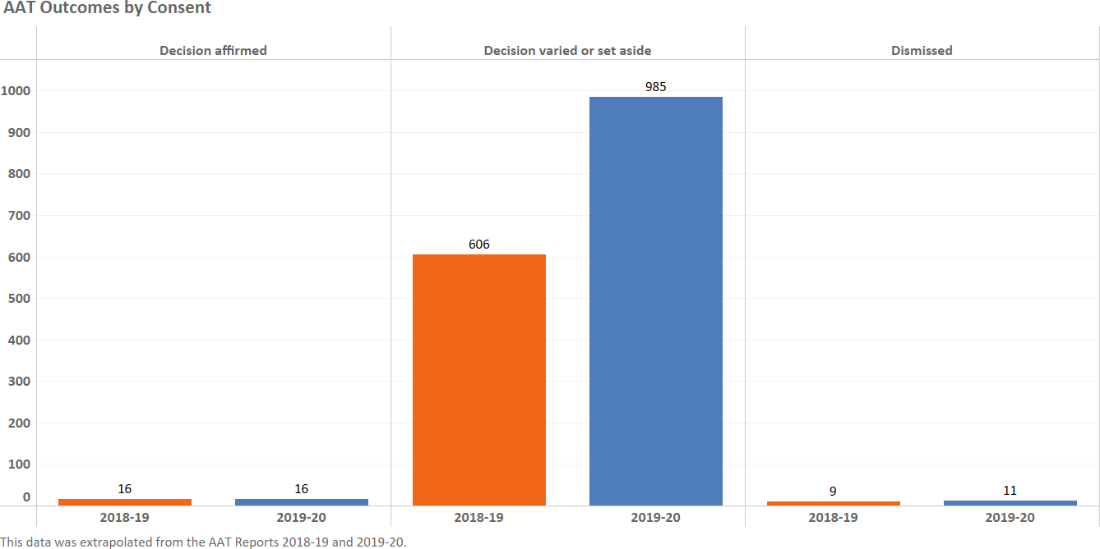

²⁹ ‘NDIS Quarterly Report to Disability Ministers’ (Q3 2021-22) 31 March 2022, p 69, https://www.ndis.gov.au/media/4466/download?attachment.
³⁰ Ibid.
³¹ ‘Administrative Appeals Tribunal Annual Report 2018-19’, p 142, https://www.aat.gov.au/AAT/media/AAT/Files/Reports/AR201819/AAT-Annual-Report-2018-19.pdf. ³² ‘Administrative Appeals Tribunal Annual Report 2019-20’, p 155, https://www.aat.gov.au/AAT/media/AAT/Files/Reports/AR201920/AAT-Annual-Report-2019-20.pdf.

Illustration 5
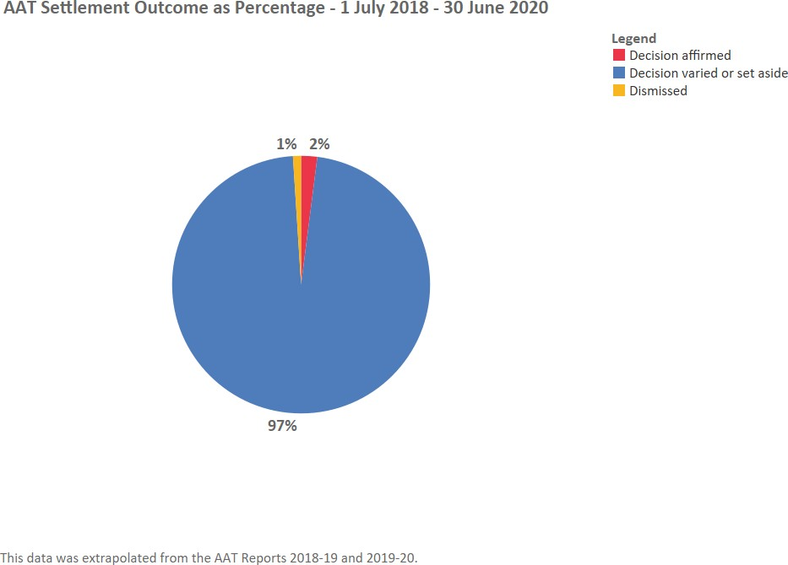

While there is no data available relating to the reason for withdrawal of applications, anecdotal reports suggest a substantial portion are due to applicants not having the capacity to deal with an AAT matter and/or the NDIA issuing a new plan outside the review process (i.e. through a section 48 process) that addresses the issues that caused them to apply to the AAT in the first place. The lack of advocates or legal representation may also be resulting in applicants withdrawing from the AAT.

Recommendation: Further work should be done to determine the reasons for the high withdrawal rates in the AAT. We repeat and support the recommendation of the Joint Standing Committee on the National Disability Insurance Scheme that the NDIA develop and publish de-identified summaries of settlement outcomes in the AAT.

QAI has spoken to several participants who have reported that lawyers engaged by the Agency have asked them to withdraw their application in exchange for the Agency agreeing to do a ‘s 48’ plan review. Such a process gives the participant no certainty nor transparency as to the result of the section 48 plan. Should it not contain the supports being sought by a participant, that participant would be required to re-start the internal review process all over again (assuming they have the energy and the capacity to continue to pursue the review). The process also leaves the participant without the benefit of the AAT’s oversight and the application of the model litigant rules, to which the NDIA is required to adhere during legal proceedings.³³

³³ The Commonwealth’s obligation to act as a model litigant is contained within Appendix B of the Legal Services Directions 2017 (Cth).

Where the Agency can see a plan review may benefit a participant at the AAT, a better process for the applicant would be for a section 42D remittal to be used to allow the review at the Agency (rather than by lawyers) while retaining the participant’s jurisdiction at the AAT if the new plan does not meet their requirements. QAI has assisted clients with the process, which has worked well. Unfortunately, we have also spoken to clients in our advice service who have been refused this process and felt (due to plan funds being exhausted) that withdrawing and doing a section 48 plan review was their only option.

As noted above in Table 4, the NDIA report for 1 July 2021 – 31 May 2022 provides that 63% of AAT matters were resolved by “consent”.³⁴ In order for a matter to be resolved by consent both the NDIA and the Applicant have to come to an agreement.

Of the cases where the outcome was by the parties’ consent, the AAT Reports prior to 1 July 2020 indicate that the majority of cases resulted in a change to the decision under review. In 2018-19, 96% of consent outcomes were for the decision under review to be varied or set aside,³⁵ rising to 97% in 2019-20.³⁶ Unfortunately, this information was not included in the AAT Report for 2020-21.

Without more recent data being available, it is impossible to understand the current trend, although it is more likely that where no change is made to the decision under review, an applicant withdraws from the process rather than makes a consent agreement.

Such a high percentage of matters being varied or set aside by consent raises the possibility that the NDIA may not be completing plan reviews effectively, or may not be following their model litigant obligations. However, it also suggests that substantially improved outcomes could be achieved for participants if they are provided with resources to identify the appropriate information and supported to supply that information at an earlier stage before the AAT process commences.

Analysis of reported decisions

To understand the matters that are going to a hearing, QAI conducted a desktop audit of AAT decisions relating to the NDIS for the period 1 January 2019 to 31 December 2021. This included reviewing the published decisions for each case (accessed through Jade and Austlii), as well as reviewing the AAT eCase information for matters where that information was publicly available. Due to a combination of confidentiality protocols and inconsistencies in the format of decisions, not all types of information we collected was available for all cases.

³⁴ ‘NDIS Quarterly Report to Disability Ministers’ (Q3 2021-22) 31 March 2022, p 69, https://www.ndis.gov.au/media/4466/download?attachment.
³⁵ ‘Administrative Appeals Tribunal Annual Report 2018-19’, p 142, https://www.aat.gov.au/AAT/media/AAT/Files/Reports/AR201819/AAT-Annual-Report-2018-19.pdf. ³⁶ ‘Administrative Appeals Tribunal Annual Report 2019-20’, p 155, https://www.aat.gov.au/AAT/media/AAT/Files/Reports/AR201920/AAT-Annual-Report-2019-20.pdf.

Of the 130 published decisions in the reporting period, 26 of the matters were in Queensland. Substantive hearings accounted for 76 decisions, while the other 54 were interlocutory matters.

Disputes relating to funded supports were the most common issue with 38 decisions, while access disputes amounted to 31 decisions, jurisdiction was the issue in 35 decisions, and other issues (e.g. directions to participate in assessment, procedural issues) were considered in the remaining 26 decisions.

Subject of AAT Decisions

Supports Access Jurisdiction Other

Table 5 below sets out a breakdown of the decided AAT cases on NDIS matters. Of the 38 substantive decisions in the reporting period which related to supports, 24% affirmed the decision under review (9 cases), 63% set aside the decision under review (24 cases), and 13% varied the decision under review (5 cases).
26
20%
38
29%
35
27%
31
24%

In those same 38 matters, 65% had a legal and/or disability advocate (25 applicants), 13% had the informal support of a family member (5 applicants), and 21% had no support or no support was reported (8 applicants).

Table 5: AAT NDIS Decisions - 1 January 2019 – 31 December 2021:
AAT decided NDIS Cases | No. | Affirmed | Set Aside | Varied
Total number of decisions on access or plans | 69 | 32  46% | 32  46% | 5  7%
Number of decisions determining access eligibility to the Scheme | 31 | 23  74% | 8  26% | 0  0%
Number of decisions considering supports in a plan | 38 | 9  24% | 24  63% | 5  13%
Number of supports decisions where applicant had a legal or disability Advocate | 25  (65% of supports decisions) | 4  16% | 19  76% | 2  8%
Number of supports decisions where applicant represented by  family member | 5 | 3  60% | 1  20% | 1  20%
Number of supports decisions where applicant not represented at  hearing | 8 | 2  25% | 4  50% | 2  25%

It was interesting to note that of the decisions made in the Queensland jurisdiction, there were only 7 decisions which considered supports for a participant and access to the scheme for a participant. Of those 7, 4 concerned supports. Of those four, 1 was varied and 3 were set aside and all involved applicants who were over 55 years of age. This demonstrates the extremely small numbers of matters which result in a substantive hearing and decision from the Tribunal.

Representation of Applicants at the AAT

While not all representation of parties at the AAT is clearly reported, the available information clearly shows there is a substantial imbalance in the legal representation of applicants to the AAT compared to the NDIA. Our experience is that the NDIA always has legal representation at the AAT.

Our analysis of the decided cases for the period 1 January 2019 – 31 December 2021, indicate 41 applicants did not have the assistance of a lawyer or advocacy service at their hearing (interlocutory or final). Of those

applicants, 29 had no assistance at their hearing, 10 applicants were assisted by informal supports such as a relative, and 2 applicants were assisted by their Support Coordinator.

While applicants who were reported to not have a legal or disability advocate were less likely to have the supports decision under review altered compared to represented applicants, they were still more likely to have the decision altered than not. Of the 13 matters where the applicant did not have a formal advocate, 5 decisions (38%) were affirmed, 5 decisions (38%) were set aside, and 3 decisions (23%) were varied.

QAI is the only organisation in Queensland providing representation services where disability advocates and lawyers work side by side on NDIS appeals. Elsewhere representation services are siloed with legal representation provided by Legal Aid Commissions and disability advocacy provided by independent disability advocate organisations. Community legal services throughout Australia offer the provision of holistic services to address legal problems through multi-disciplinary approaches. This model of representation is underutilised in NDIS appeals compared to equivalent areas such as AAT reviews of Centrelink decisions.

Advocacy organisations are currently insufficiently resourced to support all individuals with a review.

The AAT recently reported the records it held for representation at the AAT for NDIS matters in the 2021 which are set out below³⁷.

Representation of applicants in finalised applications 2021 Calendar year

Legal Representative Advocate or Agent Friend, Relative or Other Self-represented
508
20%
368
15%
637
26%
975
39%

Timeframes at the AAT

The AAT reports that the median time to finalisation in the 2021-22 financial year has remained fairly stable at 22 weeks. It further reports that 83% of NDIS cases in the 1 July 2021 – 31 May 2022 period were “resolved”

³⁷ Illustration taken from information provided by Justice Fiona Meagher (AAT President, previously Division Head of NDIS Division of AAT) at LegalWise NDIS Law Conference on 23 February 2022.

within 12 months of lodgement.³⁸ It should be noted that “resolved” includes matters where a participant has
withdrawn from the process.

We were unable to determine the lodgement date of 35 of the reported decisions, however of the 95 cases with available lodgement dates the median time from date lodged to the date the decision was published was 441 days, or 63 weeks (over 12 months). It is important to note that this calculation may be slightly distorted by delays between verbal decisions and written reasons in some cases, however this is likely offset by the fact that an AAT decision is generally not implemented immediately due to administrative delays by the NDIA.

To consider the timeframes further, we made a request to the AAT for additional data regarding the NDIS Division and the AAT were able to supply a spreadsheet of all the matters lodged in the NDIS Division of the AAT from 2019 until the end of May 2022. The information supplied included file number, lodgement date, and outcome date if finalised. The latest lodgement included in the data was 31/05/2022, while the latest finalisation date included was 22/06/2022.

From that information, QAI has been able to calculate information relating to the duration of matters lodged at the AAT since the beginning of 2019, working on the assumption that we have the finalisation date for all matters finalised by 22/06/2022.

The average and median durations we have calculated are lower than the actual figure due to ongoing matters not being included (the longest of which would have lasted 1,268 days, 181 weeks, or 3.47 years even if it was finalised as early as 23/06/2022).

Data from our analysis of AAT data:
 | 2019 | 2020 | 2021 | 2022
Median duration of matters commenced that year finalised as of  22/06/2022 | 146 days  21 weeks | 157 days  22 weeks | 148 days  21 weeks | 62 days  9 weeks
Average duration of matters commenced that year finalised as of  22/06/2022 | 202 days  29 weeks | 205 days  29 weeks | 154 days  22 weeks | 66 days  9 weeks
Number of matters commenced that  year finalised as of 22/06/2022 | 1632 | 1407 | 2730 | 346
Number of matters commenced that  year not yet finalised as of 22/06/2022 | 15 | 97 | 1831 | 2055
Percentage of matters lodged in that  year finalised as of 22/06/2022 | 99% | 94% | 60% | 14%
Number of matters taking more than  2 years (lodged prior to 22/06/2020) | 53  3.22% | 33  4.68%

The NDIA’s most recent ‘NDIS Quarterly Report to Disability Ministers’ (Q3 2021-22) noted they are “seeing an increasing number of cases proceeding to a (substantive) hearing in most recent quarters, which is consistent with the increasing number of AAT matters and the rising complexity in the multitude of the supports being requested for review by applicants”.³⁹ This suggests that while the median time to finalisation remains steady, the number of individuals facing long delays at the AAT may still be growing.

³⁸ ‘AAT Caseload Report: For the period 1 July 2021 to 31 May 2022’, https://www.aat.gov.au/AAT/media/AAT/Files/Statistics/AAT-Whole-of-Tribunal-Statistics-2021-22.pdf. ³⁹ ‘NDIS Quarterly Report to Disability Ministers’ (Q3 2021-22) 31 March 2022, p 69, https://www.ndis.gov.au/media/4466/download?attachment.

Next steps
QAI thanks the Department of Seniors, Disability Services and Aboriginal and Torres Strait Islander Partnerships for the opportunity to undertake research and prepare this report. The demand for individual advocacy services far exceeds the capacity of our advocates within our NDIS Advocacy Practice. Although advocating for change at a systemic level is embedded within our practice, it is a challenge to make the time to step back and undertake research and analysis such as that which we have carried out via this project.

As the data has verified the anecdotal stories of our clients in relation to various aspects of the NDIS review process (both at internal and external review stages), we have been able to start modifying our processes and developing tools to provide more appropriate advocacy responses. For example, the significant increase in external review applications has led to longer periods of time passing before an applicant has an opportunity to discuss their concerns with the NDIA via a facilitated discussion with an AAT conference registrar. We now advise applicants to proactively use this time to clarify the supports they are seeking and the evidence on which they are relying to demonstrate the supports meet the section 34 reasonable and necessary support criteria.

We have developed a ‘supports in dispute’ table for applicants to complete and this has proven an effective tool to correct misunderstandings by the internal reviewer and provide updates to the NDIA regarding an applicant’s requested supports, prior to the first case conference. This is just one example of the many tools we intend to develop to improve our advocacy services.

In addition, we have been able to take some initial steps to seek to overcome the limitations in publicly available data, including by lodging a request for more detailed data to the Administrative Appeals Tribunal and discussing our concerns with researchers from the Centres for Data Science and Justice at the Queensland University of Technology. This work may lead to more detailed data (eg. time to first case conference, time to receipt of section 37 documents, representative details, timing of application withdrawals), which we will be able to share with the Department via subsequent updates.

In preparing this report we would like to acknowledge Ms Brianna Bell who was engaged to assist with preparation of the report and Mr Ted Jensen, Senior Manager Individual Advocacy Queensland People with Disability, Australia who has been generous with his time to provide valuable input on data collection.

We once again thank the Department for this opportunity.

