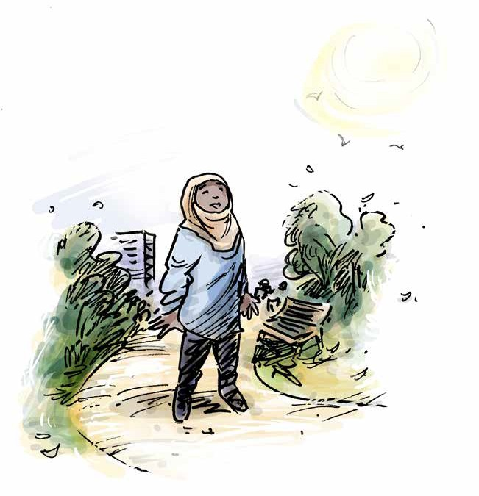Prevention of Torture
in Immigration Detention Settings

Guide to a disability aware approach

Table of
1
2
3
4
5
6
7
8
9
10

Contents

How to use this booklet

Introduction

Definitions

You have the right to be treated with dignity and respect
You have the right to not be separated from others for long periods of time You have the right to quality, accessible, medical care
You have the right to decent conditions while in this facility You have the right to be safe

You have the right to access support you need to do everyday tasks, understand what is happening to you, and make decisions

Acknowledgements

How to use this booklet

This publication is for general information only. The information provided is not legal advice and should not be treated as such.

These resources are designed to create awareness of rights under the Convention Against Torture. The Convention Against Torture is an international human rights convention that the Australian Government has committed to upholding. Local laws, such as State and Territory laws, are not the same as international human rights conventions. This means that some of the protections under the Convention Against Torture are not found in local laws.

This resource cannot be used to decide whether particular conditions of detention in Australia are lawful. Rather, the resource educates people with disability in detention, their family members, and supporters about international human rights in the Convention Against Torture. If you think you are being treated unlawfully, seek the advice of a lawyer.

Australia is in the process of setting up a framework to implement the Optional Protocol to the Convention Against Torture. This means governments will appoint bodies to monitor places of detention for breaches of the Convention Against Torture.

The monitoring bodies for each State and Territory are listed on the website of the Commonwealth Ombudsman: https://www.ombudsman.gov.au/what-we-do/monitoring-places-of-detention-opcat.

This website also has a complaint form to provide information and make enquiries.

The examples contained in these resources are fictional but draw from cases and the experiences of people with disability in Australia and around the world.

Introduction

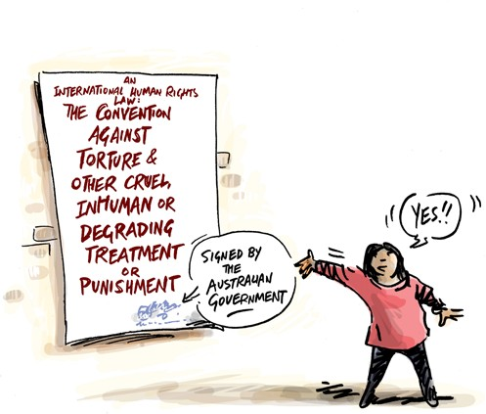
Everyone has the right to be safe from torture and cruel treatment. Everyone has the right to be treated fairly, and with dignity and respect.

If you have been questioned, searched, or detained by immigration officials, you have these rights like everyone else.

The Convention against Torture and Other Cruel, Inhuman or Degrading Treatment or Punishment is one of the international human rights laws that the Australian Government has agreed to.

By signing this Convention, the Australian Government has committed to uphold the rights of people when they are in immigration detention.

All government workers, including police, immigration detainee service officers, medical and support staff are required to uphold these rights.

This resource can help you learn about your rights under this international law, and to think about whether or not your rights are being respected.
The rights under international law might be different to the rights under the law in your State or Territory.

If you think your rights are not being respected, you can get help. Ask to speak to an advocate or lawyer.

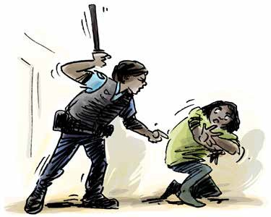
Definitions

What is torture?
Torture is when someone in an official position intentionally inflicts severe pain or suffering, whether physical or mental, on someone else.

Torture can never be justified, and can involve:

- Physical or sexual harm including beating or rape
- Psychological harm including prolonged solitary confinement or indefinite detention

What is cruel, inhuman, or degrading treatment or punishment?
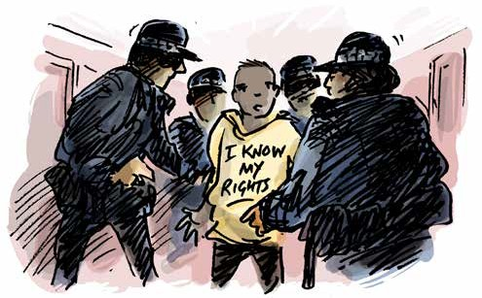
Cruel and inhuman or degrading treatment or punishment causes physical and mental suffering. This may include serious assault or abuse.

This can also include treatment or punishment that is humiliating. This can involve:
- Bullying and intimidation by staff or other detainees
- Denial of medical and psychological care or disability support
- Involuntary medical and psychological treatment without regular review
- Lack of privacy, overcrowding
- Prolonged isolation
- Inaccessible, poorly equipped, or unhygienic sanitary facilities

The following section tells you what your rights are in international human rights law. Local laws are sometimes different to international law. The questions here will help you to give relevant information to someone who can help. The examples are based on legal cases about torture and cruel and inhumane treatment around the world.

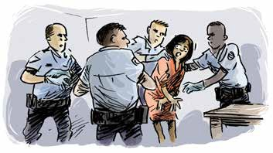
You have the right to be treated with dignity and respect
- In immigration detention only certain people are authorised to do strip searches
and cavity searches are unlawful
Examples
Questions

When you were questioned by immigration officials, did you have support from an advocate or lawyer to understand what was happening and to support you through the process?

Were you handcuffed or restrained in other ways during questioning? If so, for how long?

Were you searched by police or immigration detainee service officers? Were you strip searched?
Did someone explain to you why you were being searched?

Who searched you, and who was in the room when you were searched?
Jez was physically restrained by immigration detainee service officers after an argument he had with another detainee. Jez has physical disability, and the restraint, including detainee services officers kneeling on his neck and back and kicking him in the stomach, was not appropriate to any risk.

Alma was strip searched by immigration detainee service officers. A male officer was present during the search, despite Alma’s requests that he leave. Alma was asked to squat and was searched without officers using appropriate gloves.

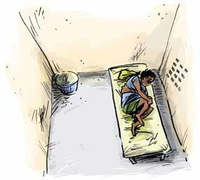
You have the right to not be separated from others for long periods of time
- This includes being separated based on disability
- When someone is held in a separate cell for more than 22 hours, this is called solitary confinement
- Solitary confinement must be a last resort and must be for the shortest amount of time possible
- Nobody should be kept in solitary confinement for more than 15 consecutive days, or, repeatedly subject to solitary confinement in consecutive periods
- You have the right to have visitors, and to see family and friends regularly
Examples
Questions

Have you ever been held or locked in a room away from others? How long was it for?

Did someone explain what was happening? Did you have support to help you understand what was happening?

Were you told when it would end, and did it end when you expected it to?

If you were locked in your room, did you see someone every day, and were you able to communicate with them face to face?

If you were in solitary confinement, what were the conditions of your room? Was it clean? Were you able to regularly use an accessible bathroom? Did you have access to things to do? Did you have constant access to water and sanitation?

Were you allowed to meet with a lawyer, or advocate?

Were you able to go outside? If you were, for how long? Did you have the support you need to move around outside?
There was a Covid-19 outbreak in Majani’s detention centre.
Having showed symptoms, Majani was locked in an isolation area. She had no access to outdoor space and was given no information about when she would be able to leave her room. She was not allowed to see her family. Majani tested negative for Covid-19 but remained in isolation for over 2 weeks.

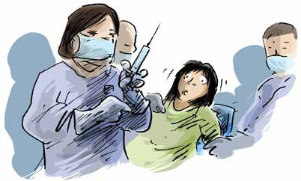
You have the right to quality, accessible, medical care
- You have the right to make decisions about the medical care you receive
- You have the right to privacy and confidentiality around your health care
- If a doctor or psychiatrist has ordered that you need to have a medical treatment, you have the right to have that decision reviewed regularly
- You should have access to all treatments, medication and therapy you need
Examples
Questions

Have your medical needs been assessed since arriving in detention? How often do you see a doctor or dentist?
Have you seen your medical records? Who else can see you medical records? Was your consent sought before you received medical or psychiatric treatment? Has the decision for this treatment been reviewed?
Do you have access to someone (interpreter, disability support worker, advocate, lawyer) who can help you understand the medical decisions being made?

Do you have access to the medication or treatment you need?
Have you ever been denied a treatment or medical appointment you have requested? Did you see a medical professional when you needed to?
After Kamran’s medications were destroyed, he received a medical assessment at the detention facility, but they could only provide one of the medications needed for his condition. Kamran started having seizures, which would often happen during his sleep and would put him at risk of serious injury.
Kamran’s seizures became worse and he was not able to obtain a medical review.

A 3-year-old girl with a disability needed medication and therapeutic support from allied health professionals. While being detained she had inconsistent access to her medication (there was no weekend
dispensing services), and no access to allied health services, which led to significant deterioration in her level of function.

You have the right to decent conditions while in this facility

- This includes having access to accessible facilities

Examples
Questions

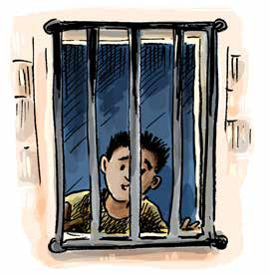Do you have a window in your room that provides natural sunlight?

Can your window be opened for fresh air, or are there other forms of ventilation?

Can you use a bathroom that is accessible for you?

Do you have privacy when using the bathroom or toilet?

How many people do you share a room with?

What is the quality of your food and drink? Have you ever been denied food or drink?
Pedro was held in immigration detention conditions which were dangerously cold. He risked developing sores because the bed was too hard. Pedro has physical disability, and due to the inaccessible room and lack of support, he was unable to go to the toilet or keep clean without considerable difficulty. Steps that led in and out of the room where he was sleeping meant that Pedro could not easily go outside without seeking help.

Fatima was a 12-year-old girl with psychosocial disability. Fatima was vomiting and had stomach pains. The staff gave her Panadol and told her to drink water. They did not organise for her to see a doctor, but moved her to an isolation room, which was on the other side of the detention centre from her family. The room was dirty and had poor ventilation, with just a bed and blanket. It did not have a bathroom. She was not allowed to see her family while in the isolation room. Fatima became very distressed, exacerbating her psychosocial disability.

Katie, a young woman with cerebral palsy, was confined to a wheelchair in Christmas Island. Despite medical officers raising concerns from the time of her arrival that
the detention environment was not suitable for her, and despite exhibiting signs of psychological distress, Katie was not transferred to another facility.

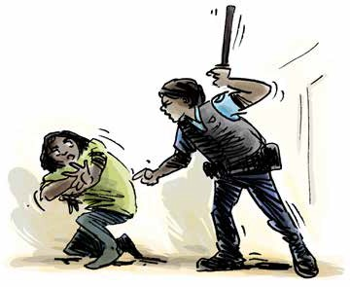
You have the right to be safe
- You should be protected from violence, abuse or neglect by staff or other detainees
Examples
Questions

Do you feel safe?

Are there particular places where you feel less safe, and if so, why? Are there particular people you feel less safe with, and if so, why? Have you been verbally bullied by staff or other detainees?
Have you ever been physically hurt by staff or other detainees? Have you ever been locked up somewhere that you could not leave?
If you have been hurt and you needed medical care, was it provided?

Has anything been done about the violence, abuse or neglect you experienced?
Nyala used a wheelchair, but a lot of the detention facility was inaccessible. She did not have family or a carer to help her and had to get help from other detainees to shower. Nyala was harassed by some of the male detainees. She told the immigration detainee service officers, but no action was taken to protect her or provide her with the disability support she required.

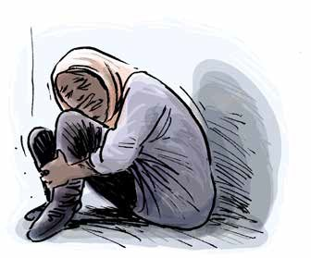Do you need help understanding what is happening or to make decisions? Have you had access to a disability advocate to support you with this?
You have the right to access support you need to do everyday tasks,
understand what is happening to you, and make decisions
- An individualised assessment of support requirements should be completed as soon as a person is detained
- This support should never be denied, withheld, or stopped without your permission
Examples
Questions

Do you need any support with everyday activities?

Has there been an assessment of the help that you need since you were questioned and detained?

Is there a plan for this support to be provided? Have you seen that plan?

Have you been provided with the support you need? For example, if you use an interpreter, has one been provided for you?

Has support ever been withheld or stopped as a punishment or to make you feel bad?

How long was your support withheld, or stopped?
A family was held in immigration detention. Both parents and their baby were profoundly deaf and used hearing aids. Their hearing aids had been destroyed on the journey to Australia. The family had been in detention for over six months, and during this time they had no hearing aids and were unable to communicate with anyone in the detention centre without extreme difficulty. The parents were not able to communicate well with their baby and could not hear their baby crying.

Acknowledgements

We acknowledge the following sources in the drafting of the examples used in this resource:

- Christmas Island Medical Officer’s Letter of Concerns – For review by International Health and Medical Services Management and Executive. November 2013
- Council of Europe/European Court of Human Rights Factsheet series (“Detention conditions and treatment of prisoners”, “Detention and Mental Health”, “Prisoners’ health rights” & “Covid-19 health crises”) 2022
- COVID-19 AND OPCAT: Detention of people with disability, and older people. Australian Disability and Aged Care OPCAT Working Group. June 2020
- Response to Australian Human Rights Commission OPCAT in Australia Consultation Paper. Advocacy for Inclusion. July 2017
- Submission to the Senate Inquiry into Violence, abuse, and neglect against people with disability in institutional and residential settings. Australian Cross Disability Alliance (ACDA) August 2015
- Submission to the Special Rapporteur on the Rights of Persons with Disability: Abuse of Students with Disability in Australian Schools. Children and Young People with Disability Australia (CYDA). July 2016
- The Plight of People Living with Disabilities within Australian Immigration Detention: Demonised, Detained, and Disowned. National Ethnic Disability Alliance (NEDA) 2015
- WWDA Response to Restrictive Practices Issues Paper – to the Royal Commission into Violence, Abuse, Neglect and Exploitation of People with Disability. Women With Disabilities Australia. July 2021

For more information or copies of the other resources in this OPCAT monitoring series, please contact us on 1300 130 582 or visit the resource webpage www.qai.org.au/opcat-monitoring-resources/.

Notes

