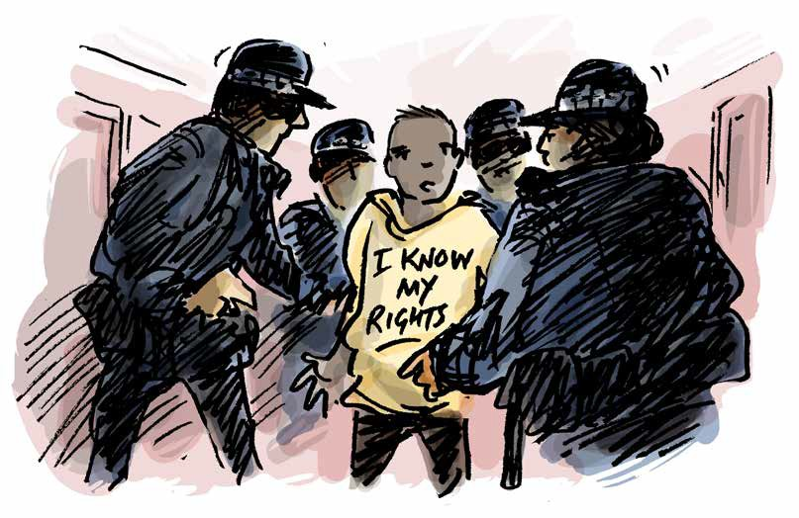Prevention of Torture in Justice Settings

Guide to a disability aware approach

Table of
1
2
3
4
5
7
9
10
11
12

Contents

How to use this booklet

Introduction

Definitions

You have the right to be treated with dignity and respect
You have the right to not be separated from others for long periods of time You have the right to quality, accessible, medical care
You have the right to decent conditions while in this facility You have the right to be safe

You have the right to access support you need to do everyday tasks, understand what is happening to you, and make decisions

Acknowledgements

How to use this booklet

This publication is for general information only. The information provided is not legal advice and should not be treated as such.

These resources are designed to create awareness of rights under the Convention Against Torture. The Convention Against Torture is an international human rights convention that the Australian Government has committed to upholding. Local laws, such as State and Territory laws, are not the same as international human rights conventions. This means that some of the protections under the Convention Against Torture are not found in local laws.

This resource cannot be used to decide whether particular conditions of detention in Australia are lawful. Rather, the resource educates people with disability in detention, their family members, and supporters about international human rights in the Convention Against Torture. If you think you are being treated unlawfully, seek the advice of a lawyer.

Australia is in the process of setting up a framework to implement the Optional Protocol to the Convention Against Torture. This means governments will appoint bodies to monitor places of detention for breaches of the Convention Against Torture.

The monitoring bodies for each State and Territory are listed on the website of the Commonwealth Ombudsman: https://www.ombudsman.gov.au/what-we-do/monitoring-places-of-detention-opcat.

This website also has a complaint form to provide information and make enquiries.

The examples contained in these resources are fictional but draw from cases and the experiences of people with disability in Australia and around the world.

Introduction

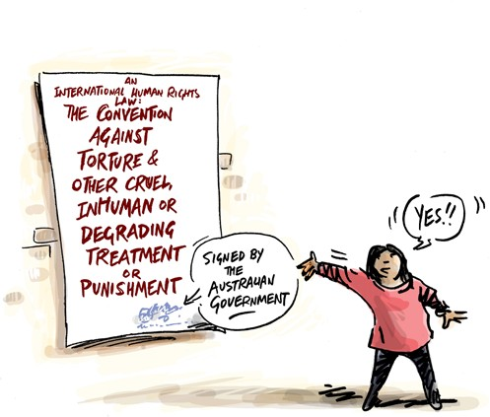
Everyone has the right to be safe from torture and cruel treatment. Everyone has the right to be treated fairly, and with dignity and respect.

If you have been arrested, and are questioned, searched, or detained, you have these rights like everyone else. This includes in watch houses, prison, court cells and prison transport.

The Convention against Torture and Other Cruel, Inhuman or Degrading Treatment or Punishment is one of the international human rights laws that the Australian Government has agreed to.

By signing this Convention, the Australian Government has committed to uphold the rights of people when they are in detention.

All government workers, including police, prison guards, medical and support staff are required to uphold these rights. This includes staff working for private companies doing government work, such as private prisons or prison transport.

This resource can help you learn about your rights under this international law, and to think about whether or not your rights are being respected.

If you think your rights are not being respected, you can get help. Ask to speak to an advocate or lawyer.

Definitions

What is torture?
Torture is when someone in an official position intentionally inflicts severe pain or suffering, whether physical or mental, on someone else.

Torture can never be justified, and can involve:

- Physical or sexual harm including beating or rape
- Psychological harm including prolonged solitary confinement or indefinite detention

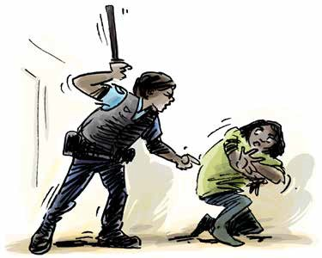
What is cruel, inhuman, or degrading treatment or punishment?
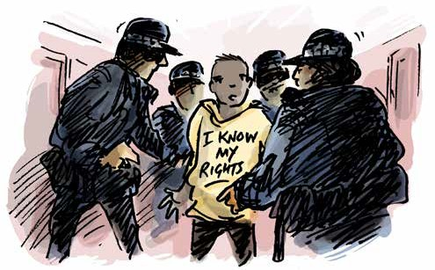
Cruel and inhuman or degrading treatment or punishment causes physical and mental suffering. This may include serious assault or abuse.

This can also include treatment or punishment that is humiliating. This can involve:
  - Bullying and intimidation by staff or other detainees
  - Denial of medical and psychological care or disability support
  - Involuntary medical and psychological treatment without regular review
  - Lack of privacy, overcrowding
  - Prolonged isolation
  - Inaccessible, poorly equipped, or unhygienic sanitary facilities

The following section tells you what your rights are in international human rights law. Local laws are sometimes different to international law. The questions here will help you to give relevant information to someone who can help. The examples are based on legal cases about torture and cruel and inhumane treatment around the world.

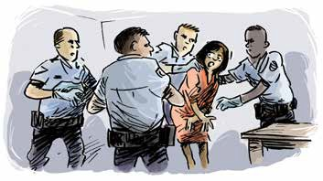
You have the right to be treated with dignity and respect
- This includes when you are being arrested, questioned, searched and detained
Examples
Questions

When you were arrested and questioned, did you have support from an advocate or lawyer to understand what was happening and to support you through the process?

Were you handcuffed or restrained in other ways during arrest, questioning or whilst being searched? How long for?

Have you been searched by police? Were you strip searched?
Did someone explain to you why you were being searched?

Who searched you, and who was in the room when you were searched?
Joseph has psychosocial disability and mobility issues associated with obesity. When he was arrested, he was handcuffed, and despite his health concerns he was kept in handcuffs for over 12 hours during questioning and while he was held in the cell. The police told Joseph he was kept handcuffed to reduce the risk he posed to staff and to other inmates. At no point during questioning had Joseph shown any indication of being a security risk. The use of the handcuffs for the prolonged period of time was disproportionate to the risk and resulted in Joseph becoming agitated and distressed.

Jake was strip searched by guards following a visit from a relative. A woman prison officer was present during the search, despite Jake’s requests that she leave while the search was conducted. Jake was asked to squat and was searched by guards who placed their hands on him unnecessarily.

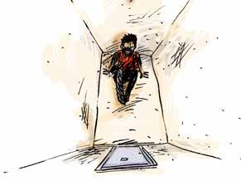You have the right to not be separated from others for long periods of time
Have you been held or locked in a room separate from others?

Did someone explain what was happening? Did you have support to help you understand what was happening? How long were you there?
Were you told when it would end, and did it end when you expected it to? Who did you see during this time?
Did you see someone every day, and were you able to communicate with them face to face?

If you were in solitary confinement, what were the conditions of your room? Was it clean? Were you able to regularly use an accessible bathroom? Did you have access to things to do? Did you have constant access to water and sanitation?

Were you allowed to meet with a lawyer, or advocate?
Were you able to go outside? If you were, for how long? Did you have the support you need to move around outside? Did you see a medical professional when you needed to?
Questions

  - This includes being separated based on disability
  - When someone is held in a separate cell for more than 22 hours, this is called solitary confinement
  - Solitary confinement must be a last resort and must be for the shortest amount of time possible

  - Nobody should be kept in solitary confinement for more than 15 consecutive days, or, repeatedly subject to solitary confinement in consecutive periods
  - While in detention you have the right to have visitors, and to see family and friends regularly

Examples
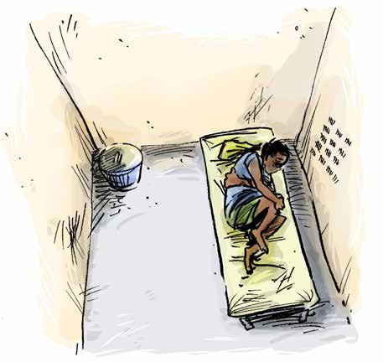
Imani was held in solitary confinement for 11 months. The prison staff told him the separation was to protect him from the abuse he was experiencing from other detainees. He was restricted in all contact with other detainees, including during outdoor exercise times. The only person he saw was the guard who brought his food. Imani was not
provided any guidance around when his solitary confinement might end. His mental health deteriorated over the time, but he was not provided access to mental health or welfare support.

Mary, a prisoner with psychosocial disability, was held in solitary confinement for 28 days. After a week on her own she was allowed outside exercise but was kept in handcuffs connected to a body belt, that restricted her movement. During exercise time, correctional officers mocked her, whistling at her like a dog, and telling her to crawl on her hands and knees. During her time in solitary confinement, Mary did
not have access to a toilet and was forced to use cardboard urine test containers. Mary was not provided with sanitary items for her menstrual cycle.

You have the right to quality, accessible, medical care

  - You have the right to make decisions about the medical care you receive
  - If a doctor or psychiatrist has ordered that you need to have a medical treatment, you have the right to have that decision reviewed regularly

Questions

Have you seen a doctor or dentist since you arrived in detention? Have you seen your medical records while in detention?
Was your consent sought/did you understand and agree before you received medical or psychiatric treatment? Has the decision for this treatment been reviewed? How often, and who was involved?
Do you have access to someone (disability support worker, advocate, lawyer) who can help you understand the medical decisions being made?

Do you have access to the medication or treatment you need?

Have you ever been denied a treatment or medical appointment you have requested? Did you see a medical professional when you needed to?

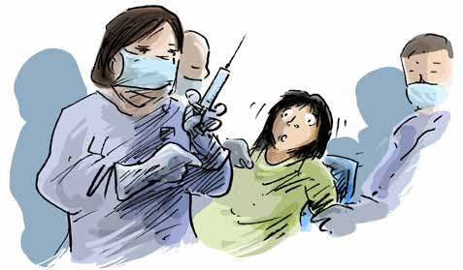

- You have the right to privacy and confidentiality around your health care
- You should have access to all treatments, medication and therapy you need
Examples

Huan has an acquired brain injury and was arrested and held in the watchhouse for a period of seven days. He received no psychiatric or health assessment during this time and was handcuffed for the majority of this period.

Despite having disability and associated health issues, the authorities did not properly assess Jed’s medical needs when he arrived in prison and did not develop a plan for his care and support. For over a year, Jed was not provided with the health care he required. This exacerbated Jed’s health issues and caused Jed significant hardship and distress.

June has serious asthma and was detained in conditions that made her asthma worse. This included being held in overcrowded, dirty cells with other inmates that smoked. She was not provided with preventative asthma medication and after a period of six months, she was hospitalised due to her illness worsening.

Janna was pregnant when she was arrested. When she attended obstetric appointments, she was handcuffed and supervised by prison staff who were often male. In addition to the lack of privacy, the confidentiality of her health records was compromised with staff observing all conversations between her and her health care team. Janna developed gestational diabetes, but a health care plan, including recommended changes to her diet, was not developed. This caused risk to Janna’s health, and to the health of her baby.

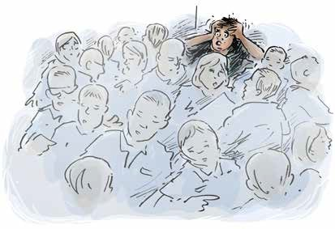
You have the right to decent conditions while in this facility
- This includes having access to accessible facilities
Examples
Questions

Do you have a window in your room that provides natural sunlight?

Can your window be opened for fresh air, or are there other forms of ventilation?

Can you use a bathroom that is accessible for you?

Do you have privacy when using the bathroom or toilet? How many people do you share a room with?
What is the quality of your food and drink? Have you ever been denied food or drink?
Pedro was held in detention conditions which were dangerously cold. He risked developing sores because the bed was too hard. Pedro has physical disability, and due to the inaccessible room and a lack of support, he was unable to go to the toilet or keep clean without considerable difficulty.

Andrew was kept in his cell for the majority of each night and day for more than seven days due to a Covid-19 outbreak in the prison. The room had no ventilation and no window and became unbearably hot. Andrew was not provided with a change of clothes at all during this period. There was only one toilet which he had to use in front of his cellmate.

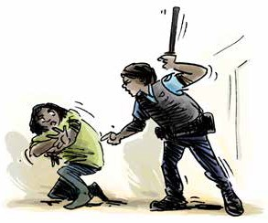
You have the right to be safe
- While you are being detained, you should be protected from violence, abuse or neglect
from staff or other prisoners
Examples
Questions

Do you feel safe?

Are there particular places where you feel less safe, and if so, why? Are there particular people you feel less safe with, and if so, why? Have you been verbally bullied by staff or other detainees?
Have you ever been physically hurt by staff or other detainees?

If you have been hurt and you needed medical care, was it provided?

Has anything been done about the violence, abuse or neglect you experienced?
Marty has a cognitive disability. He was held in a detention unit where his mental health deteriorated. He was regularly bullied by staff and other detainees, who on several occasions spat in his face, and burned him with cigarette lighters. Marty attempted suicide a number of times but rather than being offered psychological support, he was mocked by staff.

Adnan is vision impaired. He was bullied by other detainees due to his religion. Adnan was scared to use the showers, as the bathrooms were poorly lit, affecting how much he could see. He was often assaulted in the showers as there was limited supervision from prison staff. When Adnan reported the incidents to staff, he was moved to an isolation unit. He was told this was for his own protection. In the unit the prison did not assess his support needs or provide any mental health support in response to the abuse he had experienced.

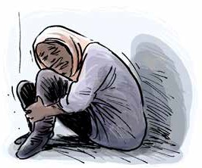
You have the right to access support you need to do everyday tasks,
understand what is happening to you, and make decisions
- An individualised assessment of support requirements should be completed as soon as a person is detained
- This support should never be denied, withheld or stopped without your permission
Examples
Questions

Do you need help understanding what is happening or to make decisions? Have you had access to a disability advocate to support you with this?

Do you need any support with everyday activities?

Has there been an assessment of the help that you need since you were arrested, questioned, and detained?

Is there a plan for this support to be provided? Have you seen that plan?

Have you been provided with the support you need? For example, if you use an interpreter, has one been provided for you?

Has your support ever been withheld or stopped as a punishment or to make you feel bad? How long was your support withheld, or stopped?
What happened to you because your support was withheld or stopped? Were you at risk of harm or in danger? Were you unable to move around and do everyday tasks? Were you isolated?
Felix has a physical disability but was provided no support while in detention. He was forced to ask one of his cellmates for assistance with using the toilet, bathing, and getting dressed or undressed. He was restricted in his ability to move around and could not leave his cell independently. His reliance on other detainees to move around made him more vulnerable to violence and abuse. There were times when Felix had no care because his cellmates were busy or directed by prison staff not to assist him.

Acknowledgements

We acknowledge the following sources in the drafting of the examples used in this resource:

- Christmas Island Medical Officer’s Letter of Concerns – For review by International Health and Medical Services Management and Executive. November 2013
- Council of Europe/European Court of Human Rights Factsheet series (“Detention conditions and treatment of prisoners”, “Detention and Mental Health”, “Prisoners’ health rights” & “Covid-19 health crises”) 2022
- COVID-19 AND OPCAT: Detention of people with disability, and older people. Australian Disability and Aged Care OPCAT Working Group. June 2020
- Response to Australian Human Rights Commission OPCAT in Australia Consultation Paper. Advocacy for Inclusion. July 2017
- Submission to the Senate Inquiry into Violence, abuse, and neglect against people with disability in institutional and residential settings. Australian Cross Disability Alliance (ACDA) August 2015
- Submission to the Special Rapporteur on the Rights of Persons with Disability: Abuse of Students with Disability in Australian Schools. Children and Young People with Disability Australia (CYDA). July 2016
- The Plight of People Living with Disabilities within Australian Immigration Detention: Demonised, Detained, and Disowned. National Ethnic Disability Alliance (NEDA) 2015
- WWDA Response to Restrictive Practices Issues Paper – to the Royal Commission into Violence, Abuse, Neglect and Exploitation of People with Disability. Women With Disabilities Australia. July 2021

For more information or copies of the other resources in this OPCAT monitoring series, please contact us on 1300 130 582 or visit the resource webpage www.qai.org.au/opcat-monitoring-resources/.

