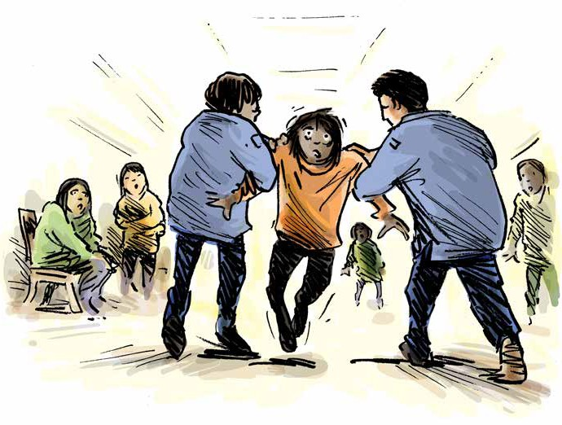Prevention of Torture in Secure Mental Health and Hospital Dementia Settings

Guide to a disability aware approach

Table of
1
2
3
4
5
6
7
8
9
10

Contents

How to use this booklet

Introduction

Definitions

You have the right to be treated with dignity and respect
You have the right to not be separated from others for long periods of time You have the right to quality, accessible, medical care
You have the right to decent conditions while in this facility You have the right to be safe

You have the right to access support you need to do everyday tasks, understand what is happening to you, and make decisions

Acknowledgements

How to use this booklet

This publication is for general information only. The information provided is not legal advice and should not be treated as such.

These resources are designed to create awareness of rights under the Convention Against Torture. The Convention Against Torture is an international human rights convention that the Australian Government has committed to upholding. Local laws, such as State and Territory laws, are not the same as international human rights conventions. This means that some of the protections under the Convention Against Torture are not found in local laws.

This resource cannot be used to decide whether particular conditions of detention in Australia are lawful. Rather, the resource educates people with disability in detention, their family members, and supporters about international human rights in the Convention Against Torture. If you think you are being treated unlawfully, seek the advice of a lawyer.

Australia is in the process of setting up a framework to implement the Optional Protocol to the Convention Against Torture. This means governments will appoint bodies to monitor places of detention for breaches of the Convention Against Torture.

The monitoring bodies for each State and Territory are listed on the website of the Commonwealth Ombudsman: https://www.ombudsman.gov.au/what-we-do/monitoring-places-of-detention-opcat.

This website also has a complaint form to provide information and make enquiries.

The examples contained in these resources are fictional but draw from cases and the experiences of people with disability in Australia and around the world.

Introduction

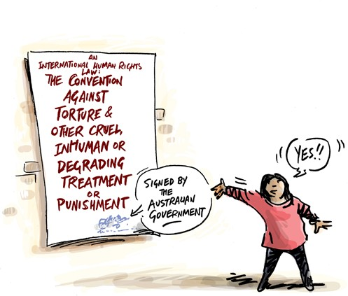
Everyone has the right to be safe from torture and cruel treatment. Everyone has the right to be treated fairly, and with dignity and respect.

If you are a patient in a Mental Health Service or are admitted to a dementia ward in a hospital, you have these rights like everyone else. The Convention against Torture and Other Cruel, Inhuman or Degrading Treatment or Punishment is one of the international human rights laws that the Australian Government has agreed to.

By signing this Convention, the Australian Government has committed to uphold the rights of people when they are in detention, including in hospitals or secure wards because of mental illness or dementia. This includes staff working for private companies doing government work.

This resource can help you learn about your rights under this international law, and to think about whether or not your rights are being respected.
The rights under international law might be different to the rights under the law in your State or Territory.

If you think your rights are not being respected, you can get help. Ask to speak to an advocate or lawyer.

Definitions

What is torture?
Torture is when someone in an official position intentionally inflicts severe pain or suffering, whether physical or mental, on someone else.

Torture can never be justified, and can involve:

- Physical or sexual harm including beating or rape
- Psychological harm including prolonged solitary confinement or indefinite detention

What is cruel, inhuman, or degrading treatment or punishment?
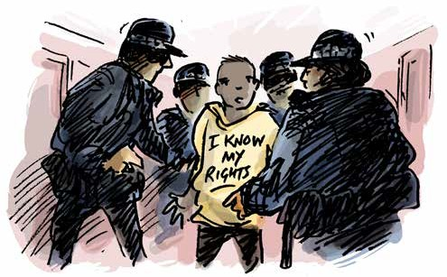
Cruel and inhuman or degrading treatment or punishment causes physical and mental suffering. This may include serious assault or abuse.

This can also include treatment or punishment that is humiliating. This can involve:
- Bullying and intimidation by staff or other patients
- Denial of medical and psychological care or disability support
- Involuntary medical and psychological treatment without regular review
- Lack of privacy, overcrowding
- Prolonged isolation
- Inaccessible, poorly equipped, or unhygienic sanitary facilities

The following section tells you what your rights are in international human rights law. Local laws are sometimes different to international law. The questions here will help you to give relevant information to someone who can help. The examples are based on legal cases about torture and cruel and inhumane treatment around the world.

You have the right to be treated with dignity and respect
- This includes while you are being detained and searched
Examples
Questions

When you were detained and admitted, did you have support from an advocate or lawyer to understand what was happening and to support you through the process?

Were you handcuffed or restrained in other ways during detainment, questioning or being searched? How long for?

Have you been searched by police or staff? Were you strip searched?
Did someone explain to you why you were being searched?

Who searched you, and who was in the room when you were searched?
When Ryan was admitted he was strip searched. His hands were cuffed behind his back while he was placed in solitary confinement after being deemed a safety risk to himself. He did not have any face-to-face interactions with staff for 6 hours.

May was repeatedly subjected to random strip searches by nursing staff when coming back from leave. Despite numerous requests for only female staff to be present, there has always been a male staff member present.
This leaves May scared to go out on leave and as a result, she experiences exacerbated distress and significantly declines in her recovery.

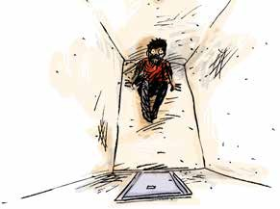
You have the right to not be separated from others for long periods of time
- This includes being separated based on disability
- When someone is held in a separate cell or room for more than 22 hours, this is called solitary confinement
- Solitary confinement must be a last resort and must be for the shortest amount of time possible
- Nobody should be kept in solitary confinement for more than 15 consecutive days, or, repeatedly subject to solitary confinement in consecutive periods
- You have the right to have visitors, and to see family and friends regularly
Examples
Questions

Have you been held or locked in a room separate from others?

Did someone explain what was happening? Did you have support to help you understand what was happening?

How long were you there?

Were you told when it would end, and did it end when you expected it to?

Did you see someone every day, and were you able to communicate with them face to face?

If you were in solitary confinement, what were the conditions of your room? Was it clean? Were you able to regularly use an accessible bathroom? Did you have access to things to do?

Were you allowed to meet with a lawyer, or advocate?

Were you able to go outside? If you were, for how long? Did you have the support you need to move around outside?
Over the course of Jacks’ admission, he has been subject to repeated periods of solitary confinement. In total Jack has spent 5 weeks in solitary confinement. Jack was told this was to keep him safe during periods of distress, however he did not speak to anyone
or engage in therapeutic supports whilst in solitary confinement.

Kim has a psychosocial disability and can get an intense sensory overload that causes distress. Kim has continually been placed in solitary confinement as a way of behaviour management instead of being offered therapeutic supports.

Harry is admitted to a dementia ward in a hospital. Due to his wandering tendencies, he has been locked in a room for three weeks. The doctors have not provided him with information that he can understand, explaining why he is there or how long he will be there for. He has not been allowed to go into common areas.

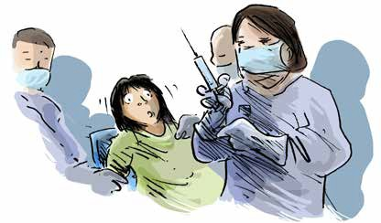
You have the right to quality, accessible, medical care
- You have the right to make decisions about the medical care you receive
- You have the right to privacy and confidentiality around your health care
- If a doctor or psychiatrist has ordered that you need to have a medical treatment, you have the right to have that decision reviewed regularly
- You should have access to all treatments, medication and therapy you need

Examples
Questions

Have you seen a doctor or dentist since you arrived in the facility? Have you seen your medical records while being here?
Was your consent sought before you received medical or psychiatric treatment?

Has the decision for this treatment been reviewed? How often, and who is involved?

Do you have access to someone (nurse, disability support worker, advocate, lawyer) who can help you understand the medical decisions being made?

Do you have access to the medication or treatment you need?

Have you ever been denied a treatment or medical appointment you have requested?
Mack has requested to see a podiatrist multiple times as he has an ingrown toenail. Mack has been repeatedly told that when his behaviour is not so challenging, it will be safe for the podiatrist to see him. As a result, Mack’s’ ingrown toenail has become infected and he now requires extensive medical intervention.

Kelly has requested multiple times to see her medical files and a list of all her current medications as she has been experiencing
concerning side effects. Her treating team has repeatedly denied Kelly’s request and advised her that she just needs to focus on getting better and not what medication she is on.

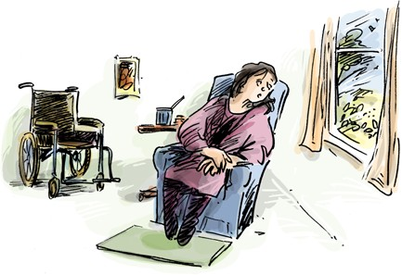
You have the right to decent conditions while in this facility
- This includes having access to accessible facilities
Examples
Questions

Do you have a window in your room that provides natural sunlight?

Can your window be opened for fresh air, or are there other forms of ventilation?

Can you use a bathroom that is accessible for you?

Do you have privacy when using the bathroom or toilet? How many people do you share a room with?
What is the quality of your food and drink? Have you ever been denied food or drink?
Whilst Jake was in solitary confinement, he was only able to flush the toilet three times a day which resulted in waste building up. Jake requested more hand soap and toilet paper as he was going to run out, however this request was denied by nursing staff who stated they did not believe him.

Isla was held in solitary confinement for 4 days, during this time she was not allowed outside due to staff shortages.
Isla’s room had no natural sunlight or windows for fresh air. Isla was also subject to repeated missed meals due to staff not being available to sit with her to eat. When Isla left solitary confinement, she had to be moved to a medical ward for treatment due to dehydration and malnutrition.

You have the right to be safe
- While you are being detained, you should be protected from violence, abuse or neglect
from staff or other patients
Examples
Questions

Do you feel safe?

Are there particular places where you feel less safe, and if so, why? Are there particular people you feel less safe with, and if so, why? Have you been verbally bullied by staff or other patients?
Have you ever been physically hurt by staff or other patients?

If you have been hurt and you needed medical care, was it provided?

Has anything been done about the violence, abuse or neglect you experienced?
James identifies as a non-binary person and has told everyone their pronouns. There are a few nurses in the facility that do not support James’ identity and purposefully use the wrong pronouns and use discriminatory slurs (e.g.,
transvestite). James has requested via their treating team that they would like to transfer facilities as they do not feel safe.
Their treating team has declined the request multiple times stating that James is making it up as part of their diagnosis.

When Diane was admitted she advised staff that she had cerebral palsy and required support with mealtimes. Diane has been experiencing challenging behaviour at mealtimes due to acute paranoia. As a result, the nursing staff repeatedly mechanically restrain Diane while force feeding her. Diane does not feel safe in the facility.

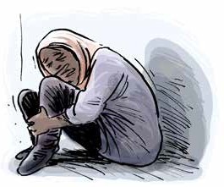
You have the right to access support you need to do everyday tasks,
understand what is happening to you, and make decisions
- An individualised assessment of support requirements should be completed as soon as a person is admitted
- If you have already been receiving support in the community, this support should never
be denied, withheld, or stopped without your permission
Examples
Questions

Do you need help understanding what is happening or to make decisions? Have you had access to a disability advocate to support you with this?

Do you need any support with everyday activities?

Has there been an assessment of the help that you need since you were admitted? Is there a plan for this support to be provided? Have you seen that plan?
Have you been provided with the support you need? For example, if you use an interpreter, has one been provided for you?

Has your support ever been withheld or stopped as a punishment or to make you feel bad?

How long was your support withheld, or stopped?

What happened to you because your support was withheld or stopped? Were you at risk of harm or in danger? Were you unable to move around and do everyday tasks? Were you isolated from friends, family, your lawyer or advocate?
Martin has an assistive technology device that supports him to communicate. The nursing staff removed this device from Martin as punishment for challenging behaviours. This often meant Martin could not communicate for periods of up to 48 hours. Martin was unable to communicate when he needed medication during these periods and as a result, was often placed in solitary confinement until he could ‘calm down.’

Louise’s NDIS supports were withheld as a result of her speaking to an advocate and raising concerns regarding her medication with one of her support workers. Louise was told that she could have her supports re-instated
if she stopped discussing her medication concerns with the support workers and agreed to adhere to the treatment plan. As a result, Louise became isolated from friends, family and her advocate.

Acknowledgements

We acknowledge the following sources in the drafting of the examples used in this resource:

- Christmas Island Medical Officer’s Letter of Concerns – For review by International Health and Medical Services Management and Executive. November 2013
- Council of Europe/European Court of Human Rights Factsheet series (“Detention conditions and treatment of prisoners”, “Detention and Mental Health”, “Prisoners’ health rights” & “Covid-19 health crises”) 2022
- COVID-19 AND OPCAT: Detention of people with disability, and older people. Australian Disability and Aged Care OPCAT Working Group. June 2020
- Response to Australian Human Rights Commission OPCAT in Australia Consultation Paper. Advocacy for Inclusion. July 2017
- Submission to the Senate Inquiry into Violence, abuse, and neglect against people with disability in institutional and residential settings. Australian Cross Disability Alliance (ACDA) August 2015
- Submission to the Special Rapporteur on the Rights of Persons with Disability: Abuse of Students with Disability in Australian Schools. Children and Young People with Disability Australia (CYDA). July 2016
- The Plight of People Living with Disabilities within Australian Immigration Detention: Demonised, Detained, and Disowned. National Ethnic Disability Alliance (NEDA) 2015
- WWDA Response to Restrictive Practices Issues Paper – to the Royal Commission into Violence, Abuse, Neglect and Exploitation of People with Disability. Women With Disabilities Australia. July 2021

For more information or copies of the other resources in this OPCAT monitoring series, please contact us on 1300 130 582 or visit the resource webpage www.qai.org.au/opcat-monitoring-resources/.

Notes

Notes

