Queensland Advocacy for Inclusion

Advocacy for people with disability

Places of Detention in Queensland

Submission by Queensland Advocacy for Inclusion

To the Royal Commission into Violence, Abuse, Neglect and Exploitation of People with Disability

September 2022

About Queensland Advocacy for Inclusion
Queensland Advocacy for Inclusion (QAI) (formerly Queensland Advocacy Incorporated) is an independent, community-based advocacy organisation and community legal service that provides individual and systems advocacy for people with disability. Our mission is to advocate for the protection and advancement of the fundamental needs, rights and lives of people with disability in Queensland. QAI’s Management Committee is comprised of a majority of persons with disability, whose wisdom and lived experience is our foundation and guide.

QAI has been engaged in systems advocacy for over thirty years, advocating for change through campaigns directed at attitudinal, law and policy reform. QAI has also supported the development of a range of advocacy initiatives in this state. For over a decade, QAI has provided highly in-demand individual advocacy services. These services are currently provided through our four advocacy practices: the Human Rights Advocacy Practice (which provides legal advocacy in the areas of guardianship and administration, disability discrimination and human rights law and non-legal advocacy support with the Disability Royal Commission and the justice interface); the Mental Health Advocacy Practice (which supports people receiving involuntary treatment for mental illness); the NDIS Advocacy Practice (which provides support for people challenging decisions of the National Disability Insurance Agency and decision support to access the NDIS); and the Disability Advocacy Practice (which operates the Pathways information and referral line, and provides non- legal advocacy support with Education and other systems that impact young people with disability).

From 1 January 2022, we have been funded by the Queensland Government to establish and co-ordinate the Queensland Independent Disability Advocacy Network (QIDAN), which includes operating the Disability Advocacy Pathways Hotline, a centralised phone support providing information and referral for all people with disability in Queensland. We have also been funded to provide advocacy for young people with disability as part of the QIDAN network, which we provide in addition to our non-legal education advocacy for Queensland students with disability. Our individual advocacy experience informs our understanding and prioritisation of systemic advocacy issues.

The objects of QAI’s constitution are:

- To advocate for the protection and advancement of the needs, rights and lives of people with disability in Queensland;
- To protect and advance human rights including the Convention on the Rights of Persons with Disabilities (CRPD);
- To be accountable to the most disadvantaged people with disability in Queensland; and
- To advance the health, social and public wellbeing of disadvantaged people with disability.

QAI’s recommendations

- The Disability Royal Commission specifically examine the experiences of people with disability in disability-specific sites of detention, such as mental health wards and forensic disability services.

- The Disability Royal Commission make recommendations regarding Australia’s implementation of the Optional Protocol to the Convention Against Torture (OCPAT) to ensure it has a disability-aware approach and includes monitoring mechanisms for disability-specific places of detention.

Introduction
QAI is dedicated to upholding the human rights of people with disability, including rights under the Convention on the Rights of Persons with Disabilities (CRPD) and the Convention Against Torture (CAT). People with disability are significantly over-represented in all sites of detention and experience higher rates of violence in these settings. They are subject to disability-specific types of torture and ill-treatment, such as the use of Restrictive Practices. Further, people with disability are subject to disability-specific types of detention, such as being held in mental health wards and forensic disability centres.

As a result of our work supporting clients in closed environments, QAI holds grave concerns regarding some of the physical and psychological conditions that people deprived of their liberty can endure when detained in certain Queensland-government funded institutions. The upcoming visit by the Subcommittee on the Prevention of Torture and other Cruel, Inhuman or Degrading Treatment or Punishment (SPT) to Australia in late 2022 represents an opportunity to highlight these conditions on the international stage. QAI has written to the SPT and recommended they visit the following three sites of detention during their upcoming visit:

- The Central Queensland Hospital Health Service (CQHHS) Rockhampton Mental Health Inpatient Unit (MHIPU);
- Queensland’s Forensic Disability Service (FDS); and
- West Moreton High Security Inpatient Service (HSIS) at The Park.

Conditions observed directly by QAI staff, along with anecdotal reports from our clients, raise concerns of potential torture and cruel, inhuman, and degrading treatment or punishment of people with disability deprived of their liberty in these institutions. They provide further evidence of the systemic abuse, neglect, and exploitation of people with disability in Australian society.

We are concerned about Australia’s limited progress with regards to implementing the Optional Protocol to the Convention Against Torture (OCPAT). The lack of OPCAT compliant monitoring in these settings, and absence of any publicly known plans to introduce OPCAT compliant monitoring in these settings, constitutes an ongoing risk to people with disability in places of detention and therefore must be examined by the Disability Royal Commission. This submission will begin by canvassing Australia’s current progress with regards to OPCAT implementation, before describing some of the concerning conditions observed in the aforementioned three places of detention.

Australia’s OPCAT implementation
The Australian Government has appeared reticent to implement OPCAT. It recently sought a further extension on its implementation deadline and the proposed model for its National Preventative Mechanism (NPM) raises questions as to its commitment to best practice OPCAT adherence. Australia’s NPM will constitute an NPM Coordinator (the Commonwealth Ombudsman) and an NPM for each state and territory to monitor places of detention within their respective jurisdictions. However, it has explicitly indicated its intention to focus on ‘primary’ places of detention such as prisons, police cells, and immigration facilities,¹ which excludes many sites of detention where people with disability are held, especially disability-specific sites. For example, in Queensland, a recent inquiry into the legislative options for its NPM recommended the passing of the Inspector of Detention Services Bill 2021 (Qld) which notably omitted psychiatric hospitals and other sites of detention primarily occupied by persons with disabilities, such as the FDS, from its remit.

As per Appendix A, this disregards at least 33 of Queensland’s 108 primary places of detention. It disregards studies that have shown Australia lacks a comprehensive system of preventative monitoring for all sites of detention² and ignores the high rates of violence against people with disability in detention settings and the failings of existing systems to protect them from harm.³ Queensland itself currently has eight existing oversight bodies, none of which meet the essential requirement of functional independence of an NPM.⁴ The table in Appendix B further depicts how disability-specific institutions have some of the weakest existing inspection frameworks in Queensland. QAI notes that many disability-specific sites such as psychiatric wards, compulsory care facilities, residential and group homes, and aged care facilities currently lack any inspection framework to monitor them.⁵

There have been no formal proposals for how these places of detention will be monitored under OPCAT and we are concerned about gaps in the monitoring system developing if some places of detention are monitored while others are not. If places of disability-specific detention are separately monitored, it risks a two-tiered system of monitoring developing with a potential for disparity in compliance. All three sites of detention we recommended the SPT visit are not covered by the proposed model of inspection in the Inspector of Detention Services Bill 2021 (Qld). This is particularly concerning given the instances of violence, abuse, neglect, and exploitation that are known to have occurred in these settings, as evidenced at the Disability Royal Commission.⁶

Australia’s obligations under OPCAT should also be considered in the context of its obligations under the CRPD which enshrines full equality under the law for people with disability and protects against discrimination on

¹ George Brandis, “Torture Convention – The Australian Government OPCAT Announcement,” Human Rights Law Centre, 22 February 2017, https://www.hrlc.org.au/bulletin-content/2017/2/22/torture-convention-the-australian-government-opcat- announcement; Manthorpe, Implementation of the Optional Protocol to the Convention Against Torture and other Cruel, Inhuman or Degrading Treatment or Punishment, 8-9.
² Richard Harding, and Neil Morgan, “Ratifying and Implementing OPCAT: Has Australia Missed the Boat?” (paper presented at the
Implementing Human Rights in Closed Environments Conference, Monash University, Melbourne, 21 February 2012), 6.
³ Disabled People’s Organisations Australia, Position Paper: Disability Inclusive National Preventive Mechanism (NPM) (Sydney:
Disabled People’s Organisations Australia, 2018), 3.
⁴ Manthorpe, Implementation of the Optional Protocol to the Convention Against Torture and other Cruel, Inhuman or Degrading Treatment or Punishment, 25.
⁵ Queensland Advocacy Incorporated, OPCAT in Australia (Brisbane: Queensland Advocacy Incorporated, 2017), 10.
6 For example, Report - Public hearing 6 - Psychotropic medication, behaviour support and behaviours of concern.

the basis of disability.⁷ In signing the CRPD, Australia committed to protecting people with disability from all forms of exploitation, violence, and abuse. ⁸ Given the overrepresentation of people with disability in all sites of detention and the disability specific forms of detention that exist, the deprivation of liberty on the basis of disability therefore enlivens rights under both CAT and the CRPD. The implementation of OPCAT is at risk of failing to meet the needs of people with disability unless specific changes are made to monitor disability specific places of detention and ensure a disability aware approach to monitoring throughout Australia. Until then, people with disability will continue to experience, and be at risk of, violence, abuse, neglect, and exploitation in these settings.

Rockhampton Mental Health Inpatient Unit (MHIPU)
QAI’s Mental Health Advocacy Practice provides support to people receiving involuntary treatment for mental illness and provides advice and legal representation before the Mental Health Review Tribunal, including for Forensic Orders, Fitness for Trial Reviews, Applications for Electroconvulsive Therapy (ECT) and Treatment Authorities. QAI maintains a regular presence in the Rockhampton MHIPU and in December 2021, QAI’s Chief Executive Officer and Indigenous Advocate visited the Rockhampton MHIPU to strengthen referral pathways for clients and to provide information about our service to MHIPU staff.

During the visit, QAI received an escorted tour of the facility’s Low Dependency Unit (LDU), High Dependency unit (HDU,) and Older Persons Unit (OPU). The LDU has 23 beds, including 3 HDU beds and 1 seclusion bed, and is intended for adults over the age of 18 years. The OPU has 8 beds and is intended for people over the age of 65 years and for Indigenous persons over the age of 50. There is no specific unit for children. Children are accommodated in the LDU, HDU or OPU depending upon bed availability.

QAI observed the following:

  - In the LDU, there was one large communal area with limited access to activities and resources. The LDU only has four single rooms, with the remainder of the rooms being shared, separated only by a hospital curtain and with very limited privacy. QAI observed that the rooms were sparse with a very basic fit out of a bed, desk, and cupboard. Blood stains were observed on one freshly made empty bed and patients share two bathroom and shower facilities.

The LDU is a high stimulus environment with a wide range of consumers at various stages of recovery. The management of consumers in the LDU is limited due to staffing and resources, with some resources having been removed due to risk. For example, the pool table has been set up as a ping pong table due to concerns about threats to staff with pool balls and the risk of assaults with pool cues.

  - The HDU is a small and highly restrictive environment. Patients share one communal bathroom/shower and have access to a small enclosed concrete courtyard with very limited furnishings. Patients are

⁷ Convention on the Rights of Persons with Disabilities, opened for signature 30 March 2007, A/RES/61/106 (entered into force 16 August 2008), Preamble
⁸ Nora Sveaass, and Victor Madrigal-Borloz, “The Preventive Approach: OPCAT and the Prevention of Violence and Abuse of Persons with Mental Disabilities by Monitoring Places of Detention,” International Journal of Law and Psychiatry 53, no. 1 (2017): 16.

accommodated in small single rooms with a foam mattress on the floor and a small window which cannot be opened to access fresh air.

  - The OPU is a newer build and when not at capacity, is used to accommodate vulnerable patients and other patients who require less oversight. Generally, adolescent patients are nursed on the OPU, however, at times they have been relocated to the LDU or HDU based on clinical presentation.

  - Central Queensland Hospital and Health Service has beds allocated in Royal Brisbane Women’s Hospital (RBWH) which are not readily available. Often, adolescents are stuck on the adult ward in Rockhampton until a bed becomes available in RBWH, or they are discharged home. Transfer to Brisbane for First Nations clients also often means a displacement from family and traditional country.

QAI has heard anecdotal reports that illicit drugs are accessible on the ward and remain a constant issue in the treatment and care of patients. We are also aware of cultural safety concerns for First Nations Australians admitted to MHIPU. First Nations patients can experience trauma when being moved from the Emergency Department to the MHIPU. Consumers can experience lengthy waits in the Emergency Department, sometimes for up to 48 hours, or are sometimes simply discharged due to no bed availability on the ward.
Once admitted to the ward, further trauma can be experienced by some First Nations patients due to inexperienced staff with little understanding of cultural differences, culturally safe practices, and a lack of understanding of First Nations communication styles and cultural nuances. The MHIPU is not a culturally welcoming space and often consumers will abscond due to feelings of isolation and being trapped in an enclosed space.

The use of Hospital Security, engaged by staff “code black” duress calls for assistance, have been observed in some situations as a behaviour management tool. This is opposed to staff using evidenced-based de-escalation techniques, with the resulting “code black” situation often resulting in seclusions in the HDU. Further, First Nations consumers relay stories of not being listened to by their doctors and having to repeat their stories repeatedly. Often First Nations patients and their families will escalate due to feeling disempowered by the mental health system, particularly when there is a lack of, or poor, communication from the treating team.

The following case study is a hypothetical example of our concerns:

Claire

Claire is a 15-year-old Aboriginal girl. Due to Claires presentation she was deemed high risk and nursed on the LDU ward. On the LDU ward, Claire was nursed alongside adult consumers of varying ages and at various stages of acute mental illness. Concerns were raised regarding some of the sexualised and inappropriate behaviour that was being demonstrated by older male consumers on the ward and at one stage, Claire was placed in HDU to manage her own behaviour. Adolescents are provided with a 1:1 special (nurse) however, the risk of exposure to trauma through being nursed on an adult ward is very high. Claire was kept on the adult ward for over two weeks whilst awaiting a bed in RBWH.

The use of Restrictive Practices in closed environments such as Rockhampton MHIPU is a particular area of concern for QAI. Research has found that Restrictive Practices are frequently improperly used in institutional settings, often in violation of existing human rights protocols.⁹ The use of seclusion and confinement is especially harmful to people with cognitive disabilities,¹⁰ and many of the behaviours they seek to control are not inherently irrational behaviours but are instead adaptive behaviours to the maladaptive environment that is institutional care.¹¹ Using Restrictive Practices as a form of behavioural control in some situations could be considered a form of cruel, inhuman, and degrading treatment, and should be considered under an OPCAT lens.

Queensland’s Forensic Disability Service (FDS)
QAI has longstanding concerns regarding Queensland’s FDS, namely in relation to the indefinite detention of some of its detainees and the conditions which detainees can be subject to during their incarceration, including inhumane treatment by staff and a lack of social and community interaction.

Under the Mental Health Act 2016 (Qld), if an accused person is found to have been of unsound mind at the time of an alleged criminal offence, or is deemed to be unfit for trial, the Mental Health Court (Court) may make a Forensic Order (Mental Health) (FO-MH) or Forensic Order (Disability) (FO-D) respectively, if it is considered necessary for the protection of community safety, including from the risk of serious harm to other persons or property.¹² The Court can decide between inpatient and community categories, the latter being traditionally less restrictive and available only if there is not an unacceptable risk to the safety of the community.¹³ Persons with a dual diagnosis of a mental health condition and a disability are placed under a FO-MH. Persons placed under a FO-MH are detained in an authorised mental health service, such as The Park, discussed below. Persons placed under a FO-D are detained at the FDS; a medium secure 10-bed facility at Wacol in Brisbane.

⁹ Paul Ramcharan et al., Experiences of Restrictive Practices: A View From People with Disabilities and Family Carers (Melbourne: Department of Human Services Victoria, 2009) 6.
¹⁰ Michael L. Perlin, “International Human Rights and Institutional Forensic Psychiatry: The Core Issues,” in The Use of Coercive Measures in Forensic Psychiatric Care Legal, Ethical and Practical Challenges, ed. Birgit Völlm, and Norbert Nedopil (Cham: Springer International Publishing, 2016), 16.
¹¹ Ramcharan et al., Experience of Restrictive Practices, 6.
¹² Mental Health Act 2016 (Qld) ss 130(1)(a); 134(1).
¹³ Ibid ss 138. See also ss 139-140.

Indefinite detention

The Mental Health Review Tribunal is tasked with determining when an individual may be released from a Forensic Order, or when the category or conditions of the order can be changed, however there are no nominal or limiting terms on how long a person may be subject to a Forensic Order.¹⁴ Consequently, individuals can be held indefinitely as an inpatient for a period longer than the maximum penalty for the offence allegedly committed.¹⁵ Even where the individual is not an inpatient, Forensic Orders can unduly infringe on their human rights by imposing disproportionately limiting conditions.

Whilst the FDS has the potential to offer a feasible habilitative alternative for persons with an intellectual or cognitive impairment with forensic issues, in its present form, the FDS is not offering a viable alternative to the mainstream criminal justice system and the use of FO-Ds that are not time limited is a serious human rights issue. Indeed, indefinite FO-Ds have many detrimental effects, are not consistent with Australia’s international legal obligations to refrain from arbitrary detention and offer negligible habilitative benefits. They deny certainty for the future and keep people enmeshed in the system beyond the point at which it is appropriate or beneficial.

The UN Committee on the Rights of Persons with Disabilities has also explicitly condemned indefinite detention of people with disability after a finding of unfitness to plead, stating that it is contrary to Article 14 of the CRPD regarding the right to liberty and security.¹⁶ Broadly, custodial and supervision orders are viewed as ‘paternalistic declarations’ preventing an individual from enjoying their autonomy due to their impairment, even if there are other factors used to justify such deprivation of liberty.¹⁷ Although the number of individuals subject to indefinite FO-Ds as inpatients is relatively low, QAI considers it to be a serious issue that must be urgently addressed due to the arbitrary nature of the detention and its impact on liberty and security of persons with disabilities.

Conditions in detention

In addition to indefinite detention of persons subject to FO-Ds at the FDS, QAI has grave concerns regarding the conditions to which some people under FO-Ds can be subject during their incarceration. The Queensland Ombudsman released a damning report on the FDS in 2019 following an investigation which found that the FDS was significantly non-compliant with the legislation designed to safeguard the care, protection, and rights of the vulnerable persons it accommodated, and that despite problems being regularly identified, little action had been taken and confusion remained as to who was responsible for ensuring compliance with the legislation.¹⁸ Among the issues identified were the use of seclusion and Restrictive Practices. For more than

¹⁴ For discussion of nominal and limiting terms, and jurisdictions utilising them, see, Bernadette McSherry et al, Unfitness to Plead and Indefinite Detention of Persons with Cognitive Disabilities (Melbourne Social Equity Institute, 2017).
¹⁵ Ibid 20-21; McCausland & Baldry (n 2) 298.
¹⁶ Arstein-Kerslake et al (n 45) 408; Piers Gooding et al, ‘Unfitness to Stand Trial and the Indefinite Detention of Persons with Cognitive Disabilities in Australia: Human Rights Challenges and Proposals for Change’ (2017) 40 Melbourne University Law Review 816.
¹⁷ Arstein-Kerslake et al (n 45) 408; Law Council of Australia (n 4) 72; Piers Gooding and Charles O’Mahony, ‘Laws on
unfitness to stand trial and the UN Convention on the Rights of Persons with Disabilities: Comparing reform in
England, Wales, Northern Ireland and Australia’ (2016) 44 International Journal of Law, Crime and Justice 122, 133-4. ¹⁸ Queensland Ombudsman, The Forensic Disability Service Report: An investigation into the detention of people at the Forensic Disability Service (August 2019)

five years, the FDS did not even have a behaviour control register, meaning that the use of Restrictive Practices was not even recorded, let alone compliant with the relevant regulatory framework.¹⁹

One person was found to have been in seclusion for more than six years, only allowed to communicate with staff through a narrow horizontal slot through which meals were passed to him and was only permitted seclusion breaks for one minute or less.²⁰ It was also reported that the police had been called on multiple occasions and frequently used dogs to control his behaviour. The investigation found that police had entered into the adult’s records that, ‘he hates dogs, and it works every time’, and that he was left crying in the foetal position in response. To QAI’s knowledge, no significant changes have occurred since this report was released in 2019.

The FDS is not intended to operate on a retributive mandate – its stated function is not to punish but rather to minimise the risk that persons placed under an FO-D allegedly pose to themselves or others, and to support those in detention with a view to ultimately releasing them and fully integrating them back into the community. Persons under an FO-D have been charged with an indictable offence, however this charge has never been tested in a court of law. Whether in fact the alleged offence was committed at all, and if so, by the accused individual, is not proven to the requisite standard, i.e. beyond all reasonable doubt. Further, a person cannot be found criminally responsible for an offence committed while the person was of ‘unsound mind’. This means that even if the person did commit the offence, they cannot be held criminally culpable for it if their intellectual or cognitive impairment impairs their capacity to the requisite extent. Indefinite restrictive orders and/or incarceration of persons with an intellectual or cognitive impairment within the FDS therefore entails multiple breaches of their human rights.

The mandate of the FDS is that each person should progress along an individualised development plan that is designed with input from the person and their family, professionals and supporters and sets out the educational and training programs that will assist the person to transition back into the community. However, the reality is starkly different, with FO-Ds effectively operating indefinitely and significantly fettering autonomy and habilitation. For those whose orders require detention, there are very limited opportunities for social and community interaction and involvement. This appears to reflect a reticence to approve community involvement due to the risk assessment-based model that the FDS operates on. Typically, the prospect of community engagement is considered to pose unduly high levels of risk and, particularly for some residents, be excessively resource-intensive and difficult to arrange. The image of the FDS as a ‘transitional’ facility is therefore challenged by the reality that, since it opened in 2011, very few residents have been successfully transitioned back into their community.

Further, the culture of the FDS Unit is highly institutionalised in an age where institutionalisation is no longer considered appropriate and social and community inclusiveness is instead the recognised goal for persons with intellectual or cognitive disability. In maintaining the FDS, Australia has not fulfilled its human rights obligations to people with disability (whose care and lives they have been entrusted with), to their families and supporters or to society. Despite the time that has passed since its inception and the significant funding that has been invested into it, the FDS Unit is a failed prototype, the trialling of which has been at significant human cost to the persons incarcerated within it.

¹⁹ Ibid, p63
²⁰ Ibid, p80

West Moreton High Security Inpatient Service (HSIS) at The Park
QAI has concerns that, if a person has a mental health condition as well as a disability, they are placed under a Forensic Order-Mental Health and may be detained in an authorised mental health service, such as The Park. This means that they are subject to a treatment paradigm that does not adequately reflect their disability needs, has limited habilitative benefit and can therefore prevent the person from accessing the support they need to successfully transition off their order.

At the West Moreton High Security Inpatient Service (HSIS) at The Park, the majority of patients are Classified patients who are transferred from custody either involuntarily or voluntarily requiring psychiatric inpatient treatment, or patients subject to a Forensic Order (MH) who may also have a disability. Whilst an inpatient at HSIS, consumers are subject to provisions under the Mental Health Act 2016 (Qld) relating to searches on entry and admission and when there is a concern of risk. In addition, there is provision under the legislation for consumers to be placed in overnight confinement for security purposes stemming from risk.

HSIS contains five secure units, including a 9 bed High Dependency Unit (HDU) for consumers who are determined to be at high risk to themselves, co-consumers, and staff. HSIS is similar to a prison environment with security checks and searches upon entry and the requirement for escorts to move around the premises. The HDU is a low stimulus unit and operates as a highly structured environment.

During the course of our work, QAI has observed conditions in the HDU. We have observed that consumer rooms are akin to seclusion rooms, with little to no furnishings due to low stimulus requirements and the risk assessment concerns of staff and management. Contact with nursing staff and provision of meals is facilitated through a latch in a heavy secure door. The HDU environment does provide options for consumers to access open areas, as deemed clinically appropriate, however our experience is that most consumers within the HDU environment do not meet the requirements for less restrictive measures such as this, as per the HSIS’s policies.

QAI representatives are frequently denied access to clients in the HDU and are unable to discuss legal matters in a confidential manner, reportedly on the basis of safety concerns. QAI has also been informed by family members that they are often refused contact with consumers via telephone or in person for the same reason and that family visitations may be cancelled on the day of the scheduled visit or even on late notice.

QAI representatives have often been required to proceed with client conferences in a non-confidential manner and obtain instructions for matters where the client is prohibited from meaningfully participating due to safety concerns of staff. It is reported that contact is typically facilitated by nursing staff holding the phone through the latch of the consumer’s room door on speaker phone to enable the consumer to talk. This is typically ineffective as the consumer is too distant from the phone to participate meaningfully and audibly raise any concerns about access to legal representation and confidentiality.

In QAI’s experience, in-person access to the HDU has only ever been facilitated via an external parameter fence that backs on to a small, grassed courtyard of the consumer's room. The client is several meters away from the legal representative during this interaction and there is a secure wire fence blocking access. This means that there is no ability to provide any legal documentation directly to the client.

Conclusion
People with disability are over-represented in all sites of detention, experience higher rates of violence in these settings, and are subject to disability-specific types of detention. OPCAT presents a unique opportunity to strengthen oversight for all sites of detention in Queensland, but particularly disability-specific and disability-dominated institutions, many of which currently lack any meaningful inspection framework and facilitate conditions that either constitute, or lead to, violence, abuse, neglect and exploitation of people with disability.

There is a critical need for disability to be held centrally to Australia’s OPCAT’s implementation and for implementation to be disability-aware. However, QAI considers that Australia’s current approach fails to fulfil its obligations under OPCAT, and we are concerned that practices of torture and cruel, inhuman and degrading treatment may occur in the absence of sufficient scrutiny. It is therefore imperative that the Disability Royal Commission examines these issues and make recommendations that will protect against further violence, abuse, neglect and exploitation of people with disability in places of detention.

QAI thanks the Disability Royal Commission for the opportunity to contribute to this inquiry. We are happy to provide further information or clarification of any of the matters raised in this submission upon request.

Appendix A

Estimated Total Number of Facilities Falling Within the Definition of Primary Places of Detention Within States and Territories

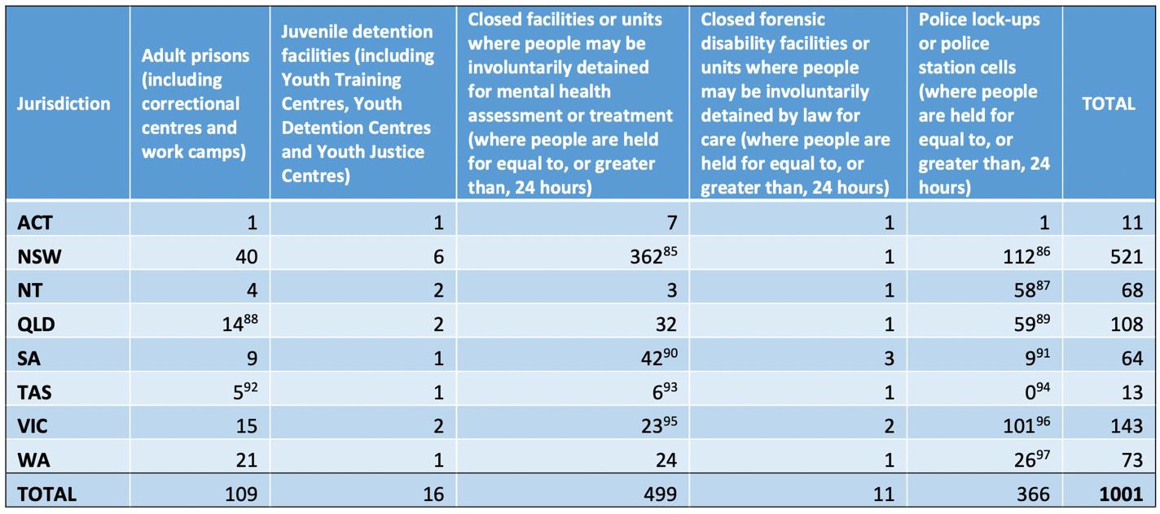

Michael Manthorpe, Implementation of the Optional Protocol to the Convention Against Torture and Other Cruel, Inhuman or Degrading Treatment or Punishment (Canberra: Commonwealth Ombudsman, 2019), 31.

Appendix B

Current Oversight for Sites of Detention in Queensland

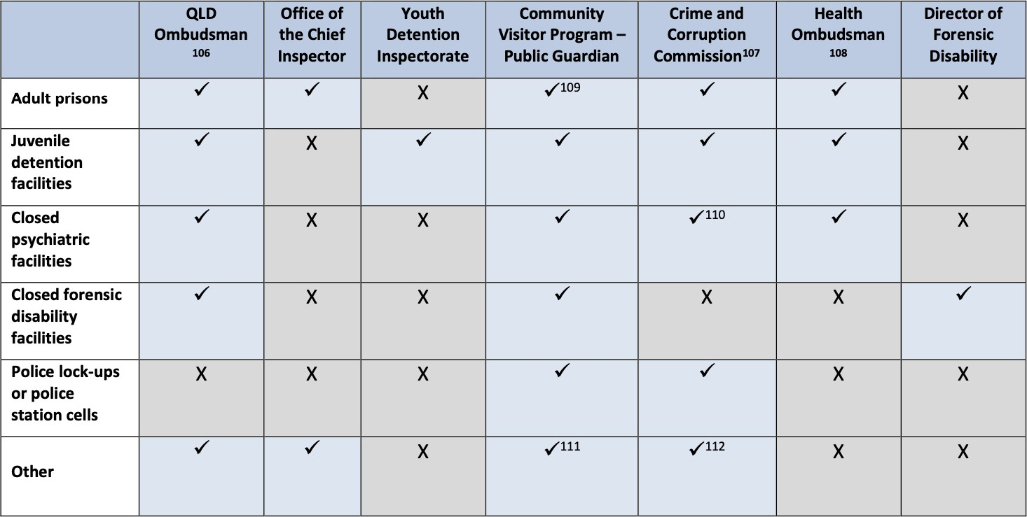

Michael Manthorpe, Implementation of the Optional Protocol to the Convention Against Torture and Other Cruel, Inhuman or Degrading Treatment or Punishment (Canberra: Commonwealth Ombudsman, 2019), 37.

