Natural Disaster Advocacy Program

What we do
Our new specialist program provides legal help to Queenslanders with disability who were impacted by the 2022 floods.

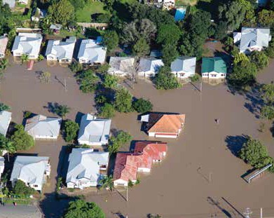
To discuss how we may be able to assist you, please contact us today.

Queensland Advocacy for Inclusion
Advocacy for people with disability

Phone: 1300 130 582
Email: qai@qai.org.au
Website: www.qai.org.au
Twitter: @QldAdvocacy
Facebook: @QueenslandAdvocacy
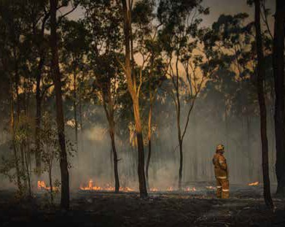
If you or someone you know needs help with the impacts of the 2022 floods, or if you would like more information about our services, please contact our office.

