

LGBTQIA+SB Pilot
Project Report

To the Department of Families, Seniors, Disability Services and Child Safety

25 July 2025

About Queensland Advocacy for Inclusion
Queensland Advocacy for Inclusion (QAI) is a Disabled Peoples Organisation. We are an independent, community-based advocacy organisation and community legal service that provides individual and systems advocacy for people with disability. Our purpose is to advocate for the protection and advancement of the needs, rights, and lives of people with disability in Queensland. QAI’s Management Committee is comprised of a majority of persons with disability, whose wisdom and lived experience guides our work and values.
QAI has been engaged in systems advocacy for over thirty-five years, advocating for change through campaigns directed at attitudinal, law and policy reform.
QAI also provides individual advocacy services in the areas of human rights, disability discrimination, guardianship and administration, involuntary mental health treatment, criminal justice, NDIS access and appeals, and advocacy for young people with disability including in relation to education. Our individual advocacy experience informs our understanding and prioritisation of systemic advocacy issues.
Since 1 January 2022, QAI has also been funded by the Queensland Government to establish and co-ordinate the Queensland Independent Disability Advocacy Network (QIDAN). QIDAN members work collaboratively to raise the profile of disability advocacy while also working towards attitudinal, policy and legislative change for people with disability in Queensland. In this report, these organisations will be referred to as “QIDAN members”.
Note on Language
Language is a powerful tool for building inclusion. We use person-first language by using the term ‘people with disability’ but recognise that many people with disability prefer identity first language (i.e. a disabled person). The term ‘people with lived experience’ is used for people with disability, as well as their family members, carers and kin.
We endeavour to use language that is respectful and in line with the QC language guide.

Contents
About Queensland Advocacy for Inclusion 2
Introduction 4
About the Queensland Council for LGBTI Health (QC) 5
What occurred during the pilot 6
Qualitative data analysis 6
Community Engagement Initiatives 7
Capacity building for advocates 8
Themes identified throughout the pilot 12
Data analysis 14
QIDAN Data 14
Data From the Community 17
Learnings from the Project 20
Barriers to the LGBTQIA+SB disability community 22
Barriers within the disability advocacy sector 26
The need for a specialist advocacy program 30
Conclusion 32
Appendix 1 33
Appendix 2 34

Introduction
QAI welcomes the opportunity to provide this report on the Lesbian, Gay, Bisexual, Transgender, Queer, Intersex, Asexual, Sistergirl, and Brotherboy (LGBTQIA+SB) Pilot Project (the Project), where we provide our findings from the Project, and make recommendations for future advocacy. QAI, as the coordinators of QIDAN, have previously identified that the Queensland advocacy sector has had limited engagement with the LGBTQIA+SB community, and have previously requested specific Queensland Government funding for LGBTQIA+SB people with disability in QIDAN’s Budget Submissions. In addition, the Royal Commission into Violence, Abuse, Neglect and Exploitation of People with Disability (DRC) also recognise that value of culturally safe advocacy, and Recommendation 6.23 of the DRC Final Report speaks to the need to improve cultural capabilities of the sector, including LGBTQIA+SB safety and inclusivity. As a result, QAI received funding from the Queensland Government to run the project in October 2024, and engaged The Queensland Council for LGBTI Health (QC) to help facilitate the Project shortly thereafter. The purpose of the Project was to:
- Build the capacity of QIDAN members and the advocacy sector;
- Build the LGBTQIA+SB community awareness of disability advocacy;
- Identify advocacy gaps and service needs for LGBTQIA+SB people with disability; and
- Increase the inclusion of the voices of LGBTQIA+SB people with disability within QIDAN’s systemic advocacy.
In this report, we provide an overview of the activities of the Project, including those undertaken with the advocacy sector and within the community of LGBTQIA+SB people with disability. We also summarise the themes of issues faced by the community of LGBTQIA+SB people with disability that were identified throughout the Project. The report then leads to a data analysis, and QAI’s learnings and key findings from the Project.
Throughout the Project, QAI identified that the community of LGBTQIA+SB people with disability face barriers to accessing individual advocacy, despite there being an apparent need for advocacy. QAI recommend that the Queensland Government commit to ongoing funding for a specific specialist advocacy service for LGBTQIA+SB Queenslanders with disability who would be dedicated to providing specialised individual and systemic advocacy to this community. Currently, there are three specialist advocacy services offered across the state, and each service focuses on providing individual advocacy to specific cohorts of people with disability (Aboriginal and Torres Strait Islander peoples, culturally and linguistically diverse peoples, and children and young peoples).

About the Queensland Council for LGBTI Health (QC)
QC has proudly served as a home and a voice for Lesbian, Gay, Bisexual, Transgender, Intersex, Queer, Sistergirl and Brotherboy (LGBTIQ+SB) communities across Queensland for over 40 years. As a community-led and community-owned health and wellbeing organisation, QC is committed to walking alongside our diverse communities, adapting our services to meet evolving needs, and ensuring every person feels seen, respected, and supported.
QC recognise the specific and often compounded challenges faced by LGBTIQ+SB people living with disability. QC’s disability-focused work is grounded in the belief that everyone deserves access to safe, inclusive, and affirming services. They are committed to creating spaces where people with disability can connect, contribute, and thrive—where identities are honoured and voices are not only heard, but amplified. Through community consultation and initiatives such as Disabilities Steering Committee, they continue to grow pathways for meaningful participation and systemic change.
2Spirits, now its own incorporated association, works closely in partnership with QC to promote the health and wellbeing of Aboriginal and Torres Strait Islander LGBTIQ+ Sistergirl and Brotherboy people across Queensland. Grounded in cultural, strength and community leadership, 2Spirits envisions a future where all Sistergirl and Brotherboy people are valued and included—both within Aboriginal and Torres Strait Islander communities and the broader LGBTIQ+SB community. The program works to build the capacity of individuals and communities to respond to issues like HIV, mental health, ageing, and substance use with culturally safe and informed approaches.
Together, QC and 2Spirits are proud to walk with our communities and partners to strengthen inclusion, visibility, and access for LGBTIQ+SB people living with disability, building a future where all people can live full and empowered lives.

What occurred during the pilot
From July 2024 to June 2025, QAI collaborated with QC to run a Project, focussing on the intersectionality of people from our LGBTQIA+SB communities and disability. Mitch Medcalf and Annabelle Oxley, both experts in this field, were seconded from QC to lead the initiative. A comprehensive project plan was jointly developed to guide the Project’s direction and ensure it effectively addressed the needs of this community.
Throughout the Project, Mitch and Annabelle, supported by QAI and QC, concentrated on several key areas, achieving largely positive results. These included data gathering, community engagement, resource development for advocates, and exploring broader advocacy within their communities.

Qualitative data analysis
The initial phase of the Project focused on collecting qualitative data to understand community perspectives. QAI sought insights into the types of advocacy issues experienced by the LGBTQIA+SB community, and some of the key issues identified were challenges navigating the National Disability Insurance Scheme (NDIS), difficult and problematic experiences in the health system, and the unique challenges faced by Aboriginal and Torres Strait Islander peoples within this intersection. The primary goal of this data collection was to ascertain the general need for a dedicated advocacy service for LGBTQIA+ people with disability.
While challenges arose, such as the scarcity of existing data on this intersectionality and access issues experienced by Aboriginal and Torres Strait Islander peoples with disability, the information gathered positively supported the need for such an advocacy service. Further details on the trends identified are elaborated in the "Themes identified throughout the pilot" section of this report.

Community Engagement Initiatives
The Project incorporated two key community engagement initiatives: in-person Tea Dances and online "Amplifying Voices" panel discussions, both designed to foster connection and address the unique needs of LGBTQIA+SB communities with disability.
Tea Dances
Held every second month at various QC sites across Queensland (Gimuy Cairns, Gurambilbarra Townsville, Naamba Sunshine Coast, Meanjin Brisbane, and Toowoomba), the Tea Dances offered a welcoming and inclusive in-person space. These events, held in partnership with QAI, aimed to provide a relaxed atmosphere where community members could connect, share stories, and celebrate diversity. While primarily in-person, an online option was also available to ensure broader participation. While these events saw lower attendance than the ILC Tea Dances, due to factors such as timing and venue location, a significant positive was the concurrent rollout of Tea Dances across all QC locations in Queensland as part of the new Gayawur Rainbow program, a joint program initiative between 2Spirits, QC and the Queensland Government.The Tea Dances provided a vital opportunity for social connection and community building, over 27 people engaged across the State, with 63% of engagement in Townsville.
Amplifying Voices Online Panels
The "Amplifying Voices" series comprised monthly online discussion panels, hosted collaboratively by QC and QAI. These one-hour sessions delved into the experiences, challenges, and future connection points within LGBTQIA+SB communities with disability. Each panel focused on specific topics relevant to the intersection of disability and identity, such as navigating the NDIS, housing rights, employment, and self-advocacy, ageing and closing the gap. Panellists, including Mitch and Annabelle, as well as advocates from QIDAN, shared insights and discussed gaps in advocacy, health, and social settings. Some of these online panels were strategically coordinated to coincide with the in-person Tea Dances, creating a blended engagement approach. These events were designed to be an insightful and transformative dialogue, open to everyone.
These online sessions were often well-attended with over 120 people engaging across the six panels, featuring informative discussions and relevant questions from participants. The online sessions were recorded and are available to view here: https://www.qc.org.au/disability.

Capacity building for advocates
QC collaborated with QAI to deliver an online Community of Practice (CoP) session to the advocacy sector on the context and learnings from the Project. The CoP session occurred on the 1st of April 2025, and 51 advocacy staff members attended. In the session, QC and QAI asked prompting questions like “is it okay to ask CALD people the intake question about being LGBTQIA+SB?” and “is it okay to use the word “queer?” to gauge the attendee’s level of comfort and competence working with LGBTQIA+SB clients with disability. QC and QAI observed that there were many attendees who were keen to develop their capacity and wanted to make their personal practice and respective organisations safer for the LGBTQIA+SB community. Some attendees shared that they were unsure of how to use certain inclusive language, and others identified complexities in asking peoples from certain cultural backgrounds questions about their gender, diverse bodies and/or sexuality. The CoP identified that there is room to learn and grow as a sector, and significant interest from advocacy staff to do so.
QC also contributed to two QIDAN events organised by QAI, including a QIDAN manager’s meeting and the QIDAN conference. The QIDAN meeting was held on the 13th and 14th of March 2025, and Mitch and Annabelle appeared on panels about the Project and about making intersectionality a priority in advocacy. The QIDAN Qld Disability Advocacy Conference was held between the 27th and 29th of May 2025, with the theme ‘Uniting for Impact’. All of the panels and speakers spoke about the importance of intersectionality in our work and lives. Mitch attended, spoke on the First Nations panel, and DJ’d at a networking event, and Annabelle spoke on a panel about community engagement. Graphic Recording of the First Peoples First panel and Centering Intersectionality keynote with Akii Ngo attached as Appendix 1.
Image of Mitch on the First Nations Fist Panel
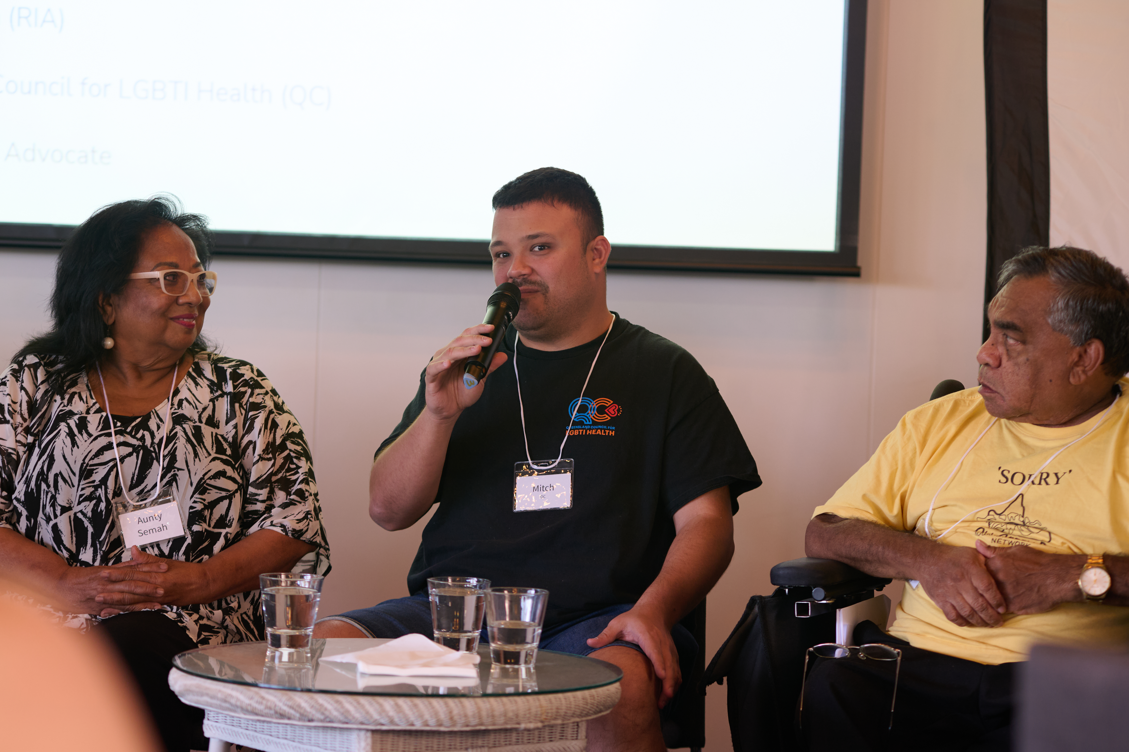
Image of Mitch as DJ
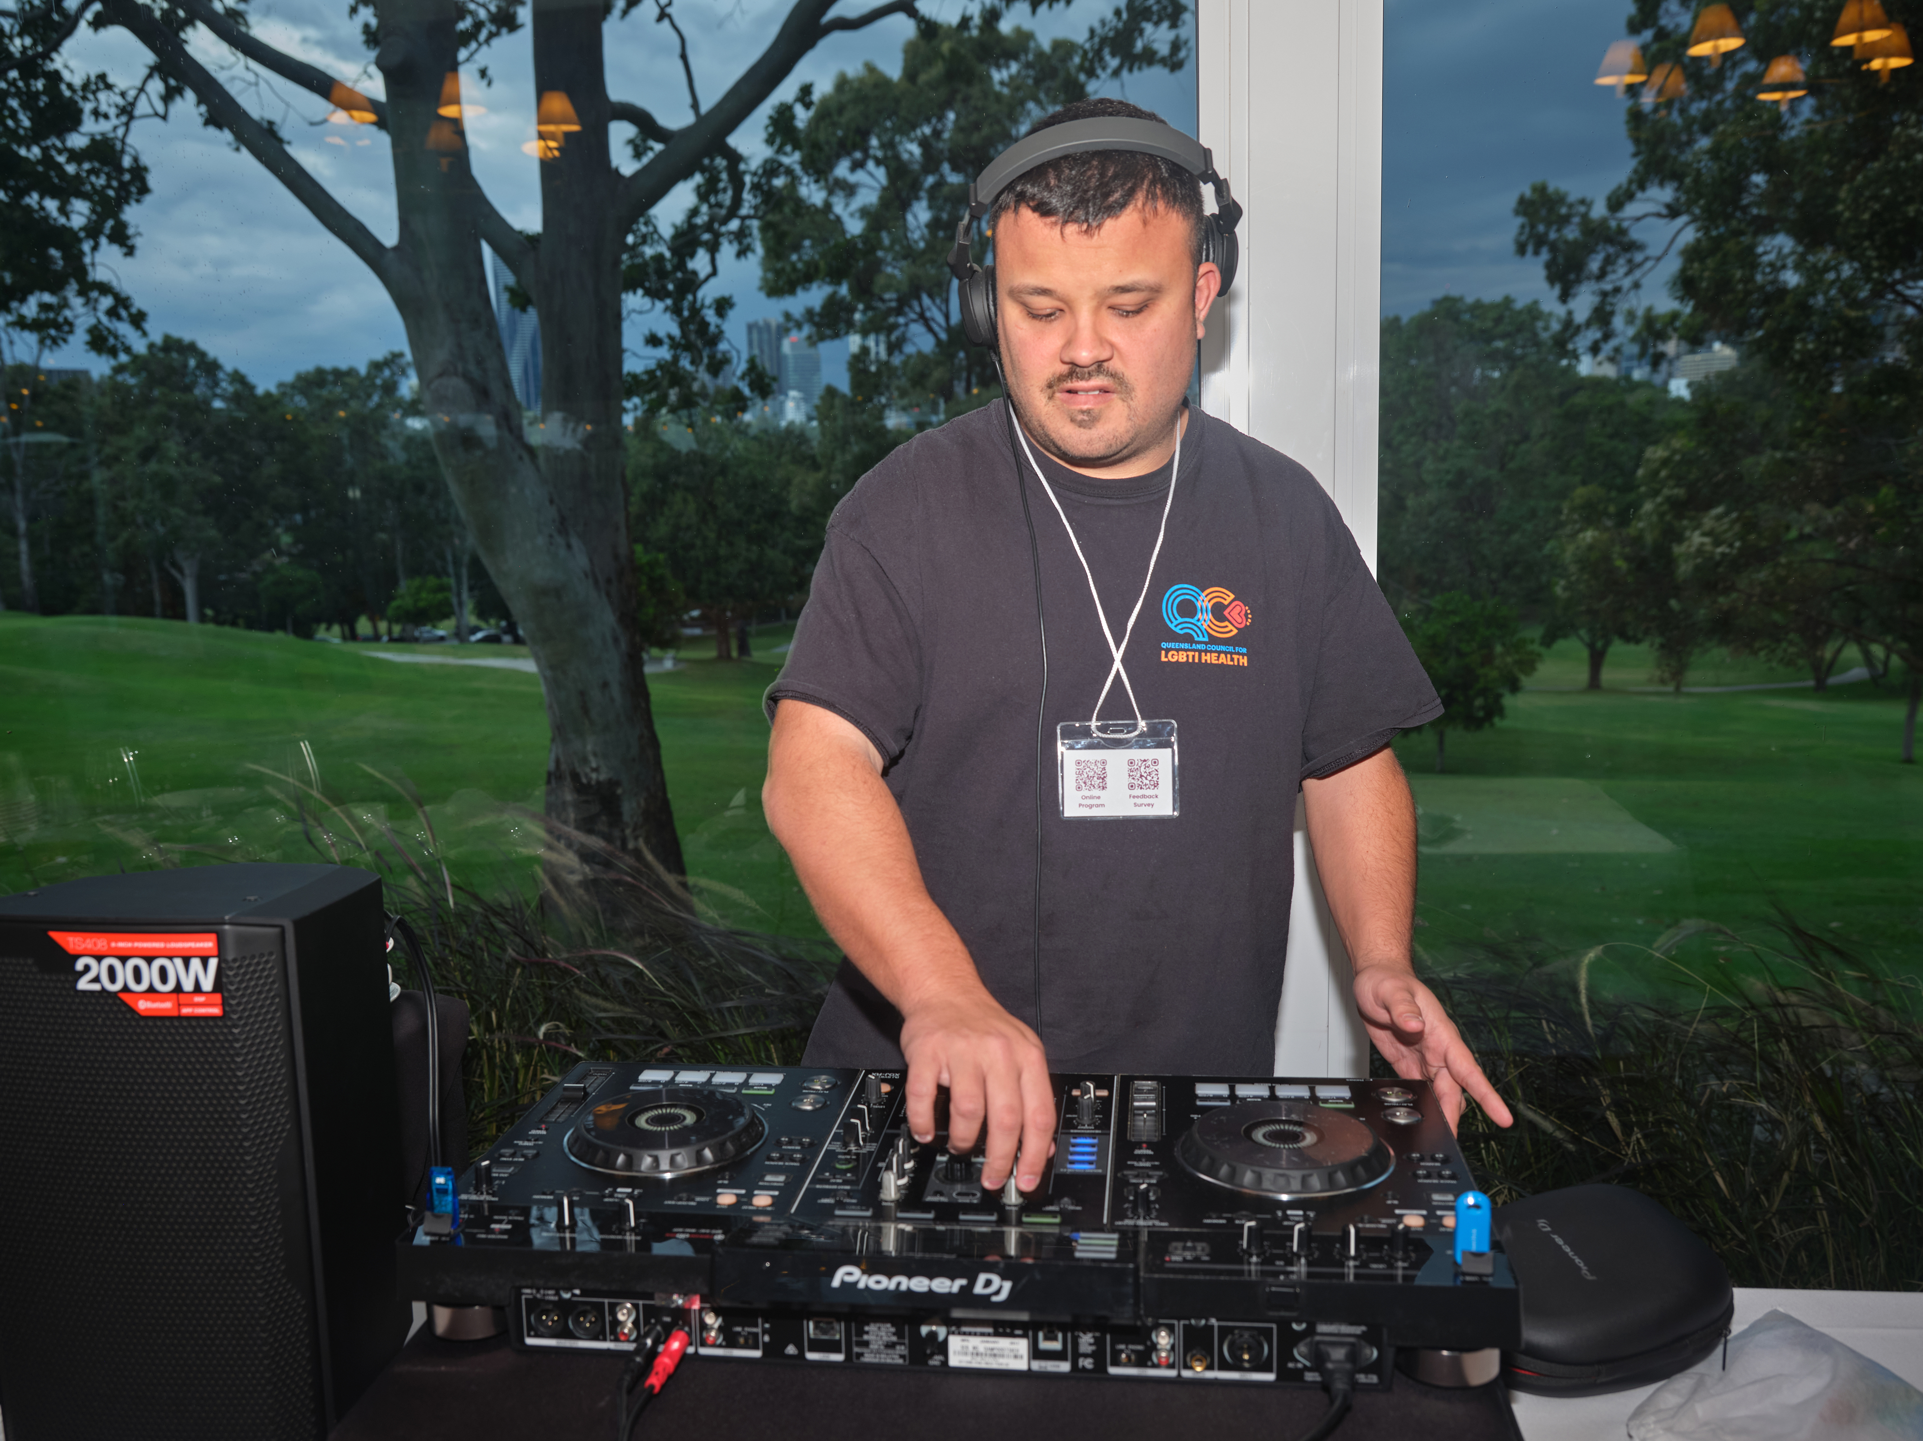
Resource Development
A key objective on the Project was to create informative and succinct resources for advocates and allies supporting LGBTQIA+SB people with disability. The team developed a resource, which is a collaborative publication between 2Spirits, QC, and QAI. This resource focuses on best practices for advocates assisting LGBTQIA+SB people with disability. Its creation drew upon personal experiences, community perspectives, and guidance from the QC Steering Committee.
The resource covers critical topics such as disclosure of gender and sexuality, understanding sensory needs, initiating early conversations with clients, and empowering clients to direct their own advocacy support. This comprehensive resource has been condensed into a fact sheet for quick and easy reference.
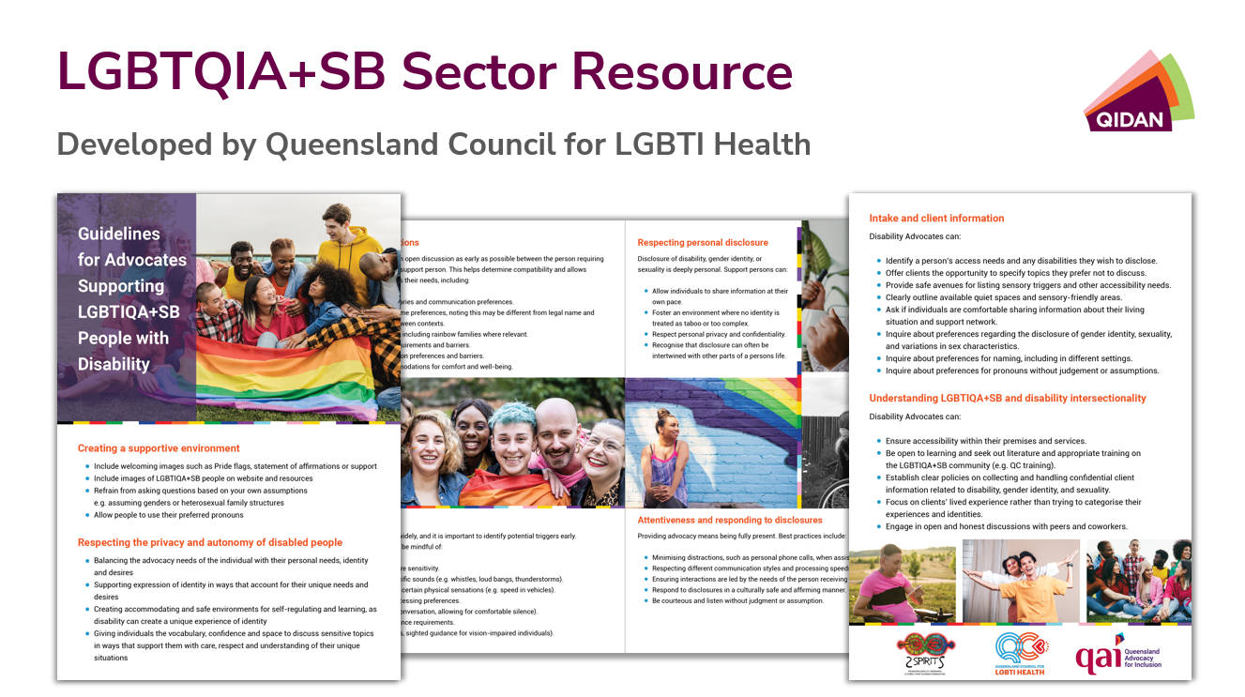
LGBTQIA+SB Disabilities Training Workshop
As part of the Project, QC and QAI delivered a professional development LGBTQIA+SB Disabilities Training Workshop for members of QIDAN. This half-day online workshop was designed to explore the intersectionality of disability and LGBTQIA+SB lived experience. 26 people RSVP’d to the training, and approximately 17 people attended on the day with the recording saved on the QIDAN Teams site for advocates access.
Grounded in lived experience and community knowledge, the workshop aimed to guide participants in:
- Understanding LGBTQIA+SB identities and how they are defined by communities.
- Exploring the unique health challenges and opportunities faced by LGBTQIA+SB people with disability.
- Developing practical strategies for creating inclusive, affirming advocacy and support spaces.
- Strengthening their internal focus of control in practice and service delivery.
The workshop provided an opportunity for attendees to connect, reflect, and enhance their capacity to deliver culturally responsive advocacy and care, offering new insights, tools, and a stronger network for both experienced advocates and those beginning their journey.
A post-training evaluation was conducted and received three responses, and attendees expressed that they gained:
- Knowledge and understanding of safe working practices.
- Clarity about correct language, showing support in everyday interactions, and how to make organisational change.
- More learning in general.
Much of the feedback from the post-training evaluation indicated high levels of learning and increased confidence when working with LGBTQIA+SB people with disability. For instance, respondents to the evaluation indicated high levels of learning around community needs, experiences of LGBTQIA+SB people with disability, inclusive practice and intersectionality, identifying protective factors, and identified feeling less discouraged raising matters around a person’s gender, diverse bodies and/or sexuality. Conversely, evaluation respondents rated low levels of learning about terminologies.

Themes identified throughout the pilot
Throughout the Project, a range of data was collected from various sources including people with disability and advocates. The focus of client feedback can be broken down into three main categories. These are:
- distrust of systems and services
- concerns over the lack of support regarding negative interactions with support providers, and
- a general lack of knowledge about advocacy services and their ability or willingness to provide support for LGBTQIA+SB people with disability.
Examples of these sentiments include generally negative experiences as expressed in a testimony shared with the QC and QAI (Appendix 2) with statements like “I’ve had nothing but trouble with medical providers and government systems ever since this became visible or otherwise known to them.” The testimony also shares explicit instances of discrimination, such as misgendering, and transphobic sentiment and misinformation around the effects of Hormone Replacement Therapy, resulting in negative outcomes for this individual.
The existence of discriminatory beliefs about the LGBTQIA+SB community within systems, such as within the NDIS, lead to multiple issues. These issues include difficulties with navigating the system itself due to both unclear language, and complex systems and paperwork which can be complicated further by inconsistent views and procedures around LGBTQIA+SB inclusion and recognition. In this context, it represents a strong deterrent for LGBTQIA+SB people with disability to access services. The testimony (Appendix 2) provides the example of a Local Area Coordinator (LAC) misgendering a client, and even though this was raised with the NDIA, the LAC maintained their position and continued to misgender the client. This pattern of transphobia continued throughout their plan and into the review process, where the person was told that they should reverse their medical transition to treat the conditions they were seeking NDIS funding for. This example demonstrates the need for a service that is aware and works in the interests of LGBTQIA+SB people with disability.
When looking at the current advocacy sector, there appears to be a lack of knowledge around LGBTQIA+SB identities as well as a degree of reluctance to directly ask questions around the LGBTQIA+SB community to clients for fear it might alienate clients. This contributes to an environment where people do not necessarily feel comfortable sharing their LGBTQIA+SB identities with these organisations.
This issue extends beyond advocacy organisations to other services and providers. The prevailing opinion of this community in this regard is summed up by the quote from the testimony (Appendix 2): “I very deliberately get my GP to put my trans status prominently on referrals - as many medical providers refuse to treat trans people. Sometimes even all LGBTQIA+SB people in general”. This fear of service refusal extends, but is not limited to, allied health and NDIS support providers, and is compounded by additional intersecting factors such as being Aboriginal and Torres Strait Islander or living in a regional and remote community. In regional and remote locations, there are often limited resources and specialised services, and disclosure of LGBTQIA+SB identities can sometimes result in isolation and discrimination. This leads to two dual outcomes: clients do not disclose this information with providers leading to false data, and a false belief that inclusive practices are not needed due to a lack of self-reporting and clients by and large will choose to disengage due to fear of backlash. This process creates a false perception around LGBTQIA+SB community which provides the environment for the negative experiences highlighted throughout the available data.
In summary, the experience of LGBTQIA+SB people with disability in the current environment exemplifies a culture of discrimination, distrust and disengagement. The need for a specific advocacy program to address these issues is evident. As shown by the mindset of both the community and current available services these services need to be community driven, focused and specialised this is paramount to prevent a widening gap of service experience and outcomes.

Data analysis

QIDAN Data
The following data analysis relates to QIDAN’s data of individual advocacy delivered under Queensland Disability Advocacy Program (QDAP). Individual advocacy is a unique, specialised one-on-one approach undertaken by a professional advocate to support a person with disability. It can involve an advocate supporting a person to navigate a system or a complaints process, receive supports, express their views or concerns about something impacting their lives, or address discrimination or unfair treatment. It is independent, person-led practice.
General data
QIDAN’s 2024 data reveals that 37 advocacy clients were people with LGBTQIA+SB with disability, with a total of 74 advocacy matters. That means that on average each LGBTQIA+SB advocacy client accessed advocacy to address two different issues. QAI acknowledge that the number of clients who identify as LGBTQIA+SB is very low and is likely an underrepresentation.
The most common type of issues that LGBTQIA+SB clients with disability accessed advocacy for were community inclusion/participation/access, NDIS access, child protection related issues, and housing/tenancy matters. 50% of LGBTQIA+SB clients had NDIS access at the time of their advocacy matter. It is important to consider these advocacy issues in the context of the intersection between disability and LGBTQIA+SB identity, and how this intersection may impact the LGBTQIA+SB experience navigating these issues. As stated in the testimony in Appendix 2, “when it comes to LBGTIQA+ disabled people, especially trans disabled people? The issues disabled people have in general with this ableist society not only apply, they're magnified. Because even the very basics, like physical safety from abusive hateful people? That’s not guaranteed”.
The average time spent on advocacy matters for LGBTQIA+SB was 31.5 hours, which is almost four-times more than the average time recorded on all other advocacy (average 8.5 hours per advocacy matter in 2024). This may suggest that matters for LGBTQIA+SB involve more complexity than other advocacy matters, therefore requiring more time to address and resolve.
Demographic data
The most commonly reported primary disability types were intellectual disability, psychosocial disability and autism spectrum disorder. Comparatively, LGBTQIA+SB Aboriginal and Torres Strait Islander advocacy clients were most commonly people with psychosocial disability, acquired brain injuries, and intellectual disability.
Out of the cohort of LGBTQIA+SB clients, 19% identified as Aboriginal Australian.

Only 1.35% identified as being from a culturally and linguistically diverse (CALD) background, all of whom required interpreting services.
62% of advocacy were delivered to LGBTQIA+SB who identified as female, compared to only 17.6% who identified as male. Both intersex and non-binary clients represented 8% of clients each.
The most common age group of LGBTQIA+SB clients was people aged 35-49, following by people aged 19-34. This is significantly different to the most common age group from all advocacy clients across the state, which is people aged 50-64. This may indicate that older LGBTQIA+SB people with disability experience additional barriers to accessing advocacy.
Risk indication data
Concerningly, 59% of LGBTQIA+SB clients reported experiencing domestic and family violence (DFV). This is significantly higher than the rate of DFV recorded for all advocacy clients, which in 2024 was 14.7%. It was noted Disability Royal Commission’s research report on violence, abuse, neglect and exploitation of LGBTQIA+SB people with disability that LGBTQIA+ people with disability experience considerably higher rates of family violence compared to people who do not have disability .

12% of LGBTQIA+SB clients were recorded as experiencing, or at risk of experiencing, homelessness at the time of their advocacy matter.
Unmet demand data
Unmet demand occurs when a person tries to access disability advocacy but is turned away and is unable to access advocacy at that time. There are several reasons why unmet demand occurs, including when organisations do not have the capacity to take on new matters.
In 2024, QIDAN reported that 32 enquiries from LGBTQIA+SB people with disability were unmet. This is almost the same number of LGBTQIA+SB people who had an advocacy matter over the year, suggesting that for almost every LGBTQIA+SB person who accessed disability advocacy, another was turned away.
47% of unmet demand in this cohort was people aged between 19-34, and only 35% identified as male. Like with the met advocacy data, it appears that older LGBTQIA+SB people with disability and those who identify as male are considerably less likely to try to access advocacy. It is worth noting that 5.6% of unmet demand enquiries for LGBTQIA+SB were for people from a CALD background.
The rate of DFV reported in the unmet demand data remained high, at 19.4%. Likewise, 5.6% of unmet demand enquiries involved a person at risk of homelessness.

Data From the Community
As part of the Project, QAI and QC developed an online survey open to the public which aimed to collect information from LGBTQIA+SB people with disability about the types of barriers they face, how independent advocacy could benefit them, and what they would like a specialist independent advocacy program to look like.
Demographic data
Most respondents identified as female, followed by non-binary respondents and male respondents. 43% of respondents indicated that their gender is different to what was presumed at their birth, and 11% indicated that they were born with intersex variation. Respondents most commonly identified as Queer, Lesbian, and Bisexual.

Respondents provided information on their disability, and autism spectrum disorder and mental health conditions were the most commonly reported. We also received responses from people with attention-deficit disorder, neurological conditions, physical disability, intellectual disability, d/Deaf people and people with hearing impairment, Ehler’s Danlos Syndrome and development disability. The majority of respondent’s reported living with two or more conditions.
21% of respondents identify as Aboriginal Australian and 7% identify as Torres Strait Islander. 26% of respondents identify as being from a CALD background.
Barriers and issues that advocacy could help with
The survey included a section on what issues and barriers the respondents experienced that they believe an individual advocate could help with, and the most common responses were:
- Support navigating systems like the NDIS and the Queensland Community Support Scheme (QCSS)
- Addressing gaps in supports
- Help with understanding one’s rights
- Support addressing discrimination on the basis of sexuality/gender identity and disability
78% of respondents indicated that they felt that these barriers impacted them more due to their sexuality, gender, gender identity, and/or sex characteristics. The leading reasons why respondents felt that these barriers impacted them more were due to experiences of social isolation, experiences of financial disadvantage, culturally unsafe health care and disability supports, and limited access to LGBTQIA+SB friendly independent disability advocacy.

Ideas for a specialist advocacy program
One of the key questions in the survey asked respondents if there should be a specialist individual disability advocacy program for LGBTQIA+SB people with disability, and if so, what it would look like. The overwhelming majority of respondents agreed that there should be a specialist advocacy program, with only two respondents saying no or no comment.
Most of the responses expressed the need for the specialist advocacy program to be staffed with advocates who are LGBTQIA+SB people with disability. Many respondents also spoke about the need for the program to be design by and for people with lived experience.
There were several respondents who stated that a specialist advocacy program should be built into an existing advocacy organisation, so long that the program is staffed with people with lived experience. Conversely, one respondent shared concerns that developing a new program in an existing organisation may mean that it will be “vulnerable to what the parents organisations believes about our community’s needs, and risks being deprioritised”. The responses demonstrate the importance of ensuring that a LGBTQIA+SB specialist advocacy program is coproduced with and staffed by people with lived experience.

Learnings from the Project
Intersectionality is a framework for understanding how different aspects of a person’s identity, such as disability, gender, and sexuality, interact to produce unique experiences of discrimination, marginalisation, or privilege. For individuals who identify as both LGBTQIA+SB and as a person with disability, these identities intersect to create compounded, and often more severe, experiences of disadvantage and discrimination.
Homophobia and transphobia encompass a range of harmful negative attitudes and prejudice against LGBTQIA+SB people. We will later share QAI’s observations, explore the implications of these types of prejudicial attitudes in the sector, and discuss the need for a specialist advocacy program.
People with disability already face systemic barriers related to ableism and inaccessibility, and LGBTQIA+SB people face challenges due to discrimination based on gender identity, unique and diverse bodies, and/or sexuality. When these identities intersect, individuals are at increased risk of violence, discrimination, and systemic issues. This includes being more likely to experience:
- discrimination from service providers
- exclusion from health services
- greater difficulty accessing appropriate and safe services
- increased vulnerability to abuse, neglect, and violence
There are several advocacy issues that are specific to LGBTQIA+SB people with disability, such as:
- LGBTQIA+SB people with disability may struggle to find healthcare that is both affirming of their identity and accessible to their disability. For example, a person requiring gender-affirming care may be unable to access a provider who also understands or accommodates their disability needs.
- The systems that manage legal identity (such as birth certificates and name changes) can be difficult to access for people with disability due to procedural complexity and digital inaccessibility. This disproportionately impacts LGBTQIA+SB people who wish to update their documents in line with their identity.
- LGBTQIA+SB people with disability may experience homophobic or transphobic behaviour from disability support workers and service providers. This can result in psychosocial harm and loss of access to essential supports.
- Institutions such as the police, courts, and government departments have historically been unsafe for LGBTQIA+SB communities. When these systems are also inaccessible for people with disability, it can prevent individuals from seeking help or knowing their rights.
QIDAN members often provide advocacy for people experiencing abuse, neglect, and violence. For LGBTQIA+SB people with disability, the risk is even greater, while the avenues for redress are limited. People may feel reluctant to seek assistance due to past discrimination, fear of not being believed, or the inability to access services that are affirming and accessible.
Case Study
Aziza* is a transgender woman with an intellectual disability from a refugee background. Aziza reached out to the Disability Advocacy Pathways Hotline after experiencing discrimination because of her gender identity and disability when reporting an instance of domestic violence to the police. Aziza identified that she required advocacy that was both disability aware, and LGBTQIA+SB aware. The Pathways Information and Referral Officer had to refer Aziza to the regional disability advocacy organisation, as well as LGBTQIA+SB community organisation for support that was LGBTQIA+SB aware. The Pathways Officer decided that two referrals were necessary as they felt the local advocacy program did not have the knowledge to provide specific LGBTQIA+SB specific disability advocacy.
*Name has been changed for confidentiality
***
Throughout the pilot, QAI has observed what can be described as two categories of barriers to advocacy faced by LGBTQIA+SB Queenslanders with disability:
- The LGBTQIA+SB community’s lack of knowledge of, and trust of, individual advocacy; and
- The advocacy sector’s gap in knowledge, skills and experience advocating for the LGBTQIA+SB community.
We will explore the many contributing factors within the two categories in the following section.

Barriers to the LGBTQIA+SB disability community
One of the most prevalent barriers to the LGBTQIA+SB disability community is that the disability advocacy sector has had little consistent engagement with the community. The lack of engagement makes it difficult to form on-going, trusted relationships with the LGBTQIA+SB community. As with any marginalised minority community, strong relationships between the community and organisations takes time and consistency to form. Additionally, QIDAN members appear to have done little to promote advocacy in the LGBTQIA+SB community, and as one of the respondents to QAI and QC’s survey stated “a [specialist LGBTQIA+SB disability advocacy organisation] would need to be widely promoted as I think it is difficult for people to find organisations to help them especially when there are intersections of disadvantage”.
LGBTQIA+SB people with disability living in regional, rural, and remote (RRR) areas often face distinct forms of disadvantage compared to those living in metropolitan areas. Geographic location is another dimension of identity and experience that intersects with disability, gender, and sexuality, and can create further exclusion and marginalisation. Social isolation is often more pronounced for LGBTQIA+SB people in RRR areas, where there may be fewer opportunities for connection with community and reduced visibility of safe spaces. For people with disability, these experiences of isolation can be increased due to limited supports and inaccessible public infrastructure in RRR areas. Inclusive and accessible services for LGBTQIA+SB people with disability are often lacking in RRR areas. As suggested previously, health services present specific challenges for people with disability who identify as LGBTQIA+SB, and these challenges are often worse outside metropolitan areas. Concerns around privacy, fear of being outed, limited-service options, and a general lack of experience in working with trans, intersex, and queer communities can contribute to a lower quality of care and reduced willingness to seek support. Engagement with LGBTQIA+SB people with disability must be intentional and inclusive of those living in RRR communities. Targeted and widespread approaches are essential to ensure that the unique voices, experiences, and advocacy needs of people in RRR locations are heard and addressed.
Another cohort of people who experience unique forms of barriers, discrimination and disadvantage are LGBTQIA+SB people from CALD backgrounds. LGBTQIA+SB people with disability from CALD backgrounds can experience racism and xenophobia, at the same time that they experience ablism, homophobia and/or transphobia. This prejudice and discrimination can occur both within a person’s cultural and ethnic group, as well as from outside the group in the broader community, and commonly impacts a person’s social and health outcomes. On a social level, CALD people can be deterred from openly identifying as LGBTQIA+SB when their cultural and ethnic group has negative beliefs about people from different gender identities, unique bodies and sexualities. This can lead to social isolation and exclusion. Additionally, some LGBTQIA+SB people from CALD backgrounds have had to flee from their country of birth due to prejudice and discrimination of their LGBTQIA+SB identity, and it may feel unsafe to disclose. For people with disability in this cohort, these barriers can be intensified and can also intersect with ablism and negative beliefs about disability and capacity. In the broader community, people from CALD backgrounds can experience difficulties connecting with local disability and LGBTQIA+SB spaces due a lack of cultural safety, inclusion and understanding. State and federal systems, such as the NDIS, do not always provide culturally informed services provision and support. Efforts made by advocates to engage with LGBTQIA+SB people with disability must be grounded in cultural-responsiveness and sensitivity, validation, and respect. Advocates must endeavor to create cultural safety spaces – supporting both for a person’s cultural and ethnic identity, and their LGBTQIA+SB identity.
Aboriginal and Torres Strait Islander people with disability who are part of the LGBTQIA+SB community also face unique and compounded forms of discrimination and disadvantage due to their intersecting identities. This cohort is more likely to experience racism, stereotyping, poverty, housing insecurity, and health inequality, all of which are intensified by ableism, transphobia, and homophobia. Many Aboriginal and Torres Strait Islander LGBTQIA+SB people experience social isolation, due to lasting impacts of colonization and discrimination. This isolation can be compounded when LGBTQIA+SB spaces are not culturally safe or inclusive of people with disability, lacking understanding of cultural protocols and accessibility needs. Disability and health services may also lack cultural awareness or trauma-informed practices, while LGBTQIA+SB services may not always understand Aboriginal and Torres Strait Islander community obligations or protocols. Socioeconomic disadvantage further exacerbates these challenges, limiting access to safe, inclusive, and culturally appropriate support. People within this community may experience multiple layers of economic marginalization, with limited employment opportunities and lower income. Moreover, Aboriginal and Torres Strait Islander LGBTQIA+SB people with disability are at increased risk of over-surveillance and criminalization by police and the justice system, particularly those with psychosocial disability or who are experiencing homelessness.
It is also essential to consider the distinct barriers faced by LGBTQIA+SB children and young people with disability. Homophobia, transphobia, and other form of discrimination impact children and young people significantly, particularly impacting their mental health. Almost 1 in 2 transgender young people in Queensland have attempted suicide. These negative outcomes are worsened by prejudicial government policy, such as blocking trans youths’ access to gender affirming care. Prejudice can also exist in the family home, and 65.8% of LGBTQIA+SB children and young people identify that they experience a lack of family support. For children and young people with disability, this lack of support can pose significant risk, particularly for those who rely on family for disability-related support and support navigating systems like the NDIS. Furthermore, parents and caregivers of LGBTQIA+SB children and young people can ignore their child’s gender identity and/or sexuality, leading to feelings of being misunderstood, not accepted, and isolated. Homophobia and transphobia that intersects with ablism can lead to bullying and ostracization in school. It has been identified that young people with disability feel like they are not included in LGBTQIA+SB spaces, and for young people with disability, finding community and acceptance outside of school can be incredibly challenging. Advocates engaging with LGBTQIA+SB children and young people must have a holistic approach, where their LGBTQIA+SB identity is acknowledged and respected, and their intersectional experiences are considered in the advocacy approach.
As explored, many people within the LGBTQIA+SB community experience discrimination, homophobia and/or transphobia. When homophobia or transphobia occurs while a person is receiving services, it can impact their emotional wellbeing, making them feel unsafe accessing that service and therefore untrusting of the service. Services that are seen as ‘safe spaces’ by the community are a space where LGBTQIA+SB individuals feel safe, supported, and respected, free from discrimination, harassment, and violence. Due to the limited community engagement with the community, individuals may not know about the independent and rights-based nature of advocacy, and the advocacy programs may be seen as unsafe and untrustworthy.
Within the LGBTQIA+SB community, trust in services is often built through lived experience and word of mouth. Services that are consistently perceived as safe, affirming, and inclusive are more likely to be recommended and accessed by members of this community. These services are often described as “showing up” for the community by being visibly supportive, engaging meaningfully, and demonstrating safety and respect to LGBTQIA+SB people.
Word of mouth plays a critical role in shaping perceptions of safety and trustworthiness for the LGBTQIA+SB community. Services, such as QC, that have earned a positive reputation through consistent and genuine engagement are more likely to see repeated and increased interaction from LGBTQIA+SB people. It is likely that the disability advocacy sector in Queensland has not yet earned this level of trust and visibility among LGBTQIA+SB communities. A lack of representation, visibility, or proactive inclusion may contribute to the sector being perceived as inaccessible or unsafe. As a result, people from LGBTQIA+SB communities may be less likely to seek advocacy support.
Building trust with the LGBTQIA+SB community requires visible commitment and sustained engagement over time.

Barriers within the disability advocacy sector
As previously mentioned, QIDAN members reported only 37 advocacy clients who identified as LGBTQIA+SB in 2024, representing only 2.7% of all advocacy matters. We believe that this number is drastically low and a significant underrepresentation on the diversity of advocacy clients. QAI has endeavoured to understand how QIDAN members use and interpret their data, and have identified some reasons why LGBTQIA+SB identity may be underreported by QIDAN, including:
- Some member organisations appear to have limited understanding of how to capture LGBTQIA+SB data (for instance, how to ask a person whether they identify as LGBTQIA+SB, at what point do you ask the question, etc.)
- There appears to be a lack of understanding about the value of LGBTQIA+SB data, which contributes to a culture of resistance against collecting this information (for instance, a lack of understand on how a person’s LGBTQIA+ identity may impact their advocacy issue and therefore potentially change courses of action)
As explored throughout this report, LGBTQIA+SB people with disability face unique forms of discrimination, harm, barriers and challenges. We have observed how some advocates do not seem to understand how the intersection of disability and LGBTQIA+SB identity can lead to these unique circumstances, which can greatly impede the advocacy process. We have also observed a trend of limited general knowledge of the LGBTQIA+SB community, and best practice in providing safer support to LGBTQIA+SB people with disability. This lack of knowledge may come from limited experience working with LGBTQIA+ people with disability.
We note the occurrence “siloing” within the sector, where some QIDAN member tend to prioritise providing advocacy to specific cohorts of people with disability that they have the most experience with and access to, which may prevent them from engaging in outreach to communities that are ‘newer’ to them.
Conversely, some QIDAN member organisations have priortised meaningful engagement with LGBTQIA+SB people with disability. When advocates commit to building trusting relationships and to developing specialist knowledge, advocacy can be safer for LGBTQIA+SB peoples, and positive advocacy outcomes can be more achievable.
Case Study
Sue* contacted her QAI to access advocacy from the Young Peoples Program for her transgender daughter, 16-year-old Kristy*, who is diagnosed with Autism Level 3, ADHD, various and mental health co-morbidities. Sue is a mother of 3 children with disability and had complex disabilities herself. Sue explained to the advocate that Kristy experiences gender dysphoria and is eagerly awaiting to commence her gender affirming treatment on her 17th birthday, and the family relocated to Brisbane from Far North Queensland to connect with more gender affirming services. However, due to the Queensland Health Public Health Directive, which restricted for new patients under 18 seeking treatment for gender dysphoria, Kristy was unable to commence her treatment through the public system, leaving her severely distressed and at risk of suicide. Sue is unable to work due to her disability and relied on the Disability Support Pension, therefore privately funding treatment and the extensive waitlist for privately funded treatment in Queensland wasn’t feasible. Sue and Kristy required advocacy support to explore private funding to seek interstate medical expertise to commence Kristy’s gender affirming treatment. The advocate also helped the family to obtain appropriate evidence from their interstate medical expert and apply for a privately funded grant.
In addition to accessing gender affirming care, Kristy also required advocacy to accessing education. Kristy was homeschooled for years due to the mainstream schooling system not being suitable, and inclusive education practices failing her. The advocate worked with Kristy and her family to explore schooling options and assisted with an enrolment to a local Flexi School. Kristy’s school fees were waived, and she was supported to integrate back into the school environment, receive appropriate reasonable adjustments, and meet peer-aged students who were supportive. Kristy’s school was very supportive of her transition, and Kristy was supported by the guidance counsellor on a regular basis. The advocate also linked Kristy with a LGBTQIA+ youth group for peer-to-peer support/gender counselling and to expand her circle of support in Brisbane in attempt to foster inclusion and limit social isolation concerns. The advocate and Kristy discussed her hobbies, and various Kirsty was connected with different community groups and support networks to further increase the feeling of community inclusion. The advocate supported Kristy and Sue to ensure Kristy could receive the appropriate gender affirming NDIS supports – including support workers, psychologists and speech pathologists.
The advocate received some pushback in the final stages of approval from the private funders, who suggested that because Kristy would be turning 18 within the 12 months, she could then access gender affirming treatment through the public system at a later stage. After months of ongoing communication between the advocate, the funders, and medical professionals, Kristy was finally approved for private funding to cover gap-fees associated with appointments until she turns 18. Kristy was able to commence her gender affirming treatment.
At the end of Kristy’s advocacy journey, with all the supports that had been implemented since engaging with QAI, Kristy legally changed her preferred pronouns and her name. Kristy and Sue know that QAI is here to support Kristy in the future.
*Names changed for confidentiality
***

The need for a specialist advocacy program
There is a clear need for a specialist disability advocacy organisation for LGBTQIA+SB people with disability in Queensland due to the lack of capacity within the current disability advocacy sector. As previously discussed, LGBTQIA+SB people with disability may not feel safe accessing the current disability advocacy programs in Queensland. A specialist LGBTQIA+SB disability advocacy program should operate similarly to the specialist advocacy organisations which are already operational within QIDAN and should be grounded in the lived experience of LGBTQIA+SB people with disability.
The specialist program must be:
- Led and staffed by people with lived experience
- Co-designed and co-produced with LGBTQIA+SB people with disability from diverse backgrounds and regions across Queensland
- Equipped to respond to the unique and intersectional experiences of discrimination, violence, and systemic exclusion faced by LGBTQIA+SB people with disability.
We recommend that the specialist advocacy program operates similar to Yarn 2 Action, the specialist advocacy organisation for Aboriginal and Torres Strait Islander people with disability, currently delivered by Aged and Disability Advocacy Australia (ADA). Yarn 2 Action prioritises the employment of Aboriginal and Torres Strait Islander advocates and delivers culturally safe advocacy which acknowledges the intersectional identities of Aboriginal and Torres Strait Islander people with disability. Similarly, the proposed LGBTQIA+SB advocacy organisation should be established within an existing QIDAN member organisation by building capacity of LGBTQIA+SB disability advocates through training and peer learning, to keep advocates in line with the QIDAN advocacy practices.
As we previously discussed in the data analysis section, QAI and QC’s survey asked the community whether they felt there should be a specialist individual disability advocacy organisation for LGBTQIA+SB people with disability, and what this would look like. The community responded clearly in favour of a dedicated program, with strong emphasis on lived experience and community governance:
- "We know that there is a gap in the knowledge and awareness of LGBTQIA+ people with disability, and a specialist service can be a way to fill that gap.
- "Having specific advocacy is important as there are so many intersections of identity and experience. Having queer disability advocates really helps!"
- "I would prefer it to be designed by LGBTIQ+SB people with disability for LGBTIQ+SB people with disability. It should operate with accessibility and inclusion at its core and aim to close the emerging gaps that exist for the community."
- "There is a need for an organisation that is built by LGBTIQ+SB people with disabilities."
These responses resonate with the sentiment of the testimony (Appendix 2), in which the author states “On … the advocate level? It's important that [advocacy] seek out LBGTIQA+ voices - especially disabled LBGTIQA+ voices - and listen and learn.”
One community member also expressed concerns about placing a specialist program within an existing disability advocacy organisation, stating a “Specialist disability advocacy for LGBTIQ+SB people is necessary to avoid bias and discrimination. Simply expanding an existing advocacy program means it will be vulnerable to what the parent organisation believes about our community's needs, and risks being deprioritised or having funding cannibalised for other needs."
These responses highlight the importance of designing a program that is not only inclusive in name, but structurally accountable to the people it serves.
We recommend that the specialist advocacy program goes through a tender process open to QIDAN member organisations. We suggest that the Department of Families, Seniors, Disability Services and Child Safety considers the demonstrated organisational capacity, lived experience of staff, proven understanding of both disability advocacy and LGBTQIA+SB community issues, and a commitment to creating a safe space for LGBTQIA+SB community members in the tender process.
In the longer term, the service delivery model should be flexible and adaptive. We suggest three potential pathways for the future:
- Continued operation within a QIDAN member organisation with dedicated funding.
- Formal partnership with a community-controlled LGBTQIA+SB organisation to enhance reach and shared learning.
- Transition to a fully independent, community-controlled LGBTQIA+SB disability advocacy organisation, once sufficient capacity and skills are established.

Conclusion
QAI thanks the Department of Families, Seniors, Disability Services and Child Safety for the opportunity facilitate this project.

Appendix 1
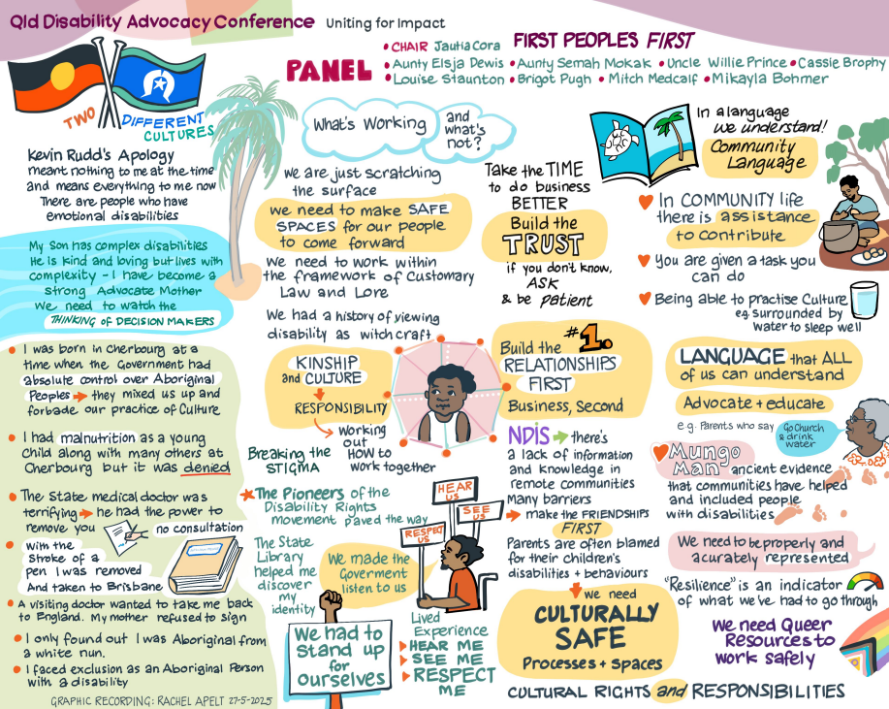

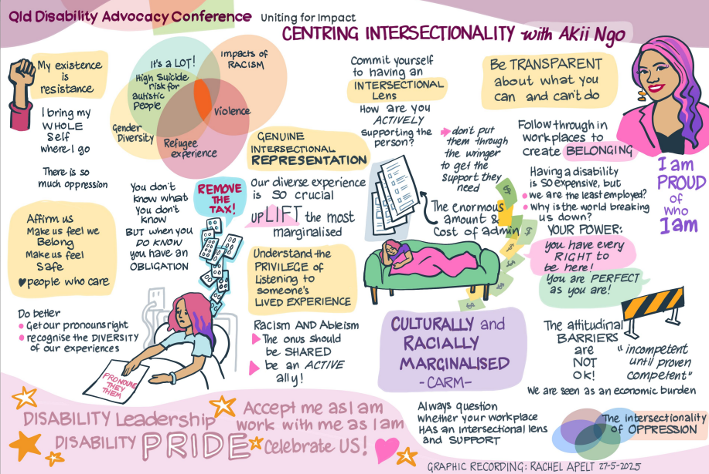

Appendix 2
I'm a multiply-disabled, multiply LBGTIQA+ trans woman.
And I’ve had nothing but trouble with medical providers and government systems ever since this became visible or otherwise known to them.
I've had multiple medical providers very deliberately misgender me. And the ones who didn't? They inevitably suggested my disabilities were due to me being trans. What's known as 'trans broken arm syndrome' in the trans community. Where a medical provider ignores the obvious problem - say, a broken arm - to blame being transgender (or the health care around such) instead as the cause of any and all symptoms and problems.
As an example of how ridiculously prevalent this is for trans people? When I was first trying to get what I now know is Long COVID investigated? Every medical professional (barring my trans-specialist GP) I saw immediately blamed every issue on my HRT or on me otherwise being transgender.
When there was clearly no causal link, at all. I'd been on HRT for years before COVID was around.
When it comes to disability services? When I first got onto the NDIS as a participant, the LAC I was assigned refused to gender me correctly.
This is someone who's meant to be an advocate for participants, mind. To other trans people, to even other disabled people, this is not particularly surprising. But if you knew nothing about this cynical and cruel system - say, you were completely new to the NDIS? You’d expect better from systems and people that make a lot of noise about 'diversity and inclusion', right?
Now, I'm a reasonably confident person, and good at working systems. And as mentioned above, well used to getting this from everyone and anyone. So I gathered my courage, and made a complaint via everyone I could within the NDIS. Asking for a different LAC as a solution.
And while my complaint was acknowledged promptly, and even appeared to be taken seriously at first? (I now know I was very lucky to get even that!) And I was assured I'd get a different LAC from then on? That was an outright lie.
My next plan rolled around, and the original LAC's name was still on my plan - and it still is. She sent me an email recently about reviewing my plan. No lessons learnt, no change at the NDIA. Despite these promises, despite these policies.
When I tried to get the NDIA to recognise all of my disabilities - numerous physical and psychosocial ones including gender dysphoria, all of which I was getting no support for beyond some token support for my (arbitrarily selected) 'primary disability' of autism?
I had the NDIA's legal team not only do the 'trans broken arm' thing again about my disabilities. But they took the lethally-inappropriate course of telling me that I was expected to 'treat' these disabilities by detransitioning. Stopping taking HRT, stopping essentially being me, in all the ways that matter.
An absolutely evidence-free 'treatment' idea which - as they surely must have known, if they'd even glanced at the literature on trans health care? Was easily foreseeable - especially with my psychosocial disabilities - to greatly increase my risk of harm, even death. At the very least, from self-harm. (The "41%" statistic that so many bigots like to taunt trans people with, whenever and wherever they can.)
Which was a pretty negative experience! The NDIA itself, actively doing its best to not only deny me appropriate disability support? But to exacerbate the harms of that lack of support, in a very knowingly anti-trans fashion!
As many other disabled people have experienced too? They were unrelentingly vicious during the appeals process too - where I was without legal support or advice almost the entire time.
I’ve mentioned that I’m a confident person, and good at working systems. I can be a fierce advocate for others as a result of this. And I try to do this where I can for others in the incredibly under-served neurodivergent and/or LBGTIQA+ part of the disabled community, as there's just no one else around to help. No one who can help, no one who just gets it. No one who speaks the right language, so to speak.
And even if there was someone? There'd be no way for those in this corner of the disabled community to afford this help if it wasn't free. And they'd be saturated almost immediately - as I’ve been, using the very limited capacity I have around my complex disabilities trying to help the very few people I can.
However, I can’t so easily self-advocate. Not for long, at least. My psychosocial disabilities don't let me. I panic. I freeze. I fall apart.
I have been abused consistently by every authority figure in my life, all my life. For things about me that I can't change. Things that I shouldn’t have to try to change. Things that for the longest time I had to hide, to try to avoid being abused further by those who won’t fix their bigotry. And hiding everything about yourself is damaging. It's left permanent scars - physical and psychological - in ways that only other trans people can really understand.
So here's me trying to fight the biggest authority figure - the government. The very people who are meant to help me. Fighting to get help for the disabilities I have - with no support even to get that help, and no accommodations for those disabilities while I’m doing so. A multi year court case, in effect - lengthened unnecessarily by the NDIA doing their very best impression of a US insurance agency - endless 'delay and deny'. I am struggling harder and harder to defend myself, to even articulate myself. To not run away from it all. To summon the will to keep moving forward with it all. My already poor mental health spiralling in bad directions.
The detransition ploy wasn't the end of the attempted harms, either. The NDIA tried very hard to (I believe illegally) get all my medical records without my consent. Presumably so that they could find an excuse to kick me off the Scheme, as they already had detailed reporting with the answers to the questions they were asking.
I had no legal recourse - because I had no legal representation. I'm not a lawyer. The best I could figure out from the disabled community's sharing of legal information - again, without lawyers in the mix, just other disabled people sharing their stories and similar cases that might help?
That told me I had little alternative but to drop the case. Just to try to block what quite foreseeably would lead to me losing what little support I had under the NDIS.
Because, of course, there's these numerous incorrect reports in my medical history. All saying that all my problems (falsely, without evidence) are just due to me being trans, right? Lots of things the NDIA can use to justify their murderously vicious detransition tactic. So lots of things they could very easily use to say "well, you're not disabled, you're ‘just’ trans, that's not our responsibility".
As anyone who’s been through this appeals process knows? They love to do this for anything they can - doing their best to declare disability care as being 'medical' and the
responsibility of Medicare wherever they can, of course. Even though they know Medicare doesn't cover any form of disability care.
And mind? At the time I was in hospital from a severe, nearly-life-ending, disability-caused accident. I was in incredible pain, barely able to do anything beyond use my mobile phone to do what research and document preparation I could. Solo. So I'm not at my best - even before the psychosocial side of this.
The NDIA knew this. And clearly, the NDIA smelt blood in the water, so to speak - and they went in 'for the kill' with this.
I became absolutely desperate to get any help I could. And sadly - everyone I turned to (even QAI) was just absolutely overwhelmed. No one with legal advocacy in their portfolio could help me.
And I get it. All public advocates like QAI have had their funding slashed repeatedly by the government. And with an ongoing - and escalating - campaign by the NDIA to slash everyone's NDIS plans, and now boot hundreds of permanently disabled people off the NDIS, a week?
There is so so much more demand here - so much more need - going unmet.
And not many who’d really understand what I was going through anyway, even if I'd won the metaphorical lottery of getting any legal advocacy.
So I had to drop the case. I have only one of my large number of disabilities recognised still. The barest minimum of support, even though my support needs have only increased. As I acquire more and more health issues - more disabilities - from a lack of appropriate support.
I'm fully expecting the NDIA to hit me any day now with an eligibility reassessment letter. As nearly a thousand other permanently disabled people are experiencing, with no warning, each and every week. The NDIA know I'm vulnerable - and they've been systematically kicking the most vulnerable off the Scheme. Particularly other autists. And too, it seems, anyone seen to advocate for others. As appears to have happened with Marc Facer. A prominent disability activist who suddenly had all of his NDIS support funding cut off by NDIA. Who died shortly after, as a result. A preventable death. A deliberate death.
It’s hard to see this as anything other than an agency disposing of those who oppose them. On top of the systematic harm of disabled people - eugenics, in other words.
The cruel and eugenicist nature of the NDIA aside? I’ve learnt to take a risk management approach to disclosure about my various identities.
If I’m going to be in a confined space with a service provider? I try to tell them as early as possible - ideally over the phone or via email. When they're well away from me and my home.
So if they're transphobic, they can have their hateful tantrum where they can't hurt me.
I very deliberately get my GP to put my trans status prominently on referrals - as many medical providers refuse to treat trans people. Sometimes even all LBGTIQA+ people in general, if they think they can get away with it.
They're not always open about it. But better to find out they're hostile early - or just have them refuse service up front - then to encounter their hostility in person. Where I'm at my most vulnerable.
I have a carefully vetted list of safe providers as a result - ones who've proven themselves safe. (Or safe enough, at least.)
And as a sometimes advocate for other LBGTIQA+ disabled people now? I explicitly reach out to providers first to check if they're okay with trans and/or LBGTIQA+ and/or neurodivergent people, before the person I'm helping goes anywhere near them.
It's just not safe - in so many ways - otherwise. As even allies can have their moments - and at the wrong time, that can cause serious harm.
For all of the reasons above? We need advocacy in all areas of life, really - individual, legal, and systemic.
We disabled people know that the world is really only designed for abled people - with accessibility and support as an afterthought. (The 'social model' of disability.)
Many societal systems do not work even for abled LBGTIQA+ people - either by not considering or being aware of their needs, or, in the particular case of trans and non-binary people? Actively excluding them - often hostilely so, as mentioned above.
Add the background of individualised support disappearing from the NDIS? A return to the 'block funding' model, where participants are increasingly forced into group housing or otherwise having their support delivered as a group? People whose needs are even slightly outside the average are suffering as a result.
So when it comes to LBGTIQA+ disabled people, especially trans disabled people? The issues disabled people have in general with this ableist society not only apply, they're magnified. Because even the very basics, like physical safety from abusive hateful people? That’s not guaranteed - even with (maybe especially) with providers registered with the NDIA.
The first and most obvious is being forced into group situations with bigoted people. An especial risk when (as many disabled people are now finding) you have no control over who you're grouped with, or who you're supported by.
I know more than a few people in this situation - and it's distressing and depressing, even second hand. Knowing they have no choice but to experience abuse because of who they are - and knowing they have no alternative to that abuse. Not if they're to stay alive.
And as heartbreaking as that is?
There are fundamental systemic issues impacting all trans people that I'd be remiss not to mention - as they will impact disabled trans people hardest.
As you might already be aware - it's a fight for trans people just to get the right name or gender marker recorded in most systems. Even abled trans people struggle to get this.
Add disability? And the very nature of the care you depend on to live is shaped by this. Delivered inappropriately and incorrectly by a system that doesn't even care to get even the most basic details right for you.
It forces you into situations which are very inappropriate for you - even dangerous. It 'outs' you routinely, in every interaction, and so exposes you to harm over and over again from within the system. From other participants (as I've mentioned) as well. And
this all leaves you ill-equipped to deal with the daily harms even abled trans people struggle to deal with.
As for expecting anti-discrimination law to help - ha! The best example of a win with this - Tickle v Giggle? That was a very hard fought, multi-year battle by an able-bodied trans woman with a well-resourced legal team. Something the vast majority of disabled people do not have access to - and especially not disabled trans people.
And while Roxy Tickle ultimately won? I know Roxy, and so I know that was a very costly battle indeed - in more ways than one. And the transphobes are still attempting to appeal this win - so the battle's not even really over yet. And the UK just lost even the pretence of anti-discrimination protection for trans people - and the US has effectively criminalised being trans. As well as made it risky - if not impossible - for trans people to even leave the US.
Expecting disabled trans people to go through lengthy court battles - well, it'll go about as well as my court case did. If not worse.
But all that aside? The looming threats are this - and this is something all trans people will need systemic advocacy around, mind, but especially disabled trans people.
The Queensland LNP government - a party ideologically not far from the far right, openly hateful, now openly Nazi one in the US? They’ve taken away access to life-saving medication for trans kids in the Queensland public health system. If they continue to follow the same path the US has, then they’ll do the same for adults, too. Or make it so difficult and expensive and inaccessible - like the UK has - that trans people have no choice but to access gender-affirming healthcare outside the country. A situation which already happens for gender-affirming surgical interventions here in Australia.
“Surely it won’t get that bad here?” On top of the gender-affirming medicine ban for trans teens in the public health system? We know the state LNP unanimously voted no to the gender self-ID birth certificate laws.
So we can guess what the LNP's actions during this term are likely to be next - emboldened by the success of the hateful campaigns of their peers in the US and the UK
It's easily foreseeable that they'll similarly roll back the self-ID changes. End whatever legal recognition and access to public spaces they can for trans people. Shut down the state-based public Gender Clinic entirely, and ban puberty blockers and HRT for all under 18s. Not just for those accessing the public system. And then do the same for trans adults, too.
Which - as I mentioned before about the attempt to make me detransition - which happened under a Labor government, mind? Is foreseeable to have lethal effects on trans kids and adults.
But even if the LNP 'just' roll back the self-ID change - and force everyone who's changed their gender marker back onto their assigned one at birth, and the name they were given at birth? As many conservative US states had done even before Trump got back into power?
That will be devastating enough to employment and accessing basic services - effectively 'outing' trans people whenever they have to show ID, anywhere and (increasingly) everywhere in public.
Exposing them immediately to all the issues I've mentioned above - discrimination, hate, even violence.
As even when someone's not visibly identifiable as being trans - maybe especially in this case?
Many cis people - cis men particularly - irrationally feel 'tricked' when they realise someone whom they presumed was cisgender is not. And get angry, often violently lashing out.
And note - many trans people are not easily visibly identifiable as being trans, by the way - I'm not, for instance. Which was a deliberate choice - and a matter of prior financial privilege which I no longer have. A choice which shouldn’t be demanded of or expected of any trans person on bodily autonomy grounds alone - especially considering the costs involved, and the poverty most trans people experience.
And particularly not the surgical interventions often demanded for legal recognition, as was the law in Queensland before the self-ID change was made. As that’s a demand for sterilisation, just to be recognised as who you are. And as something that still happens to disabled people, against their will and often even knowledge? Sterilisation is eugenics, pure and simple. Something used against a minority by a hateful authority to get rid of a population of ‘undesirables’.
And another commonality in struggles between disabled people and the LBGTIQA+ community, particularly the trans community.
Beyond this? Identity-related legal changes make the risk of random violence from the general public vastly increase. A risk in every interaction where you need to show ID. Not just a few potentially avoidable ones, here and there.
Imagine every interaction with strangers you have being one where you have a fair chance of it ending in violence. Imagine what that does to your desire to participate in society! Even if you've got funding for support to 'better access the community' - are you safe to use that? No.
And that's before we get into the prospect of 'bathroom bills', or all the other ways transphobic legislators have criminalised trans people existing in public elsewhere.
As if you can't safely use the most basic of public facilities - toilets, change rooms, gender-segregated facilities, and so on - without fear of exclusion, hostility, or even immediate violence? You can't be in public, at all.
When you apply all this to disabled trans people - the impact becomes so so much worse.
You can't run from hateful and violent people if you have mobility or energy-limiting disabilities. And if you depend on accessing public services and support just to live? Inconsistent access - especially if withdrawn abruptly, without warning - can be greatly harmful.
Even if you find a safe-enough space - say, one away from other people, away from the bigoted? You have an hour or so to spend there, tops, before you have to retreat home again. Especially so if you have continence issues.
And that's before the more subtle changes. Ones they know they can make without too much fanfare from cisgender allies.
We know the LNP voted no to decriminalising sex work. It's quite foreseeable they'll roll that back, too - their party room certainly has discussed it.
What most people might not realise is that many trans people work in sex work - especially disabled trans people. As it's one of the few industries where you can make enough money to get your needs met with just a few hours work. The few hours a week one might have available to work productively, that is - as many disabled people have, working around their disabilities.
So with a very simple legal change that few even on the left of politics would proactively protest? Many disabled trans people will find themselves thrown into the direst of poverty. More vulnerable to the other risks I've mentioned, and to the harms of hostile systems.
And that's not the end of the harm hateful governments can cause with legal changes. Subtle or otherwise.
As even the slightest increase in difficulty in accessing systems causes disproportionate harm to disabled people and trans people. Usually done on the pretence of 'safety' for cis people - when the harms were always from other cis people, and typically done to trans people, not by trans people.
"Oh, we need to make sure you're one of the good ones. So please submit XYZ documentation signed by all these expensive and inaccessible specialists - or requiring medical procedures not possible to get in Australia."
Even beyond the cost and inaccessibility part of this? If you have energy-limiting or psychosocial disabilities?
You don't have the energy or capacity to get this. Let alone keep fighting openly hostile systems in order to get what you need.
And facing this, day in, day out - it grinds you down. Even on top of what cisgender disabled people already face in these systems.
So please, have an eye to these systemic issues for trans people, as well as providing whatever individual and legal advocacy work you can. Trans disabled people will need it.
Just even for yourselves if you're not trans. Trans people are just the canary in the mine for all LBGTIQA+ people, trans women for all women, trans disabled people for all disabled people.
The first, most easily misunderstood, and hence easily targeted group. The easiest to harm in these groups.
History shows the hateful will soon progress to other groups beyond trans people - and as the US shows? Already are.
Every tactic we see used on trans people now, we've seen used before with gay and lesbian and bi people, with immigrants, with BIPOC people - even with (cis) women. Who are now starting to experience the side effects of bathroom bills in the US and the UK.
Please don't fall for it. Please help us fight it. Everyone's rights will soon depend on it - and we are stronger together, fighting back now.
On the provider level, the advocate level? It's important that service providers seek out LBGTIQA+ voices - especially disabled LBGTIQA+ voices - and listen and learn.
Everyone needs to be aware that LBGTIQA+ people - and particularly trans people - are who they say they are. That they are just a natural part of human variation. A part of every culture, for as long as humans have existed - we have quite a bit of historical, even archaeological evidence that shows that.
Beyond the basics that we're not inherently 'evil' or 'immoral' - that we're not out 'for your children' or to 'harm women' or whatever lie the bigoted use against each and every group they dislike?
It's very important that service providers understand the above - that we are who we say we are - and really internalise it. Make sure their staff get that - and embody that understanding in everything they do.
As it's not just tiring to have to educate people about who you are and what you need, in every moment of your life, in private and in public.
But it can be actively harmful in some contexts - especially medical - to be treated as 'not really a woman or non-binary but a man' or 'not really a man or non-binary but a woman' and so forth. Especially if a provider speaks on our behalf for us, when we can't for ourselves.
As trans women have the same health issues - and gender-specific presentations of such - that all women have. We know the signs of heart attacks are the same in trans women as in cis women. As for many other women/femme/non-men specific acute health issues.
And similarly so for trans men, as compared to cis men.
And for non-binary people - well, I can tell you personally, as someone who navigated the world for a few years as non-binary? Many medical systems just don't consider non-binary people. I've had an OT literally sign paperwork to that effect as "well, the gender-based disability assessment scales in this don't apply here - and they don't exist for non-binary people, at all."
It is as individual as the non-binary person themselves. So best listen, and respect those differences to support us properly, yes?
Providers also need to not presume to speak over us, or for us - unless specifically asked to do so.
Give us our full agency and autonomy - our 'choice and control', our 'dignity of risk' - in all the parts of our lives. Relationships, social life, health care, all of it.
Not just the parts that abled people understand. Not just the parts that non-LBGTIQA+ people understand. Let alone ones that they agree with.
That means support to do things providers might not understand, that they have no personal experience in. Support us in the ways we say we want to be supported, not what you think is best. As those will likely be worlds apart.
If someone's religious or cultural beliefs mean they can't or won't assist LBGTIQA+ disabled people with their needs, with their wants? They shouldn’t be working with them - and they’re likely not safe for other disabled people, to boot. Please make sure people who can and will support LBGTIQA+ in general are paired with LBGTIQA+ disabled people, for their safety.
And if you suspect someone may be bigoted or abusive in general? Please make sure they're never alone with a LBGTIQA+ disabled person - or around any disabled person, ideally.
It's hard enough for abled LBGTIQA+ people to deal with bigots - add disability, and the harms are magnified.
And please - make sure as many people as possible are aware of the political issues I've mentioned above.
Of how the intersectional struggle for LBGTIQA+ human rights benefits theirs. How keeping us safe, supporting us, understanding us, resists the same people coming after all disabled people.
Resists the hateful people coming for everyone who's different, in the end.

Queensland Independent Disability Advocacy Network. January 2025. QIDAN Budget Submission to Queensland Treasury. chrome-extension://efaidnbmnnnibpcajpcglclefindmkaj/https://disabilitypathways.org.au/wp-content/uploads/2025/01/QIDAN-Budget-submission.pdf
Queensland Independent Disability Advocacy Network. November 2023. Submission by the Queensland Independent Disability Advocacy Network (QIDAN) – Queensland Treasury. chrome-extension://efaidnbmnnnibpcajpcglclefindmkaj/https://disabilitypathways.org.au/wp-content/uploads/2023/11/QIDAN-Budget-Submission-2023.pdf
Royal Commission into Violence, Abuse, Neglect and Exploitation of People with Disability. 2022. Research Report: Violence, abuse, neglect and exploitation of LGBTQA+ people with disability: a secondary analysis of data from two national surveys”. chrome-extension://efaidnbmnnnibpcajpcglclefindmkaj/https://disability.royalcommission.gov.au/system/files/2023-01/Research%20Report%20-%20Violence%2C%20abuse%2C%20neglect%20and%20exploitation%20of%20LGBTQA%2B%20people%20with%20disability.pdf
Deborah Warr, Jennifer Cox, Sarah Redshaw. (2020). A review of associations between social isolation, loneliness and poor mental health among five population groups. https://researchoutput.csu.edu.au/en/publications/a-review-of-associations-between-social-isolation-loneliness-and-
Ibid
Victorian Aboriginal Justice Agreement. (2024). Underlying causes of Aboriginal over-representation. https://www.aboriginaljustice.vic.gov.au/the-agreement/aboriginal-over-representation-in-the-justice-system/underlying-causes-of-aboriginal
Open Doors Youth Service Inc, Youth Advocacy Centre Inc, Brisbane City Council. (2020). Affirmative practice guide for working with LGBTIQAP+ Sistergirl & Brotherboy young people experiencing homelessness in Brisbane. chrome-extension://efaidnbmnnnibpcajpcglclefindmkaj/https://yac.net.au/wp-content/uploads/2023/03/Guide-for-Working-with-LGBTIQAP-Sistergirl-and-Brotherboy.pdf
ibid

