

2025 Review of the
Disability Standards for Education

To the Australian Government and the Department of Education

21 November 2025

About Queensland Advocacy for Inclusion
Queensland Advocacy for Inclusion (QAI) is a Disabled Peoples Organisation governed by a Management Committee made up of a majority of persons with disability. Their wisdom and lived experiences guide our values, priorities, and approach. We are an independent, community-based advocacy organisation and community legal service providing individual and systems advocacy for people with disability. Our purpose is to advocate for the protection and advancement of the needs, rights, and lives of people with disability in Queensland.
For more than thirty-five years, QAI has engaged in systemic advocacy to drive attitudinal, law and policy reform. We also deliver individual advocacy across human rights, disability discrimination, guardianship and administration, involuntary mental health treatment, criminal justice, and NDIS access and appeals. Relevantly, we are funded by the Queensland Government to provide specialist advocacy for children and young people with disability (0-18 years), through the Young People’s Program (YPP). Insights from this work directly inform our understanding and prioritisation of systemic advocacy issues.
Since 1 January 2022, QAI has also been funded by the Queensland Government to establish and co-ordinate the Queensland Independent Disability Advocacy Network (QIDAN). QIDAN members work collectively to elevate the role of disability advocacy and drive attitudinal, policy and legislative change for people with disability in Queensland. This submission reflects both QAI’s experience and the insights contributed by QIDAN members.
A note on language
Language is a powerful tool for building inclusion. We use person-first language by using the term “students with disability” but recognise that many people with disability prefer identity first language (i.e. a disabled student). Throughout this submission we refer to “reasonable adjustments” as it is currently referenced in legislation and policy, however we advocate for the “reasonable adjustments” to be replaced by “adjustments”.

QAI’s recommendations
- The Standards must reflect any amendments resulting from the current Disability Discrimination Act Review (DDA Review). The recommendations proposed below must be implemented in conjunction with our recommendations made in our submission to the DDA Review, particularly the implementation of positive duties.
- Uphold students’ rights and enforce obligations with clear accountability mechanisms and robust systems of oversight and redress, by:
  - Implementing a nationally consistent monitoring and accreditation framework to drive proactive compliance with the Standards, including regular audits, public reporting, and penalties for non-compliance, as per DRC Recommendation 10, b).
  - Establishing an independent complaints body with powers to investigate, issue binding decisions, and monitor systemic issues, supported by trauma-informed, culturally safe processes and enforceable timelines, as per DRC Recommendations 10, c) and 7.11, a) and b).
  - Using complaints data to identify patterns of exclusion, delays, and inaccessible consultation, and apply findings to drive system-wide reform, training, and accountability, as per DRC Recommendations 7.12.
  - Legislating enforceable obligations for education providers to implement the consultation, issue resolution, and complaints handling principles outlined in Attachment B (The Principles). This must include documented decision-making, meaningful consultation with families that are culturally responsive and supported by interpreters, and procedural fairness through timely, accessible and transparent communication, as per DRC Recommendations 7.2 and 7.10.
- Provide families and students clear and accessible information to understand and exercise their rights. This should include:
  - Mandatory distribution of accessible, plain language, and translated summaries of rights, obligations, and complaints processes at different stages, accessible in multiple formats and languages, which must be published on education provider websites and visibly displayed in all facilities, as per DRC Recommendation 7.6.
  - Access to qualified interpreters to ensure effective communication between all education staff and parents and children from non-English speaking backgrounds, where English proficiency is limited, as per the Queensland Language Service Policy.
  - Implementation of recommendation 2 of the 2015 Standards Review, which called for every prospective student to receive an accessible summary of rights, obligations and complaints pathways at enrolment.
- Adequate funding must be invested in staff training, dedicated resources and improvement in school culture – only then meaningful inclusive education will be achieved. Educators and families must be supported to create and sustain inclusive learning environments by:
  - Requiring mandatory, accredited training for all educators and education staff on the Standards, inclusive education, trauma-informed practice, cultural safety, and working effectively with interpreters, equivalent to child protection training obligations, as per DRC Recommendation 7.8.
  - Supporting families navigating education systems and participating in decision-making by adequately funding independent advocacy services and by requiring schools to employ disability-trained liaison officers, in alignment with DRC Recommendations 6.21, c) and 7.10.
  - Adding inclusive culture as a key performance indicator for education providers, with measures to ensure schools are welcoming, respectful, and valuing of students with disability, as per DRC Recommendation 7.9.
  - Engaging external specialists when internal capacity is insufficient to support students with disability, with documented outcomes in student support plans and consequences for failure to collaborate, as per DRC Recommendation 7.8 e).
- Provide equitable access to an inclusive education setting for every student with disability. Mandate consequences for systemic practices that limit or deny participation and eliminate hidden and informal exclusion. This should include:
  - Aligning the Standards with the National Disability Strategy (Theme 5), Article 24 of the Convention on the Rights of Persons with Disabilities and the DRC Recommendation 7.1, ensuring inclusive education is upheld across all learning environments.
  - Prohibiting informal and arbitrary exclusionary practices such as early pick-ups, shortened days, and exclusion from activities. While some of these practices may be in place as reasonable adjustments, they should be all documented, time-bound, and reviewed with families, as per DRC Recommendation 7.2.
  - Requiring education providers to proactively plan and implement reasonable adjustments prior to a student’s first day, with enforceable timeframes, mandating consequences for noncompliance and mandatory written responses to adjustment requests, as per DRC Recommendation 7.11.
  - Mandating consistent application of reasonable adjustments across all educational domains, including classrooms, learning rooms or educational locations, assessments, placements, and certification, with clear and enforceable responsibilities for all relevant education bodies, as per DRC Recommendations 7.3 and 7.12.
- Create career’s guidance and transition support service for students with disability, as per DRC Recommendation 7.5.
- Immediately implement recommendations from the 2020 Review of the Standards, to include Early Childhood Education and Care providers in the Standards.

Strengthening the Disability Standards for Education
We welcome the opportunity to contribute to the Australian Government’s 2025 review of the Disability Standards for Education 2005 (the Standards). The Standards were designed to clarify the obligations of education providers under the Disability Discrimination Act 1992 (DDA) and to give practical effect to Australia’s commitments under the CRPD, particularly Article 24 on inclusive education.
As a rights-based sector committed to systemic reform, we view the Standards as a critical framework for ensuring students with disability can access and participate in education on equal terms. Yet, nearly two decades on, implementation remains inconsistent, accountability is weak, and students with disability continue to face exclusion, discrimination, and neglect across education settings. Our experience supporting families reveals that the promise of inclusive education remains far from being realised.
Recent Queensland data revealed systemic failure where schools are suspending students with disability at increasingly alarming rates. Students with disability are roughly 25% of the student cohort, however in term 2 of 2025 they made up 64% of suspended students in Queensland. The report “Include me, don’t exclude me” by the Queensland Aboriginal and Torres Strait Islander Children's Commissioner Natalie Lewis shares the experiences of children and young people who have been suspended or excluded from Queensland state schools. From existing economic cost analysis, we know that it takes $20 million annually to manage suspensions, while families are losing at least $14 million in income. That is money that could create inclusive classrooms across Queensland, instead of funding exclusionary discipline. There is also emerging evidence from the Child Safety Commission Inquiry which highlights School Disciplinary Absences (SDA) as a significant issue for foster carers and guardians.
The continued expansion of segregated special schools in Queensland further exemplifies these systemic shortcomings. This trend stands in direct contradiction to Australia’s commitments under the CRPD and the inclusive education trajectory set out by the DRC. Without substantive reform, the Standards will continue to fall short of ensuring that students with disability can participate fully, safely and meaningfully in their education.
To drive real change for students with disability, parents and educators, the Standards must be directive and enforceable, not aspirational. Language such as “should” or “encouraged to” must be replaced with “must” and “required to,” establishing explicit, non-negotiable duties for consultation and collaboration, reasonable adjustments, and accountability. These duties must be supported by clear processes, measurable outcomes, and enforceable timeframes by State and Territory education departments. The Standards must also be modernised to reflect contemporary understandings of inclusion and accessibility, moving decisively away from deficit-based language.
This submission is grounded in the collective experiences of QAI’s YPP individual advocates and it reflects the experiences of the disability advocacy sector across Queensland. While this submission presents updated recommendations for 2025, the core priorities remain consistent with those outlined in QAI’s 2020 Review of the Disability Standards for Education.
To build a transparent, accessible, and equitable system, the following reforms to the Standards continued to be advocated for:
- Enforceable timelines for responding to complaints and implementing reasonable adjustments consistently from early childhood to university
- Strengthened oversight by an independent state or national complaints body with binding powers
- Accessible rights information
- Including trauma-informed, culturally safe complaints handling processes, with a system wide learning from complaints data to inform policy and practice
- Adequate resources and mandatory training for educators, including cultural competence module addressing the intersection of disability and cultural and linguistic diversity
These reforms will create a rights-based, actionable framework that guarantees students with disability can access and participate in education fully and equally, with clear recourse when obligations are not met. These changes are essential to ensure that students with disability and their families are supported by a system that is not only responsive and accountable but genuinely committed to inclusive education.
This review offers a critical opportunity not only to strengthen the Standards, but to embed enforceable protections, transparent processes, and inclusive practices that reflect the lived experiences of students and families. Our updated recommendations expand on previous proposals, calling for broader systemic reforms to ensure inclusive education is upheld in every setting, from classrooms to assessments, placements, and certification.
Amending and updating the Standards to promote an inclusive system will result in students with disability accessing and participating in learning, extracurricular activities, and their communities to the greatest extent possible and on equal basis with their peers. This means all schools environments are safe and welcoming and are free from discrimination, and all school supports are effective and meet the diversity of students needs. The school community will embrace diversity and students with disability will feel supported in developing social skills and in maximising their capacity to make choices.
Enforce the Standards with accountability, monitoring and oversight
Students with disability have the right to an education system that is accessible, inclusive, safe and equitable from the outset, rather than reactive once barriers have already impacted a student’s participation. Yet disability advocates across Queensland continue to observe that the Standards, while well-intentioned, are not achieving their purpose in practice. The current framework relies heavily on discretionary compliance, lacks meaningful accountability, and places a disproportionate burden on students and families to secure basic rights.
Across the state, advocates routinely see inconsistent and delayed adjustments, informal exclusion, inaccessible consultation processes, and inadequate oversight of education providers. These are not isolated administrative failures but persistent systemic issues that have been identified in every previous review of the Standards and highlighted extensively by the DRC. Despite widespread agreement on the need for change, implementation remains uneven, unmonitored and largely unenforceable.
Strengthening the Standards is not merely desirable, it is essential. A revised framework must provide clear obligations, enforceable mechanisms, and consistent national oversight to drive cultural and practice change. Only through stronger, rights-based Standards can we ensure that inclusive education is not aspirational, optional or discretionary, but guaranteed for every student.
While the Standards establish clear expectations for inclusive practice, individual disability advocacy demonstrates that students with disability continue to face widespread and preventable barriers in their daily educational experiences. These barriers arise not from gaps in the legislative framework itself, but from significant shortcomings in implementation, monitoring and enforceability.
A major contributor to the students with disability experiencing delays in receiving reasonable adjustments is the system’s heavy reliance on parents and carers to advocate for their implementation. Too often, a student’s access to necessary supports depends on a parent’s ability to interpret complex policies, challenge decisions, escalate concerns, and maintain detailed records. Parents with disability face additional obstacles, including inaccessible communication formats, rapid speech during meetings, and insufficient processing time. This entrenches inequity, as students whose families cannot self-advocate as effectively may miss out on essential supports.
Disability advocates also observe widespread informal exclusionary practices across Queensland. Families describe undocumented part-time attendance arrangements, repeated requests for early pick-ups, exclusion from camps and excursions, withdrawal from specialist subjects, and subtle messaging that discourages attendance. These exclusions frequently occur without procedural fairness, written documentation, any structured planning or consultation. Informal exclusion reduces learning time, undermines social participation, and in many cases amounts to discrimination under the Disability Discrimination Act (DDA).
Decision-making processes within schools are frequently opaque and inaccessible. Families report that meetings are often held without adequate notice, agendas, and without reasonable adjustments for parents with disability, such as accessible formats, explanation or jargon and slower-paced communication. Written summaries, action plans and follow-up notes are inconsistently provided, leaving families unclear about what decisions have been made or what supports will be implemented. In the absence of enforceable consultation and collaboration obligations, the current Standards Attachment B Principles for Consultation operate as aspirational guidance rather than mandatory practice, resulting in inconsistent application across schools.
Across government, Catholic and Independent sectors, families also report substantial variation in how adjustments are documented, policies are communicated, and complaints are handled. Many non-government schools do not publish key policies online or clear information about behaviour supports, Part-Time Education Plans (PTEPs) or complaints pathways. Complaints processes are widely described as slow, overwhelming and unresponsive, with some families experiencing a deterioration in their relationship with the school after raising concerns. This inconsistency leaves families without a predictable or transparent path to resolve issues affecting their child’s right to education. Many families also experience deterioration in their relationship with the school after raising concerns, including perceived retaliation, reduced communication or exclusionary treatment of siblings. These decisions are often made unilaterally by school staff and lack clear justification, despite the obligation under Standard 3.5 to consult with parents about reasonable adjustments before they are made. These experiences create a climate of fear and discourage parents from seeking help, even when a child’s safety or participation is at risk.
The report “Include me, don’t exclude me” highlights similar issues. Children and young people described feeling unheard, excluded from decision-making and unsure of how to voice concerns safely. The report calls for complaints systems that actively support participation, upholds cultural safety, and provides timely, accessible and meaningful responses. These findings mirror the experiences reported by disability advocates across Queensland.
We strongly support reforms to strengthen consultation and complaints processes, particularly through systemic enforcement that extends beyond individual schools, as per DRC Recommendation 7.10. Complaints data must be used to inform system-wide learning. Trends such as delayed adjustments, inaccessible consultation, and informal exclusion should be tracked and addressed through policy reform, staff training, and accountability measures. A responsive system must not only resolve individual complaints but also drive continuous improvement across education sectors, as per DRC Recommendation 7.9. This information should inform training, policy reform, resource allocation and targeted supports.
Together, these systemic barriers demonstrate that without enforceability, transparent processes and consistent implementation, the Standards cannot guarantee the rights they are intended to protect. Schools must have access to strong accountability mechanisms. Schools are largely self-regulating, and oversight mechanisms are rarely activated unless a formal complaint is made. This reactive model cannot deliver consistent or equitable rights protections, and it places the burden on families to identify breaches and seek redress, often after harm has already occurred. Without clear consequences for non-compliance, discretionary approaches will continue to undermine consistency and fairness. Accountability mechanisms should not be punitive, but must ensure that rights are upheld, adjustments are implemented, and families can raise concerns safely without fear of retaliation. All these issues have been heard and addressed by the DRC, resulting in recommendation 7.3 calling for improvement of policies and procedures on the provision of reasonable adjustments to students with disability. Strengthening the practical obligations, oversight mechanisms and accountability requirements is essential to ensuring that students with disability can participate on the same basis as their peers.
Independent oversight is essential to ensuring that students with disability experience consistent rights protections across government, Catholic, Independent and private education sectors across their education journey. This is also required to ensure that schools comply with their obligations and that issues are identified before harm escalates. We strongly support the establishment of an independent oversight body with the authority to:
- investigate education-related complaints
- issue binding decisions or directives where breaches occur
- conduct audits and thematic reviews across sectors
- publish de-identified, systems-level findings
- monitor compliance with, and implementation of, the Standards.
Take an extra step and make the principles in Attachment B enforceable
We advocate for the principles outlined in Attachment B to be embedded directly into the Standards, rather than positioned as separate guidance. This ensures they carry equal legal and regulatory force, making them binding, not optional, and enables them to drive meaningful, systemic change. The need for enforceable principles is underscored by the systemic issues outlined in the previous section. Patterns of exclusion persist because the current Standards rely heavily on discretionary compliance, with few mechanisms for accountability or redress.
Although we support Option 2 of the Discussion Paper regarding the inclusion of the principles outlined in Attachment B, it does not go far enough. Adding the principles to the Standards in addition to Option 2, is our preferred approach.
In supporting Option 2 of the Discussion Paper, which requires education providers to develop, publish, implement, and comply with policies that reflect the principles, and to make those policies publicly available, we are hoping that clear and consistent expectations across schools and education systems are established. It sends a strong message to students, families, and staff about their rights and the standards they can expect. Public policies promote transparency and accountability empowering families to understand their rights and the processes schools are expected to follow. This supports self-advocacy and provides a basis for holding education providers accountable when practice does not align with policy.
Currently policies are often difficult to access, particularly in Catholic, private or independent schools. Requiring public availability would address this gap and ensure equitable access to information. Embedding the principles in written policies is essential for systemic change. It demands leadership and endorsement, which in turn supports continuous improvement, monitoring, and staff training. Policies must be more than symbolic, they must actively shape practice.
To be effective, these policies must:
- Be written in accessible language and formats
- Be supported by training and resources for development and implementation
- Be reviewed regularly, with mechanisms for consultation with students and families
- Be accompanied by public reporting on implementation and outcomes.
Beyond including the principles in policies, embedding these principles in the Standards is critical to achieving a genuinely rights-based and accountable education system. The principles reflect key recommendations of the DRC and reinforce the Standards’ purpose: to ensure students with disability are consulted, supported, and empowered to participate fully and meaningfully. Mandating them within the Standards ensures providers are held to clear obligations, processes are transparent, and students and families have meaningful avenues for redress.
Direct inclusion of these principles signals that consultation, inclusion, accessibility, and accountability are central, non-negotiable aspects of education, not optional add-ons. This transforms the Standards from aspirational guidance into a legally and ethically robust framework for equity, participation, and inclusion for all students with disability.
Nonetheless, we are concerned that, as currently drafted, these principles lack the strength, clarity, and enforceability required to deliver meaningful protections for students with disability. Without stronger language and binding obligations, the principles risk remaining aspirational rather than actionable. Language such as “should”, “encouraged to” or “actively seek” must be replaced with “must” and “required to,” establishing explicit, non-negotiable duties for consultation, reasonable adjustments, and accountability. Rather than stating education providers ‘should seek to include students and families in decision-making,’ the Standards must require that providers ‘ensure students with disability and their families are actively involved in all decisions affecting their education.’ As currently drafted, the principles largely reflect existing expectations and best practices, without introducing enforceable duties or consequences for noncompliance. Without clear duties and accountability mechanisms, inclusive decision-making risks remaining symbolic rather than systemic. Embedding directive language into the Standards affirms that participation is a right, not a courtesy, and ensures that families are empowered, consulted, and respected throughout the educational journey.
Children and families must feel supported with clear, transparent and accessible information
Awareness and understanding of the Standards among families remains critically low, despite this longstanding concern identified in the 2010, 2015 and 2020 Standards Reviews. Parents consistently report that they first learn about the Standards only after their child has experienced exclusionary discipline, denial of adjustments or conflict with the school. This reactive pattern does not support meaningful decision making, leaving families unprepared at precisely the moments when clear, accessible rights information is most urgently needed.
Existing government and school-based resources are frequently inaccessible or overly complex. Families describe difficulty navigating text-heavy websites, formal policy language, dense documents and the absence of practical, relatable examples. These barriers disproportionately affect parents with disability, families with low literacy, culturally and linguistically diverse (CALD) families, and those experiencing compounding social disadvantage. Our engagement with families consistently reveals that many remain unaware of the free online resources intended to help them understand the Standards and advocate for their rights. This is not due to a lack of resources, but to persistent barriers in accessibility, visibility, and integration into everyday school practices.
While resources such as the Nationally Consistent Collection of Data (NCCD) website exist, they are not presented in formats that families widely use or understand. Families consistently request plain language information, Easy Read materials, video and audio explanations, multilingual translations, and real-world examples demonstrating how the Standards apply in practice. In the absence of accessible formats, families are left to navigate complex systems alone, often relying on informal networks, social media or crisis-driven advocacy to understand their rights.
The issue of lack of transparency and visibility across education sectors undermines parental confidence and makes it difficult to understand expectations, rights and avenues for resolving concerns. In response to the 2015 DSE Review, the Australian Government agreed in principle to Recommendation 2, calling for every prospective student to receive an accessible summary of rights, obligations and complaints pathways at enrolment. A decade later, families report that this recommendation remains largely unimplemented. The DRC Recommendation 7.6 similarly highlighted the need for improved communication and accessible rights information, yet the lived experience of families indicates minimal progress.
Providing clear, timely and accessible information to students with disability and their families also supports them to make decisions that affect their participation in the education journey. During key transition points such as school entry, movement between year levels, or transition to secondary schooling, students and families must have access to adequate notice to meetings with clear agendas, with the option to have interpreters and communication supports, followed by accessible written summaries or follow up actions. This is particularly important for parents with disability, families with low literacy and CALD families.
Ensuring that all families receive clear, timely and accessible information about the Standards is fundamental to equitable participation. Rights cannot be exercised when they are unknown, inaccessible or withheld. Strengthening the Standards must include explicit, enforceable duties requiring education providers to proactively provide rights information in diverse, accessible formats at all key points of a student’s educational journey.
There is also a noticeable absence of proactive dissemination of information by schools beyond parents of children with disability and teachers. Accessible information about rights and obligations, in multiple formats, should be provided to the whole school community, including students without disability and their families. This will result in broader awareness where the rights of children of disability are known and respected by all, including among their peers.
Gordon’s and Helen’s story: Advocacy as a bridge to inclusion
Gordon, a parent with disability whose child, Helen*, diagnosed with a neurodevelopmental disability, experienced bullying at school and developed significant mental health challenges. Although reasonable adjustments were formally in place, they were ineffective in practice. Helen struggled to communicate when dysregulated, and staff failed to recognise or respond to signs of distress.
Gordon lodged a complaint with the education department but was deeply anxious about attending a stakeholder meeting. He expressed difficulty following rapid conversations and feared being unable to clearly communicate his concerns. With support from a YPP advocate, Gordon was able to prepare for the meeting with confidence. The advocate assisted in drafting an agenda, requested accessibility accommodations, including written notes, scheduled breaks, and single-topic discussions and attended the meeting in person. The result was a productive and collaborative dialogue. Gordon reported feeling heard, supported, and more willing to engage in future meetings when advocacy is available.
*Name has been changed for confidentiality purposes
This experience reflects a broader pattern of consultation processes that are inaccessible, intimidating, and poorly adapted to the needs of parents with disability. It highlights the systemic failure of the Standards to proactively uphold the rights of students and families, and the transformative impact of informed, inclusive advocacy. It underscores the urgent need for consultation processes that are accessible from the outset not only once problems have escalated.
Resourcing schools to deliver inclusive Education
Adequate resourcing and training are essential across all education sectors. Families frequently report inconsistent or reactive practices from educators who have not received adequate training in inclusive education, trauma-informed practice, cultural safety or communication supports. Professional development must move beyond compliance-based requirements to build the practical skills, confidence and understanding needed to support diverse learners. Every school or education region should have access to a bilingual officer or cultural support worker to assist families from CALD backgrounds in navigating systems, understanding plans, and participating in decisions. Training must be timely, ongoing, accessible and embedded across all school roles, not only classroom teachers or teachers aids.
It is essential that schools are resourced to do proactive planning. Many schools wait until difficulties arise before consulting with families or implementing reasonable adjustments, resulting in reactive, crisis-driven responses rather than preventative and supportive practice. Students are then exposed to unnecessary distress, missed learning opportunities and, in some cases, disciplinary consequences that could have been avoided through early identification and preparation.
In addition to training, resourcing schools should include smaller classroom sizes, and providing teachers adequate time to meet with families and specialists to discuss disability supports. This should also include additional classroom supports, roles dedicated to disability liaison, and multidisciplinary expertise. Where internal capacity is insufficient, clear and mandatory referral pathways to external specialists are necessary. Investment in training and resourcing must be documented, monitored and reviewed to ensure follow-through and adequate distribution of funding, as per DRC recommendations 7.8 and 7.12.
Protect the right to learn
The DRC was clear – children must receive equal access to mainstream education and enrolment (DRC Recommendation 7.1) and the use of exclusionary discipline should be used only as a last resort (DRC Recommendation 7.2). Yet, informal exclusionary practices continue to undermine participation of children in education, resulting in many children with disability traveling outside of their community to attend special schools. To uphold inclusive education, children must be able to access schools that meet their needs, and not “disability friendly schools” that could turn into another form of segregation.
Current discriminatory systems are not necessarily cheaper or more effective. The A Right to Learn campaign is publicly calling on the Queensland Government to conduct an inquiry into the use of school disciplinary absences in Queensland State Schools. As part of its role leading the campaign, QAI commissioned an analysis of the economic impacts of suspending students with disability from school which found that managing suspensions costs $20 million annually while families are losing at least $14 million in income. These resources could have been directed to resourcing teachers and invested in inclusive classrooms.
These findings are reflective of our experience supporting families, who frequently report shortened school days, requests for early pickups, and exclusion from camps or excursions, often without documentation or consultation. These practices are not only harmful, but also unlawful when carried out outside proper process. Families from CALD backgrounds often lack knowledge or confidence to challenge informal exclusion and often need advocacy support to help ensure access to schools.
All part-time arrangements must be formally documented, time-bound, and reviewed regularly in genuine consultation with families. Any exclusion without lawful justification should be deemed a breach of the Standards and subject to remedy, including reinstatement and compensation where educational opportunities have been denied.
Students with disability frequently experience lengthy delays in receiving reasonable adjustments, even when their needs are clearly documented through professional assessments. These delays are often caused by schools postponing the implementation of supports, trialling adjustments only once or twice, or abandoning strategies prematurely because they “did not work”, despite not giving students with disability, their families and school staff adequate time, consistency or resourcing to be effective. While these delays persist, students miss critical learning opportunities, disengage from school, experience emotional distress, and fall substantially behind their peers. Parents often describe a predictable pattern in which their child masks difficulties during the school day but becomes highly dysregulated at home, illustrating the profound and compounding impact of unmet needs and environments that are not consistently or appropriately adjusted. In some cases, adjustments that do not pose unjustifiable hardship are denied outright or significantly altered without consultation with the student, their family, or formal support network.
Students with disability are frequently disadvantaged when classroom adjustments, such as extra time, assistive technology, or task modifications, do not carry over into external assessments, placements, or certification processes. This disconnect undermines inclusive education and creates barriers to progression. The burden often falls on students and families to advocate for continuity, a process that is exhausting and inherently unfair.
Unfortunately, as a result of these exclusionary practices, we observe that many families choose to enrol their children in schools that are “more inclusive” or “disability friendly”, even if the school is outside their catchment zone. While we support families’ choice to enrol their children in schools that meet their disability requirements, regardless of catchment restrictions, we advocate for all schools to have access to adequate resources to provide reasonable adjustments to children with disability and to deliver inclusive education to all children.
The system fails students when reasonable adjustments disappear the moment they leave the classroom. We need stronger regulation, enforceable responsibilities, and coordinated oversight to ensure inclusive education is upheld in every setting. This includes mandating that adjustments apply consistently across classrooms, assessments, placements, and certification, and requiring collaboration across all relevant education bodies, not just schools.
As per DRC Recommendation 7.12, there needs to be a consistent allocation funding to schools based on the number of students with disability enrolled, as well as the individual needs of students with disability. Distribution of funding and resources for reasonable adjustments must happen in collaboration with families and students, and such allocation of investment must be audited and transparently reported.
Leo’s story: A practical example of the need to enforce principles of transparency, collaboration, and procedural fairness into the Standards
Leo* is a 7-year-old student attending a private school with an alternative learning style was placed on a PTEP without his parents’ consent, shortly after receiving an autism diagnosis. Previously, he had attended school full-time without difficulty. The PTEP was imposed because he often wandered out of his classroom and walked around the school. He explained to his advocate that he found it difficult to concentrate while sitting on the hard classroom mat and would go for a walk to move his body, as the classroom door was always kept open.
When his parents objected to the imposed PTEP, the school began calling them to collect their child early every day, effectively excluding him from the classroom. Despite repeated requests, the family’s efforts to have his IEP adjusted and appropriate supports put in place were disregarded. During periods when he was denied access to the classroom, the school failed to provide schoolwork, further disadvantaging Leo. Matters escalated when the school advised the family that their approach was “not a good fit” for Leo and asked that he not attend until a meeting was held with the parents.
With the support of an advocate, the family attended the meeting where the advocate pressed for the recommendations of Leos allied health professionals to be implemented and for educational materials to be provided during any absences. The school subsequently withdrew its pressure for Leo to cease enrolment, agreed to provide schoolwork, and committed to trialling the recommended adjustments. Both the family and the advocate agreed that the meeting itself was positive and that a path forward had been identified.
However, the goodwill of that meeting did not translate into sustained support. The family reported feeling increasingly dismissed by the school and observed that their other children began experiencing exclusionary treatment, which they perceived as retaliatory. Ultimately, the family felt they had no choice but to move all their children to another school.
*Name has been changed for confidentiality purposes
This case highlights the lack of enforceability within the Standards. Without binding obligations or clear accountability mechanisms, private, Catholic, and independent schools can impose exclusionary practices without due process, disregard family input, and offer only token compliance when challenged. While advocacy intervention created temporary progress, the absence of enforceable rights left the family vulnerable to systemic inequity and ultimately forced them to leave their school community. This underscores the urgent need to embed enforceable principles of transparency, collaboration, and procedural fairness into the Standards to protect students with disability and their families from exclusion and retaliation.
Supporting careers goals and aspirations beyond school
While we do not have extensive casework relating to assessment authorities or course developers, the experiences shared with us by families highlight important systemic gaps that warrant attention.
Students with disability often face significant barriers when transitioning from classroom-based learning to external environments such as work experience, vocational placements, or courses with professional accreditation requirements. Although reasonable adjustments may be in place within school settings, these supports are not frequently extended to placements, leaving students without the tools they need to succeed.
The lack of continuity creates additional stress for families who report delays, inconsistent implementation, and poor coordination between schools, placement providers, and accrediting bodies. These systemic gaps underscore the urgent need for clear responsibilities, enforceable timelines, and consistent application of adjustments across all learning environments. Transitions between early childhood, school, VET and higher education should be culturally informed and have interpreters’ involvement. A way to do this would be develop partnerships with multicultural organisations to assist families from CALD backgrounds during key transition points.
These systemic gaps are not just theoretical; they have real consequences for students and families navigating education. There needs to be a career’s guidance and transition support service for students with disability, as per DRC Recommendation 7.5.
Expand the Standards to include Early Childhood Education and Care providers
Although Early Childhood Education and Care (ECEC) is not the primary focus of the Discussion Paper, we understand that the Review is considering whether to expand the Standards to explicitly cover ECEC and Outside School Hours Care (OSHC) providers. We strongly support this reform, consistent with the recommendations of the 2020 Review of the Standards and the Disability Royal Commission’s emphasis on early intervention and inclusive foundations.
Our individual advocacy experience indicates that many ECEC and OSHC providers do not consistently provide reasonable adjustments, resulting in exclusion, restricted enrolment, or limited participation for young children with disability. Families report being told that services “cannot meet needs,” requests to reduce hours, or being required to provide additional private support at their own cost. These practices reflect inconsistent understanding of obligations under the Disability Discrimination Act (DDA) and a lack of clear guidance specific to early childhood settings.
While proposed amendments to the DDA, including the introduction of a positive duty, may strengthen obligations across the sector, they will not replace the need for clear, practical guidance within the Standards. Explicit inclusion of ECEC services would ensure that expectations are understood and applied consistently, and that early childhood providers are equipped to support the participation of children with disability from the earliest years.
Expanding the Standards to include ECEC and OSHC would:
- clarify providers’ responsibilities under the DDA
- promote equitable access and participation from the foundational years of development
- reduce uncertainty for families about rights and obligations
- ensure consistency of expectations across early childhood, school and OSHC environments; and
- support smoother, well-planned transitions for children entering Prep and subsequent schooling.
Given the critical importance of early childhood experiences and the need for continuity of supports across a child’s developmental pathway, the inclusion of ECEC and OSHC services within the Standards framework is both necessary and overdue.
Stan’s story: Discrimination in early childhood, including Outside School Hours Care
Stan is a 9-year-old boy in grade 4 at a local Queensland State School. He likes Lego, planes, games of chess with his Mum, and Minecraft. He needs to attend his school’s Outside School Hours Care (OSHC) as his Mum, Jen, who is a solo parent, works as a support worker to ensure a decent standard of living for her and her son.
Stan has had a lot to deal with in his short life. He has a diagnosis of Autism, ADHD, Dyslexia, global developmental delay, and has challenges with speech and language. He was also a victim survivor of domestic and family violence which resulted in complex post-traumatic stress disorder. While Stan is a delightful young man when he is at baseline, he does have challenges in regulating his behaviour when he is heightened, and will engage in violent behaviour towards other children, and adults.
Jen is an excellent and fierce advocate for her son to have same access to educational opportunities that his peers have, and she has fought for Stan to have reasonable adjustments at school and at OSHC, which has been challenging. This is particularly concerning when OSCH providers are run by professionals who are not qualified educators or professionals with experience and expertise in disability and inclusion.
Over the course of the past 2 years, there have been several incidents involving Stan. Stakeholder meetings have occurred, including engagement by a service that ensures children with disabilities are included in early childhood services. The OSCH provider have not engaged further with these services, implementing some of their recommendations, but not all, stating, while there hadn’t been incidents for a while that there was no need for further adjustments to be made. Subsequently, there were incidents which were violent in nature, that resulted in real harm to Stan and to other children and staff. The OSCH provider representative took it upon himself to have a “restorative conversation” with Stan, creating a significant power imbalance between a young, vulnerable boy with multiple disabilities, and an adult who is a parent at the school and has no qualifications for such intervention.
After an intervention from Stan’s advocate, a trauma-informed meeting was held where Stan’s voice was centred. However, just two weeks later, another incident involving Stan meant that he was excluded from the service. The OSCH provider informed Jen the decision “did not centre Stan’s disabilities but was made because of the violent nature of the incident”. However, this incident occurred because agreements made at the previous meeting were not implemented and there were no enforcement measures available to the family.
*Name has been changed for confidentiality purposes
The only sector of the education system that is not included in the Standards is the early childhood sector, which means the youngest people in society have no such protection in policy. OSHC providers need to be accountable to the Standards that ensure children with disabilities are included in programs that enrich them, are safe and inclusive of their needs. It is also important to recognise the importance of these services for working parents who are struggling with cost of living and housing.
Conclusion
We thank the Australian Government and the Department of Education for the opportunity to contribute to the 2025 Review of the Disability Standards for Education. Our submission primarily addresses the implementation of the Standards and inclusive decision-making, which are central to our advocacy and expertise. We are happy to provide further information or clarification on any of the matters raised in this submission upon request.
This submission is endorsed by the following organisations:
- TASC Legal and Social Justice Services
- Mackay Advocacy Inc
- Rights in Action
- Speaking Up For You
- AMPARO Advocacy Inc


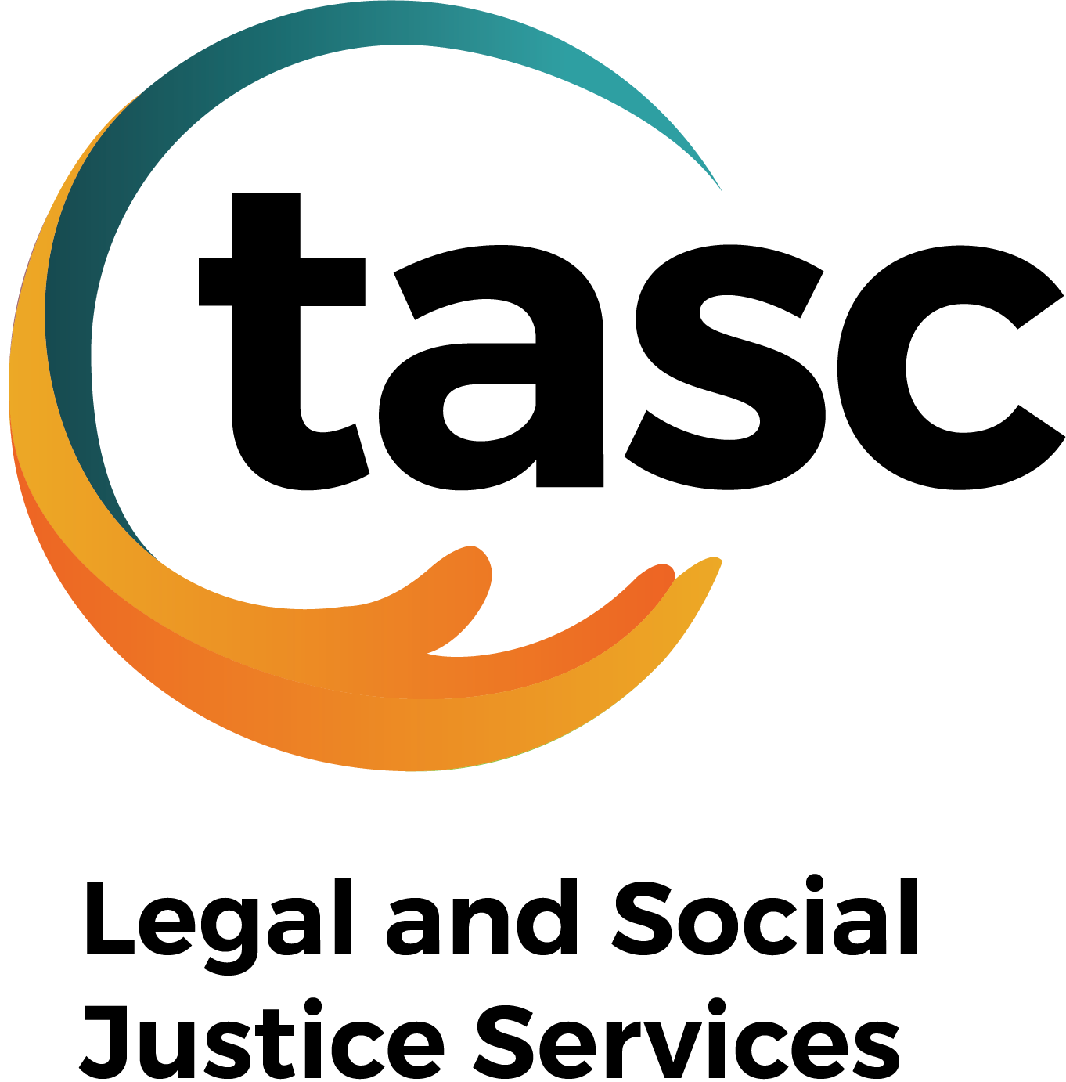

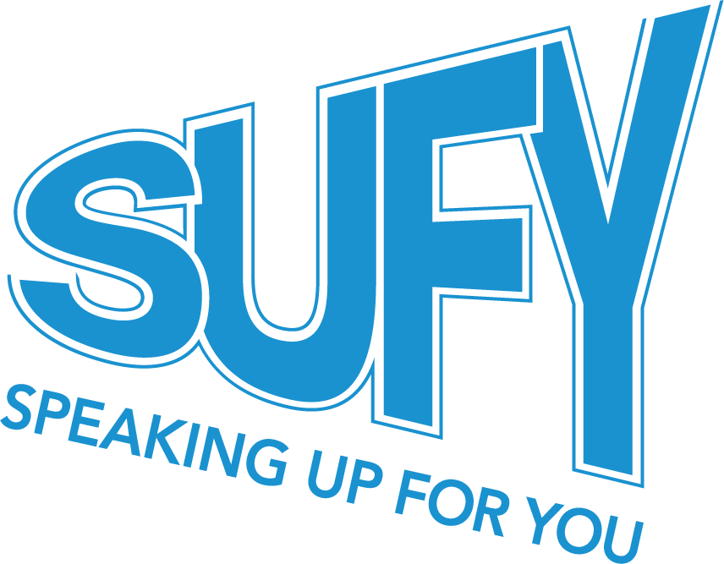
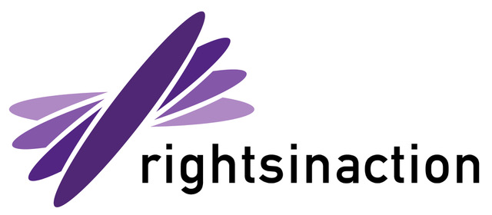

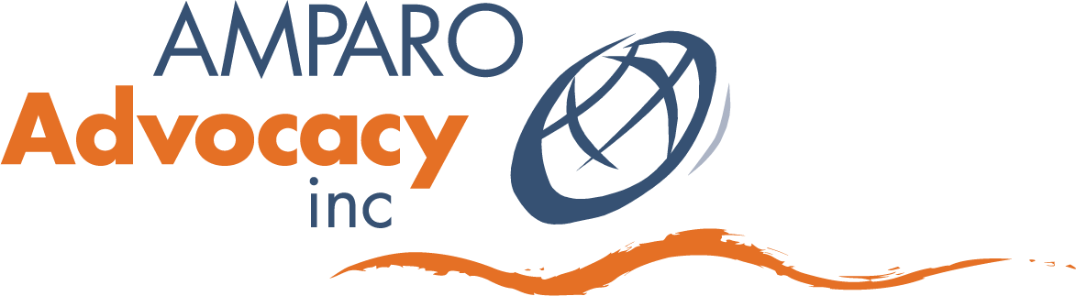

As per DRC Recommendation 4.25 and QIDAN’s Submission to the Disability Discrimination Act Review.
https://qidan.org.au/submissions/qidan-submission-to-the-disability-discrimination-act-1992-review/
Please note that we use the term “reasonable adjustments” as per current practice. However, we note our position to change the reference to “reasonable adjustments” to “adjustments”, as per QIDAN’s submission to the DDA Review.
https://www.qfcc.qld.gov.au/sites/default/files/2025-09/Report-Include-me-dont-exclude-me.pdf
https://www.childsafetyinquiry.qld.gov.au/
https://statements.qld.gov.au/statements/103771
https://www.qfcc.qld.gov.au/sites/default/files/2025-09/Report-Include-me-dont-exclude-me.pdf
“Include a requirement to develop and comply with policies that must be consistent with the principles: Require education providers to develop, implement and comply with their own publicly available policies that must be consistent with the principles”.

