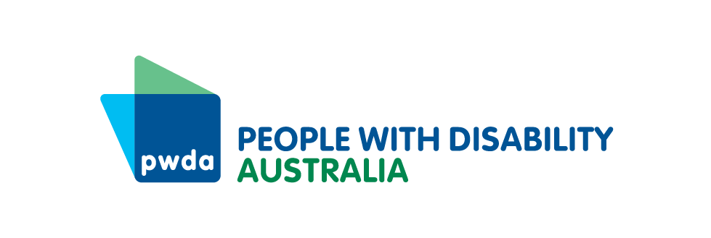
Date updated: 27 January 2026

Making Australia's Hate Speech and Vilification Laws Work for People with Disability

Joint Statement
Disability Representative Organisations acknowledge the passage of the Combatting Antisemitism, Hate and Extremism (Criminal and Migration Laws) Bill 2026 (Cth) and the additional protections it introduces to address serious forms of hate and extremism in Australia. The event of 14 December 2025 targeting the Jewish community at Bondi beach was an abhorrent act of hate and antisemitism. Such acts have no place in our Australian community. Strengthening legal responses to hatred and violence is an important part of improving social cohesion and community safety.
However, the Bill does not deliver comprehensive protection for minority groups, including people with disability and the LGBTQIA+ communities. While it strengthens responses to serious extremism and hate-motivated conduct, it does not introduce a federal criminal offence for serious vilification. Instead, at the federal level, criminal liability remains largely limited to speech that urges or threatens the use of force or violence against targeted groups. As Disability Representative Organisations have consistently argued, including through previous submissions, this threshold is too high and does not reflect the serious psychological and community harm caused by serious vilification that falls short of urging or threatening violence.
We note that the Bill introduces aggravated sentencing provisions for hate-motivated offending. While we welcome recognition that crimes motivated by hatred warrant stronger sentencing responses, we are disappointed that people with disability and LGBTIQA+ communities were excluded from these provisions. We are also disappointed that amendments which would have extended aggravated sentencing to additional targeted groups were not adopted. This outcome perpetuates gaps in Australia's hate crime laws and results in unequal treatment of communities experiencing forms of identity-based harm.
Disability Representative Organisations are concerned that Australia’s hate speech and vilification laws, taken together across jurisdictions, continue to fall short for people with disability. Protections remain inconsistent, and people with disability are not reliably or explicitly covered across legislative frameworks. Hate speech reform is therefore not finished business. To achieve social cohesion, hate speech and vilification laws must operate within a comprehensive, consistent and rights-based legal framework that provides equivalent protection across protected attributes, including people with disability.
Further reform is necessary to address gaps in Australia’s hate speech and vilification framework affecting people with disability, LGBTQIA+ communities and the settings in which our communities experience identity-based hatred. This includes congregate environments such as group homes, aged care facilities and other institutional settings, where harm is often underreported and insufficiently addressed under our existing laws. We urge Parliament to commit to this next stage of reform and to meaningful co-design with affected communities.
We acknowledge strong safeguards must sit alongside any expansion of hate and extremism laws. These safeguards are essential to protect procedural fairness, democratic participation and human rights. This includes ensuring laws do not unintentionally restrict peaceful protest, non-violent resistance, political expression or community advocacy, and that enforcement powers are applied proportionately and transparently with independent oversight.
We also acknowledge the need for protections for people with disability who may be subject to criminal justice processes. A recent case in Victoria highlighted failures in the conduct of law enforcement when engaging with a young person with disability who was charged with terrorism offences. This demonstrates the pressing need for safeguards that ensure people with disability are treated fairly and safely by law enforcement and met with support, not punishment, when harm arises from unmet needs or systemic barriers.
The signatories to this statement are united in our readiness to participate in a genuine, meaningful co-design process with government and Parliament to progress the next stage of reform. The Disability Royal Commission laid bare the scale and severity of violence, abuse, neglect and exploitation experienced by people with disability, including identity-based harm in closed and institutional settings. This harm continues to occur. Adequate legal protections and effective recourse against identity-based harm are a necessity for people with disability.
We will continue to advocate for a Human Rights Act and reforms that uphold the human rights of people with disability and strengthen Australia’s hate speech and vilification laws so they deliver real protection in practice. People with disability have the right to live free from hatred and vilification, and future reforms must reflect that fundamental principle.

Signed by
- Australian Autism Alliance
- Children and Young People with Disability Australia
- Community Mental Health Australia
- Down Syndrome Australia
- Disability Advocacy Network Australia
- National Ethnic Disability Alliance
- People with Disability Australia
- Queensland Advocacy for Inclusion
- Women With Disabilities Australia

