22 July 2026
Committee Secretary
Joint Standing Committee on Aboriginal and Torres Strait Islander Affairs
PO Box 6021
Parliament House
Canberra ACT 2600
Delivered via email: rhvinquiry@aph.gov.au

Dear Committee,
Inquiry into racism, hate and violence directed at Aboriginal and Torres Strait Islander people
We thank you for the opportunity to provide a submission to the inquiry into racism, hate and violence directed at Aboriginal and Torres Strait Islander people, referred from the Minister for Indigenous Australians, Senator the Hon Malarndirri McCarthy in March 2026.
QAI is an independent, community-based advocacy organisation and community legal service that provides individual and systems advocacy for people with disability. Our purpose is to advocate for the protection and advancement of the needs, rights, and lives of people with disability in Queensland. In the 2025-26 financial year, 20.5% of people with disability QAI assisted identified as Aboriginal and / or Torres Strait Islander.
Mob 4 Mob is a First Nations led organisation of people with a disability. Mob 4 Mob works across regional and remote communities to capture lived experience and support through culturally safe engagement, ensuring that the voices of community are not only heard, but are leading advocacy, accountability and system reform. We regularly visit people with disability in institutional settings such as youth detention centres, group homes and hospital wards and make representations for their human rights and freedom.
For our mob, the numbers below are not just statistics, they reflect real experiences of being unheard, unsafe and unsupported within systems that were not designed with us in mind:
- Almost one in four (37%) First Nations people in Australia report living with disability.
- 42% of Aboriginal and Torres Strait Islander people with disability report experiencing racism, compared with 32% of those without disability
- 50% of Aboriginal and Torres Strait Islander people with an intellectual or psychological disability reported experiencing racism
- 20% of Aboriginal and Torres Strait Islander people with any form of disability avoided the general public or essential services like healthcare or education settings due to previous experiences with racism, compared to 11% without disability
- 50% of Aboriginal and Torres Strait Islander people with severe or profound disability have been removed from their family, or had a member of their family removed, compared to 37% of those without disability
- 33% of First Nations students who live with a disability and are living in out-of-home care, received a School Disciplinary Absence (SDA) between 2018–23
Although the numbers above are good indicators, there are gaps in data, including with respect to unreported and undiagnosed disabilities including ‘invisible disabilities’ (such as disability caused as result of Traumatic Brain Injuries). Therefore, the numbers of Aboriginal and / or Torres Strait Islander peoples with disability are likely much higher than what is contained in the statistics.
It is with this evidence, alongside what we see every day in our work with mob, that we provide this response to the Joint Standing Committee on Aboriginal and Torres Strait Islander Affairs. These issues are not theoretical, they are lived realities for Aboriginal and / or Torres Strait Islander people with disability navigating systems that continue to fall short and are reflected both in the data and in the frontline experiences of our organisations.
Our work is guided by the Convention on the Rights of People with Disabilities (CRPD) and the United Nations Declaration on the Rights of Indigenous Peoples (UNDRIP). These instruments require Australia to respect, protect and fulfil the human rights of people with disability. Our views and recommendations are grounded in the concepts of self-determination, health, respect for and protection of culture, equality and non-discrimination of First Nations people with disability.
This letter includes three key recommendations:
- The need for intersectional protection of attributes
- The need for protection against vilification on the basis of disability; and
- The need for a positive duty.
This submission must be read in conjunction with the findings of the Royal Commission into Violence, Abuse, Neglect and Exploitation of People with Disability (DRC), Volumes 4 and 9 and Public Hearing 28, and the Queensland Independent Disability Advocacy Network’s (QIDAN) submission to the Disability Discrimination Act 1992 (Cth) (DDA).
The intersectional protection of attributes
Despite clear evidence of compounded vulnerability, anti-discrimination law in Australia remains structured around single, discrete protected attributes. Complaints systems and legislative frameworks largely require discrimination to be articulated and proven as occurring on the basis of either race or disability, rather than recognising how these attributes operate together in lived experience.
In Queensland, legislative reforms to the Anti-Discrimination Act 1991 (Qld) (ADA) were to commence in July 2025, including a positive duty to prevent discrimination and protection from intersectional discrimination. Unfortunately, these reforms are now delayed with no future commencement date announced.
This fragmented approach results in intersectional discrimination legally becoming invisible, particularly where Aboriginal and / or Torres Strait Islander people with disability are unable to satisfy the distinct evidentiary requirements associated with each attribute.
This is similarly problematic for Aboriginal and / or Torres Strait Islander people experiencing hate speech who are often targeted because of overlapping identities, not a single protected attribute. As a result, people are forced to fit their experiences into narrow legal categories, preventing courts from recognizing broader context and severity of the conduct.
For Aboriginal and / or Torres Strait Islander peoples, experiencing hate speech and vilification which operate within pre-existing marginalisation is grounded in the ongoing legacy of colonisation and racial hierarchy, meaning that intersecting forms of violence amplify the harm and its consequences for wellbeing, safety and inclusion.
In our work we consistently hear from Aboriginal and / or Torres Strait Islander people with disability who experience this layered discrimination in their daily lives, across services, public spaces and systems that are meant to provide support. For example, an Aboriginal woman with disability seeking healthcare, experiences her concerns being dismissed or minimised, with assumptions made about her capacity, communication and credibility. Cultural ways of communicating, decision making and the role of family and kin are often not recognised or respected. These interactions occur within systems that have historically excluded and disadvantaged Aboriginal and / or Torres Strait Islander people, meaning racism and ableism operate together creating unsafe environments, delaying care and contributing to poorer health outcomes over time.
Another example of this is students with disability and students from Aboriginal and / or Torres Strait Islander communities experiencing school disciplinary absences at twice the rate of all students. The intersection of these attributes further increases the risk of receiving a school disciplinary absence.
An intersectional approach is necessary to understand how identity attributes relate to inform experiences of racism, hate and violence. Aboriginal and / or Torres Strait Islander people with disability face a unique form of intersectional oppression - an interaction of both race-based and disability-based discrimination - the consequences of which are not confined to a single point in time but accumulate over the course of life. This reality was described by the DRC:
First Nations people with disability walk in multiple worlds, navigating Indigenous rights, disability rights and mainstream laws, culture and settings. They have told us they often experience a ‘double disadvantage’ at the intersection of racism and ableism.
An intersectional approach also requires consideration of other attributes (including age, sexuality and gender) which may compound the disadvantage of Aboriginal and / or Torres Strait Islander people with disability. For example, undetected and unsupported disability of Aboriginal and / or Torres Strait Islander peoples in early childhood carries forward into the schooling years, cumulating in greater socio-economic inequality in later life.
To effectively combat racism, hate and violence, intersectional protections must be embedded in anti-discrimination and vilification law, as emphasised by recent reviews.
Disability Vilification protections
The DRC Public Hearing 28 heard evidence from Aboriginal and Torres Strait Islander people with disability who detailed their experiences of violence and abuse in public places reflecting on the compounding disadvantage that arises from the intersection of First Nations identity, disability, gender identity and other aspects of personal identity.⁶ These testimonies demonstrate that Aboriginal and / or Torres Strait Islander people with disability are not simply exposed to ableist abuse, but to a distinct form of hostility in which multiple aspects of their identity are targeted. Protections exist for racial vilification but are absent for disability discrimination. This means that an Aboriginal and / or Torres Strait person with disability experiencing public ridicule would have to show that it was due to their race, rather than their disability when in reality it could have been either or both.
A positive duty
For our mob, harm does not begin when a complaint is made, it often begins long before, in systems that fail to recognise, respond to, or respect our needs.
To promote equality and inclusion we must shift from a reactive anti-discrimination model which is generally individual based, to prevention and elimination of systemic barriers for Aboriginal and Torres Strait people with disability more broadly. We need positive changes and actions to achieve inclusion.
As recommended by the DRC, introducing a positive duty would provide adequate protection in the first instance which may prevent the discrimination from occurring. Applying a positive duty to both the public and the private sectors is an encouragement to take meaningful positive action to eliminate discrimination. Without an enforcement of a positive duty, the discrimination framework will continue to be reactionary with little to no change to community behaviour.
The current lack of a positive duty under the DDA has a number of negative impacts on Aboriginal and Torres Strait Islander people, as it:
- makes it difficult to bring a discrimination claim under the current DDA;
- causes duty holders to act reactively instead of proactively;
- fails to address systemic discrimination; and
- creates a high burden on Aboriginal and / or Torres Strait Islander people in enforcing their rights.
By introducing a positive duty to prevent disability discrimination and racism, those who hold this duty must become informed about what it entails. This will encourage greater awareness about disability issues and rights, which in turn supports a collective cultural shift to improved equity and inclusion for all. Positive duty can act as a powerful mechanism for identifying key issues within the Aboriginal and Torres Strait Islander and the disability communities, enabling governments, organisations, and employers to identify patterns of discrimination, improve educational and awareness training, and re-design their policies towards better inclusion and diversity.
Following the publication of DRC Final Report in September, the Australian Government started a review of the DDA in late 2025, which included a proposed positive duty. No further updates or progress have been provided since. The need for a positive duty is urgent as it provides a stronger mechanism to ensure discrimination experienced by Aboriginal and Torres Strait Islander people with disability is prevented from occurring in the first place. It would require duty holders to anticipate barriers and take active steps to eliminate them before harm occurs.
Experiences of disadvantage arguably do not arise from isolated incidents that can be addressed by pursuing an individual complaint, but from structural inequality.
On an individual level, limited engagement with disability support services is attributed to remoteness, social marginalisation, cultural attitudes towards disability, and culturally inappropriate services. In 2025, the majority of Aboriginal and Torres Strait Islander people reported experiencing interpersonal racism in the past year. However, they also experience systemic racism, arising from the way policies, practices and institutions operate based on the application of apparently neutral beliefs, values, structures and processes that, nevertheless, result in differential and unfair outcomes for particular groups.
Where Aboriginal and Torres Strait Islander people experience disability at a higher rate compared to non-Aboriginal and Torres Strait Islander people, as well as suffering greater limitations due to their disability, they are also more likely to benefit from the structural changes anticipated by the introduction of a positive duty.
Our recommendations are:
- Allow claims to be brought for multiple or combined protected attributes, strengthening the Disability Discrimination Act 1992 (Cth) (DDA), making it compliant with article 5 of the Convention on the Rights of the Persons with Disabilities (CRPD).
- Amend the DDA to protect Aboriginal and Torres Strait Islander people with disability from vilification, as in recommendation 4.30 of the DRC.
- Introduce an enforceable positive duty to eliminate disability discrimination which should have broad application to all duty holders under the DDA, as per DRC recommendation 4.27. Exceptions or limits to the application of a positive duty should only be applicable to the extent necessary to ensure proportionality and fairness, and care must be taken to ensure they cannot undermine its purpose.
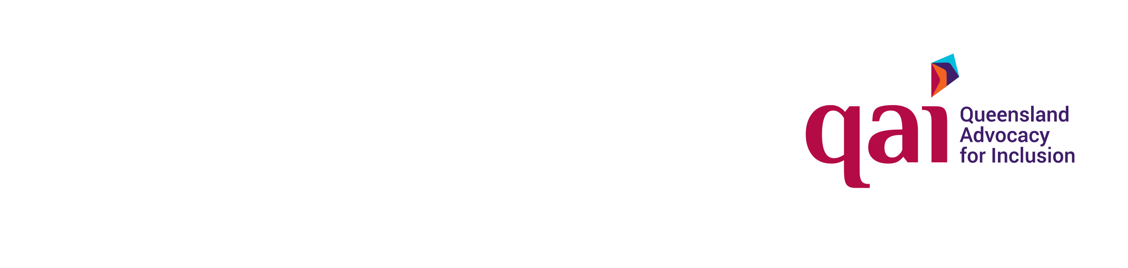
Thank you for your time and consideration.
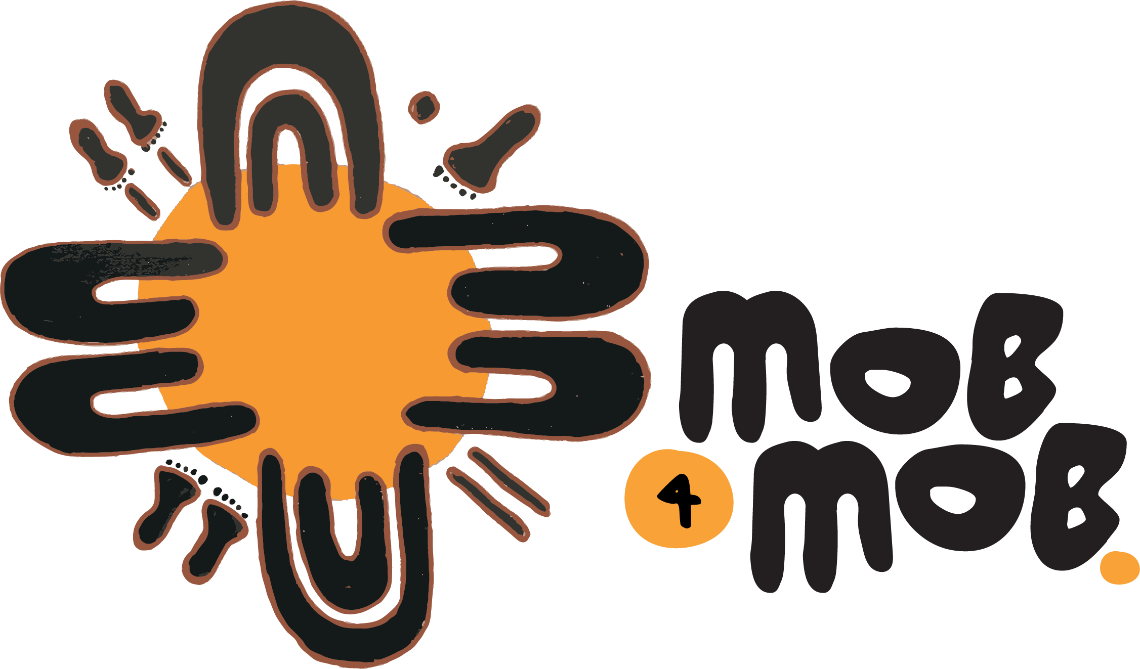
Yours sincerely,

Queensland Advocacy for Inclusion Mob 4 Mob

Queensland Advocacy for Inclusion, Annual Report 2024-2025: https://qai.org.au/wp-content/uploads/2026/01/2025-Annual-Report-Accessible.pdf
Office of the Aboriginal and Torres Strait Islander Children's Commissioner, Include me, don't exclude me report (2025), P 6.
Queensland Independent Disability Advocacy Network (QIDAN), ‘QIDAN submission to the Disability Discrimination Act 1992 Review’ https://qidan.org.au/submissions/qidan-submission-to-the-disability-discrimination-act-1992-review/.
Australian Human Rights Commission, 'Free and Equal: A Reform Agenda for Federal Anti-Discrimination Laws' (n 60) 301 - 303.
Luke McNamara and Katharine Gelber, Submission No 16: Measures to Prohibit Slogans that Incite Hatred (Submission to NSW Legislative Assembly Committee on Law and Safety, 8 January 2026) 2–3 (Submission 16 - Professor Luke McNamara and Professor Kath Gelber.pdf)
Anna Green et al., (2018) 'Interacting with Providers: An Intersectional Exploration of Experiences of Carers of Aboriginal Children with a Disability' 28(12) Qualitative Health Research 1923, 1924.
Scott Avery, Culture is Inclusion: A narrative of Aboriginal and Torres Strait Islander people with disability (First Peoples Disability Network, 2018) 37.
Commonwealth, Royal Commission into Violence, Abuse, Neglect and Exploitation of People with Disability, Final Report (2024) vol 9, (Disability Royal Commission, vol 9), 4.
Disability Royal Commission, vol 9 (n 6) 13.
Avery (n 5) 121.
See for example, Australian Human Rights Commission, 'Free and Equal: A reform agenda for federal discrimination laws' (Report, 2021) 25; 'Review of the Anti-Discrimination Act 1977 (NSW)' (Consultation paper, May 2025) 15.
Colm O’Cinneide, “A New Generation of Equality Legislation? Positive Duties and Disability Rights,” in Disability Rights in Europe: From Theory to Practice (Hart Publishing, 2005), p 235.
Law Council of Australia, Review of Disability Discrimination Act (14 November 2025) [78].
Michelle DiGiaocomo et al., 'Childhood disability in Aboriginal and Torres Strait Islander peoples: a literature review' 12(7) International Journal for Equity in Health 1, 2.
'Barometer: Racism and First Nations Peoples', Reconciliation Australia (Web Page, 18 June 2025).
Stephen Zubrick et al., 'Social Determinants of Social and Emotional Wellbeing' in Pat Dudgeon, Helen Milroy and Roz Walker (eds), Working Together: Aboriginal and Torres Strait Islander Mental Health and Wellbeing Principles and Practice, 93, 98.

